AU Bank End-to-End Insurance Platform — Chief Technology Officer Architecture Review Record
  - Architecture pre-approval document | AU Bank End-to-End Insurance Platform
DRAFT FOR REVIEW - NOT APPROVED - NOT AUTHORISED FOR DEVELOPMENT

Version | 0.1 | Date | 17 August 2026
Document owner | Mahesh, Principal Insurance Platform Architect | Approval state | Pending
Purpose | Provide a self-contained review record for the target architecture and first release | Next action | Stakeholder review and recorded decision

1. Review status
Activity | State
Architecture material prepared | Complete
Review meeting with Chief Technology Officer | Not conducted
Chief Technology Officer questions recorded | Pending
Architecture responses recorded | Pending
Technical direction decision | Pending
Other stakeholder approvals | Pending and independent

This record does not claim that a review meeting or approval has occurred.

2. Executive summary
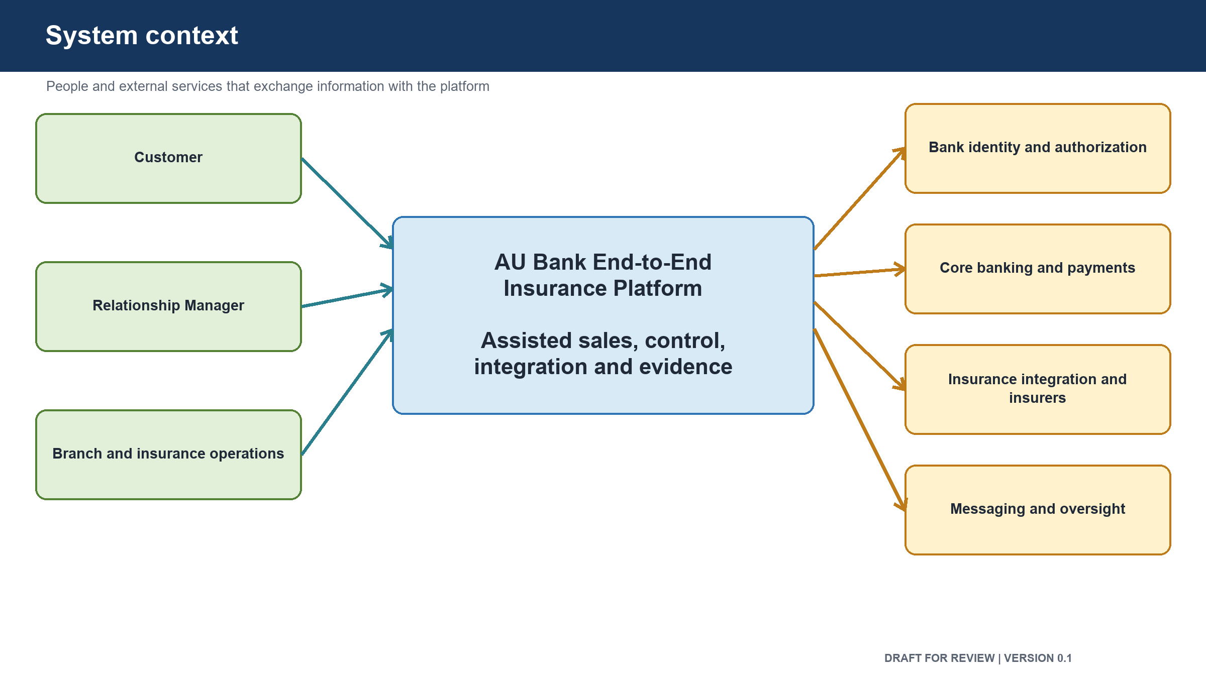
Figure: System context presented for review
The proposed platform gives the bank control of the insurance journey from customer identification through policy issuance and payment reconciliation. It starts with one assisted Term Life sale for an existing bank customer through one insurer. It expands later to more channels, products, insurance lines and partners.
The design separates customer, consent, suitability, catalogue, quotation, proposal, payment, policy, integration and audit responsibilities. The bank owns the journey and its business data. External partner formats are translated at one boundary. Suitability, consent, customer-device payment, reconciliation and durable evidence are mandatory design controls.
The main unresolved items are customer identity for self-service, approved consent and suitability rules, final product and insurer scope, partner and payment operating agreements, retention periods, component deployment grouping and recovery funding.

3. Decisions requested from the Chief Technology Officer
ID | Decision requested | Proposed position | CTO decision
CTO-01 | Endorse the bank-owned end-to-end platform direction | Proceed | Pending
CTO-02 | Endorse the phased first release | One assisted Term Life journey before broader expansion | Pending
CTO-03 | Endorse responsibility-based ownership and partner isolation | Proceed | Pending
CTO-04 | Endorse India-only protected-data hosting and recovery | Proceed | Pending
CTO-05 | Endorse engineering, security and test foundations as development entry conditions | Proceed | Pending
CTO-06 | Confirm funding and ownership for environments, security, recovery and partner access | Required | Pending
CTO-07 | Confirm that unresolved Product, Security and Compliance matters remain with their owners | Required separation of duties | Pending

4. Architecture assessment
Area | Assessment | Main observation
Business alignment | Ready for stakeholder review | Design supports the complete sale and later expansion
Scope control | Ready for stakeholder review | First release is deliberately narrow
Responsibility boundaries | Ready for stakeholder review | Ownership is defined without forcing one deployment per business area
Information flow | Ready for stakeholder review | Happy path, failure, duplicate and recovery behaviour are included
Partner integration | Ready for stakeholder review | Partner formats and credentials remain at the boundary
Security structure | Ready for Security review | Required controls are designed but not approved or proven
Data ownership | Ready for Data review | Official owners are defined; physical storage design requires approval
Reliability | Ready for Operations review | Recovery targets and failure handling are proposed
Delivery readiness | Not yet approved | External access, rule approval, environments and automated checks remain dependencies

5. Review questions

Strategy and scope
- Does the proposed platform direction match the bank's technology strategy?
- Is the first release small enough to deliver and complete enough to prove value?
- Are any capabilities required in the first release that are currently deferred?
- Is phased expansion acceptable?

Structure and ownership
- Are the responsibility boundaries clear and supportable?
- Is the partner integration boundary acceptable?
- Is the proposal to combine components unless separation is justified acceptable?
- Are data ownership and reporting boundaries acceptable?

Security, risk and compliance
- Is India-only storage and recovery accepted as a design requirement?
- Are suitability, consent, payment separation and evidence controls accepted as mandatory?
- Are the identified Security and Compliance reviews sufficient before approval?
- Which residual risks require accountable human acceptance?

Delivery and investment
- Are the required environment, delivery pipeline, test and recovery foundations funded?
- Are the external-system owners committed to providing contracts, test access and support?
- Is the proposed recovery posture proportionate to the first release?
- Who owns unresolved cross-team dependencies?

6. Conditions that must remain independent of CTO review
- Product approves business scope, customer behaviour and acceptance.
- Security approves security outcomes and residual security risk.
- Compliance and Risk approves regulatory permissibility and required evidence.
- Data and Database Architecture approves physical data integrity and recovery.
- Quality approves test and evidence sufficiency.
- Reliability and Operations approves operational readiness and recovery evidence.
- Material risk acceptance remains with the authorized human risk owner.

7. Review discussion record
Topic | CTO question or observation | Architecture response | Owner | Due date | State
 |  |  |  |  | Pending
 |  |  |  |  | Pending
 |  |  |  |  | Pending

8. Review outcome
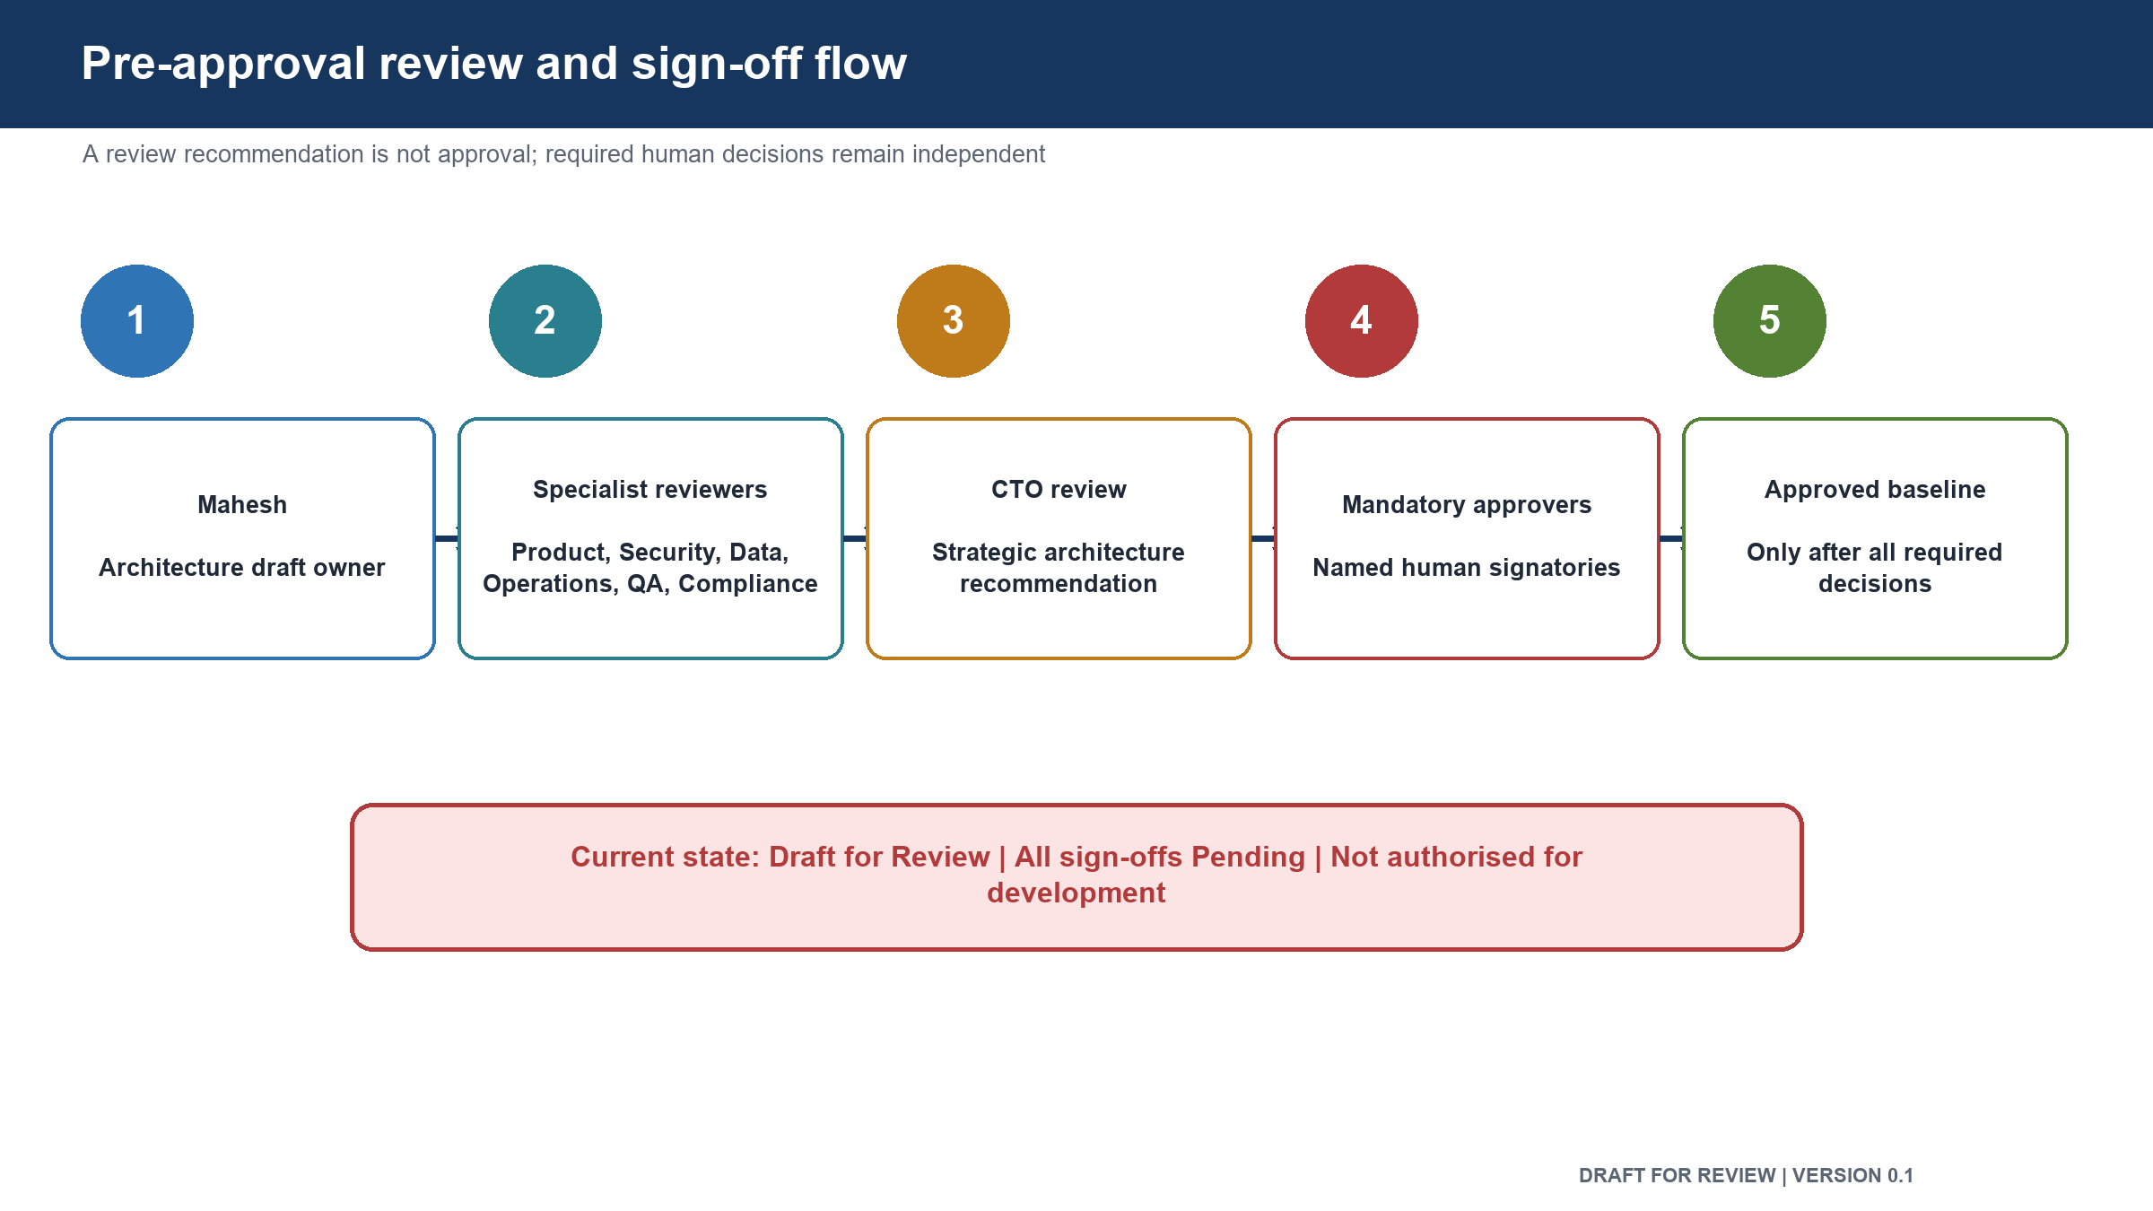
Figure: Pre-approval review and sign-off flow

Field | Value
Outcome | Pending
Conditions | None recorded
Required changes | None recorded
Risks accepted | None
Follow-up review required | To be decided

Permitted outcome values are Approved, Approved with Conditions, Changes Required, Rejected or Escalation Required. The outcome must be entered by the authorized reviewer after the review.

Approval control: review comments and recommendations do not constitute approval. The decision remains Pending until the named human stakeholder records a decision, date and signature.

9. Sign-off
Stakeholder | Role in this review | Decision | Name | Date | Comments
Chief Technology Officer | Technical direction and investment alignment | Pending
Principal Architect | Architecture recommendation and response | Pending
Product Owner | Product scope confirmation | Pending
Security Head | Independent security decision | Pending
Compliance and Risk Head | Independent compliance decision | Pending
Engineering Head | Implementation feasibility | Pending
Reliability and Operations Head | Operational feasibility | Pending
Delivery Head | Dependency and delivery coordination | Pending

10. Version history
Version | Date | Change | Approval state
0.1 | 17 August 2026 | Initial pre-approval review record | Not approved

