AU Bank End-to-End Insurance Platform — Architecture Work Progress Summary
  - Architecture pre-approval document | AU Bank End-to-End Insurance Platform
DRAFT FOR REVIEW - NOT APPROVED - NOT AUTHORISED FOR DEVELOPMENT

Version | 0.1 | Date | 17 August 2026
Document owner | Mahesh, Principal Insurance Platform Architect | Approval state | Pending
Purpose | Show what architecture work has been prepared and what remains before approval | Next action | Stakeholder review and recorded decision

1. Requested work status
Requested task | Correct document type | Architecture drafting | Review and approval
Define the end-to-end solution vision, scope, objectives and principles | Solution Vision | Complete | Pending
Identify and align required business capabilities | Business Capability Map | Complete | Pending
Determine core business domains, ownership and interactions | Business Domain and Ownership Model | Complete | Pending
Cover system context, components, flows, integrations and decisions | High-Level Design | Complete | Pending
Review access, data protection, compliance and security risks | Security Design Review | Architecture input complete | Security and Compliance decisions pending
Record technical risks, dependencies, assumptions and mitigations | Technical Risks, Dependencies and Assumptions Register | Complete | Owner validation pending
Conduct architecture review with the Chief Technology Officer | CTO Architecture Review Record | Review material complete | Meeting not conducted; decision pending

2. Completion view
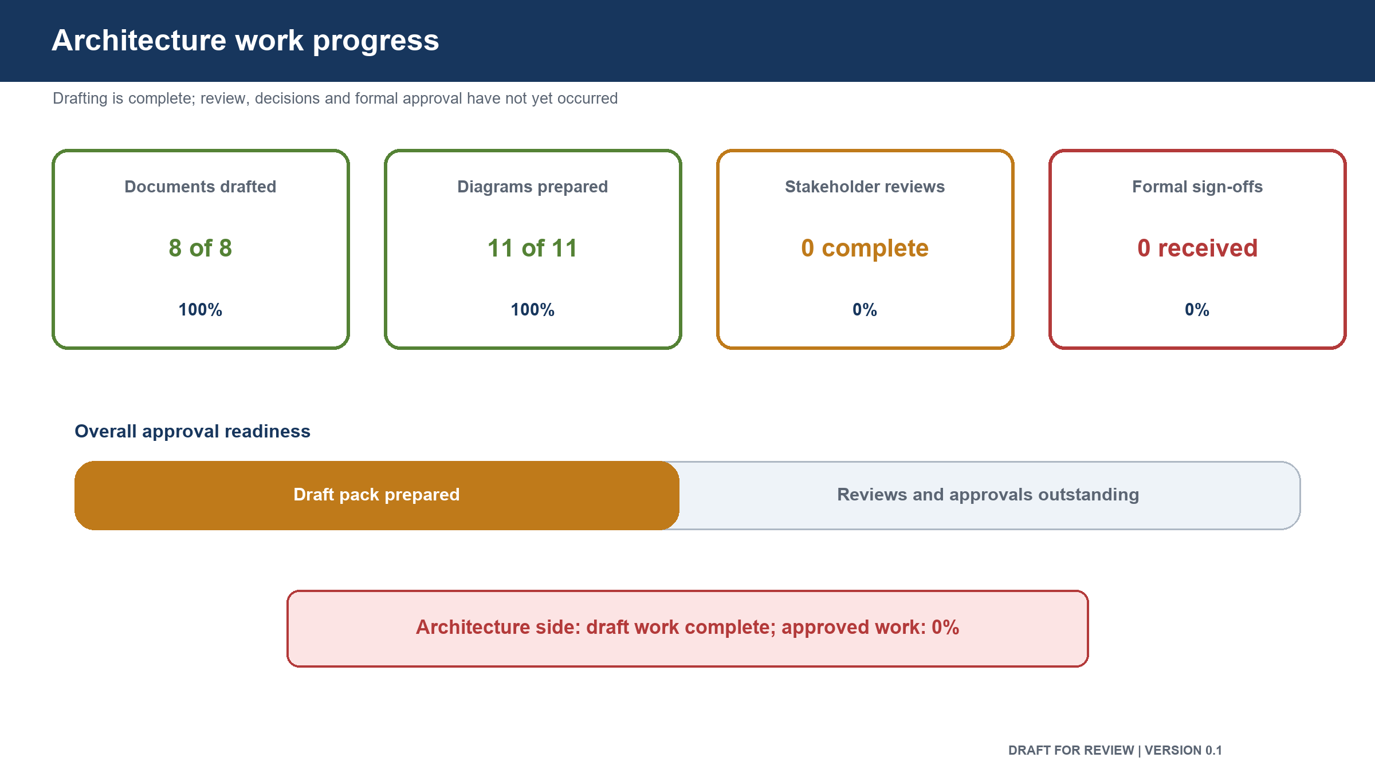
Figure: Architecture work progress

Measure | Result
Requested document types prepared | 7 of 7
Architecture drafting completion | 100%
Documents marked as pre-approval | 7 of 7
Chief Technology Officer review conducted | No
Human Architecture approval recorded | No
Product approval recorded | No
Security approval recorded | No
Compliance and Risk approval recorded | No
Data, Quality and Operations approvals recorded | No

Architecture preparation is complete for review. The solution is not approved and development authorization must not be inferred from the drafting percentage.

3. Architecture position
- The target vision and first release boundary are defined.
- Required business capabilities are mapped to solution areas.
- Business ownership boundaries and interactions are defined.
- The high-level design includes the system setting, major components, information flow,
integrations, data approach, recovery and key decisions.
- Security considerations and open security risks are recorded for independent review.
- Technical risks, dependencies, assumptions and mitigation owners are recorded.
- The Chief Technology Officer review material and decision record are ready.
- No human review, approval, exception or risk acceptance has been fabricated.

4. Work remaining before approval
Remaining activity | Responsible stakeholder
Confirm Product vision, first release scope and expected outcomes | Product Owner
Review and approve architecture direction | Human Principal Architect
Conduct technical direction review | Chief Technology Officer
Confirm implementation feasibility | Engineering Head
Approve security controls and residual security risk | Security Head
Confirm regulatory permissibility and evidence | Compliance and Risk Head
Approve data integrity, storage and recovery approach | Data and Database Architect
Confirm operating, capacity and recovery feasibility | Reliability and Operations Head
Confirm testability and evidence sufficiency | Quality Lead
Confirm dependencies, ownership and delivery sequence | Delivery Head

5. Approval status
Overall state | Meaning
Draft for Review | Architecture content is prepared for stakeholder challenge
Not Approved | No stakeholder sign-off has been recorded
Not Authorized for Development | Development approval is outside this document

6. Review acknowledgement
Stakeholder | Acknowledgement | Name | Date | Comments
Principal Architect | Pending
Chief Technology Officer | Pending
Product Owner | Pending
Security Head | Pending
Compliance and Risk Head | Pending
Engineering Head | Pending
Data and Database Architect | Pending
Reliability and Operations Head | Pending
Quality Lead | Pending
Delivery Head | Pending

7. Version history
Version | Date | Change | Approval state
0.1 | 17 August 2026 | Initial progress summary | Not approved

