C2KEST PATCH APPLY OF APRIL 2021

Shut down the Database and Listener.

Also disable the from services.

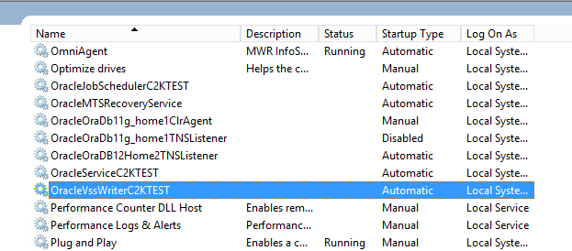

Check the OPatch Version.

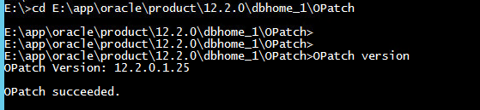

Check the currently applied patches.

Command: - OPatch lsinventory

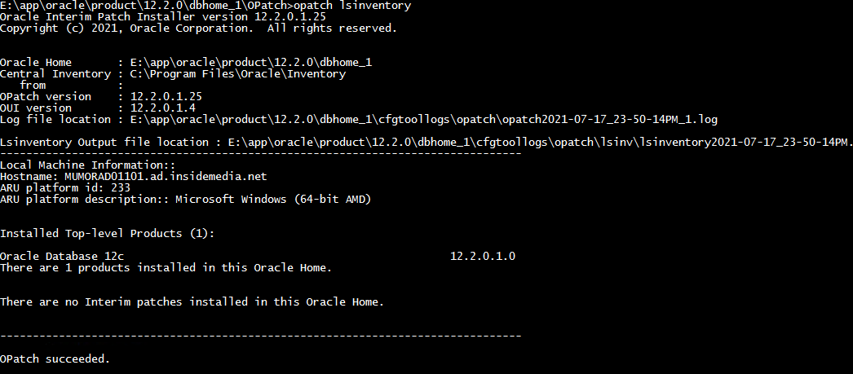

Command: - opatch prereq CheckConflictAgainstOHWithDetail -ph D:\vishal\p32392089_122010_MSWIN-x86-64\32392089

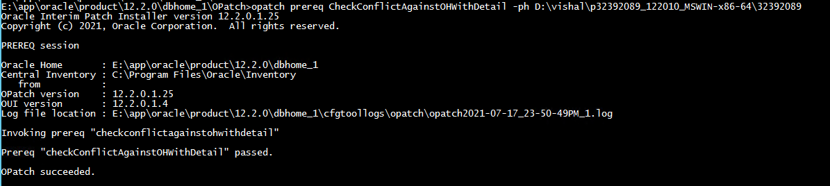

Command: - opatch prereq CheckActiveFilesAndExecutables -ph D:\vishal\p32392089_122010_MSWIN-x86-64\32392089

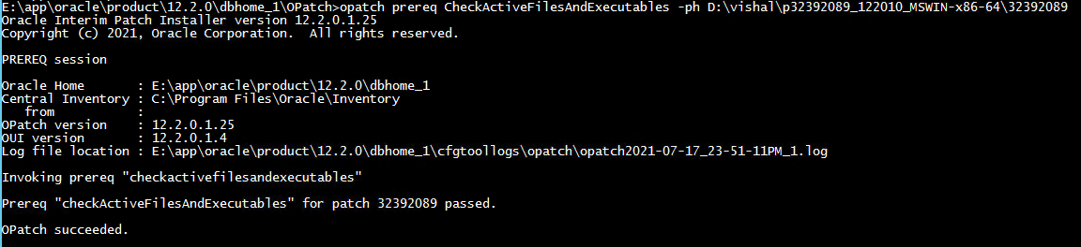

Command: - opatch prereq CheckConflictAmongPatchesWithDetail -phBaseDir D:\vishal\p32392089_122010_MSWIN-x86-64\32392089

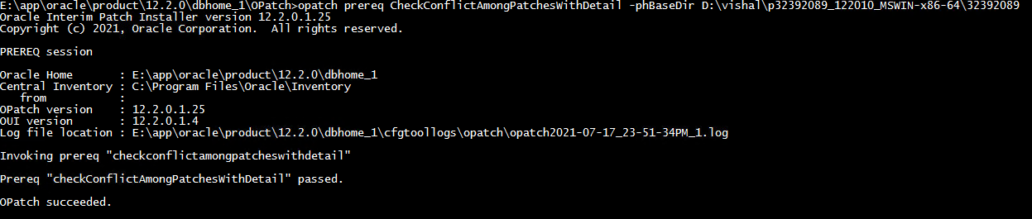

Command: - opatch apply D:\vishal\p32392089_122010_MSWIN-x86-64\32392089 -report >D:\vishal\opatch_report.log





Download the Latest OPATCH version and then replace.

Command: - opatch apply D:\vishal\p32392089_122010_MSWIN-x86-64\32392089 -report >D:\vishal\opatch_report.log





Command: - opatch apply D:\vishal\p32392089_122010_MSWIN-x86-64\32392089

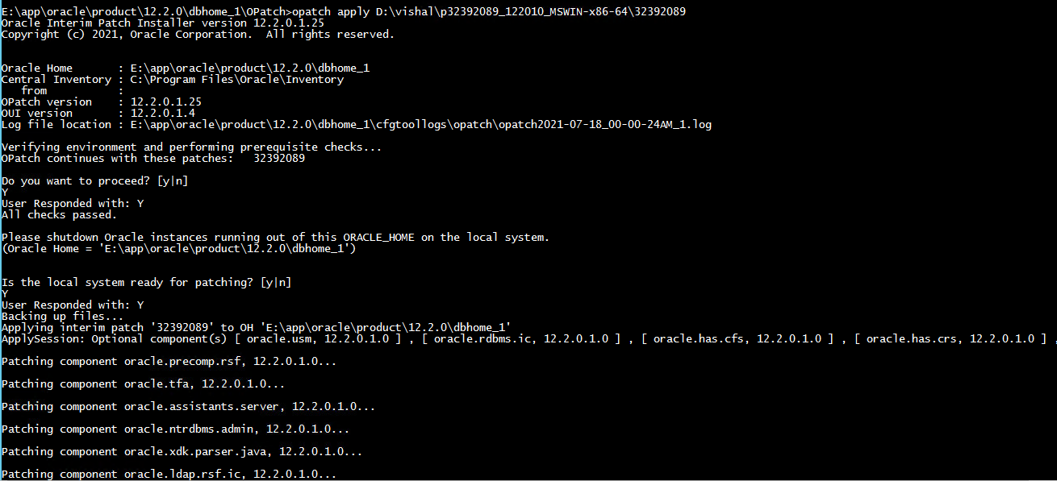



Command: - OPatch lsinventory

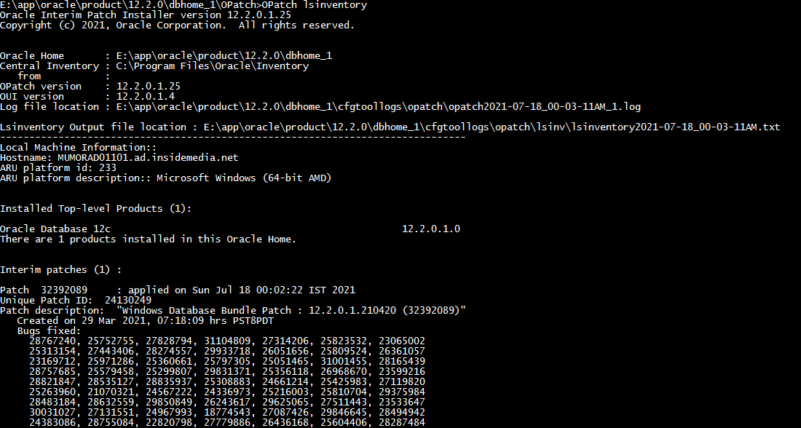



Start Database and Listener services.

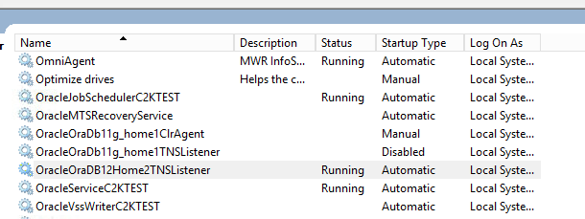

Start the Database.

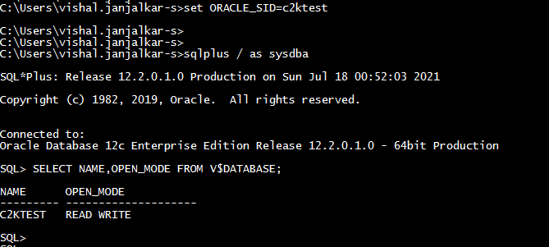

Start the Listener

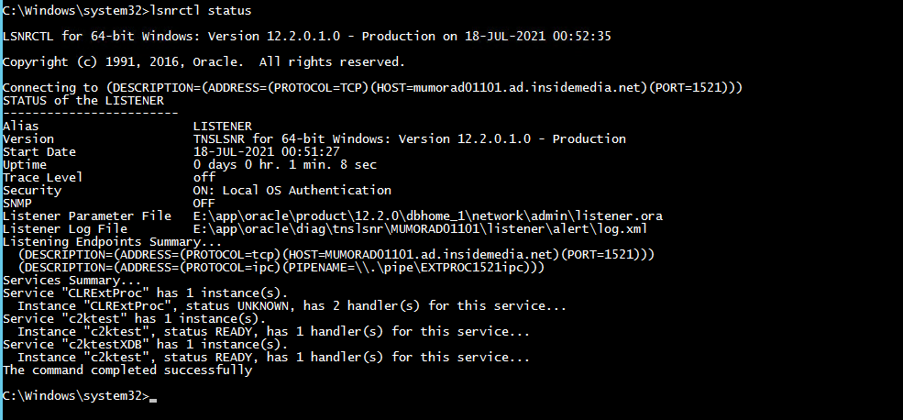

Apply the Patch to the database,

Command: - datapatch -verbose

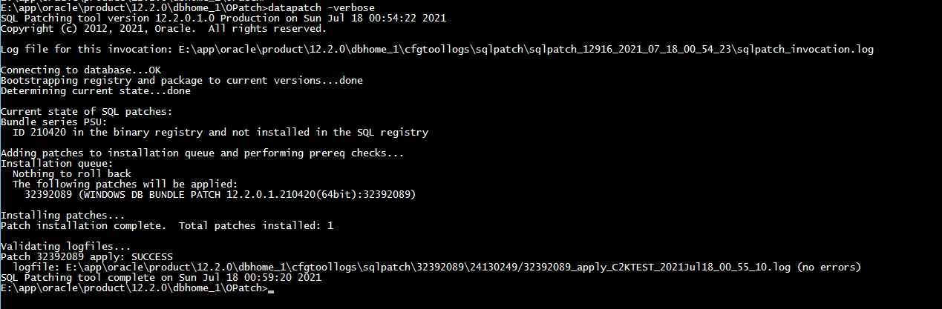

SQL> SELECT BUNDLE_SERIES,PATCH_UID,PATCH_ID,VERSION,STATUS,ACTION_TIME,DESCRIPTION FROM DBA_REGISTRY_SQLPATCH;

