**DB RESTORATION**

Step 1:-

Check db Version of prod and uat6

Step 2:-

If already db is present then firstly drop database

Shut immediate;

Startup mount exclusive restrict;

Drop database

Step 3:-

Check the DB full backup is correct or not(control file backup mandatory)

Step 4:-

Uat6 change pfile parameter:

Db name=SBDFNG

Db_file_create_dest=d:/app/oracle/oradata/uat6

Db_file_converter=E:/files to D:/app/oracle/oradata/uat6

Step 5:

Connect to DB:-

Startup nomount pfile=’D:/pfile/INITuat6.ora’

Connect to rman target /

Restore controlfile from ‘desktop/20240130/cf_ctl’;

Alter database mount;

Cross check all backup;

Delete expired backup;

**Follow the below snip:-**

Catalog start with ‘D:\rman_backup’;

Step 6:-

Run command under we set new name, restore the database, recover database, switch datafile all,recover database

Step 7:-

After recovery complete just open database as

Alter database open resetlogs;

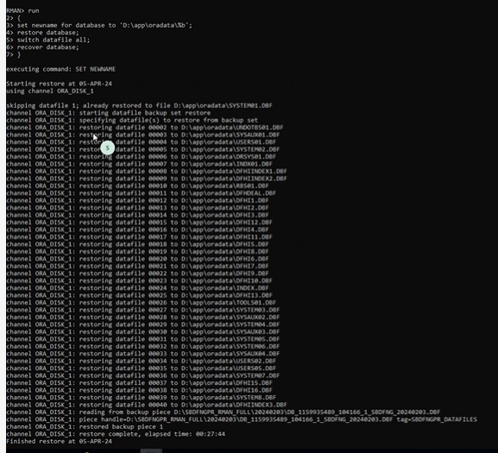

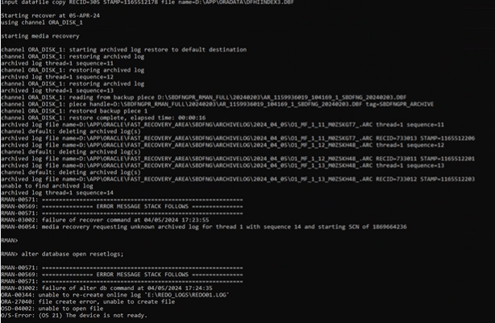

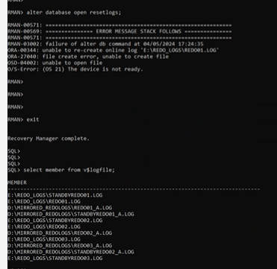

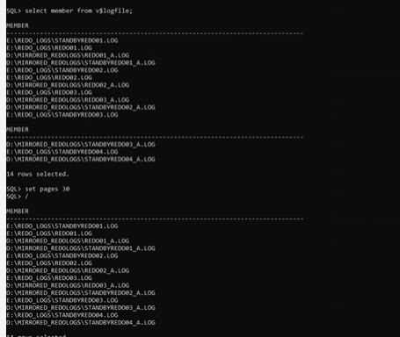

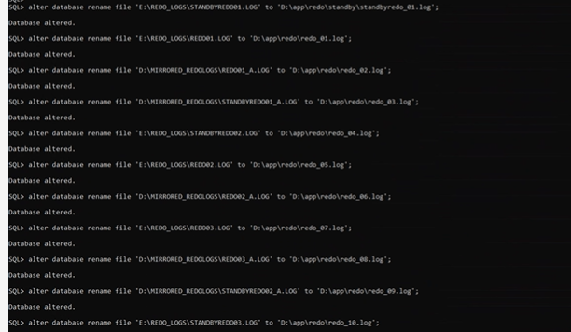

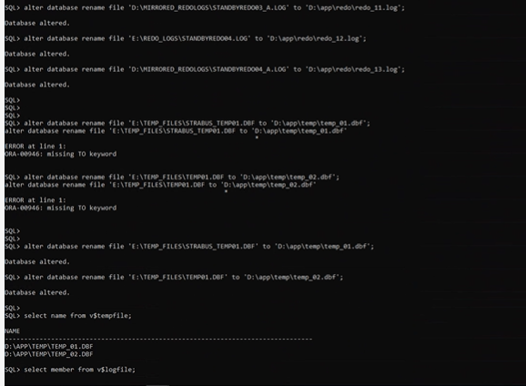

**ERRO:-**

**How to resolve**

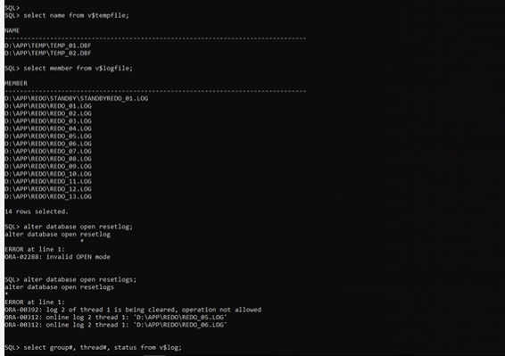

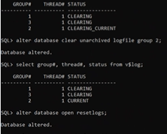

**Erro resolve now,**

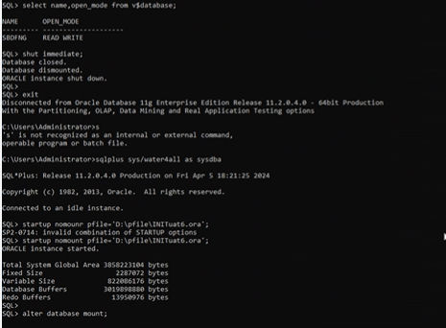

**DB Restore Sucessfully.**