BMS College of Engineering
Bull Temple Road, Basavanagudi, Bengaluru-560019
(Autonomous Institute under Visvesvaraya Technological University, Belagavi and Approved by AICTE, New Delhi, NAAC Accredited with ‘A++’ Grade)

Department of Artificial Intelligence & Data Science

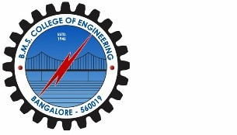

CERTIFICATE

Certified that the Social Network Analytics Mini Project - entitled “NETWORK GRAPH ANALYSIS: MAPPING HUB-SPOKE CONNECTIVITY IN INDIA'S AVIATION ECOSYSTEM” carried out by Chethan G , Mahesh C and Manvanth A, bonafide students of BMS College of Engineering, in partial fulfillment for the award of Bachelor of Engineering in Artificial Intelligence & Data Science of the Visvesvaraya Technological University, Belgaum during the year 2025-26. It is certified that all corrections/suggestions indicated for internal assessment have been incorporated in the report deposited in the department library.

Signature of the Guide Signature of the HOD

Prof. Vidushi Dr. Indiramma M
Asst. Prof. Dept. of AI & DS Prof. & Head, Dept. of AI & DS
BMSCE, Bengaluru. BMSCE, Bengaluru.

Principal
Dr. Bheemsha Arya
B.M.S. College of Engineering
External Viva
Name of the Examiners Signature with Date
1.

2.

