Trader Performance vs. Market Sentiment
An analysis of Hyperliquid trading data against the Bitcoin Fear & Greed Index

1. Objective
This analysis examines whether trader behavior and profitability on Hyperliquid differ across market sentiment regimes, using the Bitcoin Fear & Greed Index as a proxy for daily market mood. The goal is to identify patterns that could inform a systematic trading strategy conditioned on sentiment.

2. Data & Methodology
Two datasets were used:
- Historical trade data from Hyperliquid — 211,224 individual trade records across 32 unique accounts, including execution price, size, side, closed PnL, and timestamp.
- Bitcoin Fear & Greed Index — a daily sentiment score (0-100) and classification (Extreme Fear, Fear, Neutral, Greed, Extreme Greed) covering 2,644 days.
Each trade's timestamp was converted to a calendar date and joined to the sentiment index for that date. Of 211,224 trades, 211,218 (99.997%) matched a sentiment record; the remaining 6 fell outside the sentiment index's date range and were excluded. All summary statistics below are computed on the merged dataset.

3. Key Findings

3.1 Average PnL by Sentiment
Average closed PnL per trade was highest during Extreme Greed (67.89 USD) and Fear (54.29 USD), and lowest during Neutral (34.31 USD) and Extreme Fear (34.54 USD) conditions.
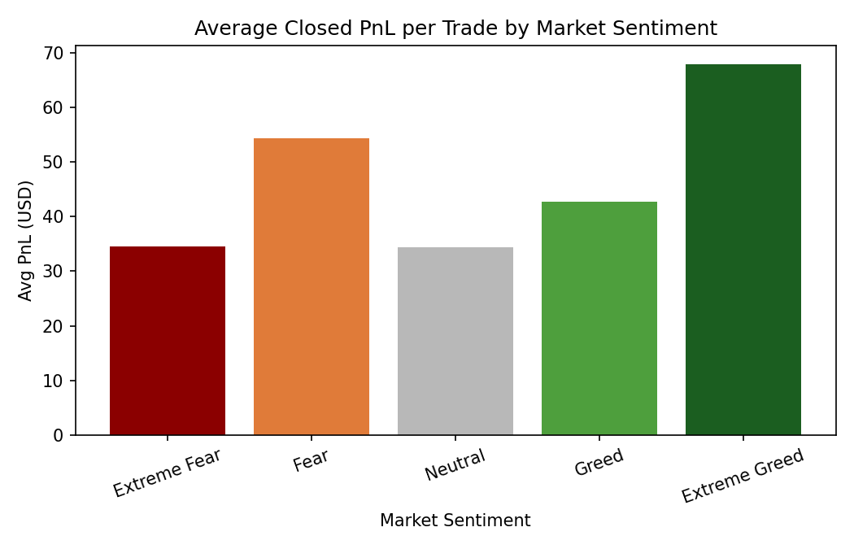
Sentiment | Trades | Avg PnL (USD) | Win Rate | Avg Trade Size (USD)
Extreme Fear | 21,400 | 34.54 | 37.1% | 5,349.73
Fear | 61,837 | 54.29 | 42.1% | 7,816.11
Neutral | 37,686 | 34.31 | 39.7% | 4,782.73
Greed | 50,303 | 42.74 | 38.5% | 5,736.88
Extreme Greed | 39,992 | 67.89 | 46.5% | 3,112.25

3.2 Win Rate by Sentiment
Win rate follows a similar pattern: traders closed a profitable trade 46.5% of the time during Extreme Greed, compared to 37.1% during Extreme Fear. Fear and Extreme Greed are the two regimes with the highest win rates, while Extreme Fear and Neutral are the weakest.
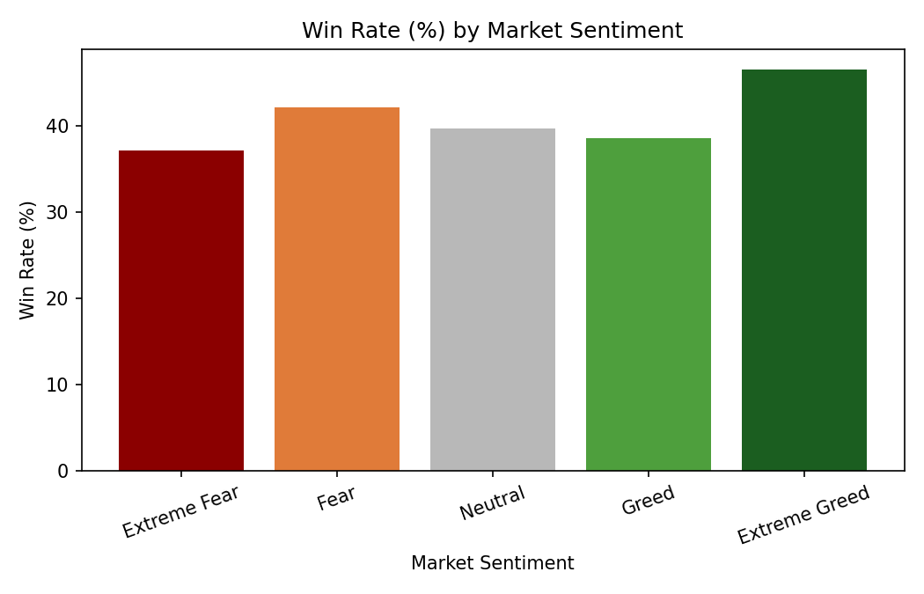

3.3 Position Sizing by Sentiment
Average trade size was largest during Fear (7,816 USD) and smallest during Extreme Greed (3,112 USD). This suggests traders commit larger capital per trade when the market is fearful but not yet in a full greed cycle, and trade in smaller size once sentiment becomes extremely greedy — possibly reflecting more frequent, smaller scalping activity or reduced conviction near market tops.
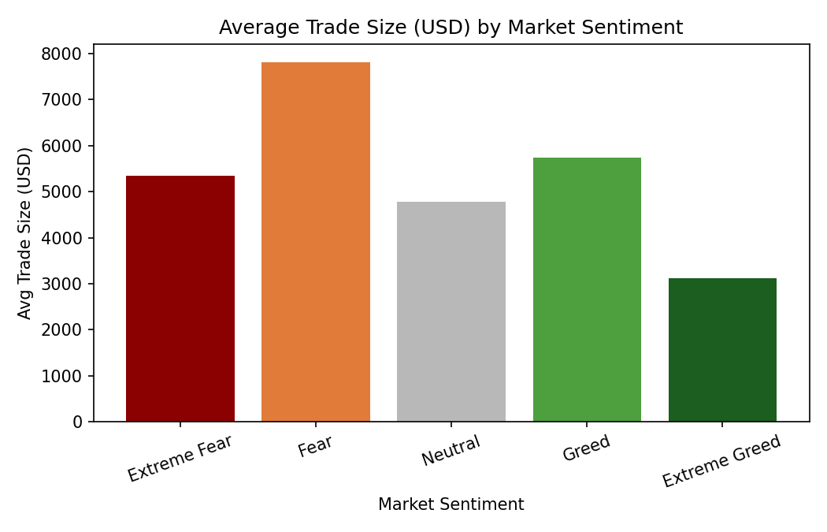

3.4 Buy vs. Sell Behavior by Sentiment
Splitting by trade direction reveals a sharper pattern: sell-side (short/close-long) trades consistently outperform buy-side trades across every sentiment regime, and the gap widens the most during Extreme Greed, where sell-side win rate reaches 59.0% versus 31.1% for buy-side.
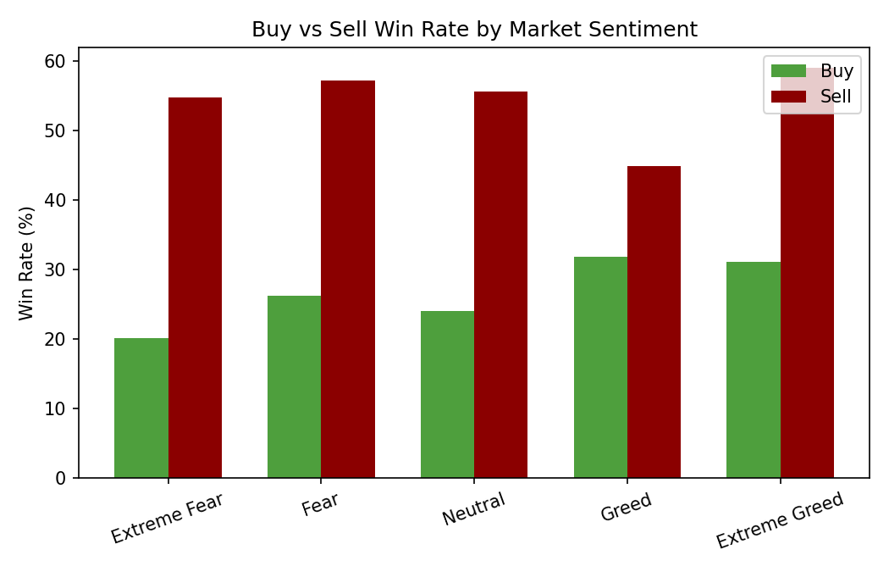
Sentiment | Buy Win Rate | Sell Win Rate | Buy Avg PnL | Sell Avg PnL
Extreme Fear | 20.2% | 54.7% | 34.12 | 34.98
Fear | 26.3% | 57.2% | 63.93 | 45.05
Neutral | 24.0% | 55.6% | 29.23 | 39.46
Greed | 31.8% | 44.9% | 25.00 | 59.69
Extreme Greed | 31.1% | 59.0% | 10.50 | 114.59
This pattern is consistent with a contrarian dynamic: closing/selling positions during Greed and Extreme Greed phases produces the strongest average PnL (114.59 USD per trade during Extreme Greed), while buying during those same phases is comparatively weak.

3.5 Statistical Significance
A Welch's t-test comparing closed PnL between Fear-regime trades (Fear + Extreme Fear, n = 83,237, mean = 49.21 USD) and Greed-regime trades (Greed + Extreme Greed, n = 90,295, mean = 53.88 USD) returned t = -0.99, p = 0.32.
At a 5% significance threshold, this difference is not statistically significant at the aggregate, all-trades level. The more meaningful signal in this dataset comes from the buy/sell split (3.4) and coin-level segmentation, not the raw Fear-vs-Greed average alone.

4. Strategy Implications
- Selling/closing positions during Greed and Extreme Greed phases has historically produced the strongest average PnL and win rate in this dataset — consistent with a 'sell into greed' contrarian approach rather than chasing momentum on the buy side.
- Buying during Extreme Greed produced the weakest results (10.50 USD average PnL, 31.1% win rate), suggesting new long entries are least favorable once sentiment is already euphoric.
- Fear phases combine the largest average position sizes with above-average win rates, indicating traders who commit more capital during fearful markets have historically been rewarded — though this reflects the specific accounts in this dataset, not a market-wide guarantee.
- Coin-level results vary meaningfully (see appendix data), so any sentiment-based rule should be validated per asset rather than applied uniformly.

5. Limitations
- Data covers 32 unique accounts on a single platform (Hyperliquid), so results reflect this trader population and may not generalize to the broader market.
- Sentiment is measured at a daily resolution while trades occur intraday; a trade near a sentiment regime change may be mis-classified relative to the exact market mood at execution.
- Closed PnL reflects realized outcomes only and does not account for open/unrealized positions, fees netting, or funding costs.
- The Fear-vs-Greed aggregate difference was not statistically significant; conclusions here are directional and exploratory, not confirmed causal relationships.

6. Conclusion
Sentiment alone is a weak standalone predictor of aggregate trade profitability in this dataset, but combining sentiment with trade direction reveals a clearer pattern: selling into greed and buying into fear both outperform the opposite behavior. This supports treating the Fear & Greed Index as one input among several — alongside position direction and asset-specific behavior — rather than a standalone signal for a trading strategy.

