1. **Early learning years**

Early learning years begin to display a spurt in growth and curiosity. The class is uniquely designed to promote this spirit of inquiry. Mobile toddlers are shifting from feeling secure to exploring their environment and eventually to developing an identity. We understand the natural developmental of children and develop our curriculum according to their needs.

#### Fine Motor Skills/Art

Children are given plenty of opportunities to play with different textures: water, play dough, fingerprint, shaving cream, and more. They are exposed to art materials such as paint and paintbrushes, crayons and paper, chalk, and clay. Students are introduced to simple and varying levels of shaped puzzles (some with knobs on the pieces) and materials are rotated to provide variety.

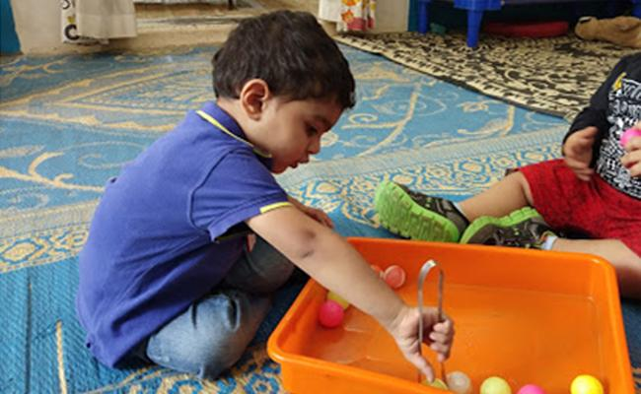

#### Active Physical Play

Children participate in crawling through tunnels, balancing, climbing, playing ball, and more. Carts and wagons are provided, riding toys for children to push, pull and ride. Outdoor play is required on a daily basis with a minimum of 30-45 minutes of physical active play.

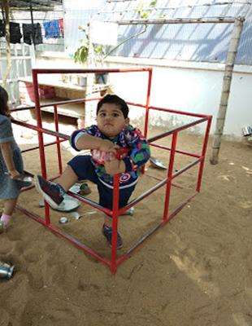

#### Music & Movement

Musical toys, instruments, and genres of music are introduced to children from the very beginning. Children are exposed to various types of music: classical and popular, music characteristic of different cultures, and songs sung in different languages. Students learn to dance, clap to rhythm of songs, or even sing along.

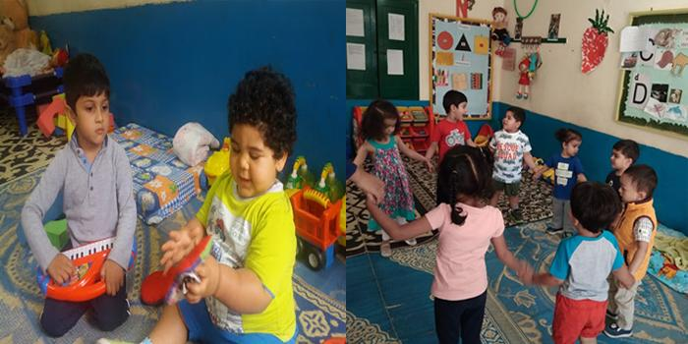

#### Blocks

Wooden and board blocks, including transportation toys, people, signs, and animals, are important materials to promote a child’s imagination and develop spatial and mathematical relationships.

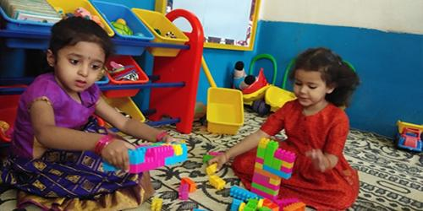

#### Dramatic Play

Child-sized play furniture and props represent what children experience in everyday life (household routines, work, transportation). Teachers pretend with children in play (talk to child on toy telephone, talk to baby doll). Pretend play with real and/or pretend objects such as pots and pans, typewriters, or phones. Students are exposed to dolls representing different races/cultures.

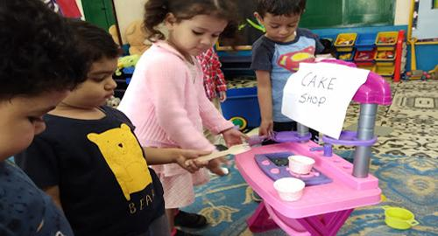

#### Sand and Water Play

Children can explore a variety of activities with sand or water. Each day can be a different focus: water used for washing dolls, observing floating toys, develop hand eye coordination for pouring, or simply having fun playing with moon sand and water!

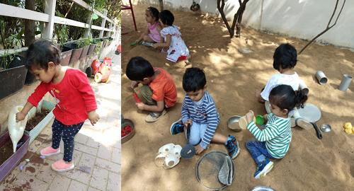

#### Nature/Science

Active Physical PlayChildren are exposed to experiences with living plants or animals indoors/outdoors. Daily exploration of the world around us, such growing plants or flowers in the classroom, studying animals, examining the texture of a tree bark, and sorting various types of seashells.

1. **Playgroup**

Two-year-olds are at an “in-between” age in early childhood education. This is an exciting developmental stage where a child is trying out new ideas, exploring his or her surroundings, and finding possible solutions to problems, but all awhile staying close to a parent or teacher as the child needs base of support and trust. Our playgroup program provides many opportunities that teaches a child on how to manage conflicting feelings of separation—the “push-pull” between the pleasures of oneness with the parent along with the exhilaration of growing independent. By understanding the cognitive, social/emotional, and physical developments of this age group, our teachers are equipped to instill positive attitudes and motivation, to teach strong basic learning skills, to introduce a wide variety of disciplines, to foster early social skills and to inspire in children the love of learning.

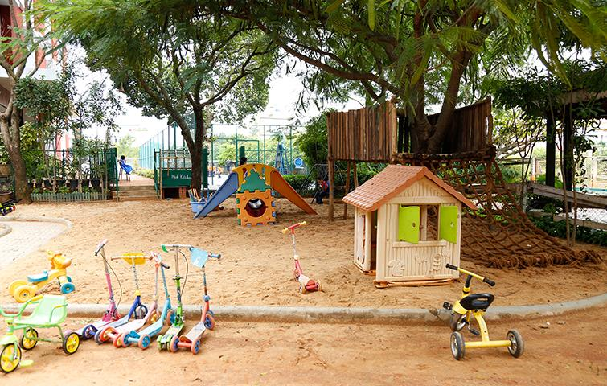

Learning through play and having an adult acknowledge the child’s success are the basis for a child to flourish socially and emotionally. Play enables a child to feel good about him or herself and supports a child’s willingness to persist at a task. The classroom’s environment and daily activities are specifically designed to help a child’s growth from rudimentary stages of exploration to subsequent mastery of various skills. With the emphasis on “play and autonomy,” each child will express his or her feelings safely and honestly and will be given opportunities to take more responsibility for self. Students will engage in cognitive activities, such as figuring out how to make a block structure, deciding which items to paste on a collage, selecting colours for a painting, making a grocery list, seeing “what happens when…,” working out the rules to a game, looking in a mirror, playing with dolls or toy animals, talking on the telephone, and many more.

While most 2-year olds are interested in other children, parallel play (side-by-side, solitary play within the same space as another child) is common for this age group. Being focused on their own needs rather than the needs of others is exactly where 2-year-olds are supposed to be in their development of social and emotional skills. Students are given multiple activities to exercise their assertiveness and independence; at the same time our teachers impart kindness, sharing, and fairness into the daily curriculum. A child’s social development will be enhanced by play experiences that include opportunities to take turns, cooperate together, and work out problems without adult interference.

#### Fine Motor Skills/Art

Children are given plenty of opportunities to play with different textures: water, play dough, fingerprint, shaving cream, and more. They are exposed to art materials such as paint and paintbrushes, crayons and paper, chalk, and clay. Students are introduced to simple and varying levels of shaped puzzles (some with knobs on the pieces) and materials are rotated to provide variety.

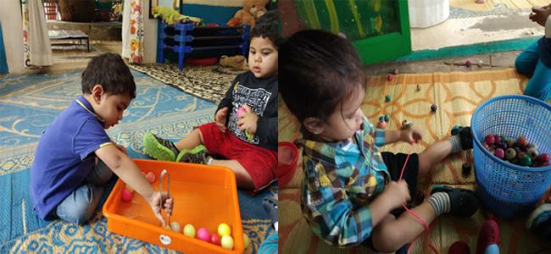

#### Active Physical Play

Children participate in crawling through tunnels, balancing, climbing, playing ball, and more. Carts and wagons are provided, riding toys for children to push, pull and ride. Outdoor play is required on a daily basis with a minimum of 30-45 minutes of physical active play.

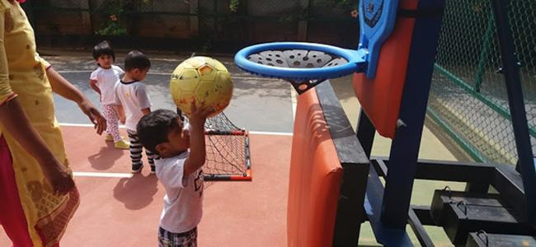

#### Music and Movement

Musical toys, instruments, and genres of music are introduced to children from the very beginning. Children are exposed to various types of music: classical and popular, music characteristic of different cultures, and songs sung in different languages. Students learn to dance, clap to rhythm of songs, or even sing along.

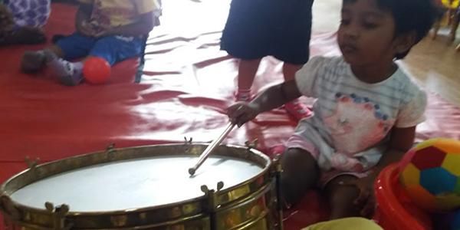

#### Blocks

Wooden and board blocks, including transportation toys, people, signs, and animals, are important materials to promote a child’s imagination and develop spatial and mathematical relationships.



#### Dramatic Play

Child-sized play furniture and props represent what children experience in everyday life (household routines, work, transportation). Teachers pretend with children in play (talk to child on toy telephone, talk to baby doll). Pretend play with real and/or pretend objects such as pots and pans, typewriters, or phones. Students are exposed to dolls representing different races/cultures.



#### Sand and Water Play

Children can explore a variety of activities with sand or water. Each day can be a different focus: water used for washing dolls, observing floating toys, develop hand eye coordination for pouring, or simply having fun playing with moon sand and water!

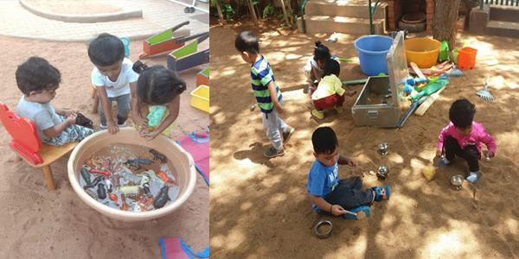

#### Nature/Science

Children are exposed to experiences with living plants or animals indoors/outdoors. Daily exploration of the world around us, such growing plants or flowers in the classroom, studying animals, examining the texture of a tree bark, and sorting various types of seashells.

1. Nursery

Three-year olds are full of wonder and spend a lot of time watching, observing, and imitating. Their imagination is working at all times. They are particularly interested in perfecting their fine motor skills that they once found it challenging when they were two years old. A three-year-old loves to pour, mix, mash and squeeze. At this age, a child will learn to hold his or her crayon better; thus, our classrooms are equipped with various writing tools to help with pretend writing and drawing. The gross motor skill development of this age group will learn to throw and catch a large ball. Hopping, climbing and skipping are activities that the child loves to practice and are incorporated into everyday activities. One of the favorite words during this period is asking “why?” Three years old want to know what causes the events around them. They will also learn to listen to the explanations of others with interest.



All of our classrooms are designed with learning centers, which give children the opportunity to play by themselves or in groups. The classroom itself is a prepared environment designed to provide children with only positive experiences. The furniture is scaled to their size, and thoughtfully placed in the room to achieve a natural flow of movement. Everything in the room is arranged in predictable fashion, so that children are able to take charge of their own learning, and to discover on their own. With its sensible structure, the classroom itself replaces the teacher as the center of focus. The teacher becomes a facilitator in helping the children utilize their space to learn independently. Our teachers skillfully plan engaging learning activities that build upon what your child can do, encouraging exploration along the way.

Traditional subjects such as math, language skills and social studies are integrated into the learning centers and introduced in the context of play. The learning centers within a classroom offers social learning—playing together to develop healthy development and underlies children’s ability for later academic learning. Our teachers are especially attuned to the emotional quality of classroom interactions and help children identify emotions (their own and others’) and learn problem-solving strategies. For example, in the dramatic play area, a supermarket gives children chances to count money, sort and classify objects (math); make signs to label shelves or advertise special sales (language); and experience foods from other cultures (social studies).

These centers constantly change according to the theme for the month. New activities and projects are introduced to meet emerging interests and individual learning goals. Most importantly, learning centers offers opportunities for intellectual and social development, which is the key to a successful transition to our pre-kindergarten program.

### The following are skills/learning centers for this age group:

#### Fine Motor Skills/Art

Children are given plenty of opportunities to play with different textures: water, play dough, fingerprint, shaving cream, and more. They are exposed to art materials such as paint and paintbrushes, crayons and paper, chalk, and clay. Students are introduced to simple and varying levels of shaped puzzles (some with knobs on the pieces) and materials are rotated to provide variety. Stacking blocks, shaking bells, doing puzzles, pouring, drawing, pasting, and swinging. Play enables a child’s small-muscle coordination to develop.

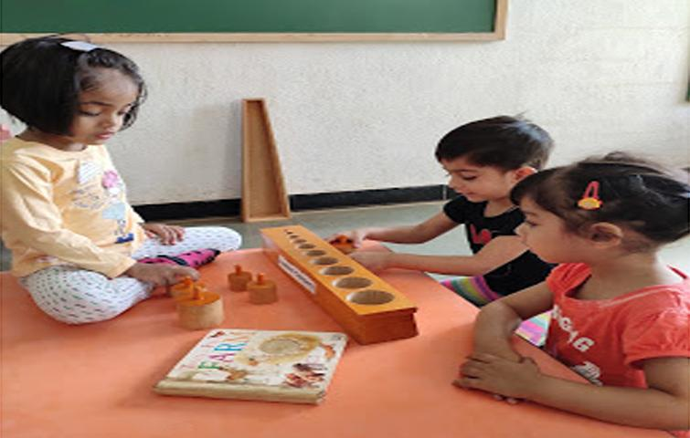

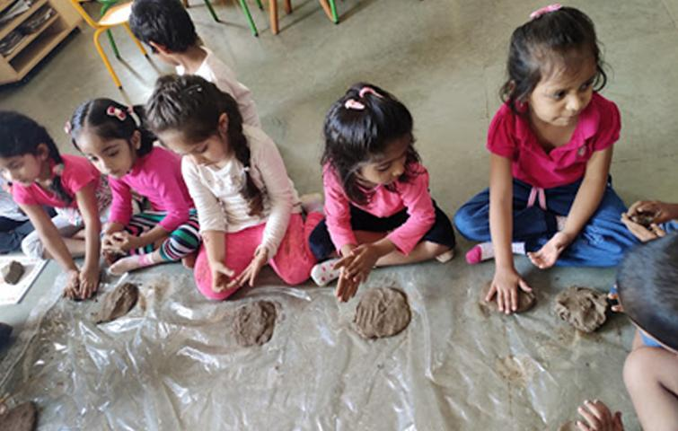





#### Active Physical Play

Running, jumping, climbing, lifting, pulling, pedaling, reaching, hopping, dancing, skipping, rolling, bending. Play enables a child’s large-muscle coordination to develop. Outdoor play is required on a daily basis (weather permitting) with a minimum of 60 minutes of physical active play.

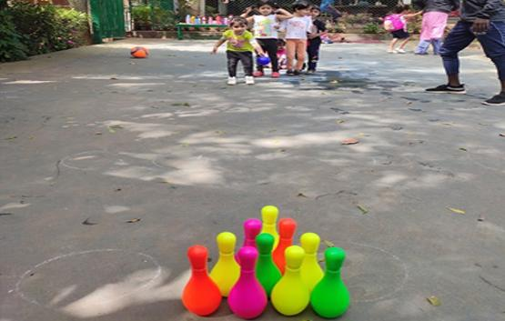

#### Music & Movement

Musical toys, instruments, and genres of music are introduced to children from the very beginning. Children are exposed to various types of music: classical and popular, music characteristic of different cultures, and songs sung in different languages. Students learn to dance, clap to rhythm of songs, or even sing along. Play enhances eye-hand coordination and muscle development.

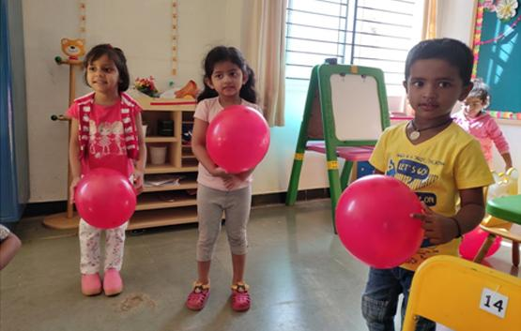

#### Blocks

Daily use of block manipulation (including transportation toys, people, signs, and animals) help to develop spatial and mathematical relationships and most importantly imagination.

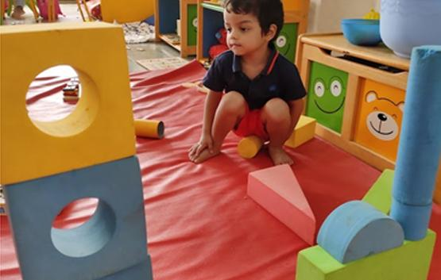





#### Dramatic Play

Child-sized furniture and props represent what children experience in everyday life (household routines, work, transportation). Teachers pretend with children in play (talk to child on toy telephone, talk to baby doll) or pretend play with objects such as pots and pans, typewriters, fruits and vegetables. Students are exposed to dolls representing different races/cultures. Play fosters a child’s language, reading, and writing development.

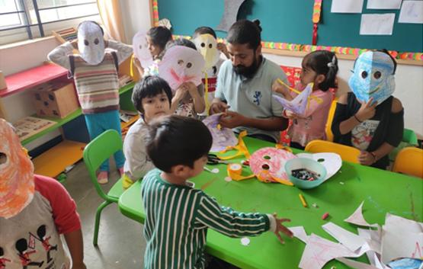

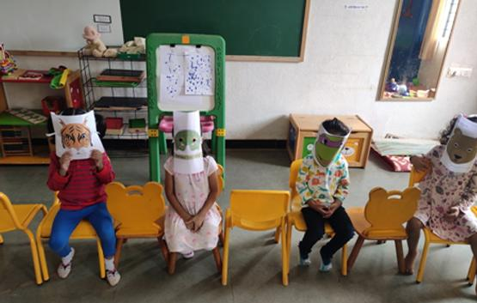





#### Sand & Water Play

Different activities done with sand or water (on different days water used for washing dolls, floating toys, and pouring.)

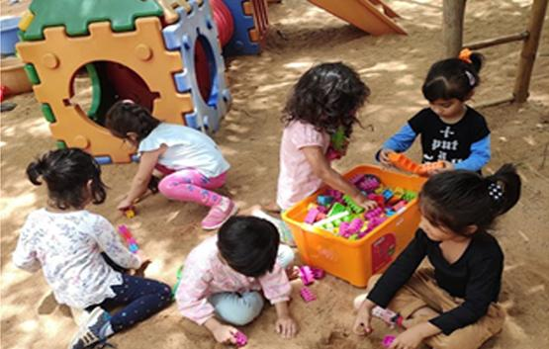

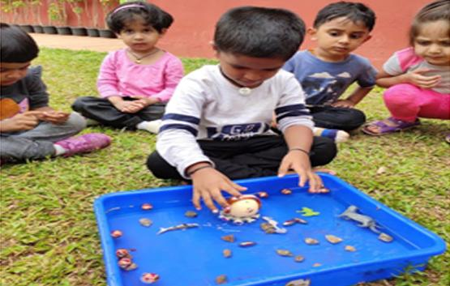





#### Nature/Science

Daily experiences with living plants or animals indoors. Caring for pets help children handle natural things carefully. There are daily explorations of the world around us, such as growing plants or flowers in the classroom, studying animals, examining the texture of a tree bark, and sorting various types of seashells.

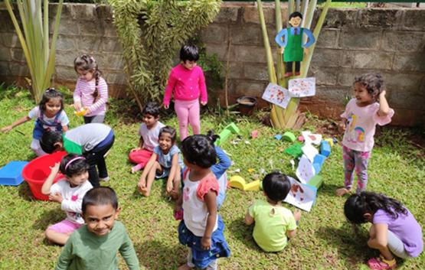

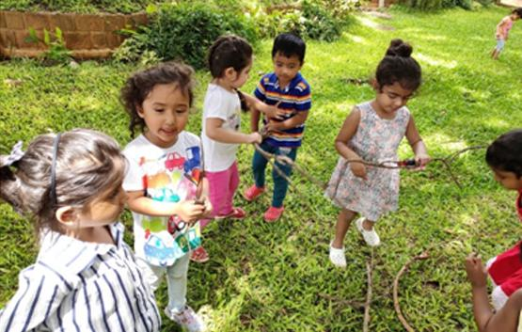





1. LKG/ UKG

First Steps is committed to providing an excellent education that meets each student’s interests, abilities, and needs and promotes an appreciation for diversity in our community as an integral part of school life. First Steps challenges each student to develop intellectual independence, creativity and curiosity and a sense of responsibility toward others both within the school and in the community at large.

Story time is particularly important for this age group. The child’s imagination and the increased ability to remember the past make the child an interesting storyteller. Teachers give students opportunities to recite familiar stories that they have read. Children learn that reading is about playing with words and sounds through rhymes, songs and stories.

The curriculum for the kindergarten classes has been structured to foster the development of lifetime cognitive skills. We encourage our children to become accomplished readers and writers, skilled in mathematics and practiced in the arts of observation, creative thinking, and problem solving. The learning process is as important as the educational content. We provide opportunities for children to question and express their curiosity, which results in developing confidence, independence, and high self-esteem. The classrooms provide nurturing, child-centered settings for children to master their language, math, science, social, and sensorial skills. Through our thematic based curriculum, modified Montessori methods that provide for the exploration of individual interests as they develop, high academic standards, and a strong focus on social development, First Steps students will aspire to become lifelong learners.

### Kindergarten Abilities:

* Soak up the world of knowledge with incredible speed.
* Capable of nonstop mental and physical gymnastics.
* Respond joyfully to dance, creative movement, outdoor play and drama.
* Learn best through their own play, by being read to, by acting out stories and fairy tales, by manipulating clay, paint brushes, finger paints, building blocks, math materials.
* Outdoor play is essential. This is an age where much learning is transmitted through the large muscles.
* Learning goes from the hand to the head, not the other way around.
* Teachers need to focus on observing and redirecting behavior and asking questions that lead children toward the next level of cognitive exploration and understanding.
* Learning is at its best for this age group when it is both structured (with predictable schedule) and exploratory (interest areas where children can initiate their own activity.)

#### Thematic Based, Interdisciplinary Curriculum:

Each quarter a new theme will be developed and explored. Students will have opportunities to build upon their language arts, math and science, and social studies skills. Students will begin to learn how “things around them” are all connected. Specifically, our thematic based, interdisciplinary curriculum is built upon the following:

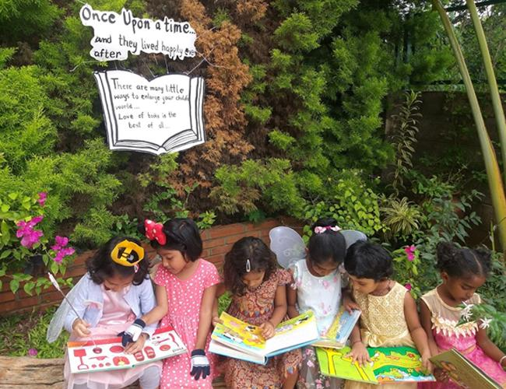

#### Language Arts:

Students will build and strengthen their word knowledge, language development, verbal expression and reasoning, social interaction and awareness. All of these are essential pre-reading skills. Students will learn to name and classify shapes, letters, numbers and natural forms such as shells, stones and leaves. Students will master specific words and concepts such as back, front, under, over, in, on, and up. Proficiency in these areas is achieved through circle time activities, finger play, story time, dramatic play, music, creative movement, free play both indoors and out.

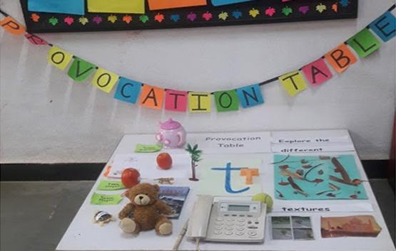

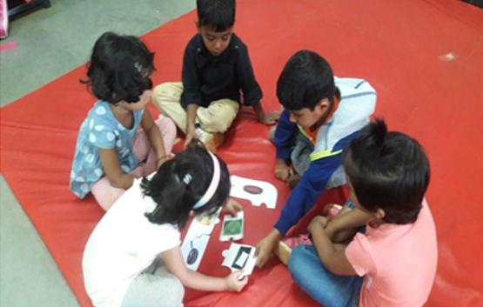

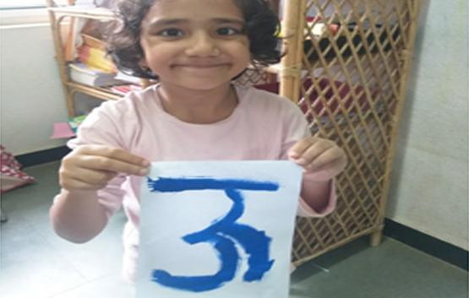

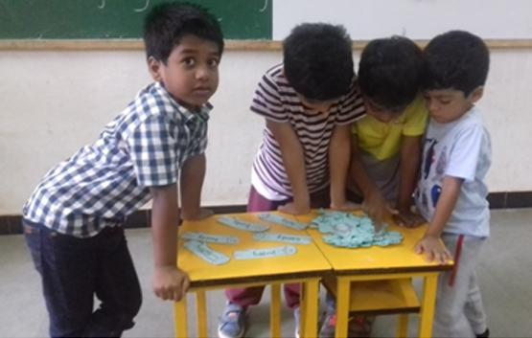





#### Math & Science:

Students are exposed to counting, numerical recognition and reasoning, whole-part relationships, spatial relationships, and identifying and creating patterns. These skills are achieved through block building; stringing beads, puzzle assembly, calendar activities and art activities. Manipulatives teach the children to sort, order and classify. Collecting, measuring and graphing are taught through cooking and nature activities.

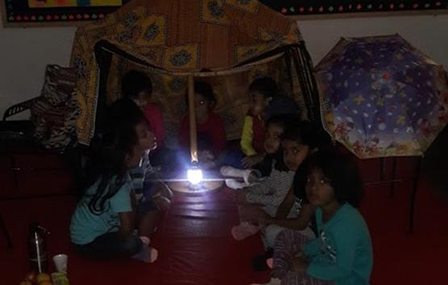

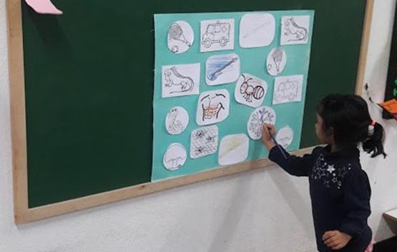

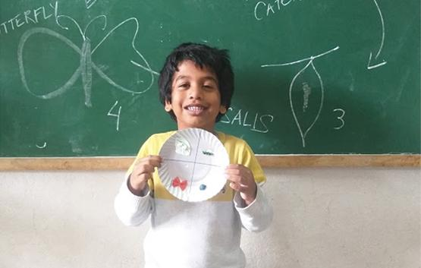

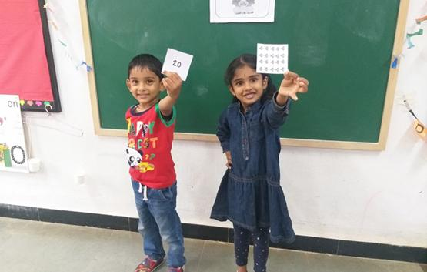





#### Social Studies:

This curriculum is designed to open children to the world around them. We begin at the center of the child's experience -- themselves -- and spiral out to include the classroom community, the school community and the community beyond school. As we discuss, explore and experience the world, the children obtain information about themselves and their families. Students explore how basic needs are met, families are constituted, and holidays are observed in similar and different ways throughout the world. The children experience multicultural awareness and appreciation through food, music, language and art. At the heart of this curriculum is the need to promote acceptance of diversity. Cultural awareness is taught in a variety of activities (various types of music, celebration of different holidays and customs, ethnic foods served).

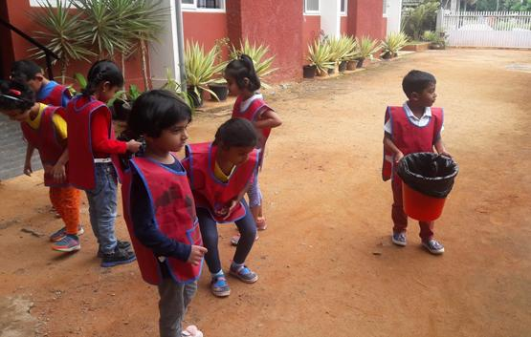

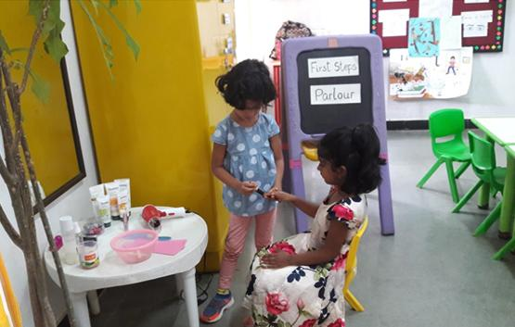





### **Typical Learning Centers in a 4 to 6 year-old Classroom**

1. Library- Language / Books
2. Reading and Writing
3. Technology / Computer
4. Construction / Blocks
5. Math and Science
6. Dramatic Play
7. Art and Sensory Experiences (sand/water table)
8. Circle Time (Morning/Afternoon Discussion area)

Class 1-10

### **Grades 1 to 10**

#### First Steps follows a CBSE curriculum with a multidimensional approach to the learning program.

* The student-centred curriculum supports every child to celebrate success.
* Life skills are embedded into disciplines through structured team learning activities.
* Skilled teachers manage classrooms to create Safe and Supportive environment.
* The creative and innovative assessments provide qualitative information about student’s progress.
* The collaborative learning environment helps to proceed from where a child is and not from where we are.

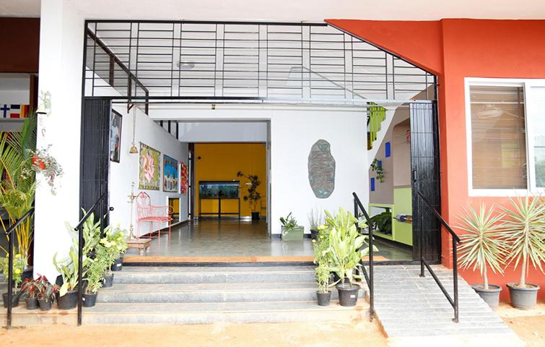

First Steps School started in the year June 2014. The building accommodates classes' up to 10th standard. Each class has one section and there are no multiple sections this has been designed keeping the individual attention to the student in mind and building a school which in its expansion still continues to retain a personal touch. Science labs, library and a computer room are fitted with modern apparatus designed to support learning in these areas. While we fully comprehend the importance of academics, learning is imparted in such a manner that the subject is understood for a lifetime. Activities and various tools of learning contribute to this methodology. Opportunities are given for raising questions thinking and problem solving. If the right motivation and opportunity is given, every child can grow to become a successful and self-dependent individual. We strongly believe that no child is a failure. This philosophy has supported the progress of our children over several decades. As a school we encourage our children to accept their peers for who they are and not attach importance to the social status or economic background. This prepares them for the real world and to live in a society which includes people from all walks of life.