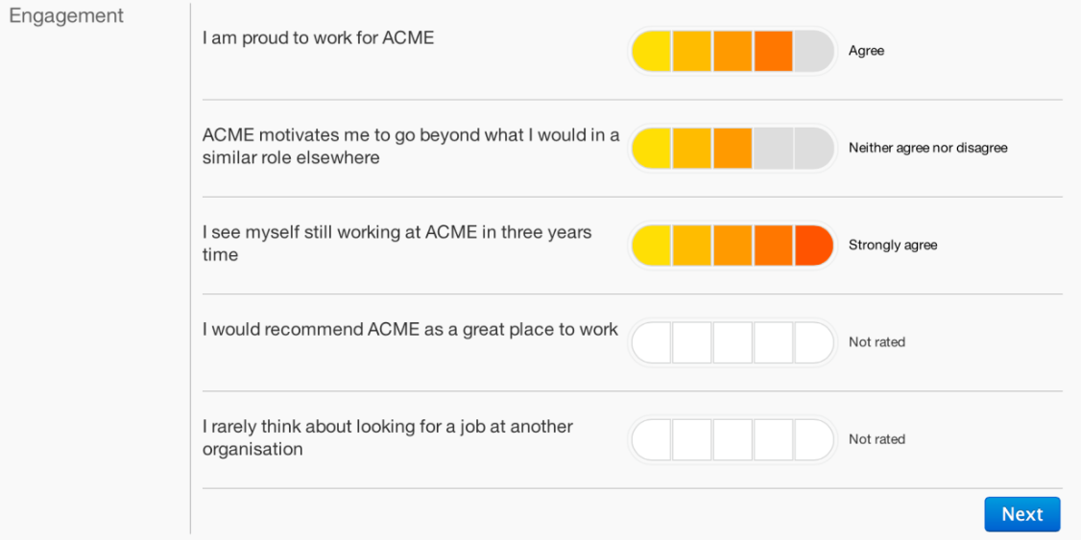

Description:
- Add a screen with feedback-questionnaire as above. Please use #3D3DCC instead of the above
Please use the following Questions instead of the above:
For type, A:
- I am satisfied with the trainings that have been conducted
- I am motivated by the project assignments given to me, in my current role
- I have enjoyed my interaction with my team members and they were always helping
- I am satisfied with my interaction with my supervisor
- Rate the quality of the trainings conducted during AJS sessions (excellent, good, average, poor)
For type, B:
- I am satisfied with the trainings that have been conducted
- I am satisfied with the performance of the trainees
- I have enjoyed my interaction with my team members and they understand the project and work culture clearly
- I am satisfied with the process followed by the Trainees
- Then, on click of next button it should navigate to the below screen. Please use #3D3DCC instead of the given color:
Hint:First one is a dropdown. So, please use either UIB Bootstrap (AJS UI Bootstrap Dropdown) Or Bootstrap 3 Dropdown to achieve the design. (Ref: http://getbootstrap.com/components/ or https://angular-ui.github.io/bootstrap/)
Feedback type:
- Trainees to Trainers and
- Trainer to Trainees.
Contact details: Name, Employee ID, and Email.
Please keep Social share icons (Use Glyph icons - http://getbootstrap.com/components/ - as place holders) for now. No Redirect/interaction on click is required.
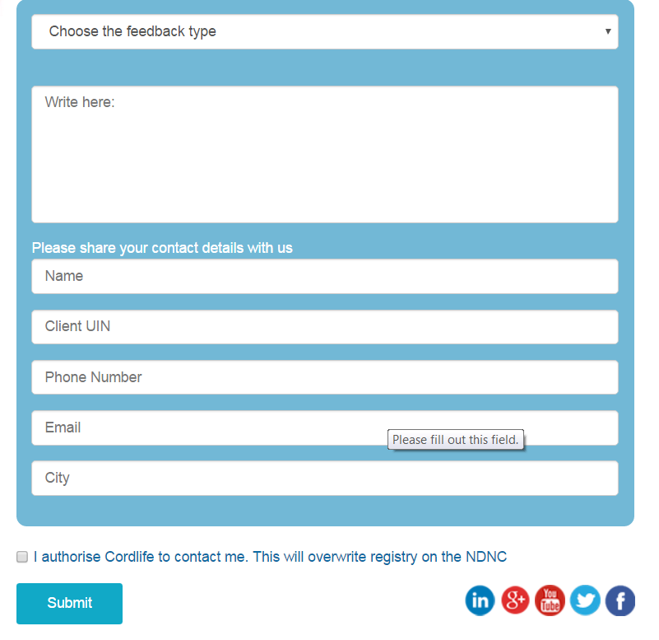

- On click of submit, It should navigate to next screen and the following icons should be displayed and user should be able to click on it.
Hint: Please use Bootstrap buttons and customize it using image (Please download similar image from Google)


- Final on submit (click of the button in above screen, you should show number of people who have taken the survey till current date).
Other conditions:
- The data must be saved in a JSON file or a local Server
- Please use Bootstrap 3 or above
- Please use Angular 1.4.x or above
- No of people who took survey must be fetched on real time either from local JSON or local server based on where you have stored it
- All the data format must be JSON
- Application must be responsive, at least for Desktop and Tablets, iPads, if not mobile.
- Please avoid using media queries as much as possible
(Ref: http://www.w3schools.com/css/css_rwd_mediaqueries.asp)
- Please use CSS specificity instead of !important
(Ref: https://developer.mozilla.org/en/docs/Web/CSS/Specificity)

