

# SQL

**Total Points = 78**

SQL stands for the structured query language.

SQL is the standardized language used to access the database.

ANSI/SQL defines the SQL standard. The current version of SQL is SQL:2016. Whenever we refer to the SQL standard, we mean the current SQL version.

SQL contains three parts:

Data definition language includes statements that help you define the database and its objects, e.g., tables, views, triggers, stored procedures, etc. Data manipulation language contains statements that allow you to update and query data. Data control language allows you to grant the permissions to a user to access specific data in the database.

Follow instructions below:

1. For questions and dataset, click on excercise links given in respective topics. Click Begin button upon landing on the page.
2. To navigate within a particular excercise, you can find previous and next exercise links on both top and bottom of the page.
3. For every topic, first solve the question mentioned in [https://pgexercises.com/ (https://pgexercises.com/)](https://pgexercises.com/) in exercises under respective headings for your practice, try to solve it and understand the mistakes with the help of answer and discussion part given under every question.
4. Then solve the question assigned under every heading in this notebook for the same respective dataset and and write your solution here. The output format is attached below every question here.
5. Each question is of two marks so attempt carefully.
6. After completing the assignment submit it accordingly.

STUDY MATERIALS:

1. [https://www.w3schools.com/sql/default.asp (https://www.w3schools.com/sql/default.asp)](https://www.w3schools.com/sql/default.asp)
2. [https://www.youtube.com/watch?v=taMe4NMsOn8&list=PLbGui_ZYuhigbr-fJ_9HlOqwg0S24Z73- (https://www.youtube.com/watch?v=taMe4NMsOn8&list=PLbGui_ZYuhigbr-fJ_9HlOqwg0S24Z73-)](https://www.youtube.com/watch?v=taMe4NMsOn8&list=PLbGui_ZYuhigbr-fJ_9HlOqwg0S24Z73-)

Practice the following questions to enhance your SQL based skills!

## Basics

Exercise link: [https://pgexercises.com/questions/basic/ (https://pgexercises.com/questions/basic/)](https://pgexercises.com/questions/basic/)

16 points Reference:- [https://www.youtube.com/watch?v=Z_hEj2U_5tI (https://www.youtube.com/watch?v=Z_hEj2U_5tI)](https://www.youtube.com/watch?v=Z_hEj2U_5tI)

1. Write an SQL statement to retrieve a list of only slots and start time of bookings(Print first five rows only).

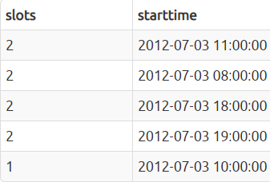In [1]:

*#write your query*

1. Retrieve the name of facilities with monthly maintainence greater than 1000.

In [ ]:

*#write your query*

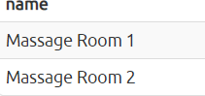

1. How can you produce a list of facilities that charge a fee to members, and that fee is less than one fourth of the guestcost as well as the monthlymaintenance is less than 100? Return the facid, facility name, member cost, and monthly maintenance of the facilities in question.

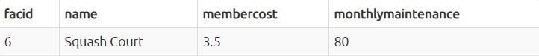In [ ]:

*#write your query*

1. How can you produce a list of all facilities with the letter 'T' and letter 'P' in their name?

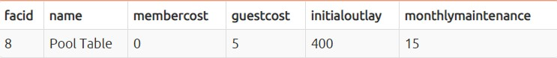In [ ]:

*#write your query*

1. How can you retrieve the details of all the bookings with face id greater than 1 and less than 4 without using AND operator?

In [ ]:

*#write your query*

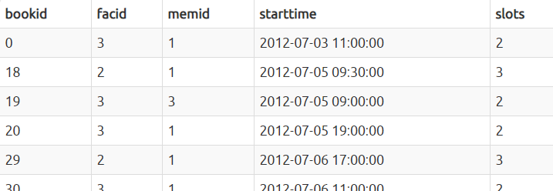

(f). How can you produce a list of bookings, with each labelled as 'available' or 'not available' depending on if their slots lies in range of 2 to 5( 2 and 5 not included) ? Return all the details of such bookings.

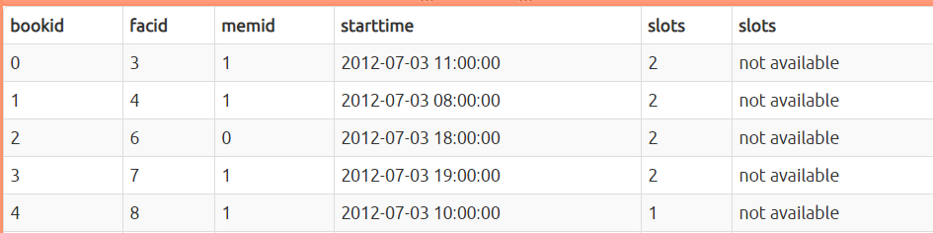In [ ]:

*#write your query*

1. How can you produce a list of booking with start time between august 2012 and end of october 2012? Return facid,memid and starttime for the given question.(Here the output will contain more rows , all rows cannot be shown below)

In [ ]:

*#write your query*

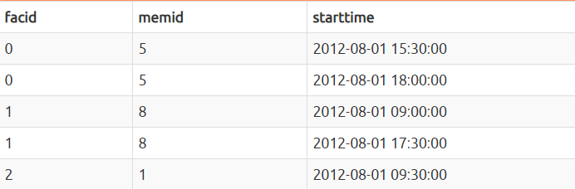

1. How can you produce an ordered list of the first 3 slots in the booking table with facid greater than 2? The list must not contain duplicates.(Return facid,memid,slots)

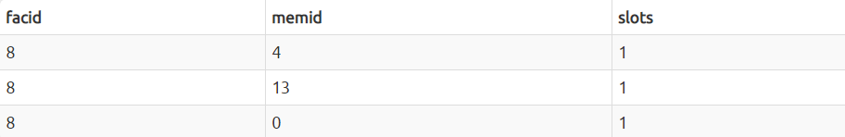In [ ]:

*#write your query*

## Joins and subqueries

Exercise link: [https://pgexercises.com/questions/joins/ (https://pgexercises.com/questions/joins/)](https://pgexercises.com/questions/joins/)

10 points

Reference:-

* 1. [https://www.youtube.com/watch?v=Jh_pvk48jHA (https://www.youtube.com/watch?v=Jh_pvk48jHA)](https://www.youtube.com/watch?v=Jh_pvk48jHA)
  2. [https://youtu.be/zYH-e6tUYbw (https://youtu.be/zYH-e6tUYbw)](https://youtu.be/zYH-e6tUYbw)

1. How can you produce a list of the first five start times for bookings by members?

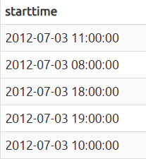In [ ]:

*#write your query*

1. How can you produce a list of the name and their member cost for facilities with booking slots greater than 3 and guestcost>10?( output below contains few rows of total output just for reference)

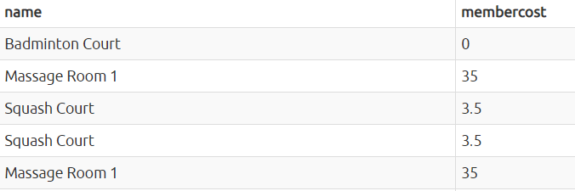In [ ]:

*#write your query*

1. How can you output a list of firstname of all members who have recommended another member and the joindate of members who have recommended others is between september 2012 and end of october 2012? Ensure that there are no duplicates in the list, and that results are ordered by firstname.

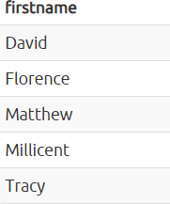In [ ]:

*#write your query*

1. How can you produce a list of all members who have used a badminton court and table tennis and the member cost is zero ? Include in your output the name of the court, and the name of the member formatted as a single column. Ensure no duplicate data, and order by the member name followed by the facility name.

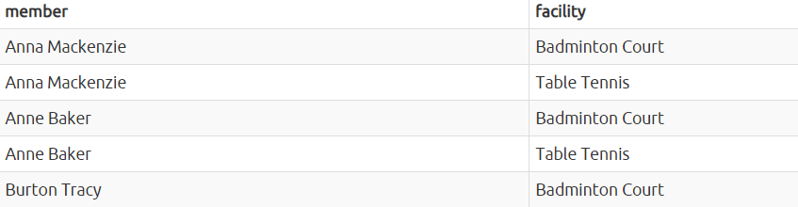In [ ]:

*#write your query*

1. How can you produce a list of all members who have used a tennis court? Include in your output the name of the court, and the name of the member formatted as a single column. Ensure no duplicate data, and order by the member name followed by the facility name.

*#write your query*

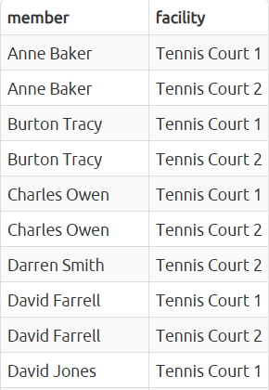

## Modifying Data

Exercise link: [https://pgexercises.com/questions/updates/ (https://pgexercises.com/questions/updates/)](https://pgexercises.com/questions/updates/)

16 points

Reference:-

1. [https://www.youtube.com/watch?v=G3v82C6ThlM (https://www.youtube.com/watch?v=G3v82C6ThlM)](https://www.youtube.com/watch?v=G3v82C6ThlM)
2. [https://www.youtube.com/watch?v=R8EeH46xuOg (https://www.youtube.com/watch?v=R8EeH46xuOg)](https://www.youtube.com/watch?v=R8EeH46xuOg)
3. Add a new data to the facilities table. Use the following values:

facid: 10, Name: 'Spa 2', membercost: 10, guestcost: 50, initialoutlay: 10000, monthlymaintenance: 500.

*#write your query*



1. Insert multiple rows in table facilities : Use the following values:
   1. facid: 11, Name: 'Lawn tennis', membercost: 50, guestcost: 40, initialoutlay: 200000, monthlymaintenance: 600.
   2. facid: 12, Name: 'Squash Court 2', membercost: 6.5, guestcost: 27.5, initialoutlay: 6000, monthlymaintenance: 800.

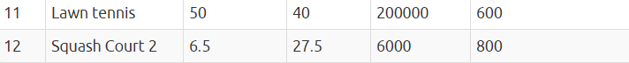In [ ]:

*#write your query*

1. Update the data in table facilities for facid =3 , changeguest cost to 30 and membercost to 10.

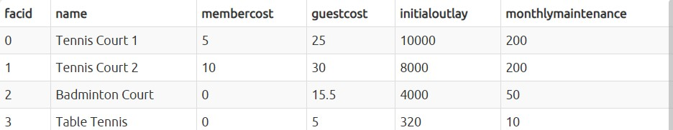In [ ]:

*#write your query*

1. We want to alter the price of the badminton court for facid 3 so that it costs 20% less than the price of tennis court 2 for facid= 2. Try to do this without using constant values for the prices, so that we can reuse the statement if we want to.

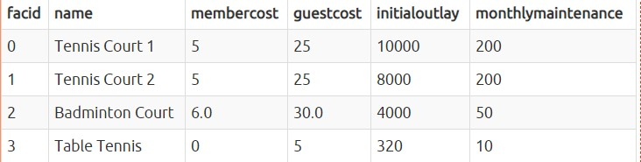In [ ]:

*#write your query*

1. Delete all details of facilities from the cd.facilities table( without using delete statement)

In [ ]:

*#write your query*

1. We want to remove member 44, who has never made a booking, from our database. How can we achieve that?

In [ ]:

*#write your code*

1. Delete all bookings

In [ ]:

*#write your code*

(h). How to delete all members who have never made a booking?

*#write your code*

## 4. Aggregates

Exercise link: [https://pgexercises.com/questions/aggregates/ (https://pgexercises.com/questions/aggregates/)](https://pgexercises.com/questions/aggregates/)

12 points

Reference:

1. [https://www.youtube.com/watch?v=jcoJuc5e3RE (https://www.youtube.com/watch?v=jcoJuc5e3RE)](https://www.youtube.com/watch?v=jcoJuc5e3RE)
2. [https://www.youtube.com/watch?v=nNrgRVIzeHg (https://www.youtube.com/watch?v=nNrgRVIzeHg)](https://www.youtube.com/watch?v=nNrgRVIzeHg)
3. Count the number of members

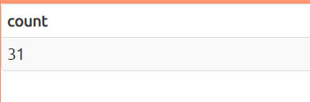In [ ]:

*# write your code*

1. Produce a count of the number of facilities that have maintenance cost greater than 100 and guest cost of 20 or more.

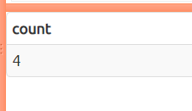In [ ]:

*# write your code*

1. Produce a list of facilities with more than 1000 slots booked and start time after 1st of august 2012. Produce an output table consisting of facility id and slots, sorted by facility id.

*#write your code*

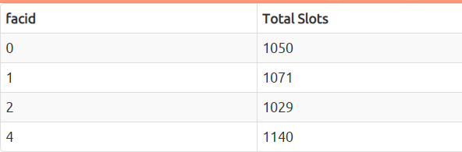

1. Find the total number of distinct facilities with monthly maintenance greater than 100.

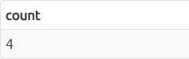In [ ]:

*#write your code*

1. Solve the following:
   1. List the total slots booked per facility in the month of august 2012

*# write code for first part*

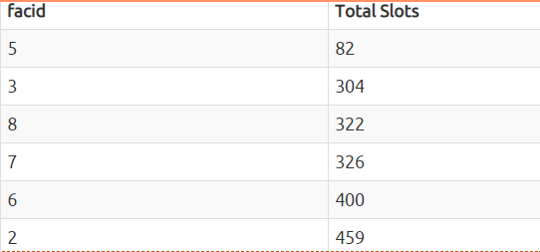

1. Solve the following:
   1. calculate the amount of time each facility will take to repay its cost of ownership. Remember to take into account ongoing monthly maintenance. Output facility name and payback time in months, order by facility name. Don't worry about differences in month lengths, we're only looking for a rough value here!

In [ ]:

*# write code for first part*

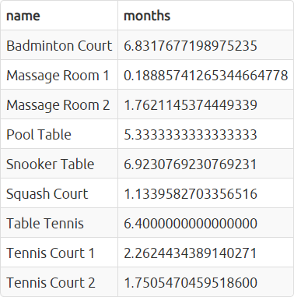

## 5. Date

Exercise link: [https://pgexercises.com/questions/date/ (https://pgexercises.com/questions/date/)](https://pgexercises.com/questions/date/)

14 points

[Reference- https://www.mysqltutorial.org/mysql- timestamp.aspx#:~:text=The%20MySQL%20TIMESTAMP%20is%20a,%3A14%3A07'%20UTC%20 (https://www.mysqltutorial.org/mysql- timestamp.aspx#:~:text=The%20MySQL%20TIMESTAMP%20is%20a,%3A14%3A07'%20UTC%20)](https://www.mysqltutorial.org/mysql-timestamp.aspx#%3A~%3Atext%3DThe%20MySQL%20TIMESTAMP%20is%20a%2C%3A14%3A07%27%20UTC%20).

1. Produce a timestamp for 2 a.m. on the 16st of september 2012

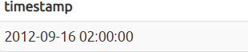In [ ]:

*# write your code here*

1. Find the result of subtracting the timestamp '2012-09-30 02:00:00' from the timestamp '2012-10-31 02:00:00'

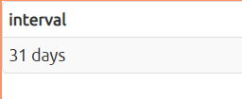In [ ]:

*# write your code*

1. Produce a list of all the dates in september 2012. They can be output as a timestamp (with time set to midnight) or a date.

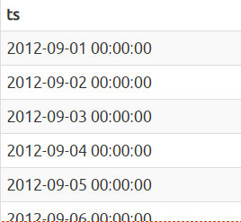In [ ]:

*# write your code*

1. Get the day of the month from the timestamp '2012-09-30' as an integer.

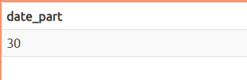In [ ]:

*# write your code*

1. Solve the following:
   1. Work out the number of seconds between the timestamps '2012-08-25 01:00:00' and '2012-09-25 00:00:00'

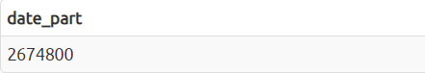In [ ]:

write your code

1. Solve the following :
   1. For any given timestamp, work out the number of days remaining in the month. The current day should count as a whole day, regardless of the time. Use '2012-08-10 02:30:00' as an example timestamp for the purposes of making the answer. Format the output as a single interval value.

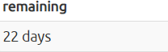In [ ]:

*# write your code*

(g). Return a count of bookings for each month, sorted by month.

In [ ]:

*#write your code*

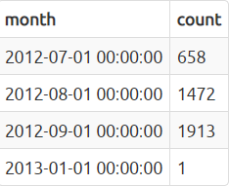

## 6. Strings

Exercise link:[https://pgexercises.com/questions/string/ (https://pgexercises.com/questions/string/)](https://pgexercises.com/questions/string/)

10 points

Reference-

1. [https://www.youtube.com/watch?v=3d4f6HNKj-8 (https://www.youtube.com/watch?v=3d4f6HNKj-8)](https://www.youtube.com/watch?v=3d4f6HNKj-8)
2. [https://www.youtube.com/watch?v=6Fj7am_-E8k (https://www.youtube.com/watch?v=6Fj7am_-E8k)](https://www.youtube.com/watch?v=6Fj7am_-E8k)
3. [https://www.w3schools.com/sql/sql_wildcards.asp (https://www.w3schools.com/sql/sql_wildcards.asp)](https://www.w3schools.com/sql/sql_wildcards.asp)

(a). Output the names of all members, formatted as 'Surname, Firstname','Surname'

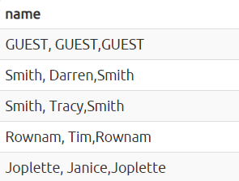In [ ]:

*# write your code*

1. Find all facilities whose name ends with 'Court'. Retrieve all columns.

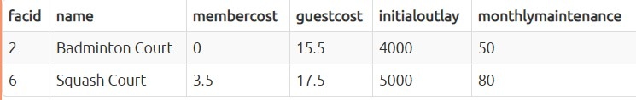In [ ]:

*# write your code*

1. Find all facilities whose name starts with Badminton and ends with 'Court'. Retrieve all columns.

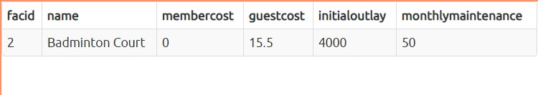In [ ]:

*# write your code*

1. You'd like to produce a count of how many members you have whose surname starts with each letter of the alphabet. Sort by the letter, and don't worry about printing out a letter if the count is 0.

In [ ]:

*# write your code*

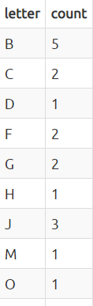

(e). You've noticed that the club's member table has telephone numbers with very inconsistent formatting. You'd like to find all the telephone numbers that contain parentheses, returning the member ID and telephone number sorted by member ID.

In [ ]:

*#write your code*

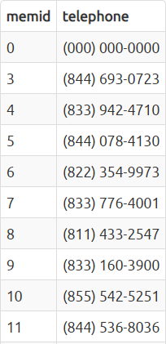

Hey! You did a great job so far. Let's solve few more advance sql qureries in the nesxt part of this module

# Give youself a treat:) Congratulations! you have completed the SQL challenge.

**FeedBack**

We hope you’ve enjoyed this course so far. We’re committed to help you use "AI for All" course to its full potential, so that you have a great learning experience. And that’s why we need your help in form of a feedback here.

[Please fill this feedback form https://zfrmz.in/MtRG5oWXBdesm6rmSM7N (https://zfrmz.in/MtRG5oWXBdesm6rmSM7N)](https://zfrmz.in/MtRG5oWXBdesm6rmSM7N)