RETAIL SALES ANALYSIS
A Data Analytics Project
Analyzing 18 Months of Multi-City Retail Sales Data to Drive Business Decisions
Technologies Used
Python • Pandas • NumPy • Matplotlib • Seaborn • Jupyter Notebook

Prepared by: Mahesh
Data Analyst Project — Portfolio & Internship Submission

Table of Contents
2. Executive Summary
3. Project Overview
4. Business Problem
5. Project Objectives
6. Dataset Overview
7. Tools and Technologies
8. Data Loading
9. Data Exploration
10. Data Cleaning and Preprocessing
11. Exploratory Data Analysis
12. Numerical Analysis (NumPy)
13. Data Visualization
14. Key Business Insights
15. Business Recommendations
16. End-to-End Project Workflow
17. Challenges and Limitations
18. Future Scope
19. Conclusion
20. Technical Implementation Summary
21. GitHub Project Documentation

2. Executive Summary
Project Overview
This project analyzes 1,500 retail sales transactions collected across eight cities in Maharashtra over an 18-month period (January 2025 to June 2026). The analysis was carried out end-to-end in Python using Pandas, NumPy, Matplotlib, and Seaborn inside a Jupyter Notebook.
Business Problem
The retail company needed a structured way to understand its sales performance, customer behavior, product performance, discount impact, and payment trends from raw transactional data, in order to support management decision-making.
Purpose of the Analysis
The purpose was to clean the raw dataset, explore it statistically, compute key numerical indicators, visualize patterns across cities, products, categories, time periods and payment methods, and translate the findings into actionable business insights.
Analytical Approach
The workflow followed a standard data-analytics pipeline: loading the CSV data, exploring its structure, handling missing values and checking duplicates, converting date fields, computing summary statistics with NumPy, performing group-wise analysis with Pandas, and building eleven Matplotlib/Seaborn visualizations covering the required business questions.
Major Outcomes
- Total Net Sales across the dataset: ₹5,09,19,666.15, averaging ₹33,946.44 per order.
- Nashik is the top revenue-generating city; Electronics is the top revenue-generating category.
- Karan is the top-performing salesperson by Net Sales; UPI is the most-used payment method.
- Returning customers generate the highest total revenue among the three customer types.
- Unit Price is the strongest driver of sales value (correlation of 0.87 with Net Sales); discount level shows almost no correlation with Net Sales (-0.04).
Business Value
The analysis converts raw transactional records into a clear picture of where revenue is concentrated (by city, category, product, and salesperson) and what factors do and do not influence sales value — giving management a data-backed basis for pricing, staffing, and promotional decisions.

3. Project Overview
Background
A retail company operating across multiple Maharashtra cities collected 18 months of sales data spanning orders, products, categories, pricing, discounts, payments, customers, and salespersons.
Problem Statement
The company wants to understand its sales performance, customer behavior, product performance, discount impact, payment trends, and sales patterns using this data.
Business Context
Retail businesses generate large volumes of transactional data that, left unanalyzed, offer little strategic value. Systematically analyzing this data allows a business to identify its strongest and weakest markets, products, and sales channels.
Project Objectives
- Load, clean, and pre-process the raw retail sales dataset.
- Explore the dataset's structure, data types, and statistical distribution.
- Perform numerical analysis of sales values using NumPy.
- Analyze sales performance by city, category, product, salesperson, and customer type.
- Analyze sales trends across months, quarters, and years.
- Visualize key patterns using Matplotlib and Seaborn.
- Examine correlations among numerical variables, including the effect of discounting.
- Derive and document business insights and recommendations from the findings.
Scope
The scope of this project is limited strictly to the 1,500 transaction records and 18 fields provided in the dataset, covering the period January 2025 – June 2026 across eight cities and six product categories. No external data sources were used.

4. Business Problem
Retail businesses operate across multiple locations, product lines, and sales channels, generating data that is difficult to interpret in raw form. Without structured analysis, management cannot easily answer basic but critical questions — which cities, products, or salespeople are driving revenue, whether discounts are helping or hurting margins, or when demand peaks during the year.
This project addresses that gap by transforming raw order-level data into summarized, visualized, and interpreted business intelligence. Understanding these patterns is useful because it lets management prioritize marketing spend where it will have the greatest effect, plan inventory and staffing around demand cycles, evaluate whether discount strategies are actually growing revenue, and recognize which products and sales staff are under- or over-performing.

5. Project Objectives
Restated as measurable analytical objectives derived from the problem statement:
- Load and validate a dataset of 1,500 records and 18 columns using Pandas.
- Quantify data quality by measuring missing values (39 missing values found, 2.6% of all cells) and duplicate records (0 found), and resolve missing values through imputation.
- Convert the Date field to a proper datetime type to enable time-based grouping.
- Compute total, average, minimum, and maximum Net Sales using NumPy.
- Rank sales performance across 8 cities, 6 categories, 31 products, 10 salespersons, and 3 customer types.
- Aggregate sales by month, quarter, and year to identify seasonal patterns.
- Answer all 12 business questions specified in the problem statement using group-by, correlation, and sorting operations.
- Produce all 11 required visualizations covering distribution, comparison, trend, and correlation analysis.

6. Dataset Overview
The dataset (retail_sales_analysis_project.csv) contains 1,500 sales records and 18 columns, covering order, product, pricing, discount, payment, customer, and time-period information.
Data Dictionary
Column | Business Meaning | Data Type
Order_ID | Unique order number | int64
Date | Date of order | datetime64 (after conversion)
City | Order city | object (text)
Category | Product category | object (text)
Product | Product name | object (text)
Quantity | Units sold | int64
Unit_Price | Price per unit | float64
Discount_Percent | Discount given (%) | float64
Payment_Method | Payment type used | object (text)
Customer_Type | New, Returning, or VIP | object (text)
Salesperson | Employee handling the sale | object (text)
Gross_Sales | Sales value before discount | float64
Discount_Amount | Value of discount applied | float64
Net_Sales | Final sales value after discount | float64
Month | Month name of order | object (text)
Month_Number | Numeric month (1–12) | int64
Quarter | Quarter of order (Q1–Q4) | object (text)
Year | Year of order | int64
Key Statistical Summary (from df.describe())
Metric | Quantity | Unit_Price (₹) | Discount_Percent (%) | Net_Sales (₹)
Count | 1,500 | 1,500 | 1,485 | 1,500
Mean | 4.40 | 8,324.19 | 7.36 | 33,946.44
Std Dev | 2.29 | 14,922.47 | 5.80 | 71,308.86
Min | 1 | 20.70 | 0 | 37.26
Max | 8 | 89,748.69 | 20 | 5,83,507.51
Important fields for this analysis are City, Category, Product, Salesperson, Customer_Type, Discount_Percent, Quantity, and Net_Sales, since these underpin every business question in the problem statement.

7. Tools and Technologies
Technology | Purpose in This Project
Python | Core programming language used to write the entire analysis.
Pandas | Loading the CSV, exploring structure, handling missing values, duplicate checks, group-by aggregations, filtering, and sorting.
NumPy | Converting the Net_Sales column to an array and computing total, mean, minimum, and maximum sales values.
Matplotlib | Bar chart, line chart, scatter plot, histogram, and pie chart visualizations.
Seaborn | Count plot, bar plot, box plot, scatter plot (by category), correlation heatmap, and pair plot visualizations.
Jupyter Notebook | Interactive environment used to write and run the analysis, cell by cell, with inline chart output.

8. Data Loading
The dataset was loaded directly from a local CSV file using Pandas:
df = pd.read_csv("retail_sales_analysis_project.csv")
This produced a DataFrame of 1,500 rows and 18 columns, matching the structure described in the project's problem statement.

9. Data Exploration
Operation | Result / What It Tells Us
df.head() / df.tail() | Displayed the first and last 5 rows, confirming column layout and realistic-looking values (e.g., last records dated 2026-06-29 and 2026-06-30).
df.shape | Confirmed the dataset has 1,500 rows and 18 columns.
df.columns | Listed all 18 column names, confirming the schema matches the data dictionary.
df.dtypes / df.info() | Showed that Date, City, Category, Product, Payment_Method, Customer_Type, Salesperson, Month, and Quarter are text (object) fields, while Quantity, Unit_Price, Discount_Percent, Gross_Sales, Discount_Amount, Net_Sales, Month_Number, and Year are numeric.
df.describe() | Produced summary statistics (count, mean, std, min, max, quartiles) for numeric columns, revealing wide variation in Unit_Price (₹20.70 to ₹89,748.69) and Net_Sales.

10. Data Cleaning and Preprocessing
Missing Value Handling
BEFORE — df.isnull().sum() found 39 total missing values (2.6% of all cells) across three columns:
Column | Missing Values | Percentage
Discount_Percent | 15 | 1.0%
Payment_Method | 12 | 0.8%
Customer_Type | 12 | 0.8%
All other columns | 0 | 0.0%

ACTION — Missing values were imputed rather than dropped, to preserve all 1,500 records:
- Discount_Percent → filled with the column median.
- Payment_Method → filled with the column mode (most frequent value).
- Customer_Type → filled with the column mode (most frequent value).
AFTER — df.isnull().sum() confirmed 0 missing values remaining across all 18 columns, with the dataset shape unchanged at (1,500, 18).
Duplicate Record Check
BEFORE — df.duplicated().sum() returned 0 duplicate rows. ACTION — df.drop_duplicates() was applied as a safeguard. AFTER — the row count remained 1,500, confirming no duplicate records existed in the raw data.
Date Type Conversion
BEFORE — the Date column was stored as object (text). ACTION — pd.to_datetime(df["Date"]) was applied. AFTER — the column's dtype became datetime64[ns], enabling correct chronological sorting and month/quarter/year grouping.

11. Exploratory Data Analysis
11.1 Sales by City
Rank | City | Net Sales (₹)
1 | Nashik | 73,69,482.92
2 | Thane | 69,30,987.27
3 | Kolhapur | 68,06,661.96
4 | Navi Mumbai | 67,41,558.98
5 | Pune | 65,07,873.86
6 | Aurangabad | 61,33,120.01
7 | Nagpur | 56,53,727.64
8 | Mumbai | 47,76,253.51
11.2 Sales by Category
Rank | Category | Net Sales (₹)
1 | Electronics | 3,12,77,842.31
2 | Furniture | 1,28,47,315.39
3 | Sports | 28,28,850.45
4 | Clothing | 27,56,620.91
5 | Beauty | 7,44,934.32
6 | Grocery | 4,64,102.77
Electronics alone contributes the majority of total revenue despite being one of six categories, indicating heavy revenue concentration in high-value items.
11.3 Top-Performing Products (by Net Sales)
Rank | Product | Net Sales (₹)
1 | Laptop | 1,09,51,501.61
2 | Mobile | 74,19,978.45
3 | Tablet | 57,19,121.71
4 | Bed | 45,43,633.89
5 | Monitor | 42,38,839.93
11.4 Lower-Performing Products (by Net Sales)
A direct query for the lowest-revenue products (df.groupby("Product")["Net_Sales"].sum().sort_values().head()) returned:
Product | Net Sales (₹)
Sugar | 11,770.86
Flour | 14,597.97
Biscuits | 19,422.35
Oil | 34,088.88
Face Wash | 41,911.22
Notably, Flour is the single best-selling product by quantity (highest total units sold), yet it ranks near the bottom in revenue — a low unit-price item sold in high volume but contributing comparatively little to total Net Sales.
11.5 Sales by Salesperson
Rank | Salesperson | Net Sales (₹)
1 | Karan | 65,41,276.01
2 | Priya | 60,46,081.18
3 | Neha | 58,83,155.37
4 | Pooja | 56,68,513.80
5 | Rohan | 53,60,043.71
6 | Rahul | 50,87,485.49
7 | Sneha | 45,62,812.17
8 | Anjali | 42,75,816.10
9 | Amit | 41,79,562.42
10 | Vikas | 33,14,919.90
11.6 Sales by Customer Type
Customer Type | Net Sales (₹)
Returning | 2,28,24,332.58
New | 2,04,13,392.25
VIP | 74,95,872.63
11.7 Sales by Month, Quarter and Year
Month | Net Sales (₹)
January | 63,79,185.11
February | 53,77,828.56
March | 58,74,255.08
April | 52,83,948.69
May | 44,17,432.78
June | 43,53,573.91
July | 28,15,504.36
August | 30,05,734.38
September | 27,78,330.31
October | 40,82,161.80
November | 40,03,492.06
December | 25,48,219.11
Quarter | Net Sales (₹)
Q1 | 1,76,31,268.75
Q2 | 1,40,54,955.38
Q3 | 85,99,569.05
Q4 | 1,06,33,872.97
Year | Net Sales (₹)
2025 | 3,50,73,037.30
2026 (partial, through June) | 1,58,46,628.85
Sales peak in Q1 (January in particular) and decline through Q3, with a partial recovery in Q4. Note that the 2026 figure covers only January–June, so it is not directly comparable to the full-year 2025 figure.
11.8 Filtering and Sorting
- Filtering: rows with Net_Sales greater than ₹50,000 were extracted — these were dominated by high unit-price Electronics items (Tablet, Monitor, Laptop) sold in larger quantities.
- Sorting (highest first): the top 10 highest-value single orders were almost entirely Laptop and Mobile sales in Nashik, Kolhapur, and Thane, with the single highest order (₹5,83,507.51 equivalent, Order 50587) a Laptop sale in Nashik.
- Sorting (lowest first): the 10 lowest-value orders were dominated by Grocery items (Sugar, Biscuits, Flour) sold in quantities of 1–2 units.

12. Numerical Analysis (NumPy)
The Net_Sales column was converted to a NumPy array (sales = df["Net_Sales"].to_numpy()) and summarized using np.sum(), np.mean(), np.min(), and np.max():
Metric | Formula | Value (₹)
Total Sales | np.sum(sales) | 5,09,19,666.15
Average Sales | np.mean(sales) | 33,946.44
Minimum Sales | np.min(sales) | 37.26
Maximum Sales | np.max(sales) | 5,83,507.51
These figures show a very wide spread between the smallest and largest individual sale — consistent with a product mix ranging from low-cost Grocery items to high-value Electronics.

13. Data Visualization
Eleven visualizations were created using Matplotlib and Seaborn, directly matching the visualization requirements in the problem statement.
13.1 City-wise Sales — Bar Chart
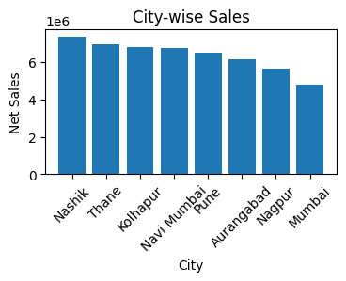
plt.bar() — City (x) vs total Net Sales (y)
Purpose: compare total revenue across the 8 cities. Insight: Nashik leads, Mumbai trails; the spread between top and bottom city is roughly ₹26 lakh. Business relevance: helps prioritize regional marketing and inventory allocation.
13.2 Monthly Sales Trend — Line Chart
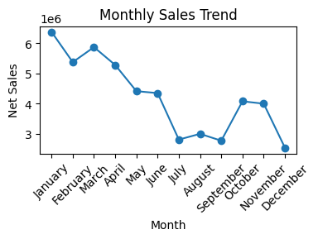
plt.plot() — Month (x) vs total Net Sales (y)
Purpose: track how revenue moves across the calendar. Insight: sales are highest in January and trend downward through the middle of the year before partially recovering toward Q4. Business relevance: supports seasonal planning for staffing, stock, and promotions.
13.3 Quantity vs Net Sales — Scatter Plot
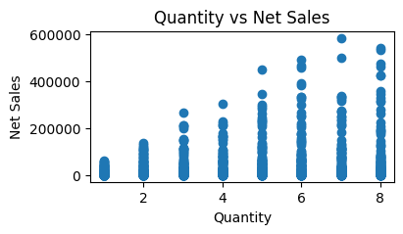
plt.scatter() — Quantity (x) vs Net Sales (y)
Purpose: visualize the relationship between units sold and sales value. Insight: the relationship is loosely positive but noisy, consistent with the measured correlation of 0.24 — Unit_Price, not Quantity, is the main driver of a sale's value.
13.4 Net Sales Distribution — Histogram
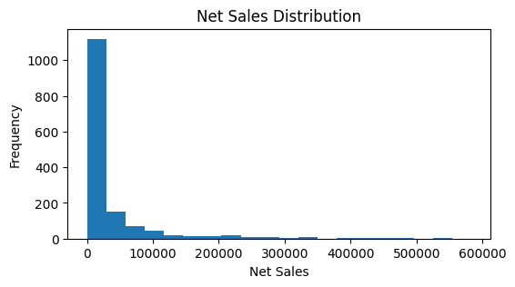
plt.hist(), 20 bins — Net Sales (x) vs frequency (y)
Purpose: show how individual order values are distributed. Insight: most orders fall at the lower end of the range, with a long right tail of high-value Electronics/Furniture orders pulling the average above the median-range bulk of transactions.
13.5 Payment Method Distribution — Pie Chart
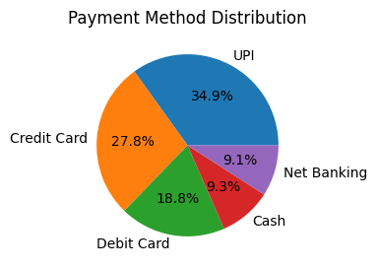
plt.pie() with percentage labels — share of orders by Payment_Method
Purpose: show the relative popularity of each payment method. Insight: UPI is the most-used payment method. Business relevance: confirms where to prioritize checkout/payment-experience investment.
13.6 Category-wise Orders — Count Plot
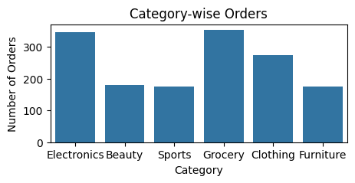
sns.countplot() — Category (x) vs number of orders (y)
Purpose: compare order volume (not revenue) across categories. Insight: order counts are more evenly spread across categories than revenue is, showing that Electronics' revenue lead comes from higher unit prices rather than far more orders.
13.7 Category-wise Sales — Bar Plot
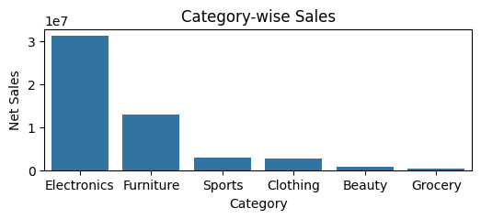
sns.barplot() — Category (x) vs total Net Sales (y)
Purpose: directly compare total revenue by category. Insight: reinforces that Electronics and Furniture together dominate total Net Sales, while Grocery and Beauty contribute comparatively little.
13.8 Sales Distribution by Category — Box Plot
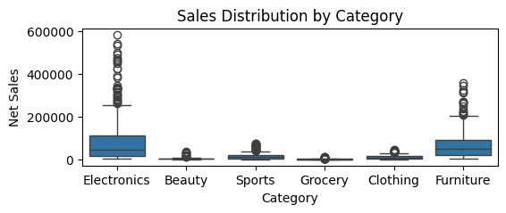
sns.boxplot() — Category (x) vs Net Sales (y)
Purpose: show the spread and outliers of order values within each category. Insight: Electronics shows the widest spread and the most high-value outliers, consistent with its wide Unit_Price range (₹20.70–₹89,748.69 dataset-wide).
13.9 Quantity vs Net Sales by Category — Scatter Plot
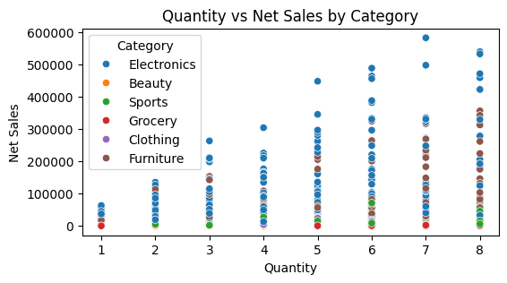
sns.scatterplot(hue=Category) — Quantity (x) vs Net Sales (y), colored by Category
Purpose: check whether the quantity–sales relationship differs by category. Insight: Electronics orders cluster at higher Net Sales values across all quantity levels, again pointing to unit price rather than quantity as the main revenue driver.
13.10 Correlation Heatmap
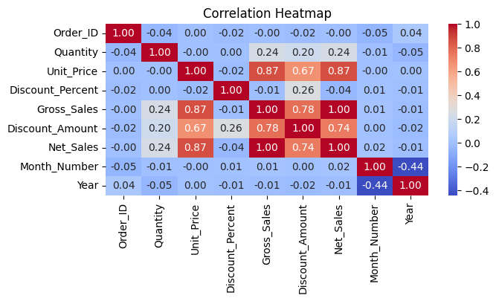
sns.heatmap() — correlation matrix of all numeric columns
Purpose: quantify linear relationships between all numeric variables at once. Insight: Unit_Price correlates strongly with Gross_Sales (0.87) and Net_Sales (0.87); Quantity correlates weakly (0.24); Discount_Percent correlates negligibly with Net_Sales (-0.04); Order_ID (an identifier) is uncorrelated with everything, as expected.
13.11 Pair Plot — Quantity, Unit Price, Net Sales
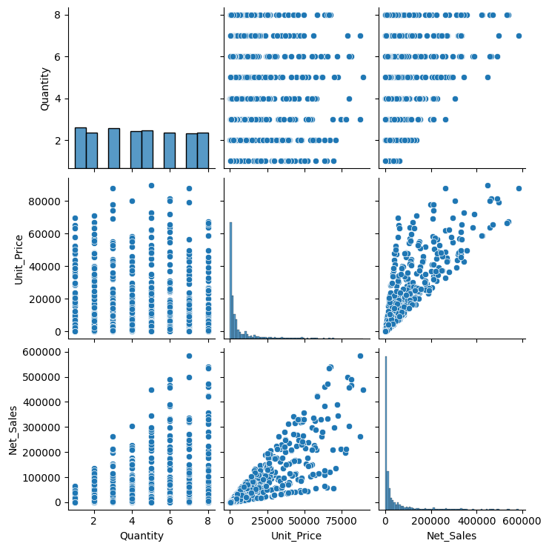
sns.pairplot() — pairwise relationships and distributions of Quantity, Unit_Price, and Net_Sales
Purpose: inspect pairwise relationships and individual distributions together. Insight: Net_Sales tracks Unit_Price closely (a near-linear pattern), while its relationship with Quantity is far more scattered, visually confirming the correlation values above.

14. Key Business Insights
- Nashik generates the highest revenue (₹73.69 lakh) among all 8 cities, while Mumbai generates the least (₹47.76 lakh) — a gap of roughly ₹26 lakh.
- Electronics is the dominant category, contributing ₹3.13 crore of total Net Sales — more than the next four categories combined.
- Unit Price is the strongest driver of a sale's value (correlation 0.87 with Net Sales), far outweighing Quantity (correlation 0.24).
- Discount level has almost no measurable relationship with Net Sales (correlation -0.04); orders with 15% and 20% discounts actually show lower average Net Sales (₹26,837 and ₹18,816) than orders with 0%, 5%, or 10% discounts (₹34,253–₹37,205).
- Karan is the top-performing salesperson (₹65.41 lakh in Net Sales); the gap between the top and bottom salesperson (Vikas, ₹33.15 lakh) is nearly 2x.
- UPI is the most popular payment method among customers in this dataset.
- Returning customers generate the most total revenue (₹2.28 crore), ahead of New customers (₹2.04 crore) and VIP customers (₹74.96 lakh).
- January is the single highest-revenue month, and Q1 is the highest-revenue quarter (₹1.76 crore); revenue declines through Q3 before a partial Q4 recovery.
- Flour is the best-selling product by quantity but ranks among the lowest by revenue — a clear case of high sales volume not translating into high revenue due to low unit price.
- Grocery items (Sugar, Flour, Biscuits) dominate the lowest-value individual orders, consistent with Grocery being the lowest-revenue category overall.

15. Business Recommendations
Recommendation 1 — Prioritize high-revenue cities and categories
Finding: Nashik and Electronics together account for a disproportionate share of total revenue. Recommendation: allocate marketing and inventory investment toward reinforcing strength in Nashik and Electronics, while investigating why Mumbai and Grocery underperform. Expected business relevance: focused investment where revenue concentration already exists is likely to yield a better return than spreading resources evenly.
Recommendation 2 — Re-evaluate high discount tiers
Finding: 15% and 20% discount orders show lower average Net Sales than smaller or no discounts, and the overall correlation between discount and Net Sales is effectively zero. Recommendation: review whether discounts above 10% are actually necessary, since they do not appear to be driving higher sales value in this dataset. Expected business relevance: tightening high-discount promotions could protect margin without a corresponding loss in sales volume.
Recommendation 3 — Study and replicate top salesperson performance
Finding: Karan generates nearly double the Net Sales of the lowest-performing salesperson, Vikas. Recommendation: review Karan's approach (customer segments, product mix, or city assignment) to identify practices that could be shared with lower-performing staff. Expected business relevance: even a partial narrowing of this performance gap across 10 salespeople could meaningfully lift total revenue.
Recommendation 4 — Strengthen retention programs for Returning customers
Finding: Returning customers already generate the most revenue of the three customer types. Recommendation: invest in loyalty or repeat-purchase incentives specifically for this segment, since it is already the proven highest-value group. Expected business relevance: retention spend on an already-high-value segment typically carries lower risk than acquisition spend on new segments.
Recommendation 5 — Plan inventory and staffing around the Q1 peak and Q3 dip
Finding: Q1 (particularly January) is the strongest quarter, while Q3 is the weakest. Recommendation: align stock levels and staffing schedules with this seasonal pattern rather than treating all quarters uniformly. Expected business relevance: better-matched inventory and staffing reduces both stockouts during peak demand and excess holding costs during the slow quarter.

16. End-to-End Project Workflow
- Data Collection — 1,500-row, 18-column retail sales CSV provided.
- Data Loading — pd.read_csv() into a Pandas DataFrame.
- Data Exploration — head(), tail(), shape, columns, dtypes, info(), describe().
- Data Cleaning — missing-value imputation (median/mode), duplicate check, Date-to-datetime conversion.
- Numerical Analysis — NumPy sum/mean/min/max on Net_Sales.
- Exploratory Data Analysis — group-by aggregations across city, category, product, salesperson, customer type, month, quarter, and year; filtering and sorting.
- Visualization — 11 Matplotlib/Seaborn charts covering distribution, comparison, trend, and correlation.
- Business Insights — 12 business questions answered directly from the analysis.
- Recommendations — 5 practical, finding-based recommendations documented.

17. Challenges and Limitations
- Missing data: 39 values (2.6% of cells) were missing across Discount_Percent, Payment_Method, and Customer_Type, requiring imputation that introduces some approximation into those fields.
- Partial final year: the 2026 figures cover only January–June, so year-over-year comparisons with the full 2025 period are not on equal footing.
- Weak explanatory power for Quantity and Discount: both show weak-to-negligible correlation with Net_Sales, meaning much of the variation in sale value is driven by factors (chiefly Unit_Price and product mix) rather than volume or promotions.
- Single-dataset scope: the analysis is limited to the fields provided; no external benchmarking or customer-level demographic data was available.

18. Future Scope
The following are realistic future extensions and are not part of the current implementation:
- Building an interactive Power BI or Tableau dashboard on top of this dataset.
- Automating monthly/quarterly report generation from fresh data extracts.
- Sales forecasting using time-series models to project future demand.
- Customer segmentation (e.g., RFM analysis) to better target New, Returning, and VIP customers.
- Predictive analytics / advanced ML models to predict order value or discount sensitivity.
- Real-time analytics if the company moves to a live transactional data feed.

19. Conclusion
This project took a raw 1,500-record retail sales dataset through a complete analytics workflow — cleaning, exploration, numerical analysis, visualization, and business interpretation — using Python, Pandas, NumPy, Matplotlib, and Seaborn.
The analysis achieved all 12 business questions and all 11 required visualizations specified in the project brief. Key learnings include the outsized influence of Unit_Price (versus Quantity or Discount) on sales value, the concentration of revenue in specific cities and categories, and clear seasonal and customer-type patterns in the data.
From a business standpoint, the analysis provides management with a concrete, data-backed foundation for decisions on city/category investment, discount policy, salesperson performance management, and seasonal planning. Natural next steps include building a live dashboard and layering in forecasting, as outlined in the Future Scope section.

20. Technical Implementation Summary
Library | Key Operations Performed
Pandas | read_csv, head/tail, shape, columns, dtypes, info, describe, isnull/duplicated checks, fillna, drop_duplicates, to_datetime, groupby + sum/mean, sort_values, boolean filtering, corr.
NumPy | to_numpy, sum, mean, min, max on the Net_Sales array.
Matplotlib | bar, plot (line), scatter, hist, pie, figure sizing, titles/labels, xticks rotation.
Seaborn | countplot, barplot, boxplot, scatterplot (with hue), heatmap (with annotations), pairplot.

21. GitHub Project Documentation
Project Title
Retail Sales Analysis — Python Data Analytics Project
Project Description
An end-to-end exploratory data analysis of 1,500 multi-city retail transactions using Pandas, NumPy, Matplotlib, and Seaborn — covering data cleaning, numerical analysis, visualization, and business insight generation.
Key Features
- Full data-cleaning pipeline: missing-value imputation and duplicate checks.
- NumPy-based numerical summary of total, average, minimum, and maximum sales.
- Multi-dimensional group-by analysis across city, category, product, salesperson, customer type, month, quarter, and year.
- 11 Matplotlib/Seaborn visualizations, including a correlation heatmap and pair plot.
- 12 answered business questions with supporting business insights.
Technologies
Python · Pandas · NumPy · Matplotlib · Seaborn · Jupyter Notebook
Project Workflow
Data Collection → Data Loading → Data Exploration → Data Cleaning → Numerical Analysis → Exploratory Data Analysis → Visualization → Business Insights → Recommendations
Suggested Folder Structure
retail-sales-analysis/
├── data/
│ └── retail_sales_analysis_project.csv
├── notebook/
│ └── retail_sales_analysis.ipynb
├── charts/
│ └── (exported PNG visualizations)
├── report/
│ └── Retail_Sales_Analysis_Report.docx
└── README.md
Files Included
- Jupyter Notebook with the full analysis code and outputs.
- Source CSV dataset.
- Cleaned dataset exported after preprocessing (df.to_csv).
- This project report.
How to Run the Project
- Install dependencies: pandas, numpy, matplotlib, seaborn, jupyter.
- Place retail_sales_analysis_project.csv in the same directory as the notebook (or update the file path).
- Open and run the notebook cell by cell in Jupyter Notebook or JupyterLab.
Expected Output
Console/table output for all exploration, cleaning, and business-question steps, plus 11 rendered charts, and a cleaned CSV export at the end of the notebook.
Future Improvements
As listed in the Future Scope section: Power BI dashboarding, automated reporting, sales forecasting, customer segmentation, predictive analytics, and real-time analytics.
End of Report

