**Project Documentation**

Calculating Family Expenses Using ServiceNow

**(ServiceNow Administration)**

**Team Details**

* **Team ID:** LTVIP2025TMID30141
* **Team Size**: 4
* **Team Leader:** Jagana Deepak Kumar
* **Team Member:** Balaga Anith Ram
* **Team Member:** Allumolu Sai Janardhan
* **Team Member:** Baratam Satyaprabhas

# 1. INTRODUCTION

## 1.1 Project Overview

Managing and tracking daily family expenses can often become unorganized and inefficient when done manually. This project, "Calculating Family Expenses Using ServiceNow," aims to provide an automated and structured solution using the capabilities of the ServiceNow platform. With ServiceNow’s flexible table creation, relationships, and workflows, a family can efficiently manage, monitor, and analyze their daily financial transactions.

## 1.2 Purpose

The main purpose of this project is to build a simple, user-friendly system where a user can record and categorize family expenses, view related records, and ensure relationship mapping using ServiceNow features. It simplifies the process of financial tracking and helps in understanding and managing spending habits better.

# 2. IDEATION PHASE

## 2.1 Problem Statement

Families often struggle to keep track of their daily expenses due to a lack of structured recording tools. Manually entering data into spreadsheets or paper-based ledgers can lead to errors and inconsistencies. This project proposes a ServiceNow-based application to digitally manage daily expenses using a customizable data structure.

## 2.2 Empathy Map Canvas

Who? Family members managing household budgets  
Think/Feel? They want an easy and clear system to track spending  
See? Disorganized records or missed entries  
Say/Do? Often discuss overspending or unplanned expenses  
Hear? Suggestions to maintain better budgeting  
Pain? No automation, poor tracking  
Gain? Automated, transparent tracking and reporting of expenses

## 2.3 Brainstorming

We explored multiple solutions:  
- Manual ledger tracking  
- Excel or Google Sheets  
- Mobile budgeting apps  
- Final Choice: ServiceNow due to its structured, low-code capabilities, relationship modeling, and easy record management

# 3. REQUIREMENT ANALYSIS

## 3.1 Customer Journey Map

Set up a ServiceNow instance  
Create tables for "Family Expenses" and "Daily Expenses"  
Link the tables through a relationship  
Configure related lists to view expense data  
Create business rules for automated behavior  
View and analyze expenses easily through the instance

Flow:  
Login → Navigate to Tables → Create Records → Track Daily Expenses → View Related Entries → Analyze Data

## 3.2 Solution Requirement

- ServiceNow instance  
- Custom tables: Family Expenses and Daily Expenses  
- Relationships between the two tables  
- Update sets for configuration tracking  
- Business rules for automation  
- Related lists for data visualization

## 3.3 Data Flow Diagram

## 

## 3.4 Technology Stack

- Platform: ServiceNow  
- Language: JavaScript (for business rules)  
- Modules Used: Tables, Relationships, Business Rules, Related Lists  
- Testing Method: Manual validation using instance records and forms

# 4. PROJECT DESIGN

## 4.1 Problem Solution Fit

Manual expense tracking is inefficient. Using ServiceNow, we provide a structured and relational data management system that supports automation, accurate data entry, and better insights through connected records.

## 4.2 Proposed Solution

- Create update sets to track changes  
- Build two tables: one for family expenses and another for daily entries  
- Define a relationship between these tables  
- Use business rules to trigger actions or validations  
- Display related records in an easy-to-navigate form view

## 4.3 Solution Architecture

Frontend:  
ServiceNow platform interface for adding and viewing expenses  
  
Logic Layer:  
Business rules that control behavior and validation logic  
  
Data Layer:  
Custom tables for storing and linking data records  
  
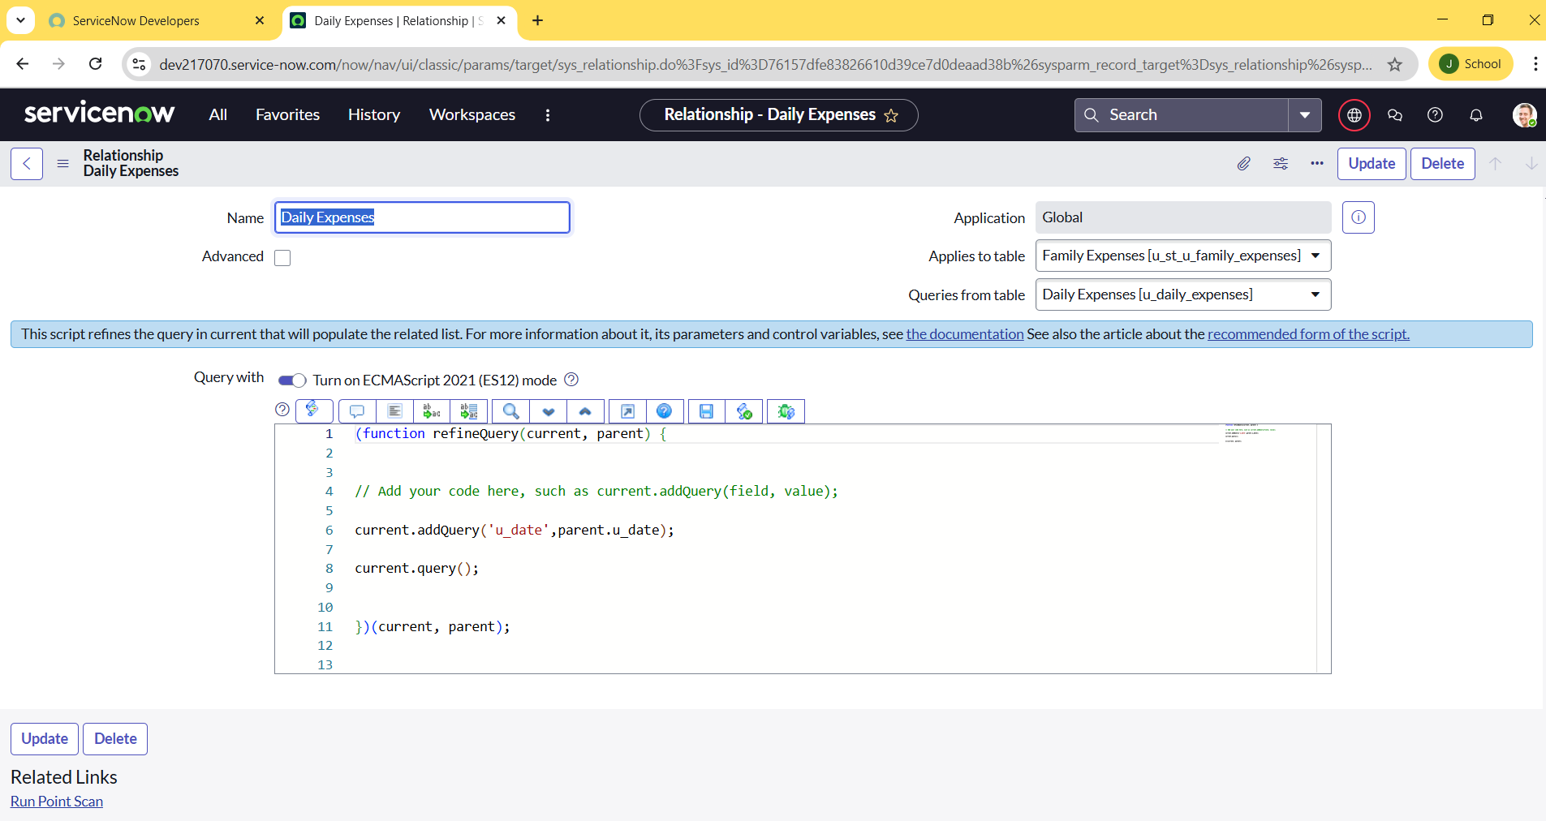

# 5. PROJECT PLANNING & SCHEDULING

## 5.1 Project Planning

- Set up ServiceNow instance  
- Create a new update set to track all changes  
- Design custom tables for Family and Daily Expenses  
- Create relationships between tables  
- Add related list for visibility  
- Configure business rules

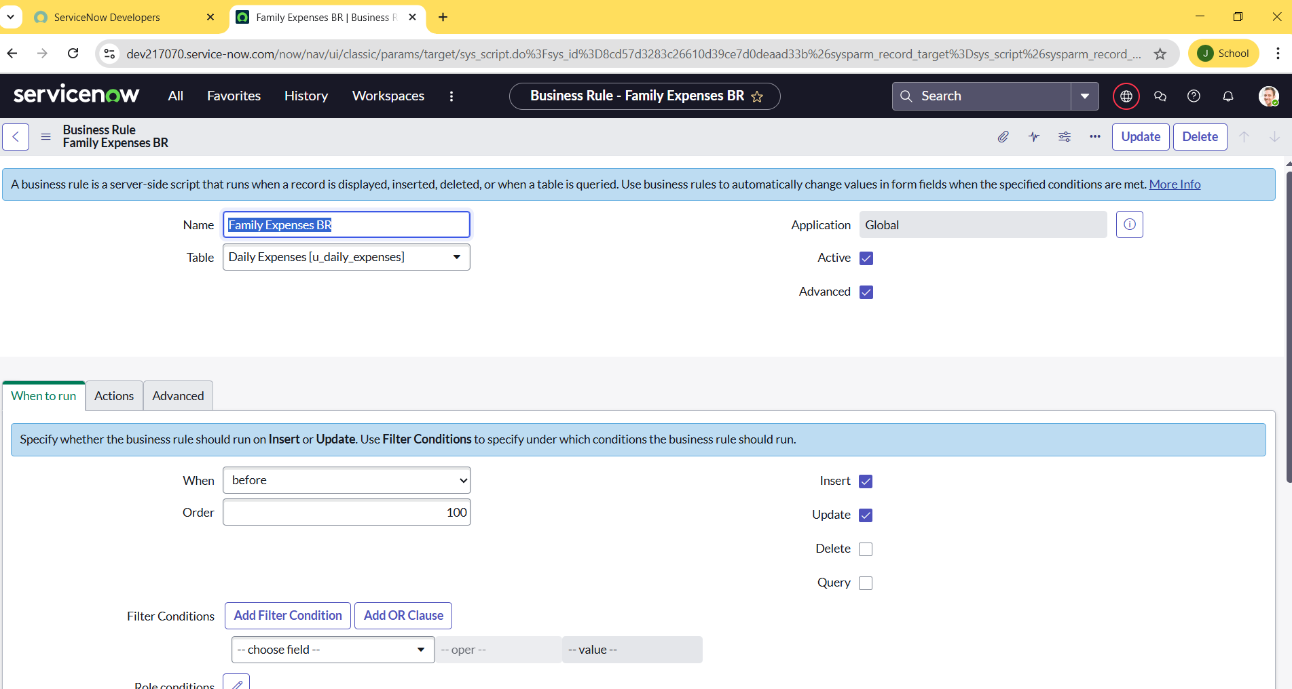  
- Perform validations and testing

# 6. FUNCTIONAL AND PERFORMANCE TESTING

## 6.1 Performance Testing

- Verified table creation and accessibility  
- Tested record insertion and form load time  
- Ensured relationships display correct related records  
- Validated business rule executions  
- Checked user-friendly navigation and behavior under test data

# 7. RESULTS

## 7.1 Output Screenshots

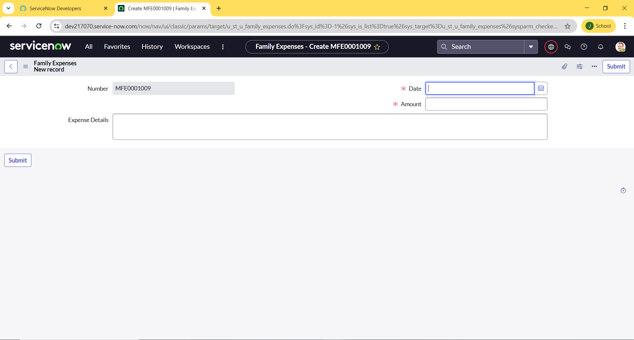

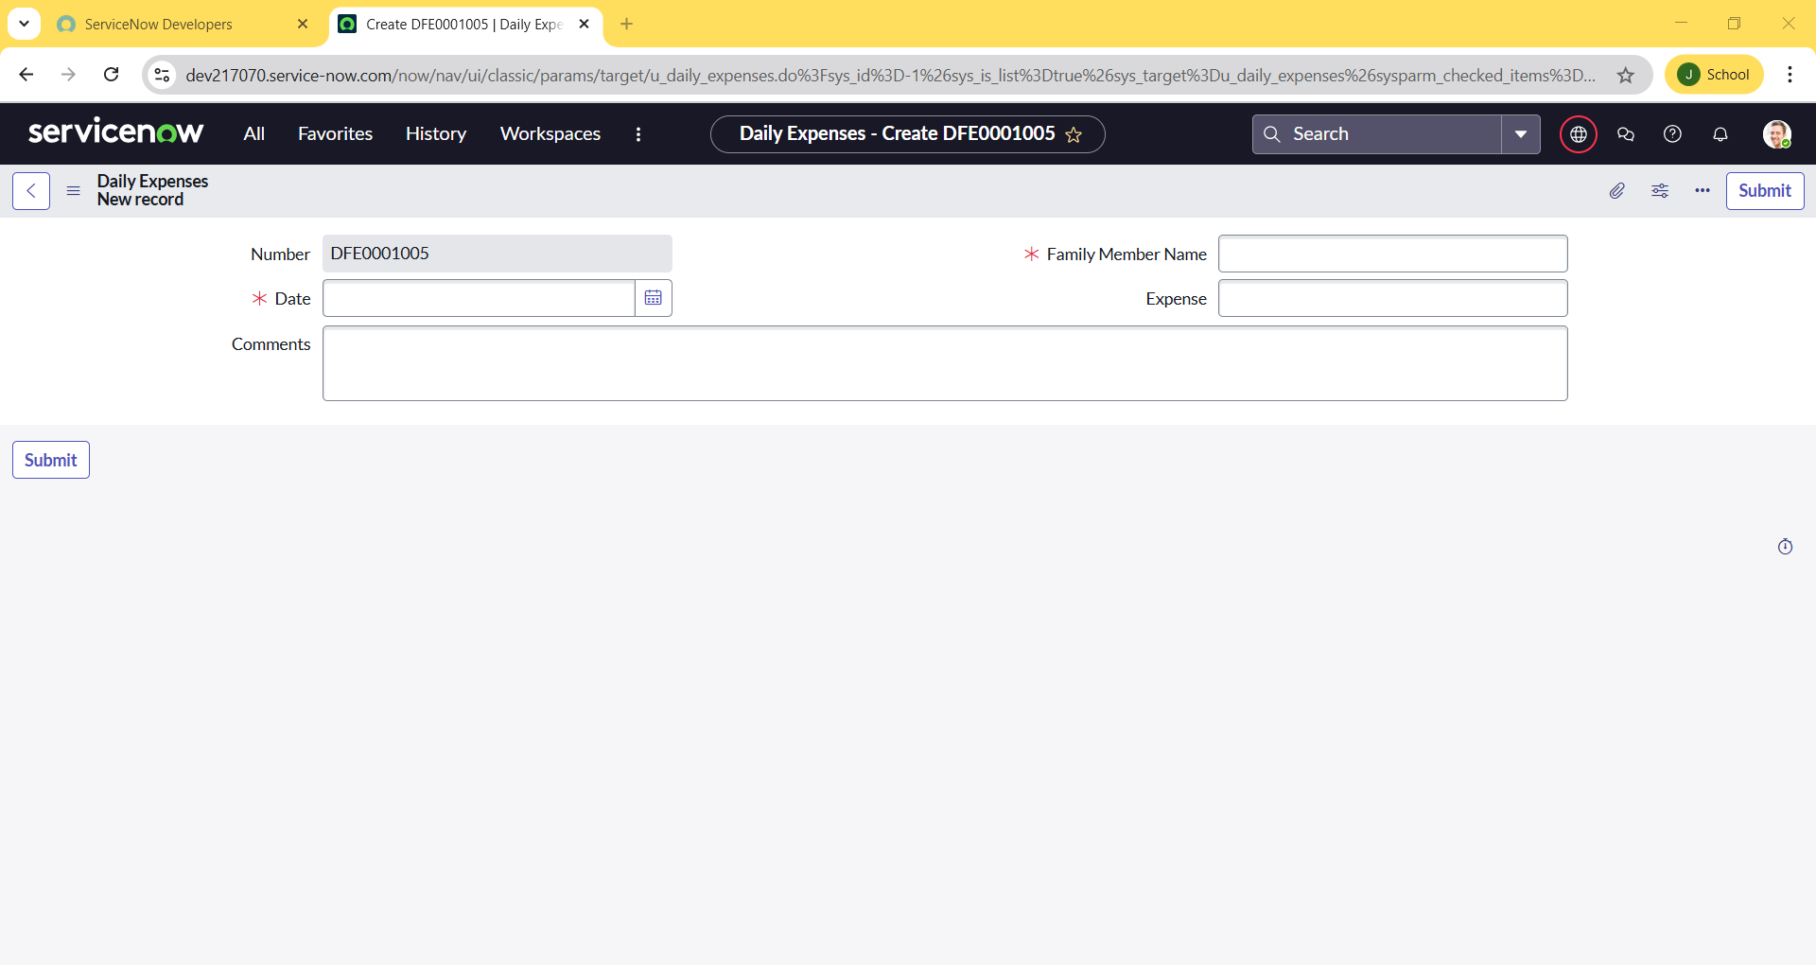

# 8. ADVANTAGES & DISADVANTAGES

* Advantages
* Fully automated and centralized tracking system
* Easy relationship management
* Efficient data retrieval through related lists
* Scalable for additional features
* Disadvantages
* Requires ServiceNow platform knowledge
* Initial setup may be time-consuming for new users

# 9. CONCLUSION

This project effectively demonstrates the use of ServiceNow in a non-enterprise context like managing household expenses. It utilizes ServiceNow's powerful table and relationship features to create a dynamic and connected system that can be easily extended. The solution improves clarity, tracking, and budget management for everyday family expenses.

# 10. FUTURE SCOPE

- Add analytical dashboards for monthly/yearly expense summaries  
- Integrate SMS/email alerts for overspending warnings  
- Include expense categorization and filtering options  
- Enable import/export to Excel or PDF for offline tracking  
- Multi-user access for family members with roles

# 11. APPENDIX

GitHub Link: https://github.com/JAGANADEEPAKKUMAR/Family-Expenses

Project Demo Link: https://youtu.be/bIIzow6NUk4?si=KyQP6XRC-3KJluky