**A Project Based Seminar Report on**

**“Google Glasses For Blind People”**

Submitted to the

Savitribai Phule Pune University

In partial fulfillment for the award of the Degree of

Bachelor of Engineering

in Information Technology

by

**Name Roll no.**

**Akanksha Vyavahare 42**

**Gauri Joshi 12**

**Mahesh Doiphode 04**

**Ajay Kamble 14**

Under the guidance of

**Prof. Prajakta Lokhande**



Department Of Information Technology

Dhole Patil College of Engineering, Pune, Maharashtra, India

2020-2021



**CERTIFICATE**

This is to certify that the project based seminar report entitled **“Google Glasses For Blind People”** being submitted by **Akanksha Vhyavhare (42), Gauri Joshi (12), Mahesh Doiphode(04), Ajay Kamble (14)** is a record of bonafide work carried out by them under the supervision and guidance of **Prof. Prajakta Lokhande** in partial fulfillment of the requirement for **TE (Information Technology Engineering) – 2015 course** of Savitribai Phule Pune University, Pune in the academic year 2020-2021.

Date:

Place: Pune

Prof. Prajakta Lokhande Prof. Namdeo Kedare Prof. Rahul Ghode

Guide Seminar Coordinator Head of the Department

This project based seminar report has been examined by us as per the Savirtibai Phule Pune University, Pune, requirements at Dhole Patil College of Engineering, Pune on . . . . . . . . . . . . . .

(Name & Signature) (Name & Signature)

Internal Examiner External Examiner

**I**

**ACKNOWLEDGEMENT**

The completion of the report on “Google Glasses For Blind People” has given me immense pleasure and knowledge. I am sincerely thankful to Principal **Dr. N. Walimbe , Prof. Rahul Ghode** our head of the IT Department, project based seminar guide **Prof. Prajakta Lokhande** and project based seminar in charge **Prof. Namdeo Kedare** who have cooperated with me at different stages during the preparation of this report.

My sincere thanks to the staff of the Information Technologies Department without whose help it would not have been possible for me to complete this report. This work is virtually the result of inspiration given by them.

I would also like to thank all the library and non teaching staff for their help and last but not least, I would like to thank all my friends for their constant help and support.

Akanksha Vyavahare

Gauri Joshi

Mahesh Doiphode

Ajay Kamble

**II**

**Abstract**

More than a billion people around the world have vision problems for different reasons, and these numbers are increasing every year. This leads us to make different innovations in the field of computer vision, with the aim of providing a better quality of life for these people. In this document we present as a resource, the development of an intelligent lens, which incorporates a Raspberry Pi ZW connected to the Google Cloud Vision API through the Wifi of the user's mobile phone, where at the touch of a button, the Raspberry camera, captures the image, processes it in a few seconds and retrieves its main features, obtaining important information for mobilization such as: pedestrian crossings, bus stop sign, vehicles, green light, etc. 150 people from the National Union of the Blind of Peru (NUBP) were evaluated with different degrees of blindness, obtaining a 40.5% increase of independence for their mobilization.

**III**

**Contents**

Certificate I

Acknowledgement II

Abstract III

List of Tables IV

List of Figures V

|  |  |  |  |  |  |  |  |  |  |  |  |  |  |  |  |  |  |  |  |  |  |  |  |  |  |  |  |  |  |  |  |  |  |  |  |  |  |  |  |  |  |  |  |  |  |  |  |  |  |  |  |  |  |  |  |  |  |  |  |  |  |  |  |  |
| --- | --- | --- | --- | --- | --- | --- | --- | --- | --- | --- | --- | --- | --- | --- | --- | --- | --- | --- | --- | --- | --- | --- | --- | --- | --- | --- | --- | --- | --- | --- | --- | --- | --- | --- | --- | --- | --- | --- | --- | --- | --- | --- | --- | --- | --- | --- | --- | --- | --- | --- | --- | --- | --- | --- | --- | --- | --- | --- | --- | --- | --- | --- | --- | --- |
| |  |  |  |  | | --- | --- | --- | --- | | **Sr.** | | **Chapter** | **Page No** | |  | |  |  | | **1.** |  | **Introduction** |  | |  | 1.1 | Introduction to Project | 7 | |  | 1.2 | Motivation behind | 8 | |  | 1.3 | Objective of the work | 8 | |  |  |  |  | | **2.** |  | **Literature Survey** |  | |  | 2.1 | Literature Survey | 9 | |  | 2.2 | Previous Technologies | 10 | |  |  |  |  | | **3.** |  | **Understanding the Matter** |  | |  | 3.1 | Methodology | 11 | |  | 3.2  3.3 | Results  Advantages and Disadvantages | 15  16 | | **4.** |  | **Conclusion** | 18 | | **5.** |  | **References** | 19 | |

**LIST OF TABLES**

**Sr. No. Figure Name Page No.**

1. Previous Technologies 10

2. Classification of visual impairment 11

3. Requirement Survey 12

4. Requirement Survey 16

**IV**

**LIST OF FIGURES**

**Sr. No. Figure Name Page No.**

1. Prototype for the reading system 09

2. Lens Prototype 13

3. Prototype Architecture 13

4. Python code for Geolocation detection 15

5. Comparison of increase in autonomy response 16

**V**

**CHAPTER 1**

**INTRODUCTION TO PROJECT TOPIC**

* 1. **Introduction to Project :-**

According to the World Health Organization (WHO), in its October 2019 report, at least 2.2 billion people worldwide are visually impaired or blind, and according to reports from previous years, these numbers are increasing, affecting the most vulnerable people the most, such as the elderly, people with disabilities, ethnic minorities, indigenous populations and those on low incomes. In Perú about 160,000 people are blind for various reasons, the main cause of blindness is bilateral cataract with 47%, followed by uncorrected refractory errors with 15%, glaucoma with 14% and diabetic retinopathy with 5%. Thirty-seven percent of those who are blind due to cataracts are distributed in the Sierra and Selva regions, mostly in rural areas; the remaining 63% are located in urban-marginal areas of the Coast, including Lima and Callao. The prevalence of blindness in the country is about 0.6% if people with severe visual impairment (vision <20/200) are included, and most cases are preventable, treatable or recoverable. This document aims to provide a better quality of life for people with visual impairment of the National Union of the Blind of Peru (NUBP), through the development of smart glasses connected to Google Cloud Vision. Many of these people with blindness do not have the necessary means or economic availability to be able to acquire devices that help them improve their quality of life, even more so since most of them are over 50 years old. There are different devices that help blind people to move around fluently, however, many of these have not been very successful due to the lack of support when developing this type of project. One of the first devices to appear was the white cane and guide dog; with technological advances, new tools are being created such as the use of Google Cloud Vision in assistive technology scenarios, where the benefits of this Google tool, remote processing of images in the cloud and audio output on a speaker are presented; Today, devices have been created that further facilitate the daily activity of a person, as is the case of Google Assistant implementation in Raspberry Pi, processor that is used in this document, connecting it with the Api of Google Cloud, focusing on blind people. Based on the assumption of such scenarios, the development of the first prototypes of smart glasses has started. Based on the new innovative technologies, the aim is to create a non-invasive and economic device that will provide a better way of life for the visually impaired, enabling these blind people to function outside their homes more independently and autonomously. An embedded lens prototype will be developed with Rasberry Pi Zero W, this family of raspberries is considered one of the most ideal for IOT because of its low energy power, according to an evaluation of the performance of rasberry Pi Zero W, since our user will carry the lenses in his daily life, so their energy consumption should be very small; will be connected to a camera in the front, in which the user will press a button, the camera will take a picture, will process it remotely by means of the RES Google Vision API and will inform by audio, connected by means of bluetooth, the result of the image processing, being able to detect between places, logos, letters in front, gestures in the faces, etc. The prototype is noninvasive, allowing the user to walk by the streets with more independence allowing him to make an image capture at will and to listen to the result of the processing in his hearing aids. This report is structured in four parts. The next part presents the methodology used in the development of the research showing the initial evaluations, materials to be used, programming and tests carried out; the third part shows the results obtained and finally presents the conclusions of this report.

* 1. **Motivation behind project topic :-**

Now-a-days the people with disabilities are not able to live their life as normal people does, their disability becomes a big barrier for it. But as of Science and technology has reached at a very high level that most types disabilities people suffering from are living a normal life with other people. People who have lower limb differences need assistance for mobility and science has worked greatly for that by innovating prosthetic devices, wheelchairs, walkers, crutches, canes, etc. People suffering from ear problems, being deaf have hearing aids which at a very extent help deaf people hear. As same there are techniques or maybe some solutions which includes surgery and all exist for blind people too, but as in IT field we wanted to do something for the blund people and here we are with an idea that can help blind people be independent in their life at least for some extent. The problems faced by the blind people and their dependency on other people for their living everytime was the point why we selected this topic for our project.

* 1. **Aim and Objective(s) of the work :-**

**Project aim**:

The aim of this project is to help blind people to be independent in their life for some extent, and for this we are using Google’s cloud storage vision api to store the images, and read the text out with the help of OCR.

**Project objectives** :

Glasses are designed to be the eye for the blind person and people who suffer from vision difficulties to make their life easier and be able to continue living their life as a normal human to follow up and achieve their goals and dreams.

• Convert printed text to audio.

• Inform the user by the location of the classes in the green zone.

• It makes their life easier and they will be able to live a normal life.

• Increase education level because “Smart Glasses” will help all people with vision difficulties to study with these glasses with normal people in any school and University.

**CHAPTER 2**

**LITERATURE SURVEY**

**2.1 Literature Survey :-**

Text detection and recognition have been a challenging issue in different computer vision fields. There are many research papers that have discussed different methods and algorithms for extracting the text from the images. The main purpose of this literature review is to view some of these methods and their effectiveness regarding their accuracy rates.

* Using Google Cloud Vision in Assistive Technology Scenarios :-

With technological advances, new tools are being created such as the use of Google Cloud Vision in assistive technology scenarios, where the benefits of this Google tool, remote processing of images in the cloud and audio output on a speaker are presented. A computer vision system evaluates data from an image source, typically a camera, and extracts information about captured images. The equipment used includes a Raspberry Pi 2 Model B board , used for the instantiation of our application, and a Raspberry camera module, as vision sensor. Then, exploit the Google Cloud Vision API to process images on the Google Cloud Platform.

Fig.2.1 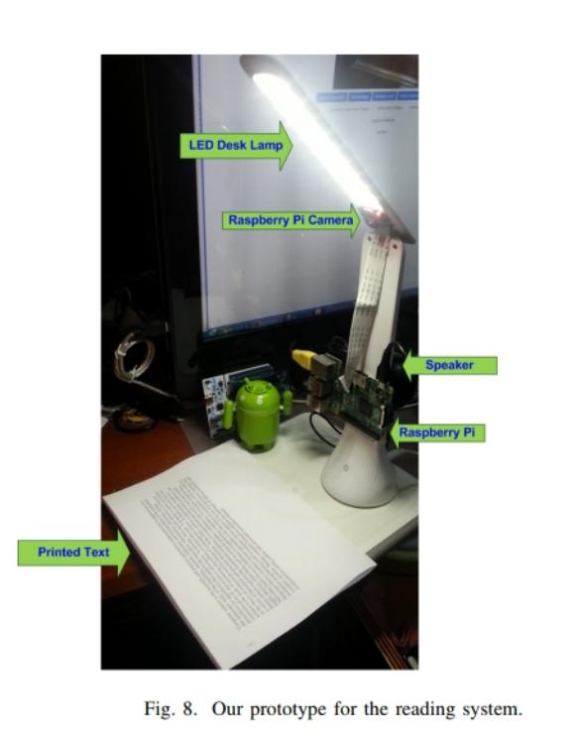 Prototype for the reading system

Author,Journals :-

D. Mulfari, A. Celesti, M. Fazio, M. Villar and y A. Puliafito, IEEE Workshop on ICT solutions for eHealth.

Year of Publishing :- 2016.

* A Performance Evaluation of Raspberry Pi Zero W Based Gateway Running MQTT Broker for IoT :-

An embedded lens prototype will be developed with Rasberry Pi Zero W, this family of raspberries is considered one of the most ideal for IOT because of its low energy power, according to an evaluation of the performance of rasberry Pi Zero W, since our user will carry the lenses in his daily life, so their energy consumption should be very small; will be connected to a camera in the front, in which the user will press a button, the camera will take a picture.

Author,Journals :-

*D. B. C. Lima, R. M. B. d. S. Lima, D. d. F. Medeiros, R. I. S. Pereira, C. P. d. Souza and y O. Baiocchi,*IEEE 10th Annual Information Technology Electronics and Mobile Communication Conference (IEMCON).

Year of Publishing :- 2019.

**2.2 Previous Technologies :-**

|  |  |  |  |  |
| --- | --- | --- | --- | --- |
| **Sr. No.** | **Paper Name** | **Author,Journals** | **Year of Publishing** | **Work** |
| 1. | Using Google Cloud Vision  in Assistive Technology Scenarios. | D. Mulfari, A. Celesti, M. Fazio, M. Villar and y A. Puliafito, IEEE Workshop on ICT solutions for eHealth. | 2016 | A computer vision system evaluates data from an image  source, typically a camera, and extracts information about  captured images and  audio output on a speaker are presented. |
| 2. | A Performan- ce Evaluation of Raspberry Pi Zero W Based Gateway Running MQTT Broker for IoT. | *D. B. C. Lima, R. M. B. d. S. Lima, D. d. F. Medeiros, R. I. S. Pereira, C. P. d. Souza and y O. Baiocchi,*IEEE 10th Annual Information Technology Electronics and Mobile Communication Conference (IEMCON)*.* | 2019 | Rasberry Pi Zero W, this family of raspberries is considered one of the most ideal for IOT because of its low energy power.  Since, our user will carry the lenses in his daily life, so their energy consumption should be very small. |

**CHAPTER 3**

**UNDERSTANDINGS THE MATTER**

**3.1 METHODOLOGY :-**

For the development of the project, the Design Thinking methodology will be used. Design Thinking, consists of a series of steps forming a development method to generate innovative ideas, focusing on learning and solving the real needs of users.

1. **Understanding and Observing:**

Discovering people (Empathy), the study was conducted with the people of the National Union of the Blind of Peru (NUBP) located at Plaza Bolognesi N° 477 - 479, Cercado Lima - Peru.

150 people were selected and used the International Classification of Diseases (2018)- WHO, which classifies visual impairment into two groups according to the type of vision: far and near.

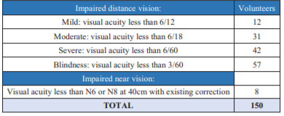  
 **Table 3.1. Classification of visual impairment**

1. **Find Patterns (Define the Problem):**

Interviews will be conducted on their autonomy to move on the streets without the use of the research lenses, their requirements will be consolidated.

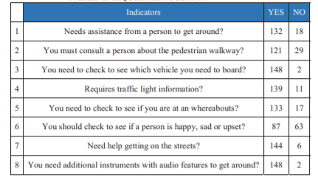

**Table 3.2. Requirement survey**

1. **Devise the possible solutions (design principles):**

The first research prototype is configured according to the suggestions given; the requirements of the prototype are established. For the development of the application and the prototype, the following materials were implemented:

• Glasses: Preferably medium size and lightweight plastic tool for comfort, this will support the wiring system.

• Raspberry Pi ZERO W: Used as our computer, it is very small, ideal for IOT projects, composed of an ARM processor, wifi connection and bluetooth.  
• Cámara Raspberry Pi: This high definition (HD) Raspberry Pi camera board connects to the Raspberry Pi W for photo capture.

• Google Cloud Vision API: A powerful image recognition tool, this API recognizes and classifies images quickly, is able to detect individual objects and faces, and reads printed words that appear in images.

• Internet: The user will provide internet access through his mobile phone by means of the wifi integrated in the Rasberry pi Zero W

• Battery. Integrated into the embedded system, considering that the Rasberry pi Zero W is a low power consumption hardware very useful for IOT projects.

1. **Prototype the models (make them tangible):**
   1. *Lens Prototype:*

Tests are carried out with the prototype already created and configured.

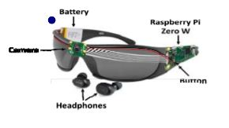

**Fig. 3.1. Lens Prototype**

* 1. *Prototype architecture:*

Diagram of how the prototype is developed and interacts with the different components.

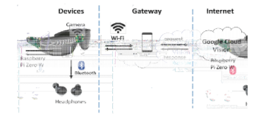

**Fig 3.2. Prototype architecture**

The prototype is activated when the user presses the image capture button, the Raspberry pi W commands the camera to take a picture of whatever is in front of it at that moment, the information of the captured image is sent to the Google Cloud Vision RES API via the Wi-Fi of the user's cell phone. The image is processed and equivalents are searched in the database of Google Cloud Vision, the response is sent in a few seconds again to the Rasberry pi Zero W, which is programmed to send this result through the integrated bluetooth to the headphones previously configured in our processor.

1. *System Configuration:-*

*I. Configuration of the environment:*

We created a virtual machine hosted on the wifi ip to be able to enter remotely:

*Sudo vncserver :2 –geometry 1920x1080 –depth 24*

We updated Python3. We downloaded and installed the Google Vision API. Installed a Python library - installed a new version of PiCamera according to the model of the camera we are using:

*python3 –m pip install --user pip*

*python3 –m pip install --user google-cloud-vision*

*python3 –m pip install --user Pillow*

*python3 –m pip install --user picamera*

We must have the JSON file in the directory we have downloaded from the project created previously in google vision. We execute the Python script to recognize objects from the capture made by the camera.

II. *Development of the system:*

Next, we will show some of the python codes used, for example the geolocation:

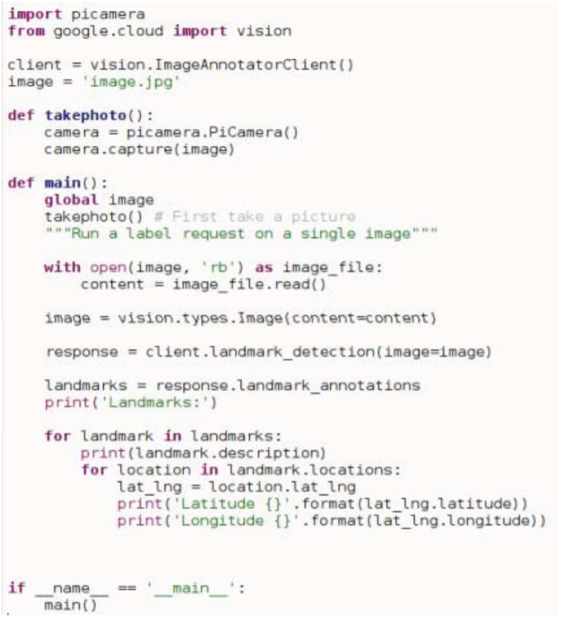

**Fig. 3.3. Python code for Geolocation detection**

**3.2 RESULTS :-**

The 150 volunteers were surveyed again according to Table II and the following results were obtained: A comparison between Tables II (without the use of the lenses) and Table III (after the use of the lenses) shows an increase in "NO" responses, which are an indicator of autonomy. The comparison of the range responses is shown below:

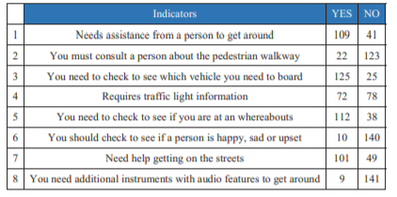

**Table 3.3. Requirements Survey**

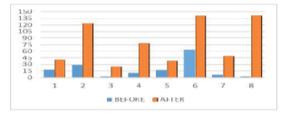

**Fig. 3.4. Comparison of increase in autonomy responses**

**3.3 ADVANTAGES AND DISADVANTAGES :-**

**ADVANTAGES:**

1. The first and the foremost advantage of Google Glasses is that it offers convenience. Users can easily send messages without using their hands. 2.
2. Google Glass will show you text messages as well as emails you receive and allow you to reply to them via voice commands.
3. Multiple options are made available which allows the user to use either voice commands or small hand gestures for operating this amazing device.
4. Another main advantage of Google Glasses is that you can capture those amazing moments of your life in a very simple and easy way. The video and camera capabilities that offered are hi-class.
5. This user friendliness and freedom is one of the USPs of this project.
6. This is a neat feature that may come in handy when you travel abroad. You simply need to ask Google Glass to translate a phrase or sentence from one language to another and it will speak that out.
7. The sound creation takes place with the help of vibrations which is considered as less abrasive as compared to headphones. This is also called as Bone-Induction concept. The clarity of the sound is also pretty good as compared to normal headphones or speakers.

**DISADVANTAGES:**

1. Google Glass cannot be used by those people who already having some issue with their eyes and wears glasses in their daily routine.
2. You cannot use these Google Glass while driving, as the picture, video or data will be in front of the eyes of the user, which can distract them.
3. Google Glass can be easily broken as it is a sensitive device, after all it’s a glass not a bullet proof glass.
4. The face recognition technology can be easily misused and it might turn out to be offensive for that person.
5. One of the main disadvantages of Google Glasses is that there is chance of breach in the privacy of the person who is using this device. The video and camera can be misused and anybody can capture anything without letting the other person know about it.
6. Common glass are even not wearable while Running, Dancing or similar activities. So would you expect that you can wear these sensitive glasses.
7. Google glasses that are of consumers concerns are the cost of the glasses, the track pad, social interactions, privacy and recording issues, and more.

**CHAPTER 4**

**CONCLUSION**

You get a non-invasive lens, aesthetic, portable and easy to use, achieving the implementation of the connection with Google Cloud Vision for effective capture, processing and audio output to the user, achieving the detection of the necessary images, generating greater autonomy in the mobilization of blind users. Given the results obtained, the indicators of autonomy are improved by 40.5%; likewise, the persons evaluated indicated that the prototype of the intelligent lens helps to become independent from guide persons and that they would use the product.

**CHAPTER 5**

**REFERENCES**

List all the material used from various sources for making this project proposals

[1] [2020 International Conference on e-Health and Bioengineering (EHB)](https://ieeexplore.ieee.org/xpl/conhome/9279433/proceeding) – [Michael Cabanillas-Carbonell](https://ieeexplore.ieee.org/author/37087322630); [Alexander Aguilar Chávez](https://ieeexplore.ieee.org/author/37088577910); [Jeshua Banda Barrientos](https://ieeexplore.ieee.org/author/37088577507), "Glasses Connected to Google Vision that Inform Blind People about what is in Front of Them” Site: https://ieeexplore.ieee.org/document/9280268/

, vol. #, no. #, pp.5, Oct 2020.

[2] “In Peru about 160,000 people are blind for various reasons”, Andina, 17 nov 2014. [Online]. Available: https://andina.pe/agencia/noticia-enperu-cerca-160000-personasson-invidentes-diversas-causas531943.aspx.

[3] “NATIONAL UNION OF THE BLIND OF PERU – NUBP”, [Online]. Available: https://uncp.pe/. [Último acceso: 14 Jan 2019].

[4] A. Garcia, “Products that make life easier for blind people”, Consumer, 05 May 2009. [Online]. Available: http://www.consumer.es/web/es/solidaridad/proyectos_y_campanas/200 9/05/05/185103.php.

[5] D. Mulfari, A. Celesti, M. Fazio, M. Villar y A. Puliafito, Using Google Cloud Vision in Assistive Technology Scenarios, IEEE Workshop on ICT solutions for eHealth , 2016.

[6] S. Mischie, L. Mâiu-Iovan y G. GŠpresc, «Implementation of Google Assistant on Rasberry Pi,» IEEE - International Symposium on Electronics and Telecommunications (ISETC), 2018.

[7] D. B. C. Lima, R. M. B. d. S. Lima, D. d. F. Medeiros, R. I. S. Pereira, C. P. d. Souza y O. Baiocchi, «A Performance Evaluation of Raspberry Pi Zero W Based Gateway Running MQTT Broker for IoT,» IEEE 10th Annual Information Technology, Electronics and Mobile Communication Conference (IEMCON), 2019. [8] Google Cloud Vision, «Get started with Vision AI, » [En línea]. Available: https://cloud.google.com/vision/overview/docs/get-started. [Último acceso: 18 jan 2020]. ‘

[9] “Design Thinking”, Dinngo, [Online]. Available: https://designthinking.es/inicio/index.php. [Último acceso: 12 Aug 2019].

[10] WHO, « Blindness and visual impairment » WHO, 20 mar 2020. [En línea]. Available: https://www.who.int/es/news-room/factsheets/detail/blindness-and-visual-impairment. [11] Raspberrypi, «Raspberry Pi Zero W,» raspberrypi, [En línea]. Available: https://www.raspberrypi.org/products/raspberry-pi-zero-w/. [Último acceso: jan 2020] [12] “Cámara Raspberry Pi v2 - 8 Megapixels”, BricoGeek, [En línea]. Available: https://tienda.bricogeek.com/accesorios-raspberry-pi/822- camara-raspberry-pi-v2-8-megapixels.html.

[13] Api, google cloud, “Google Cloud Vision API”, ackstorm, 11 Jan 2018. [Online]. Available: <https://www.ackstorm.com/google-cloud-visionapi/>

[14] WHO, «WHO launches first World report on vision,» WHO, 8 oct 2019. [En línea]. Available: https://www.who.int/es/news-room/detail/08-10- 2019-who-launches-first-world-report-on-vision.