**Intership**

**Report**

**On**

**“Bus Booking System Project Using Java & Mysql”**

Presented by:Gadhe Mahesh



**Introduction**

* To develop an bus booking system Using Java & Mysql to book a bus according to date.
* After filling the proper details of customer we can book bus and see the status of our ticked whether it is booked or not.
* This system helps customer to book a ticket without going to Bus stop or station.
* Customer can enter the date and booked the ticket.

**OBJECTIVE**

1. This project is an innovation, which makes the booking of ticket simple as compared to manual work. This project has been implemented using java and mysql.

2.It maintain error free records and easily incorporates the future developments and changes.

3.To develop as well designed interface or page to shows the details of the customers.

4.To help Customer to saves his time and money.

**Design**

* Bus booking Panel :- In this design panel there are two main fields first is seat add and busbook In seat add we add seat according to date and in busbook entering that date we can book ticket.
* Seat Add panel:-In this panel there are two fields first is bus no and other is date so in bus no there is bus no details and in date we can add date.
* Ticket booking Panel:- In this panel when we add date it will show the table chart of bus Including status,customer name, seat,status,mobile no, date .

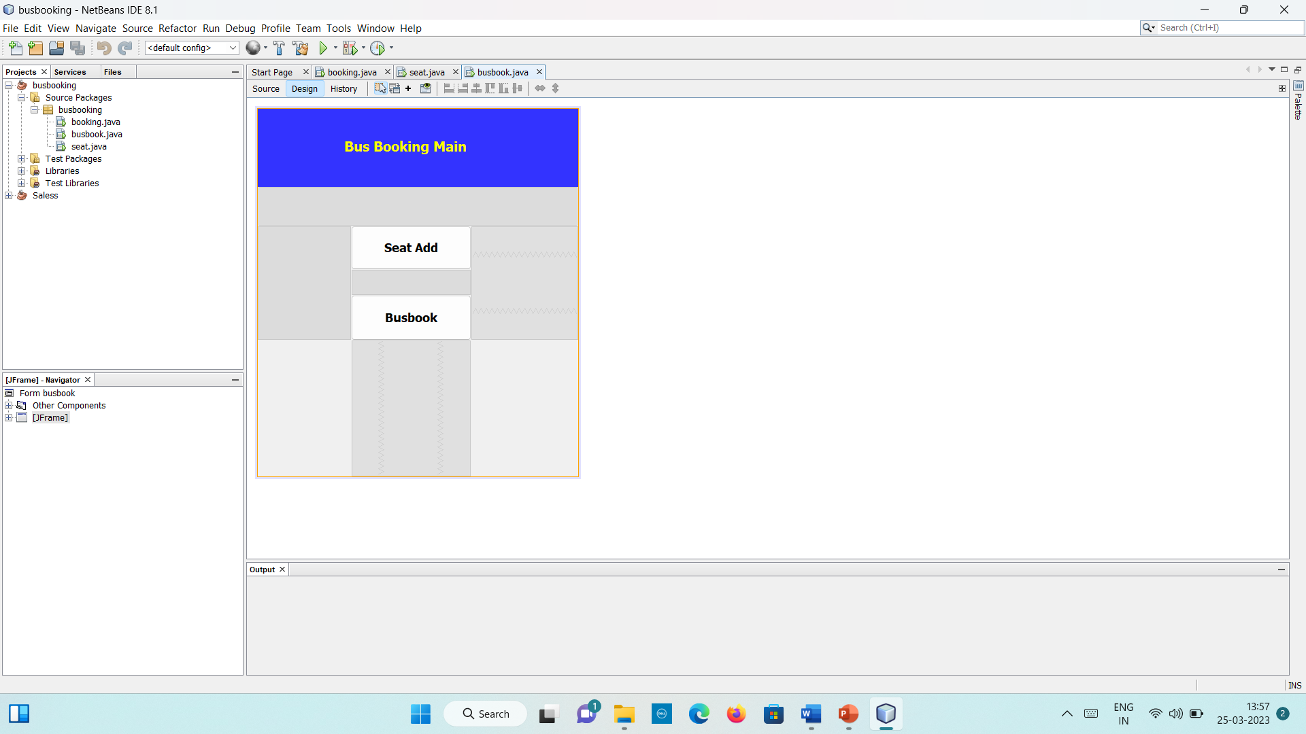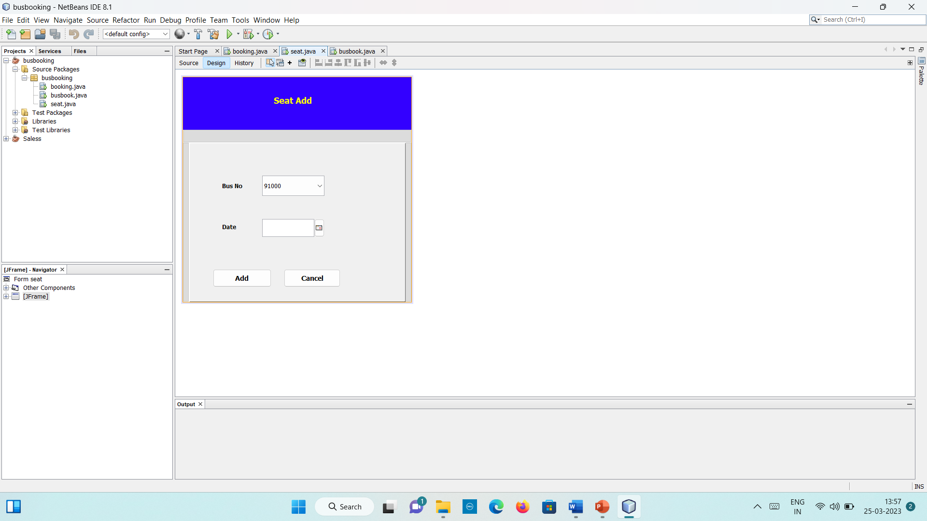

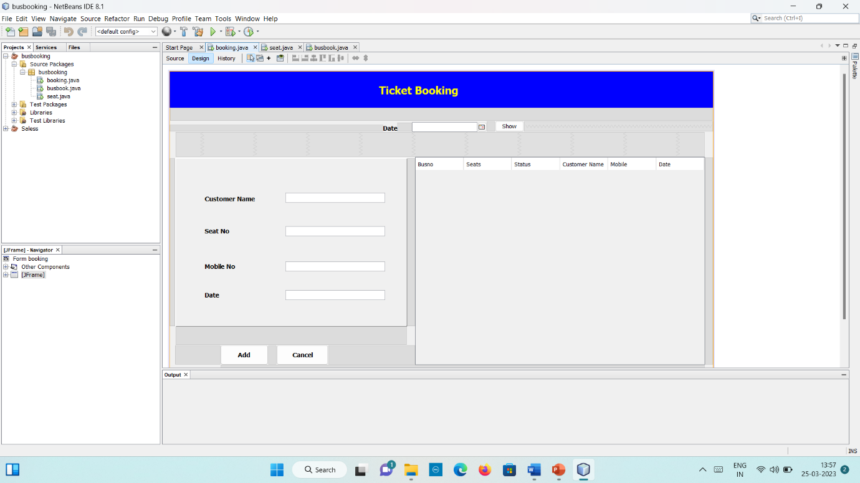

**REQUIREMENTS OF PROJECT**

* Window 10/XP
* Installed java editor
* Installed java jre
* Installed java jdk
* Installed Net Beans
* Installed Mysql workbench

1.Java is a **programming language** and a **platform**. Java is a high level, robust, object-oriented and secure programming language.

Java was developed by Sun Microsystems (which is now the subsidiary of Oracle) in the year 1995. James Gosling is known as the father of Java. Before Java, its name was Oak. Since Oak was already a registered company, so James Gosling and his team changed the name from Oak to Java.

2.Netbeans Ide:

NetBeans IDE offers first-class tools for Java web, enterprise, desktop, and mobile application development. It is consistently the first IDE to support the latest versions of the JDK, Java EE, and JavaFX. It provides smart overviews to help you understand and manage your applications, including ouf-of-the-box support for popular technologies such as Maven.

With its end-to-end application development features, constantly improving Java Editor, and continual speed and performance enhancements, NetBeans IDE sets the standard for application development with cutting edge technologies out of the box

3.Mysql workbench:

MySQL Workbench is a unified visual tool for database architects, developers, and DBAs. MySQL Workbench provides data modeling, SQL development, and comprehensive administration tools for server configuration, user administration, backup, and much more. MySQL Workbench is available on Windows, Linux and Mac OS X.

**Result**

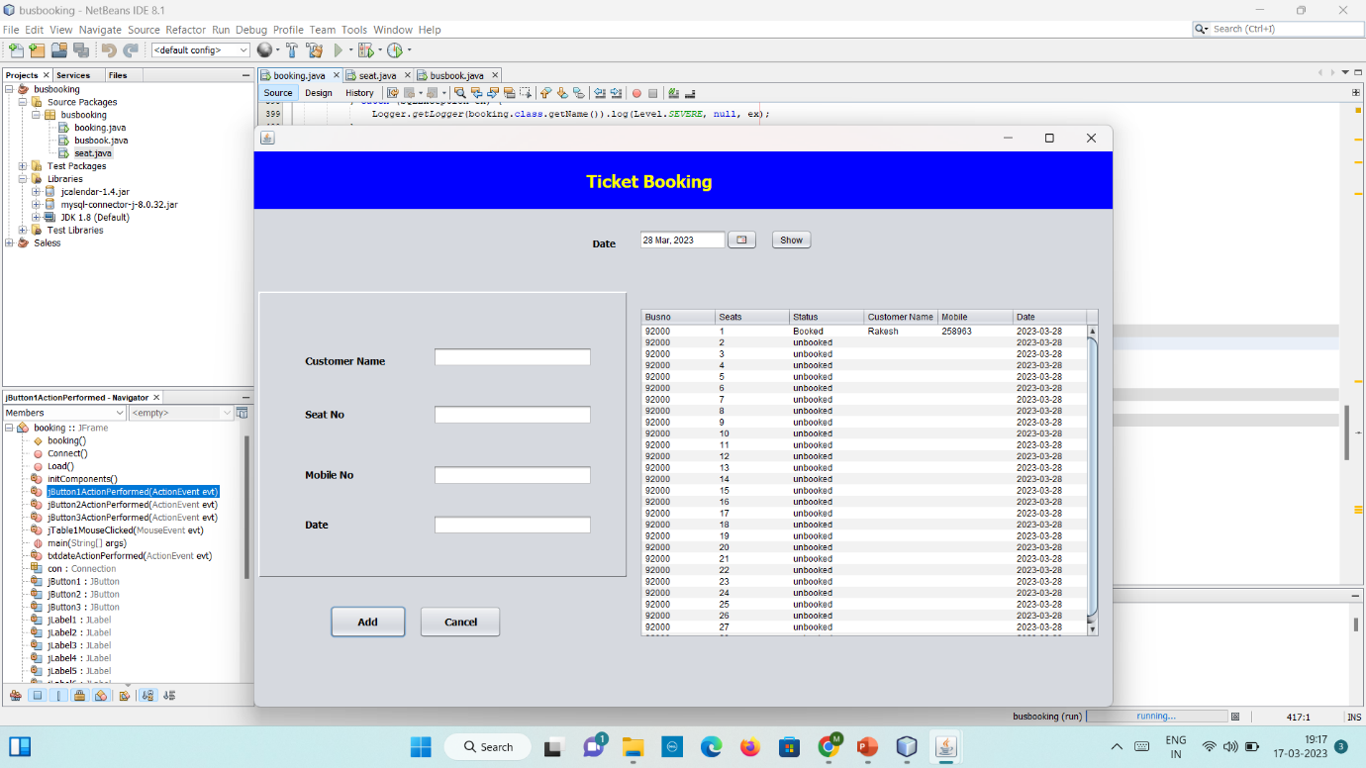

The result is displayed when we booked the seat the status is shown whether seat is booked or not, if seat is booked the status is shown as booked and no other customer can book the same seat.

This is simple project using java and mysql and helps customer to book a seat from home and with the time.

**ADVANTAGES**

* Help in maintain the Booking system and saves time of customer
* Easy to use.
* Flexible
* Increase the efficiency.

**Future Scope**

* Customer can saves time and money and do other work in that time.
* Helps our friends ,family in future.
* As any human don’t have much time so it helps customer to save time.