**S3 bucket issue**

Due to some issues we changed the keys related to S3 storage.

All S3 bucket configurations are configured in “S3StorageManager.java”.

public String secKey = "";

public String accessKey = "";

In order to affect the changes in production we need to build the project and move the war file to the server.

1. We need to configure the s3 keys in “**S3StorageManager.java**”. secKey and accessKey.

S3 Storage will accept any changes related to storage only after moving the new war file configured with new keys.

Here the steps , how to build the war file:

1)After configuring the keys in S3StorageManager

Right click project folder🡪 omics🡪Run as🡪 Maven build🡪 Clean install. Please find the attachments.

1)

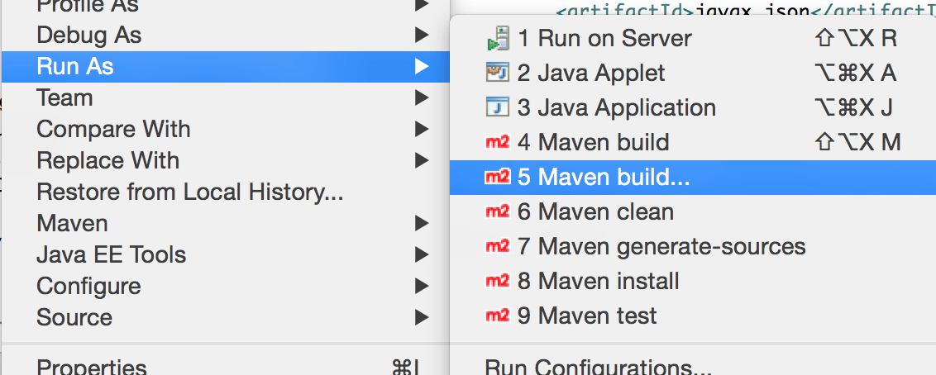

2) 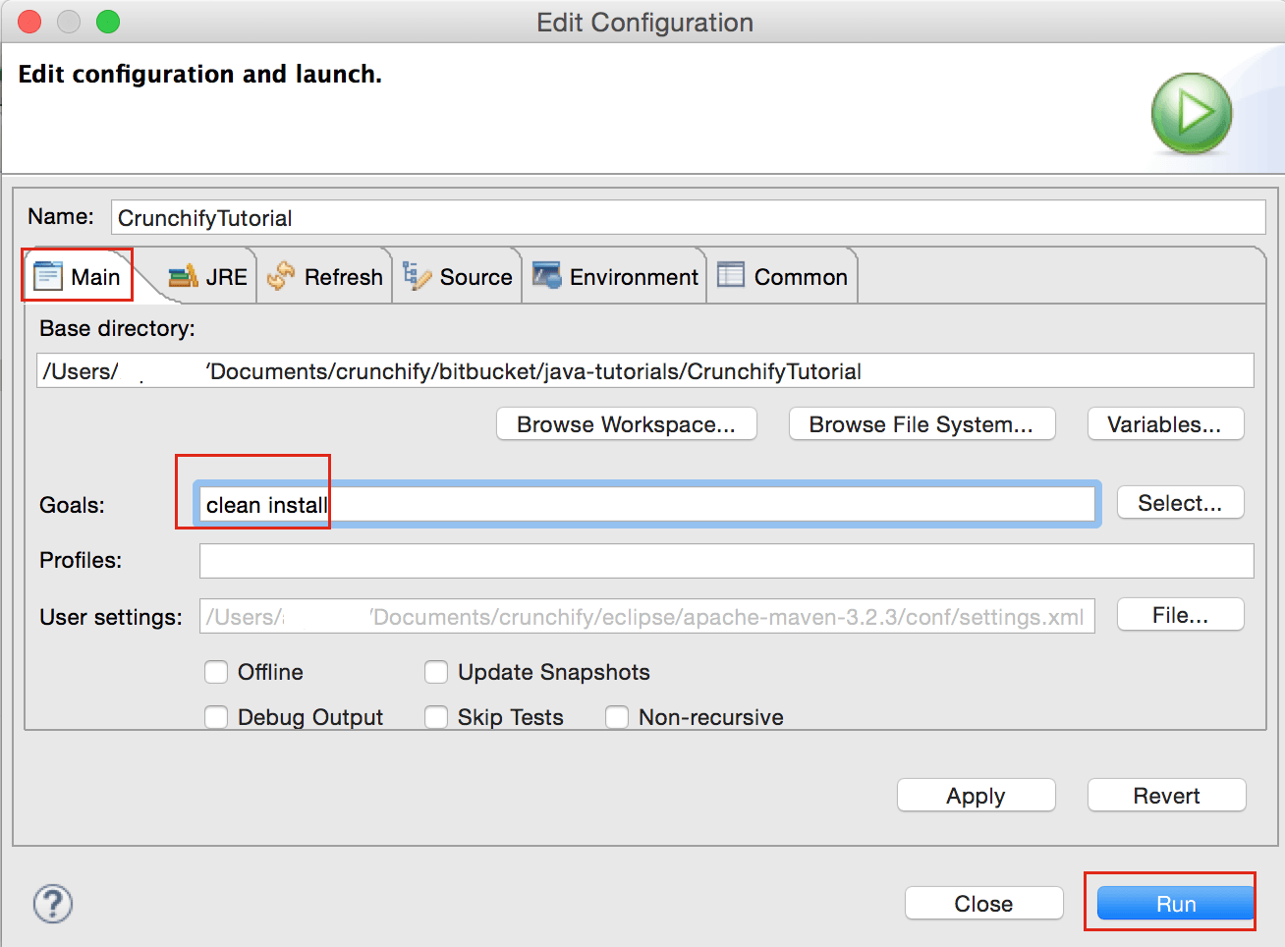

Clean install command will start the entire maven life cycle in order to build the war file.

Finally you will get the log in Console like below.

Building omics 0.0.1-SNAPSHOT

[INFO] ------------------------------------------------------------------------

[INFO] Downloading: http://repo1.maven.org/maven2/org/springframework/boot/spring-boot-maven-plugin/1.3.0.BUILD-SNAPSHOT/maven-metadata.xml

[INFO] Downloading: http://repo.spring.io/snapshot/org/springframework/boot/spring-boot-maven-plugin/1.3.0.BUILD-SNAPSHOT/maven-metadata.xml

[INFO] Downloading: http://repo.spring.io/milestone/org/springframework/boot/spring-boot-maven-plugin/1.3.0.BUILD-SNAPSHOT/maven-metadata.xml

[INFO] Downloaded: http://repo.spring.io/snapshot/org/springframework/boot/spring-boot-maven-plugin/1.3.0.BUILD-SNAPSHOT/maven-metadata.xml (3 KB at 1.6 KB/sec)

[INFO] Downloading: http://repo1.maven.org/maven2/org/springframework/boot/spring-boot-tools/1.3.0.BUILD-SNAPSHOT/maven-metadata.xml

[INFO] Downloading: http://repo.spring.io/snapshot/org/springframework/boot/spring-boot-tools/1.3.0.BUILD-SNAPSHOT/maven-metadata.xml

[INFO] Downloading: http://repo.spring.io/milestone/org/springframework/boot/spring-boot-tools/1.3.0.BUILD-SNAPSHOT/maven-metadata.xml

[INFO] Downloaded: http://repo.spring.io/snapshot/org/springframework/boot/spring-boot-tools/1.3.0.BUILD-SNAPSHOT/maven-metadata.xml (819 B at 0.6 KB/sec)

[INFO] Downloading: http://repo1.maven.org/maven2/org/springframework/boot/spring-boot-parent/1.3.0.BUILD-SNAPSHOT/maven-metadata.xml

[INFO] Downloading: http://repo.spring.io/snapshot/org/springframework/boot/spring-boot-parent/1.3.0.BUILD-SNAPSHOT/maven-metadata.xml

[INFO] Downloading: http://repo.spring.io/milestone/org/springframework/boot/spring-boot-parent/1.3.0.BUILD-SNAPSHOT/maven-metadata.xml

[INFO] Downloaded: http://repo.spring.io/snapshot/org/springframework/boot/spring-boot-parent/1.3.0.BUILD-SNAPSHOT/maven-metadata.xml (820 B at 0.7 KB/sec)

[INFO]

[INFO] --- maven-clean-plugin:2.5:clean (default-clean) @ omics ---

[INFO] Deleting D:\New code\OMICS\target

[INFO] ------------------------------------------------------------------------

[INFO] BUILD SUCCESS

[INFO] ------------------------------------------------------------------------

[INFO] Total time: 35.455 s

[INFO] Finished at: 2019-07-29T17:12:30+05:30

[INFO] Final Memory: 9M/122M

[INFO] ------------------------------------------------------------------------

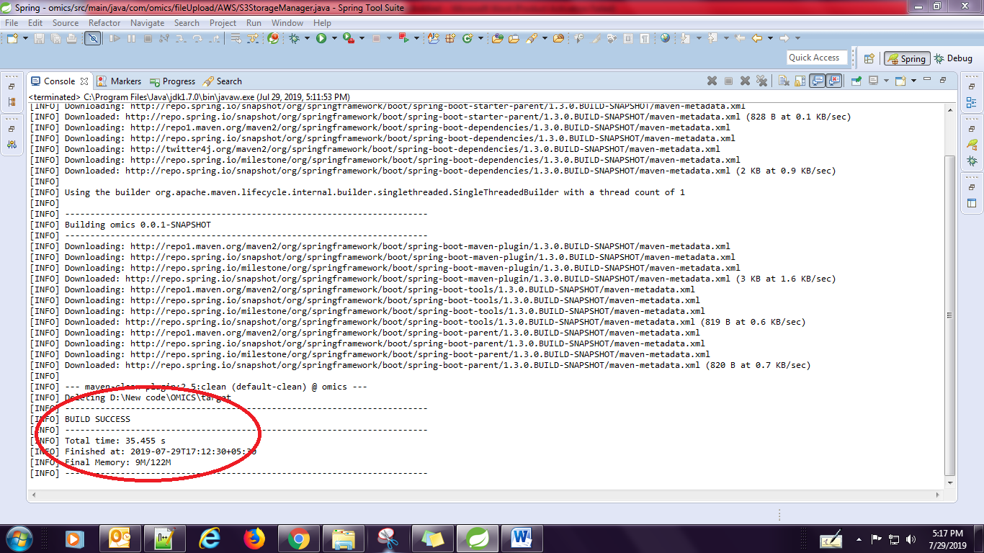

After successfully completion of build process, you need to check the target folder for war file.

Find the “omics-0.0.1-SNAPSHOT.war.” and change the name as “omicso2.war” and move into server.

**Changing the payment gateway keys(Stripe)**

Payment gateway related keys has configured in two files .

1. <https://d1aueex22ha5si.cloudfront.net/resources/js/minified/combined_custom.min.gz.js>
2. **stripe.properties** under resource folder.

We have two keys related to payment gate way

1. secret-key 2) publishable-key

**1)combined_custom.min.gz.js**

Find this.stripePublishableKey = "pk_test_CyVebdLliwVWVt5go0uo50RZ"; in “combined_custom.min.gz.js”. and change the publishablekey as per the requirement and replace the file into particular location.After completion of this process we need to invalidate the file then and only newly updated keys will be updated.

**2)stripe.properties**

Both secret-key and publishable-key need to change in stripe.properties. This file we need to access from server only.

**Info about Solr Server**

Solr is a scalable, ready to deploy, search/storage engine optimized to search large volumes of text-centric data.

The main advantage of Solr server is to search the large volumes of data basing on input.

In our project only some tables data has been indexed on solr server, so that the indexed data only can retrieve basing on requirement.

**Fixed the issue related to solr indexing**

While doing changes in production, solr engine has been restarted. so that all the data indexed on solr engine has been deleted.

We fixed the issue by re indexing the solr engine from base.

For this we need to raise the requests from browser.

**Steps to follow the indexing the data to Solr engine:**

1. <http://alliedacademies.com/Search/copyUsersToSolr?fromid=1&toid=9460>

In this request all the users data has been indexed on Solr engine.

1. <http://alliedacademies.com/Search/copyUniversitiesToSolr?fromid=1&toid=3151>

In this request all the universities data has been indexed on Solr engine.

1. <http://alliedacademies.com/Search/copyCountriesToSolr?fromid=1&toid=253>

In this request all the countries data has been indexed on Solr engine.

1. <http://alliedacademies.com/Search/copyStatesToSolr?fromid=1&toid=798>

In this request all the states data has been indexed on Solr engine.

1. <http://alliedacademies.com/Search/copyCitiesToSolr?fromid=1&toid=764>

In this request all the cities data has been indexed on Solr engine.

1. <http://alliedacademies.com/Search/copySubjectsToSolr?fromid=1&toid=57>

In this request all the subjects data has been indexed on Solr engine.

1. <http://alliedacademies.com/Search/copyKeywordsToSolr?fromid=1&toid=2>

In this request all the search related keywords data has been indexed on Solr engine.

1. <http://alliedacademies.com/Search/ConferenceListingPageToSolr?fromid=1&toid=2>

In this request all the conference title data has been indexed on Solr engine.

**Changing the order of Scientific program pdf’s in Conference pages**

We have one scientific program pdf for one conference . so that in current project we have used Hashmap to store the years as keys and url of scientific program pdf as values.

While displaying the scientific programme pdf’s related to conference, it won’t follow the particular order.

Note: HashMap doesn’t follow the insertion order. Due to this there is no particular order in displaying the scientific program pdf’s.

Then we used TreeMap class to provide the particular order for displaying the scientific program pdf’s.

For this we need to do the changes in “**ConferenceHandler.java**”

Map<Long,String> previousConfIdPDFPathMap=new TreeMap<Long, String>();

Map<Integer,String> output=new TreeMap<Integer, String>();

After this modification we need to build the project and move the war tile to the server.

Then this changes will be affected.

**Fixed the issuer related to Solr(No Space Left On Device)**

One EC2 instance is created for Solr engine and some space is attached to the instance.

While production whatever the space allotted to solr engine has filled and no space left on device. So it unable to take no more requests from application.

In order to fix the issue we need to attach one more volume to the solr instance. And once attach the volume we need to existing file system on to the attached volume. Then and only the attached space is available for usage.

Please check the image for more information for this issue.

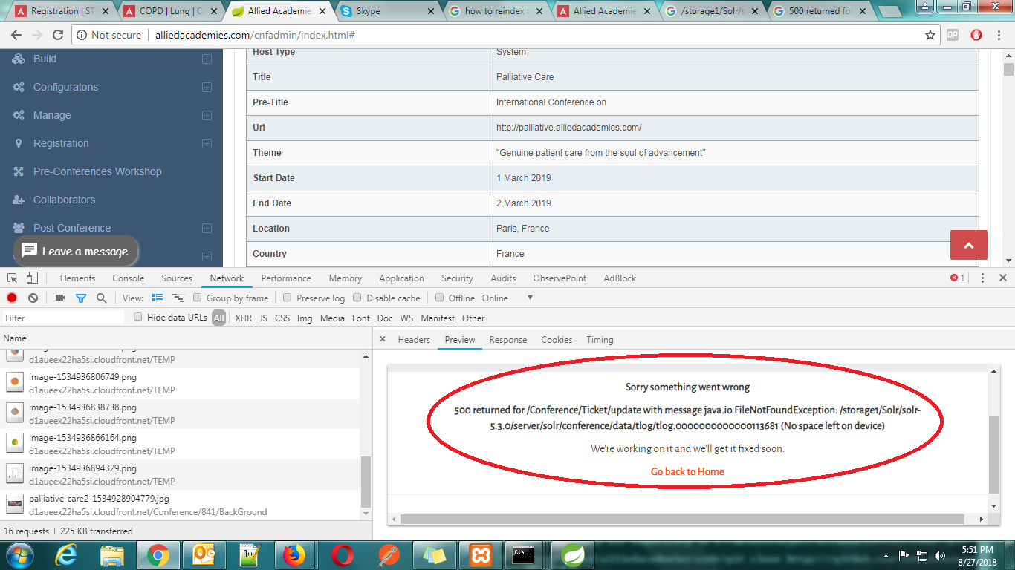

**Attaching an Amazon EBS Volume to an Instance:**

Please refer the below link:

<https://docs.aws.amazon.com/AWSEC2/latest/UserGuide/ebs-attaching-volume.html>

**Extending a Linux File System After Resizing a Volume**

Please refer the below link:

<https://docs.aws.amazon.com/AWSEC2/latest/UserGuide/recognize-expanded-volume-linux.html>

**Changes Done in conference Pages**

1. Added the Global footer in allied home page.
2. Enabled the conference background images.