Ossie Semantic Model Builder — Design, Capabilities & Usage Guide
Audience: Data platform, analytics engineering, BI, and AI/text-to-SQL stakeholders
Product: Apache Ossie (Open Semantic Interchange) Semantic Model Builder
Primary UI: Streamlit web app
Spec: [Apache Ossie core-spec](https://github.com/apache/ossie/tree/main/core-spec) (`0.2.0.dev0`)
**How to publish this page to Confluence**
1. Create a blank Confluence page.
2. Attach all files from `docs/images/` (or drag them into the page).
3. Paste this Markdown into Confluence using the **Markdown** macro, **or** import the Word file `docs/Ossie_Semantic_Model_Builder_Design_and_Capabilities.docx`.
4. After paste/import, re-link images if needed (Confluence may rename attachments).
See also: `docs/HOW_TO_PUBLISH_TO_CONFLUENCE.md`.
---

1. Executive summary
The Ossie Semantic Model Builder turns catalog-exported spreadsheets into a validated Apache Ossie semantic model YAML, then optionally:
- Enriches it with AI context and approved SQL (SPOKE)
- Derives an **ontology** layer from FACT/DIM tables
- Converts **bidirectionally** to/from **Power BI** using the official Apache **`ossie_microsoft`** converter (TMSL `model.bim` / `.pbip`)
Business benefit: one governed semantic definition that can feed BI (Power BI / Fabric) and AI/text-to-SQL consumers without hand-building models twice.
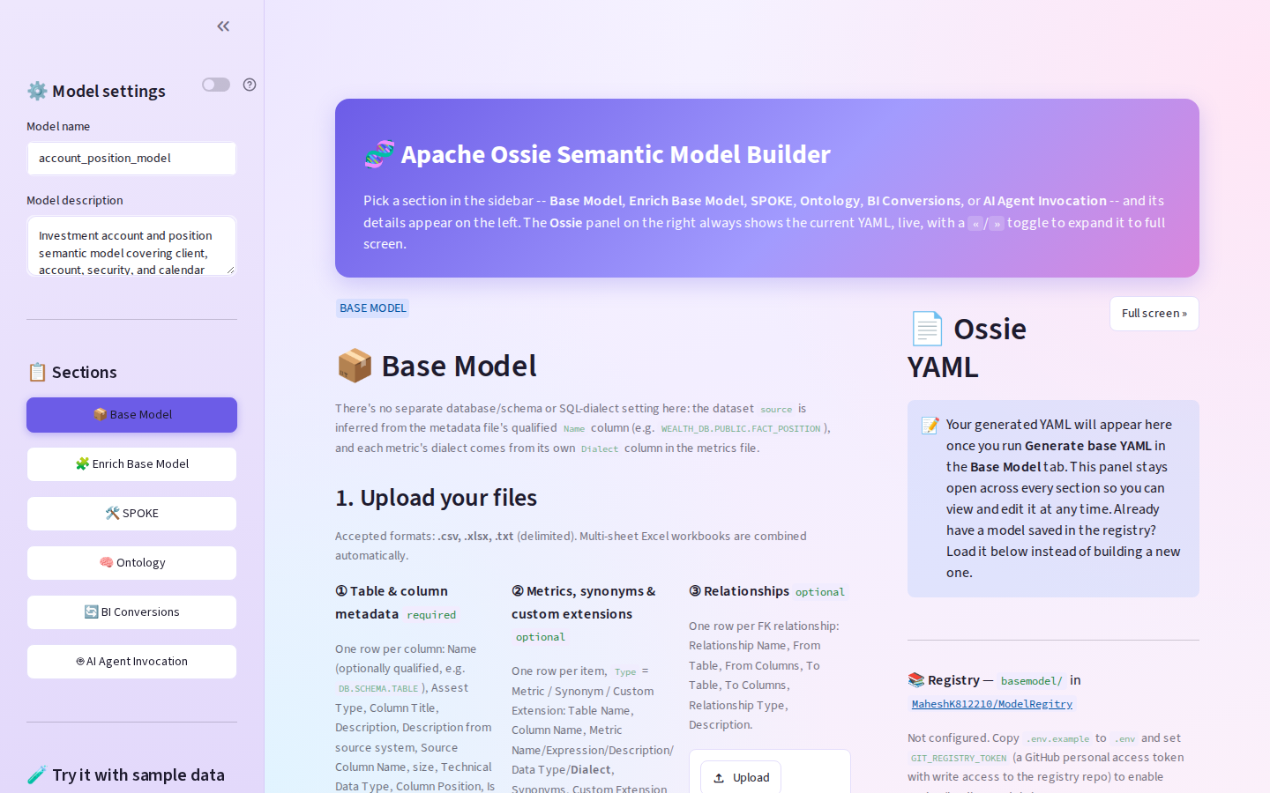
Figure 1 — Application home: sidebar sections, Base Model upload area, Ossie YAML panel.
---

2. Problem & benefits

Pain points addressed
Pain | Without this tool | With this tool
Semantic models live only in Power BI | Hard to reuse for AI / SQL agents | Ossie YAML is the portable source of truth
Catalog → BI is manual | Weeks of Tabular modeling | CSV → validated Ossie → TMSL in minutes
Metrics drift across tools | Different DAX vs SQL definitions | Metrics captured once; converter translates where safe
Public-repo import blocked | Cannot pull Apache packages live | Converter **vendored** under `vendor/apache-ossie-microsoft`
Round-trip from Fabric/PBI | Rebuild Ossie by hand | Upload `model.bim` → Ossie panel

Key benefits
- **Single semantic layer** — datasets, fields, relationships, metrics, AI context in one YAML.
- **Official Microsoft path** — uses Apache `ossie_microsoft` for Ossie ↔ Power BI (not a one-off hack).
- **Org-friendly packaging** — no need to import the public `apache/ossie` repo; source is committed locally.
- **Snowflake-aware export** — optional post-process to `Snowflake.Databases(...)` M partitions.
- **Validation** — JSON Schema validation against bundled Ossie schemas.
- **Demoable end-to-end** — sample Account/Position model with one click.
---

3. Architecture & design
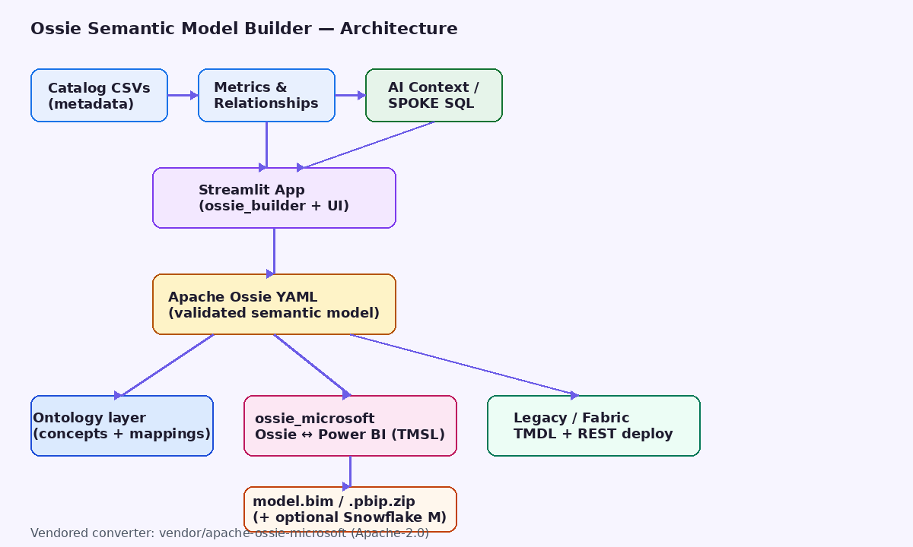
Figure 2 — High-level architecture: catalog inputs → Streamlit builder → Ossie YAML → Ontology / Power BI / Fabric paths.

Design principles
- **Ossie-first** — the app’s native document is `{"semantic_model":[...]}`; BI formats are exports/imports.
- **Additive enrichment** — Enrich / SPOKE append context; they do not wipe the base model.
- **Official converter for interchange** — `ossie_microsoft` owns SQL→DAX safety rules and POWER_BI stash round-trip.
- **Legacy path retained** — in-repo `powerbi_export.py` + `fabric_deploy.py` for TMDL + Fabric REST when needed.
- **No secrets in exports** — Snowflake account/warehouse only; Power BI prompts for credentials on refresh.

Major components
Component | Role
`app.py` | Streamlit UI (sections, YAML panel, registry)
`ossie_builder.py` | CSV/XLSX → Ossie model, merge, validate
`ontology_builder.py` | Semantic model → Ossie ontology + mappings
`llm_gateway.py` | SPOKE: SQL → instruction JSON via LLM gateway
`ossie_microsoft_bridge.py` | Unwrap/wrap app models; call official converter; PBIP zip; Snowflake M
`vendor/apache-ossie-microsoft/` | Official Apache converter (Apache-2.0)
`powerbi_export.py` | Legacy TMSL/TMDL export + metric preview
`fabric_deploy.py` | Legacy Fabric REST deploy (TMDL)
`git_registry.py` | Optional GitHub Contents API save/load

Document shapes (important)
- **This app** stores: `{"semantic_model": [ { name, datasets, relationships, metrics, ... } ]}`
- **`ossie_microsoft`** expects a **flat** Ossie document: `{ version, name, datasets, ... }`
- The bridge **unwraps** on export and **wraps** on import so the UI stays consistent.
---

4. Capabilities by section

4.1 Base Model
Upload catalog extracts → generate validated Ossie YAML.
- Table & column metadata (**required**)
- Metrics, synonyms & custom extensions (optional)
- Relationships (optional)
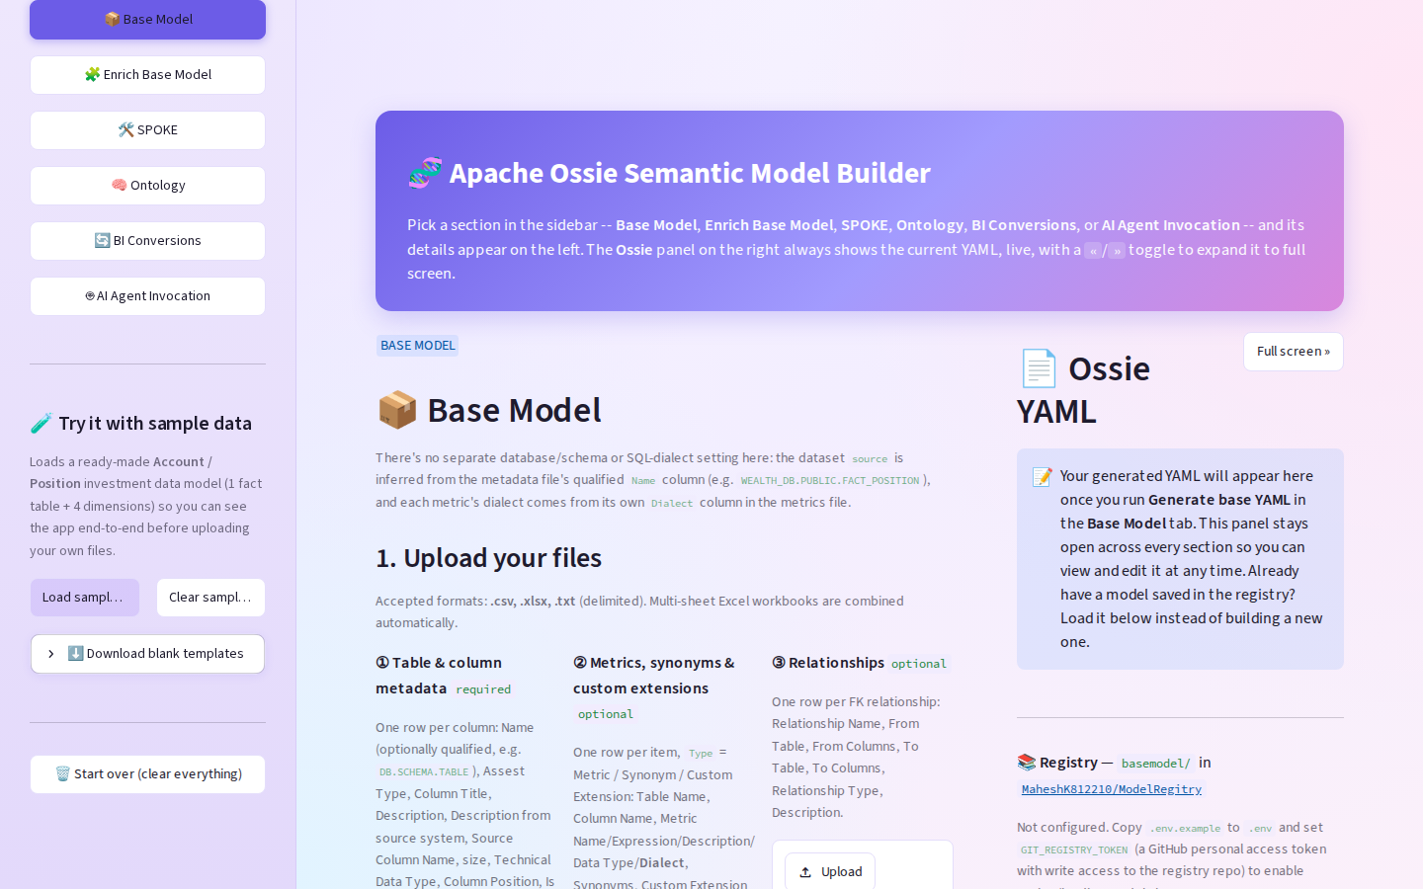
Figure 3 — Sample Account/Position metadata loaded; tree selection of tables/columns.
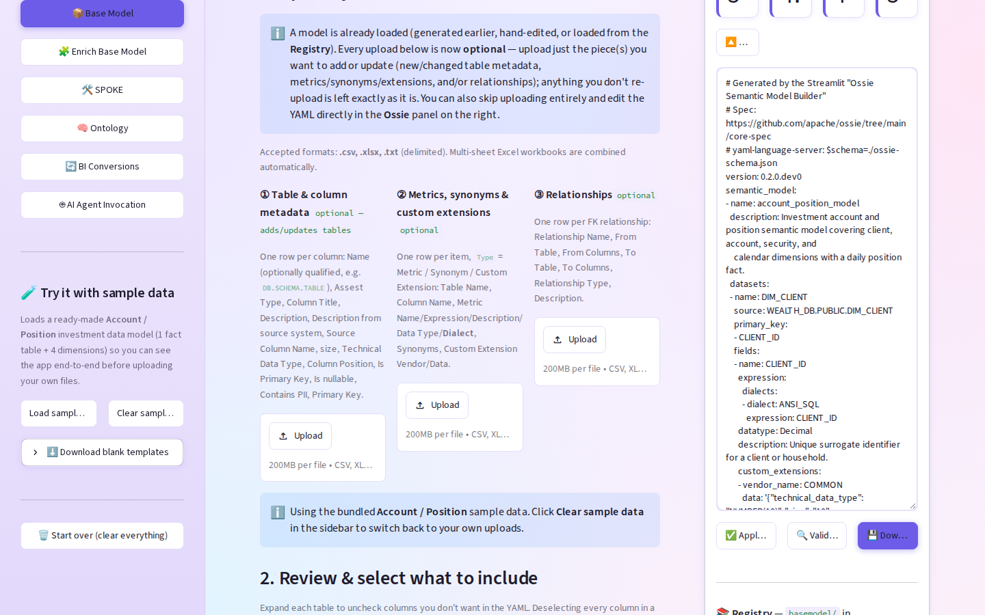
Figure 4 — After **Generate base YAML**: live Ossie panel with datasets, fields, relationships, metrics.
Capabilities
- Infers dataset `source` from qualified `Name` (e.g. `WEALTH_DB.PUBLIC.FACT_POSITION`)
- Maps technical types → Ossie datatypes
- Supports **Source Column Name** vs logical **Column Title** for Power BI `sourceColumn`
- On-demand **Validate YAML** against `schema/ossie-schema.json`
- Editable YAML + **Apply edits**

4.2 Enrich Base Model
Layer AI/business context without overwriting the base.
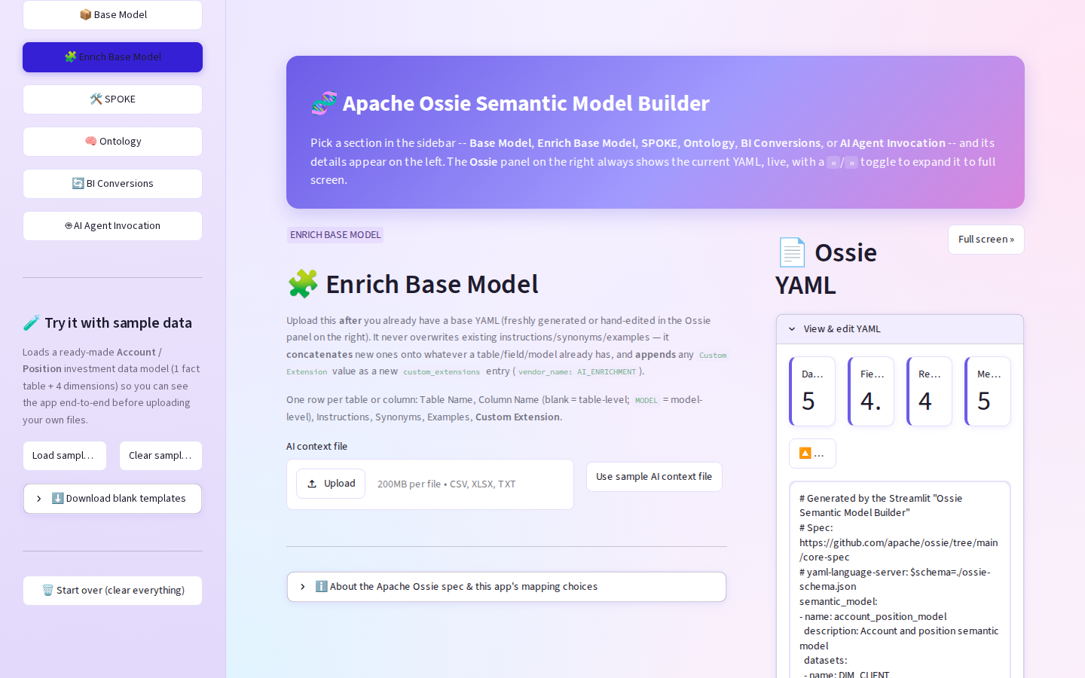
Figure 5 — Enrich Base Model: upload AI context CSV to append instructions, synonyms, examples.

4.3 SPOKE
Attach approved `.sql` → LLM Gateway → model-level `custom_extensions` (`vendor_name: SPOKE`).
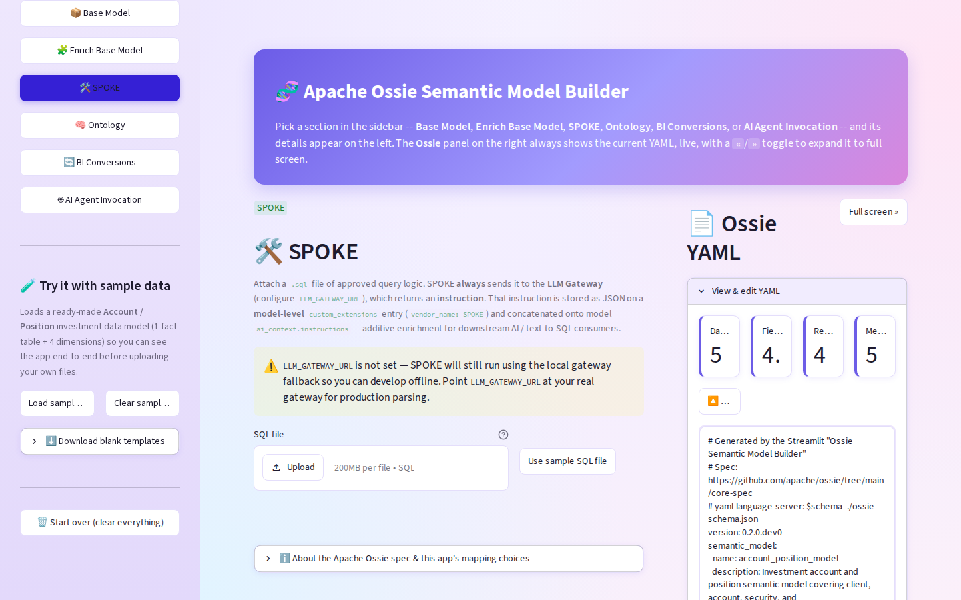
Figure 6 — SPOKE section: SQL attachment and enrichment into the semantic model for downstream AI.

4.4 Ontology
Derive conceptual EntityType / ValueType ontology + mappings from FACT/DIM semantic model.
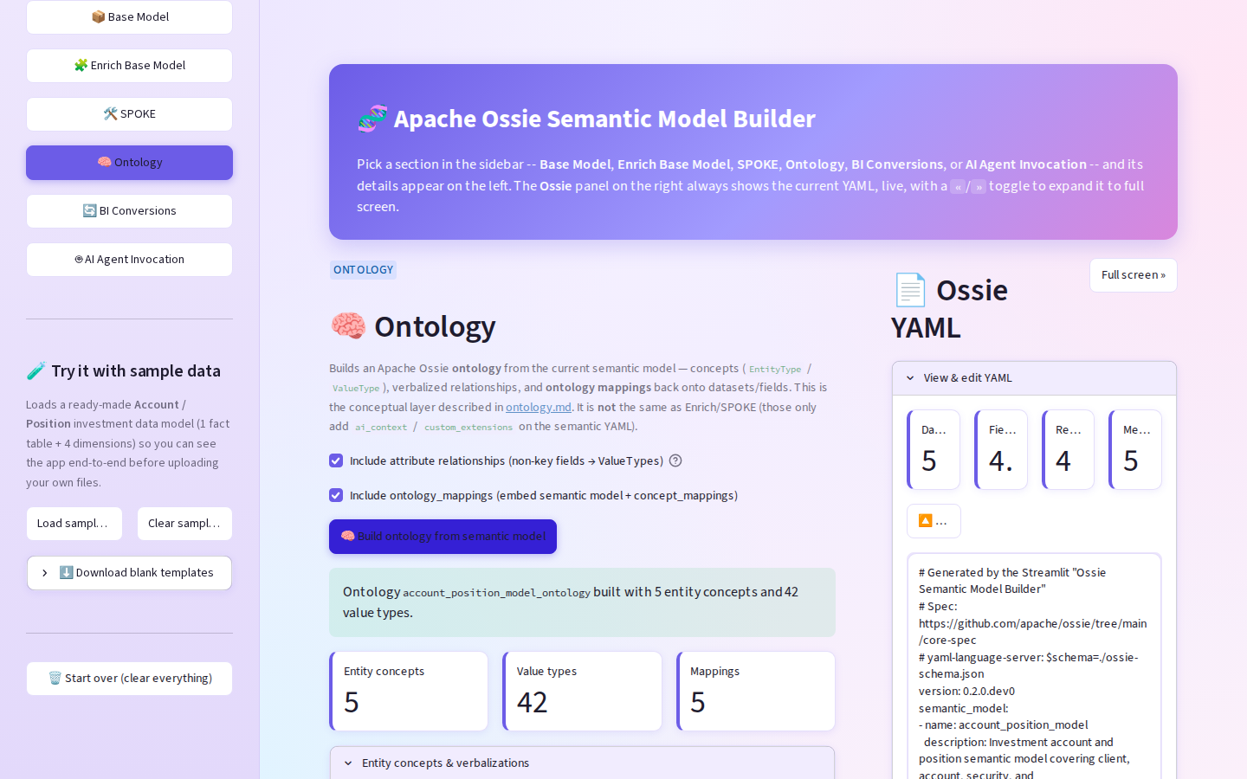
Figure 7 — Ontology section: conceptual layer alongside (not replacing) the semantic YAML.

4.5 BI Conversions (Ossie ↔ Power BI)
Bidirectional conversion via official `ossie_microsoft`.
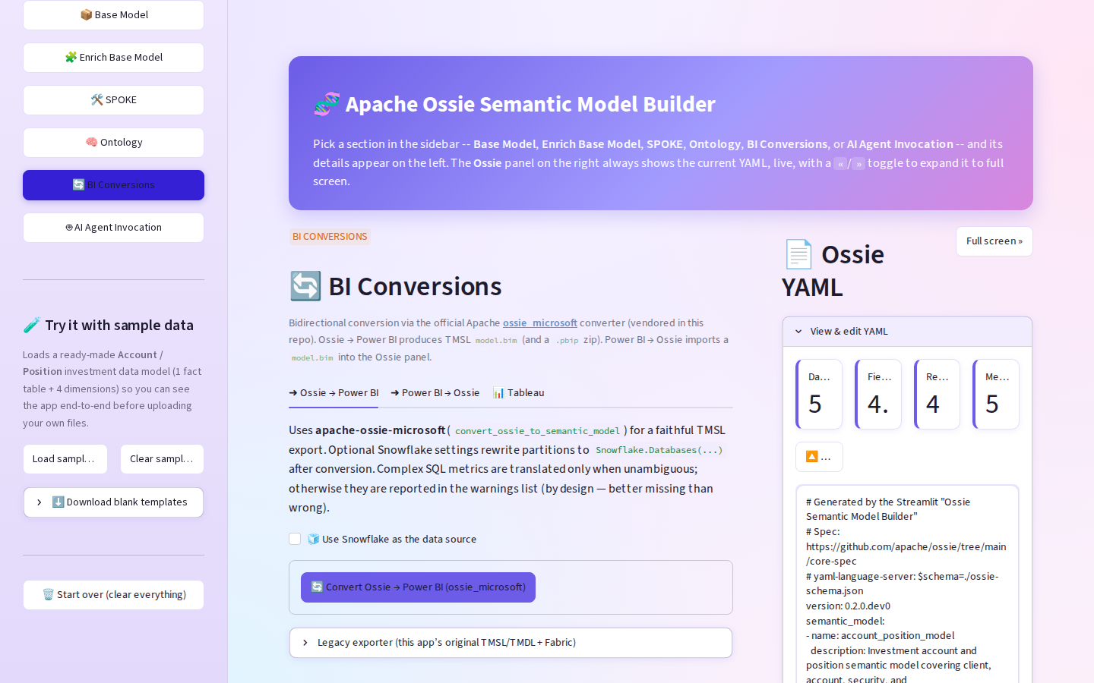
Figure 8 — BI Conversions entry: Ossie → Power BI, Power BI → Ossie, Tableau (placeholder).

Ossie → Power BI
- Calls `convert_ossie_to_semantic_model`
- Downloads **`model.bim` (TMSL)** and **`.pbip.zip`**
- Optional Snowflake partition rewrite
- Shows converter warnings (by design: skip ambiguous SQL rather than emit wrong DAX)
- Legacy exporter (TMDL / Fabric / synthetic metrics) remains in an expander
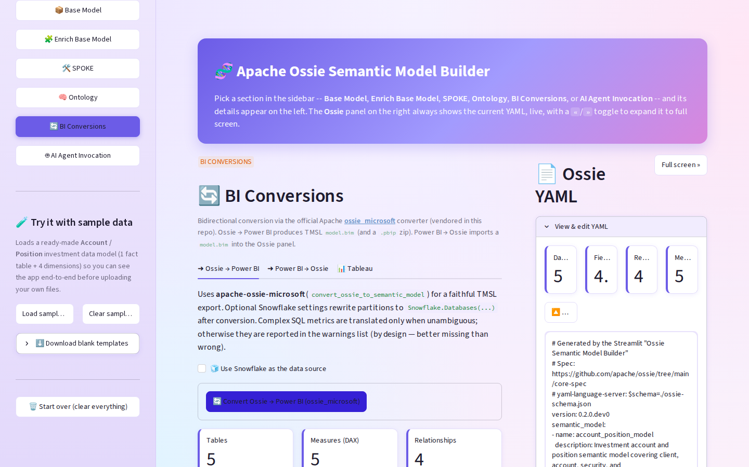
Figure 9 — Successful Ossie → Power BI: tables / measures / relationships + downloads.

Power BI → Ossie
- Upload Fabric / Desktop **`model.bim`**
- Calls `convert_semantic_model_to_ossie`
- Loads wrapped model into the Ossie panel
- Power BI–only constructs preserved in `custom_extensions` (`POWER_BI`) when possible
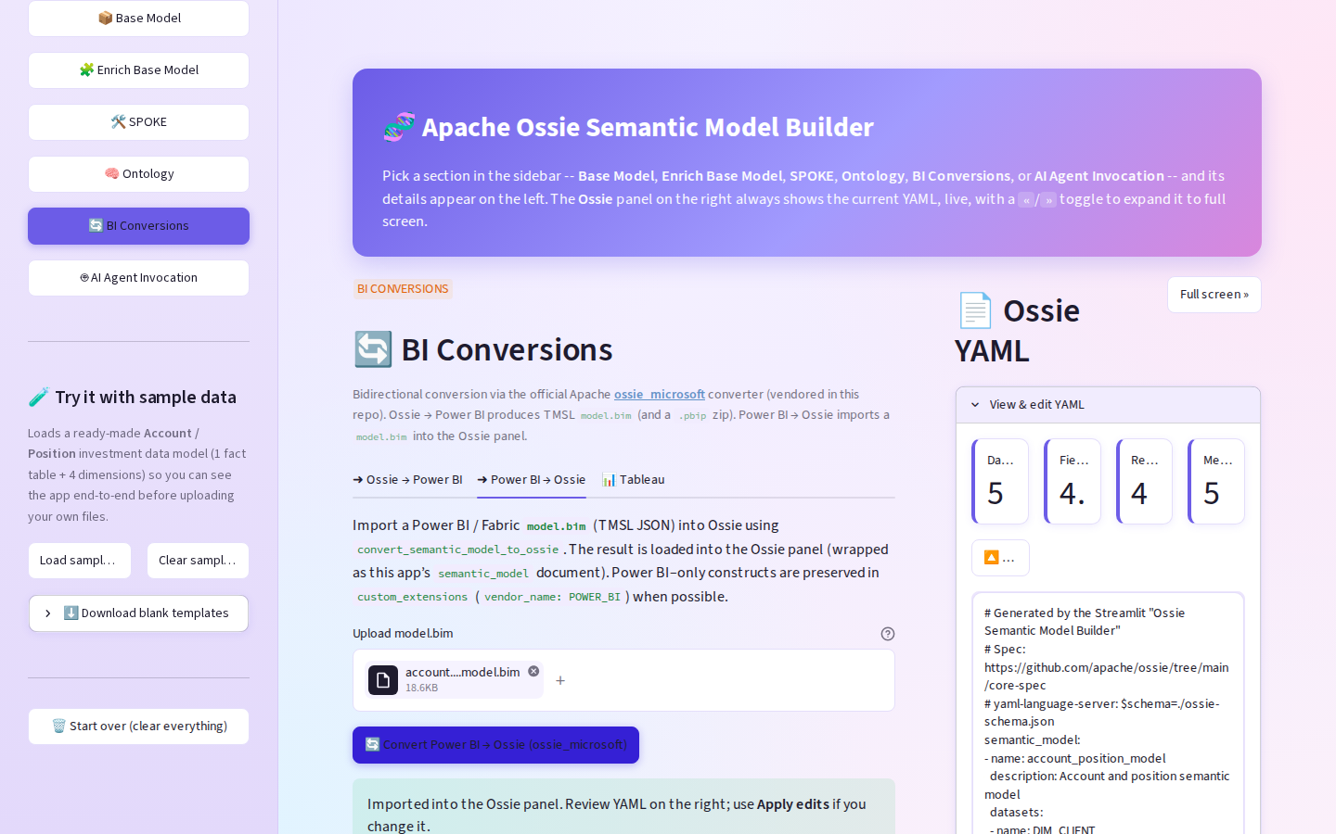
Figure 10 — Power BI → Ossie import success and YAML reload.

4.6 Fabric deployment (current state)
Path | Format | Fabric REST in UI?
Official `ossie_microsoft` | TMSL (`model.bim`) | Not wired in UI yet (engine exists in vendor package)
Legacy expander | TMDL via `fabric_deploy.py` | Yes — workspace ID + bearer token
Note: Fabric accepts both TMSL and TMDL. TMDL is preferred for git-oriented projects; TMSL remains the interchange/API format used by the official converter.

4.7 AI Agent Invocation
Placeholder for future NL Q&A against the current Ossie model.
---

5. TMSL vs TMDL (for stakeholders)
 | **TMSL** | **TMDL**
What | JSON (`model.bim`) | Folder of `.tmdl` text files
Age | Established Tabular scripting format | Newer project/source format
Best for | Converters, APIs, Tabular Editor, round-trip | Fabric/Power BI Project git workflows
This app’s official path | **Yes (primary)** | Legacy / Fabric deploy path
Why this tool uses TMSL for Ossie ↔ Power BI: the official Apache `ossie_microsoft` converter’s public API is TMSL in / TMSL out. That is the correct interchange choice; TMDL remains available for Fabric-oriented legacy packaging.
---

6. End-to-end usage (happy path)
- Start app: `pip install -r requirements.txt && streamlit run app.py` → `http://localhost:47531`
- Sidebar → **Load sample data** (or upload your catalog CSVs)
- **Generate base YAML** → review Ossie panel → **Validate YAML**
- Optional: Enrich / SPOKE / Ontology
- **BI Conversions** → **Convert Ossie → Power BI** → download `model.bim` or `.pbip.zip`
- Open in Power BI Desktop (*File → Open → Power BI Project*) or Tabular Editor
- Optional reverse: upload `model.bim` → **Convert Power BI → Ossie**

Snowflake refresh path
- Check **Use Snowflake as the data source**
- Enter Account URL + Warehouse (+ optional Role)
- Convert — partitions become `Snowflake.Databases(...)` M
- Credentials are **not** stored; Power BI prompts on first refresh
---

7. Inputs & outputs

Inputs (sample templates under `sample_data/`)
File | Purpose
`01_table_column_metadata.csv` | Tables/columns (required)
`02_metrics_synonyms_extensions.csv` | Metrics, synonyms, extensions
`03_relationships.csv` | FK relationships
`04_ai_context.csv` | Enrichment
`05_spoke_*.sql` | SPOKE SQL
`06_*_ontology.yaml` | Sample ontology

Outputs
Artifact | Producer
Ossie semantic YAML | Base / Enrich / SPOKE / import
Ontology YAML | Ontology section
`model.bim` (TMSL) | Official converter
`.pbip.zip` | Bridge packaging
TMDL + Fabric deploy | Legacy path
---

8. Security & governance notes
- Uploaded files stay in-session memory (Streamlit process); not uploaded to third parties by default.
- LLM Gateway / Git registry tokens via `.env` (see `.env.example`) — never baked into exports.
- Converter warnings should be reviewed before production deploy (unsupported extensions, ambiguous metrics).
- Vendored Apache software retains `LICENSE` / `NOTICE` under `vendor/apache-ossie-microsoft/`.
---

9. Limitations (honest)
- Tableau export is not implemented.
- Official UI path does not yet expose Fabric REST deploy (legacy expander does).
- Composite keys reduce to Tabular single-column relationships where needed.
- SQL→DAX only when unambiguous; complex SQL may appear as warnings rather than measures.
- Blank `.pbip` report scaffold is best-effort; `model.bim` alone remains usable via Tabular Editor.
---

10. Runbook
git checkout cursor/ossie-yaml-streamlit-app-7d77
pip install -r requirements.txt
streamlit run app.py
# opens http://localhost:47531 (see .streamlit/config.toml)
pytest # optional
Editable install of the official converter is included via:
-e ./vendor/apache-ossie-microsoft
in `requirements.txt`.
---

11. Related links
- Apache Ossie core spec: https://github.com/apache/ossie/tree/main/core-spec
- Official Microsoft converter: https://github.com/apache/ossie/tree/main/converters/microsoft
- Fabric semantic model REST API: https://learn.microsoft.com/en-us/rest/api/fabric/semanticmodel/items/create-semantic-model
- Project README: repository root `README.md`
---
*Document version: 1.0 — generated for Confluence / stakeholder review.*

