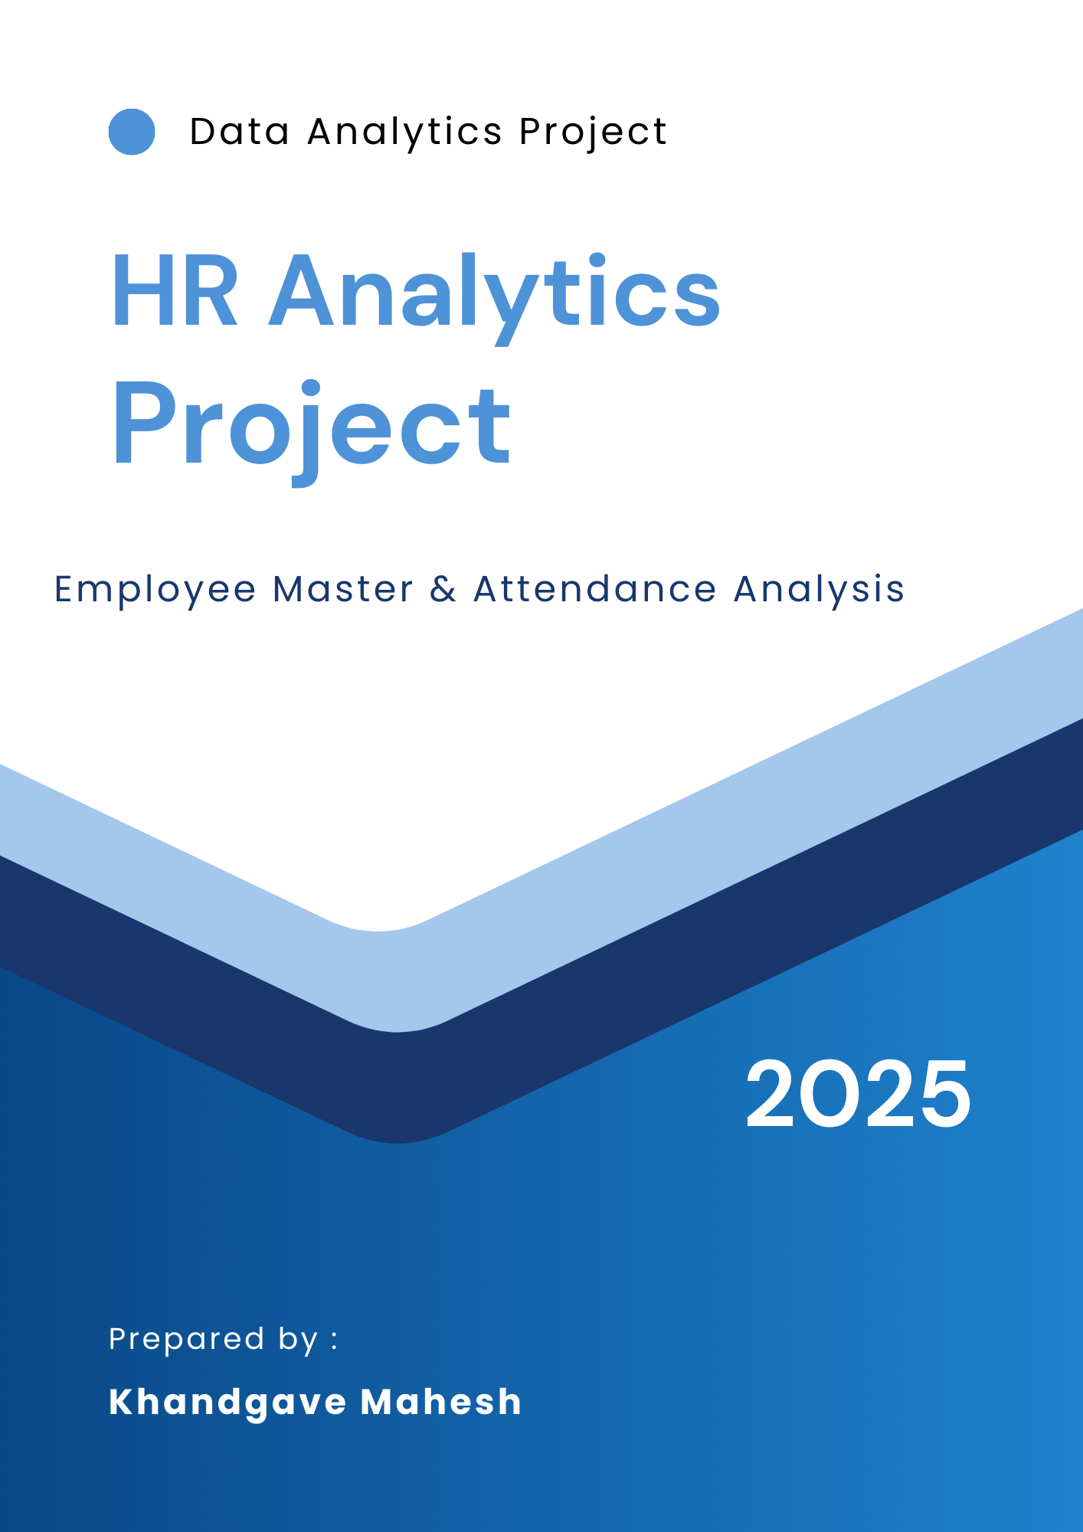
Index
1.Introduction 3
2.Objective of the Project 4
3. Dataset Description 5
4. Tools Used in This Project 6
5. Dashboard Explanation 8
6. SQL Query Explanation 11
7. Insights & Findings 12
8. Conclusion 13

1.Introduction

This project focuses on HR Analytics using Excel, Power BI, Tableau, and SQL.
The goal is to understand employee attrition, job satisfaction, salary trends, departmental performance, and work-life balance.
Dashboards were created in Excel, Tableau, and Power BI, and SQL was used to fetch employee insights from the HR database.

2.Objective of the Project

- Identify factors influencing employee attrition

- Understand salary distribution across departments

- Analyze work-life balance and its impact

- Compare job roles and performance patterns

- Provide insights to improve employee retention

3. Dataset Description
The dataset contains HR records including:

- Employee ID
- Age
- Gender
- Department
- Monthly Income
- Job Role
- Attrition Status
- Distance from Home
- Work-Life Balance
- Performance Rating
- Years at Company
- Education Level
- Overtime
- Environment Satisfaction

4. Tools Used in This Project

Excel
Excel was used for:
- Data cleaning
- Pivot tables
- KPI dashboards
- Trend charts

Power BI
Power BI was used for:

- DAX formulas
- KPI indicators
- Interactive slicers
- Dynamic analysis

Tableau
Tableau was used for:
- Interactive visualizations
- Trend comparison
- HR behaviour patterns

SQL
SQL was used for:
- Created database and tables.
- Inserted cleaned data.
- Run queries to extract insights such as:
- Total number of employees
- Department-wise employee count
- Employees with highest salaries
- Attrition analysis
- Experience and age-based segmentation

5. Dashboard Explanation
5.1 Excel Dashboard
- Shows employee distribution
- Gender and age segmentation
- Total employees, attrition, salary KPIs
- Clean and professional KPI visual layout
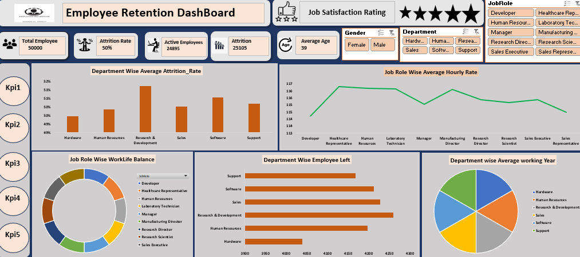
5.2 Power BI Dashboard
- Dynamic charts for attrition
- Overtime vs salary
- Job role performance
- KPI cards for workforce metrics
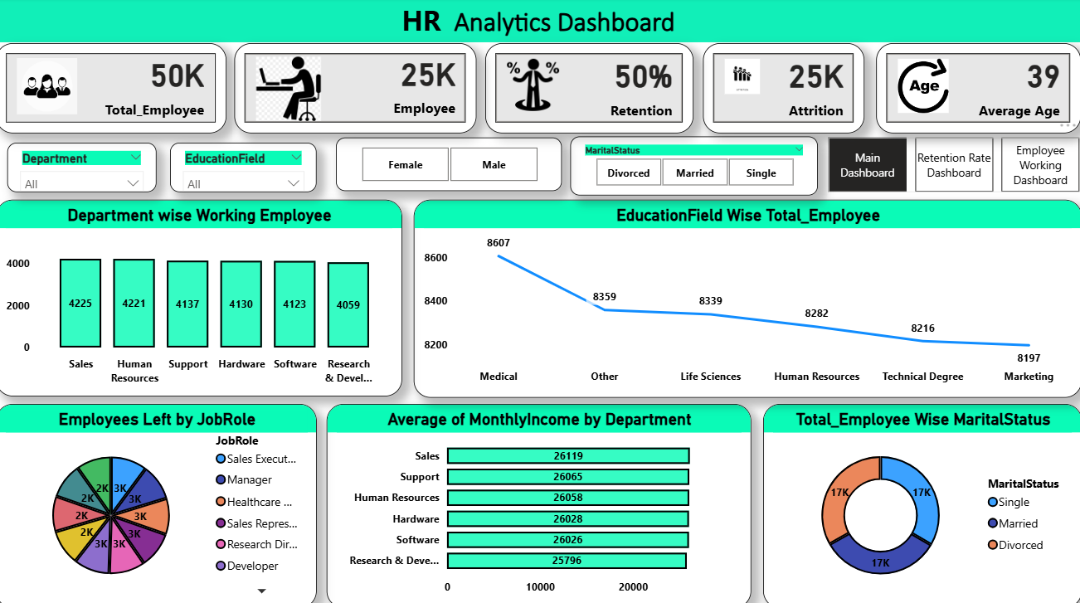
5.3 Tableau Dashboard
- Department-wise Attrition
- Salary vs Age Relationship
- Job Role Comparison
- Attrition by Gender
- Work-Life Balance Ratings
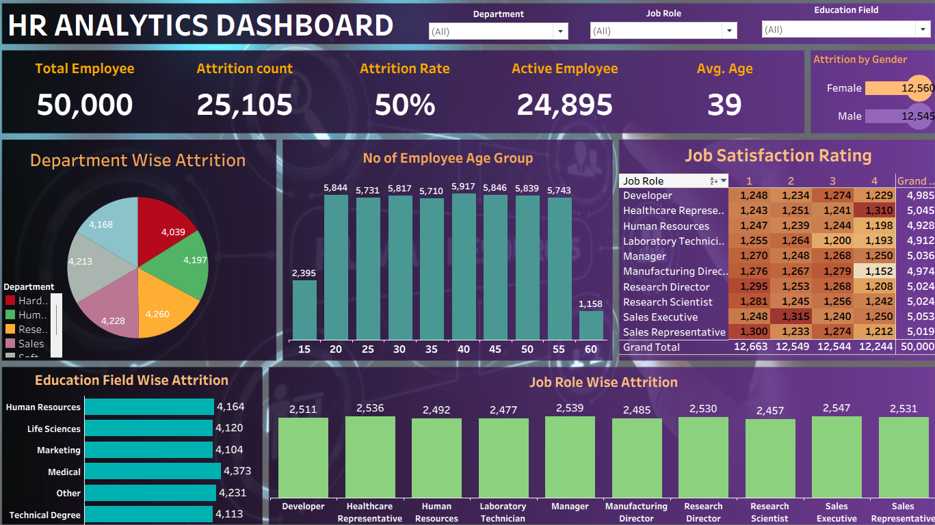

6. SQL Query Explanation
Query 1: Total Employees
SELECT COUNT(*) AS total_employees
FROM hr_1;
This query returns the total number of employees in the HR dataset.

Query 2: Employees Working (Non-Attrition)
SELECT COUNT(Attrition) AS employees_working
FROM hr_1
WHERE Attrition = 'No';
This query shows how many employees are currently working in the company.

Query 3: Attrition Count
SELECT COUNT(Attrition) AS attrition
FROM hr_1
WHERE Attrition = 'Yes';
This query gives the total number of employees who have left the company.

7. Insights & Findings

Based on dashboard and SQL analysis, the major insights are:

- Departments with the highest employee count.
- Gender diversity ratio.
- Major contributors to employee attrition.
- Salary distribution patterns.
- Education and experience trends.
- Age group concentration
- Employees with OverTime have a significantly higher attrition rate.
- Middle-aged employees (25–35) leave more frequently.
- Sales and Research departments show the highest attrition.
- Employees with low work-life balance are more likely to quit.
- Low salary ranges show higher attrition compared to higher salary groups.
- Job roles like Laboratory Technician, Sales Executive, and Human Resources show higher employee turnover.

8. Conclusion

This HR Analytics project provided comprehensive insights using Excel, Power BI, SQL, and Tableau. The dashboards and analysis help in understanding the workforce distribution, attrition behavior, and performance trends, useful for HR planning and decision-making.

