Machine Learning Operations (MLOps) - AIMLCZG523
Assignment 01
End-to-End ML Model Development, CI/CD and Production Deployment
Heart Disease Risk Prediction (UCI Heart Disease Dataset)

Student ID | 2025af05162
Email | 2025af05162@wilp.bits-pilani.ac.in
GitHub repository | https://github.com/MaheshKrishnaNaik/mlops-assignment1
Deployed API | Local Kubernetes (Minikube) - access instructions in Section 8

1. Introduction and Architecture
The goal of this assignment is to build a classifier that predicts the presence of heart disease from patient health data, and to ship it the way a production ML service is shipped: reproducible training, tracked experiments, automated tests and CI, a containerised API, a Kubernetes deployment and basic monitoring. Every stage is automated by a script in the repository so that the whole flow can be re-run from a clean checkout using only requirements.txt.

1.1 Architecture
UCI data --> src/data.py (clean) --> src/train.py (LogReg + RandomForest, GridSearchCV, 5-fold CV)
--> MLflow tracking (params, metrics, plots, models)
--> models/model.joblib (one sklearn Pipeline: preprocessing + estimator)
--> FastAPI service (/predict, /health, /metrics) --> Docker image
--> Kubernetes Deployment + LoadBalancer Service (Minikube)
--> Prometheus scrapes /metrics --> Grafana dashboard
GitHub Actions: flake8 -> pytest -> data -> train -> upload artifacts -> docker build + smoke test

1.2 Repository layout
Path | Purpose
src/ | data.py (download/clean), features.py (pipeline), train.py (training + MLflow), app.py (API)
tests/ | pytest unit tests for data cleaning, model pipeline and API
notebooks/ | eda.py (EDA), inference.py (load model and predict)
data/ | raw and cleaned dataset
models/ | model.joblib and metrics.json
k8s/, monitoring/ | Deployment/Service/Ingress manifests; Prometheus + Grafana compose file
.github/workflows/ci.yml | CI pipeline
screenshots/ | EDA plots and run evidence used in this report

2. Setup and Installation
git clone https://github.com/MaheshKrishnaNaik/mlops-assignment1.git
cd mlops-assignment1
python3 -m venv .venv && source .venv/bin/activate
pip install -r requirements.txt
python -m src.data # download + clean data
PYTHONPATH=. python notebooks/eda.py
python -m src.train # train, track, save model
pytest -v && flake8 src tests
mlflow ui # http://127.0.0.1:5000
The dataset is fetched by src/data.py from the UCI repository (https://archive.ics.uci.edu/static/public/45/data.csv), so no manual download is required. The raw and cleaned CSV files are also committed for convenience. All dependencies are listed in requirements.txt with version ranges; Python 3.12 was used.

3. Data Acquisition and Exploratory Data Analysis

3.1 Dataset
The Heart Disease UCI dataset (Cleveland subset) has 303 patients and 13 predictors: age, sex, chest pain type (cp), resting blood pressure (trestbps), cholesterol (chol), fasting blood sugar (fbs), resting ECG (restecg), maximum heart rate (thalach), exercise-induced angina (exang), ST depression (oldpeak), slope of the ST segment (slope), number of major vessels coloured by fluoroscopy (ca) and thalassemia (thal). The original target 'num' ranges from 0 to 4; following the assignment it is binarised so that any value greater than 0 means heart disease is present.

3.2 Cleaning
- Missing values appear only in 'ca' (4 rows) and 'thal' (2 rows). Both are categorical codes, so they are imputed with the column mode. Numeric columns would use the median.
- No duplicate rows were found in the raw data; the cleaning function still drops duplicates.
- All columns are coerced to numeric so that '?' placeholders become NaN before imputation.
- Categorical columns (sex, cp, fbs, restecg, exang, slope, ca, thal) are kept as integer codes in the cleaned file and one-hot encoded inside the modelling pipeline, which avoids leaking encodings between train and test splits.

3.3 Findings
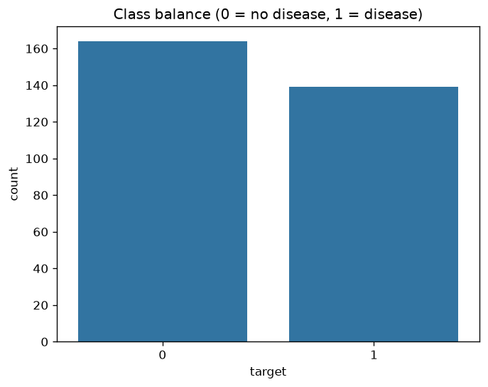
Figure 1: Class balance (54.1% no disease, 45.9% disease).
The classes are close to balanced, so accuracy is a meaningful metric and no resampling is needed. Recall is still tracked because missing a sick patient is the costlier error in this domain.
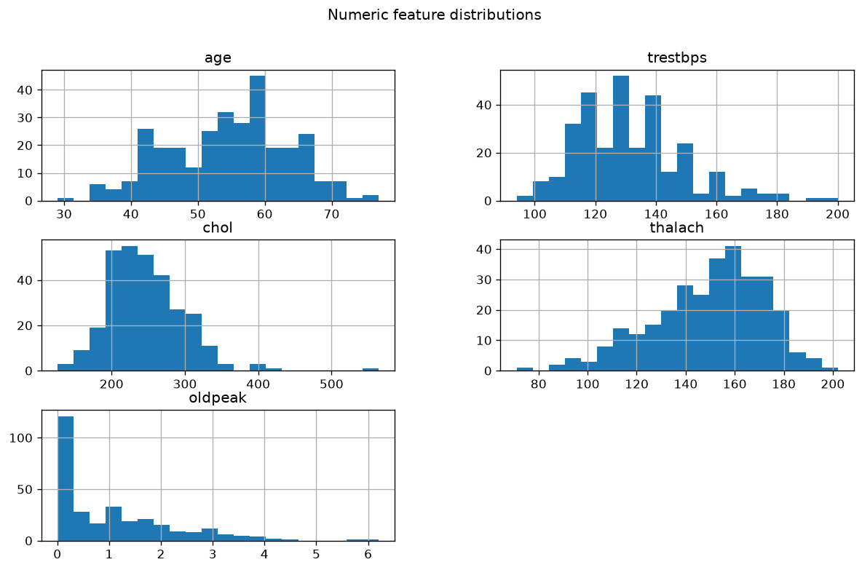
Figure 2: Distributions of numeric features.
Age is roughly bell-shaped around 55; cholesterol is right-skewed with a few very high values; oldpeak is strongly right-skewed with many zeros. Standard scaling is therefore applied to the numeric features.
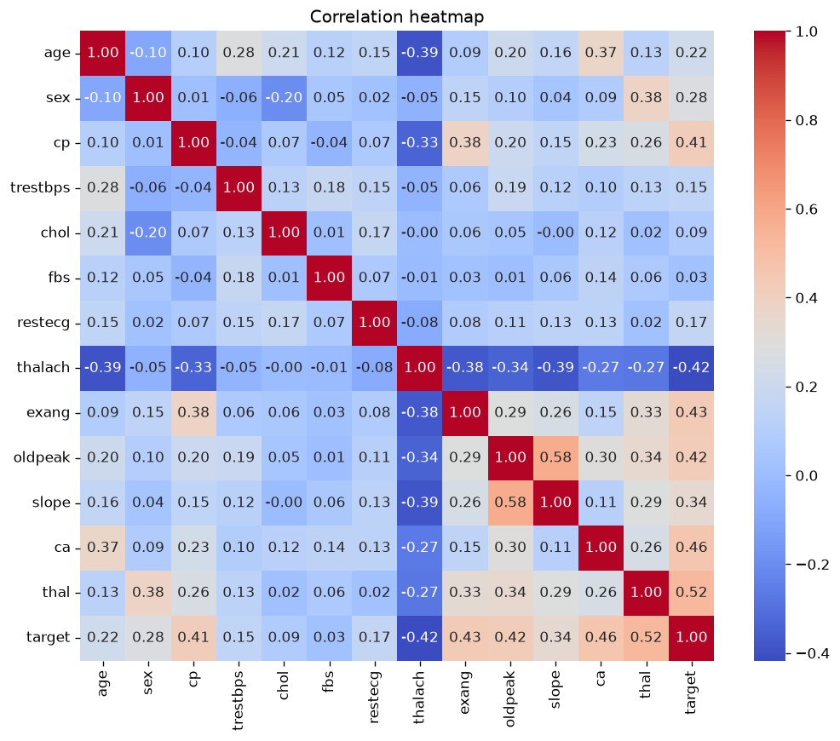
Figure 3: Correlation heatmap including the target.
The strongest correlations with the target are thal (0.52), ca (0.46), exang (0.43), oldpeak (0.42), cp (0.41) and thalach (-0.42, a lower maximum heart rate goes with disease). Fasting blood sugar (0.03) and cholesterol (0.09) are only weakly related. Patients with disease average 56.6 years against 52.6 and a maximum heart rate of 139 against 158 bpm.
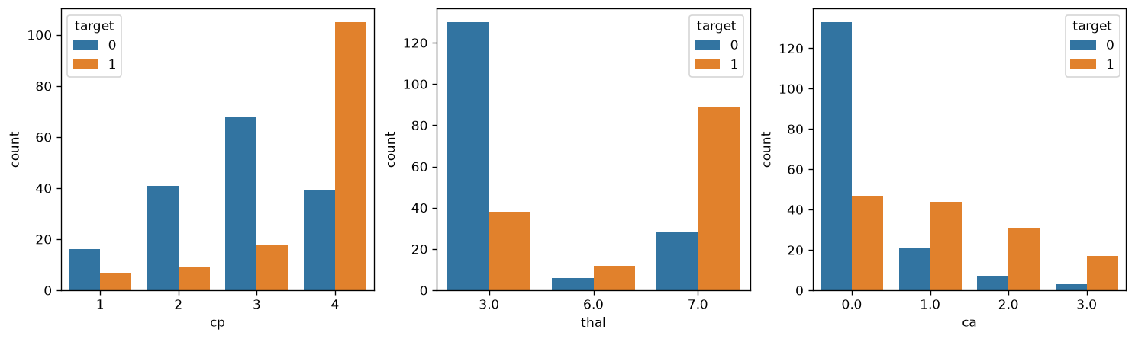
Figure 4: Chest pain type, thal and ca versus the target.

4. Feature Engineering and Model Development
Preprocessing and the estimator form a single scikit-learn Pipeline (ColumnTransformer: StandardScaler for numeric columns, OneHotEncoder with handle_unknown='ignore' for categorical columns). Persisting the whole pipeline guarantees that the API applies exactly the transforms used in training, and unseen category values do not crash inference (covered by a unit test).
The data was split 80/20 with stratification (random_state=42). Hyperparameters were tuned on the training part with GridSearchCV (stratified 5-fold, ROC-AUC scoring):
Model | Search grid
Logistic Regression | C in {0.01, 0.1, 1, 10}, max_iter=2000
Random Forest | n_estimators in {100, 300}, max_depth in {3, 5, None}

The tuned pipeline of each model was then cross-validated (5-fold) for accuracy, precision, recall and ROC-AUC, and finally evaluated once on the hold-out test set.
Model | CV Acc | CV Prec | CV Rec | CV AUC | Test Acc | Test Prec | Test Rec | Test AUC
Logistic Regression (C=1) | 0.847 | 0.877 | 0.783 | 0.902 | 0.885 | 0.839 | 0.929 | 0.966
Random Forest (100, depth=None) | 0.818 | 0.817 | 0.783 | 0.897 | 0.869 | 0.812 | 0.929 | 0.943

Model selection: Logistic Regression has the higher cross-validated accuracy, precision and ROC-AUC, is much simpler and produces well-behaved probabilities, which suits a risk-score API. Random Forest did not outperform it on this small dataset. The selection criterion is CV ROC-AUC (0.902 versus 0.897). The test set contains only 61 patients, so the test figures are noisy and were not used to choose the model.

5. Experiment Tracking with MLflow
Each model trains inside an MLflow run in the experiment 'heart-disease'. Per run the code logs: the best hyperparameters, all cross-validation metrics (cv_accuracy, cv_precision, cv_recall, cv_roc_auc), the hold-out metrics, the ROC curve and confusion matrix as image artifacts, and the fitted pipeline as an MLflow model. The MLflow UI (mlflow ui) is used to compare runs.
[Insert screenshot: mlflow_runs.png]
Figure 5: MLflow experiment with both runs (add screenshot).
[Insert screenshot: mlflow_compare.png]
Figure 6: MLflow run comparison (add screenshot).

6. Model Packaging and Reproducibility
- Final model saved as models/model.joblib (full Pipeline) and as an MLflow model artifact.
- requirements.txt pins compatible version ranges; the API image installs only the runtime subset.
- Fixed random_state=42 for the split, cross-validation and Random Forest.
- models/metrics.json stores the selected model name and all metrics for audit.
- notebooks/inference.py shows loading the saved pipeline and predicting for a new patient.

7. CI/CD Pipeline and Automated Testing

7.1 Unit tests
File | What it verifies
tests/test_data.py | target binarisation, no nulls after cleaning, duplicate removal, '?' handling
tests/test_model.py | both pipelines fit/predict, probabilities sum to 1, unseen categories, metric ranges
tests/test_api.py | /health, /predict output, input validation (422), /metrics counters

11 tests pass locally. One test exposed a genuine bug (an entirely missing categorical column crashed mode imputation); it was fixed in src/data.py.

7.2 GitHub Actions
The workflow .github/workflows/ci.yml runs on every push and pull request: install requirements, flake8, pytest (JUnit XML), data preparation, model training, upload of test results, model and MLflow runs as artifacts, Docker build, and a smoke test that starts the container and calls /health and /predict. Because each step runs without continue-on-error, any lint failure, failing test or training error fails the workflow, and the logs show the failing step.
[Insert screenshot: github_actions_run.png]
Figure 7: Successful GitHub Actions run (add screenshot).
[Insert screenshot: github_actions_artifacts.png]
Figure 8: Uploaded workflow artifacts (add screenshot).

8. Containerisation and Deployment

8.1 Docker
The API is a FastAPI application. POST /predict accepts the 13 features as JSON (validated with Pydantic ranges) and returns the predicted class, the confidence in that class and the disease probability.
docker build -t heart-api:latest .
docker run -d --name heart-api -p 8001:8000 heart-api:latest
curl -X POST http://localhost:8001/predict -H "Content-Type: application/json" \
-d '{"age":63,"sex":1,"cp":1,"trestbps":145,"chol":233,"fbs":1,"restecg":2,"thalach":150,"exang":0,"oldpeak":2.3,"slope":3,"ca":0,"thal":6}'
# {"prediction":0,"confidence":0.83,"risk_probability":0.17}
[Insert screenshot: docker_run.png]
Figure 9: Docker build/run and sample /predict call (add screenshot).

8.2 Kubernetes
k8s/deployment.yaml defines a Deployment with 2 replicas, readiness and liveness probes on /health, resource requests/limits, and a Service of type LoadBalancer (port 80 to container port 8000). k8s/ingress.yaml optionally exposes it through an Ingress. It was deployed on Minikube:
minikube start --driver=docker
docker build -t heart-api:latest .
minikube image load heart-api:latest
kubectl apply -f k8s/deployment.yaml
kubectl get pods,svc
kubectl port-forward svc/heart-api 8001:80
curl http://localhost:8001/health
Access instructions for local testing: after the commands above the API is at http://localhost:8001 (interactive docs at /docs).
[Insert screenshot: kubectl_pods_svc.png]
Figure 10: kubectl get pods,svc (add screenshot).
[Insert screenshot: k8s_predict.png]
Figure 11: /predict served through Kubernetes (add screenshot).

9. Monitoring and Logging
Every HTTP request is logged with method, path, status and latency by a FastAPI middleware, and each prediction logs its class and confidence. The /metrics endpoint exposes Prometheus metrics: api_requests_total{path,status}, api_request_latency_seconds (histogram) and api_predictions_total{label}. monitoring/docker-compose.yml starts Prometheus (port 9090) and Grafana (port 3000).
Panel | PromQL
Request rate | sum(rate(api_requests_total[1m])) by (path)
p95 latency | histogram_quantile(0.95, sum(rate(api_request_latency_seconds_bucket[1m])) by (le))
Predictions by class | api_predictions_total

[Insert screenshot: grafana_dashboard.png]
Figure 12: Grafana/Prometheus dashboard (add screenshot).

10. Conclusion and Limitations
The project delivers a reproducible pipeline from raw UCI data to a monitored, containerised API on Kubernetes, with experiment tracking and CI that fails on lint, test or training errors.
- The dataset is small (303 rows), so metrics have wide confidence intervals; results are indicative, not clinical.
- Only two model families were compared; boosting models or calibration could be explored.
- The service has no authentication and no model-drift monitoring; both would be needed in production.
- The model is baked into the image; a registry-based deployment (MLflow Model Registry) would allow updates without rebuilding.

References
- UCI Machine Learning Repository - Heart Disease dataset.
- scikit-learn, MLflow, FastAPI, Prometheus and Kubernetes documentation.
- Code repository: https://github.com/MaheshKrishnaNaik/mlops-assignment1

