**HOW TO ADD ENV FILE/MAP IN LGSVL**

For adding new map we required environment file.

Use below link for downloading env file for particular map

e.g. environment_JTA_R1

<https://drive.google.com/drive/folders/1Y8xL3gp7foDDYOv_HDe77pzpz-OlHURR>

**Following steps need to follow for uploading ENV file.**

1. Copy environment file in home directory

File name environment_JTA_R1 –: for JTA_R1

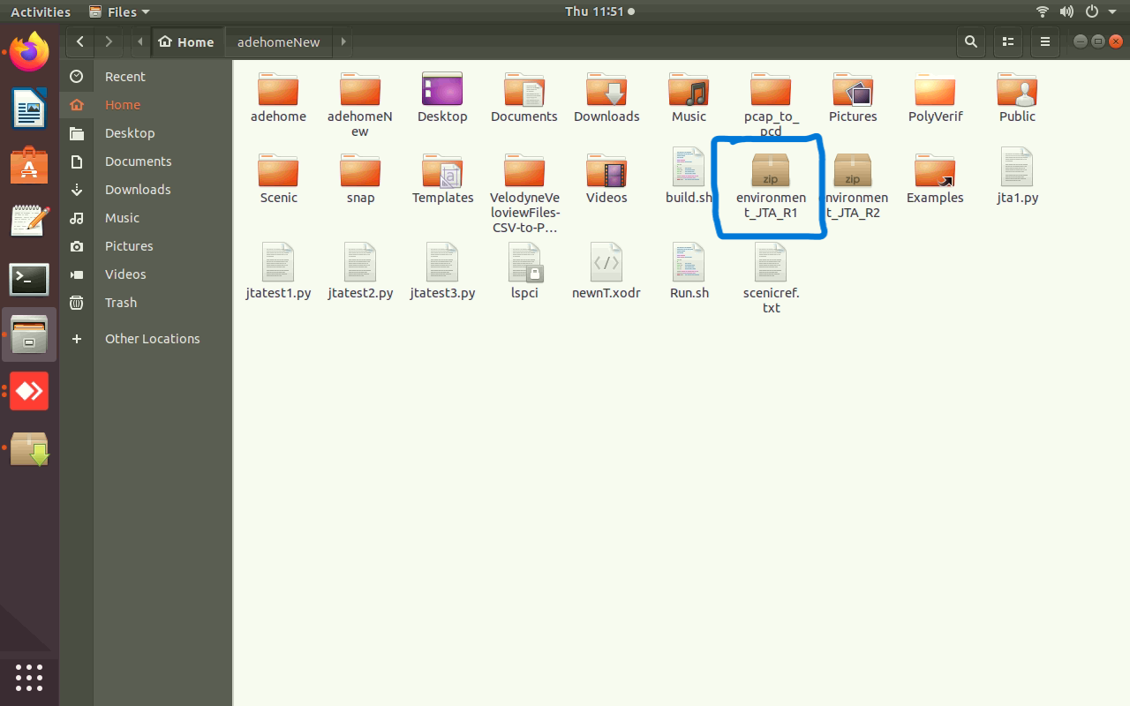

2. Run Polyverif with following command.

I> **cd adehome/Poly_Suite**

II> **./polyverif**

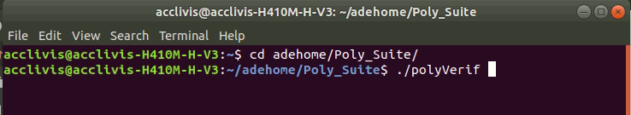

3. After that PolyVerif will open then click on **start ade**

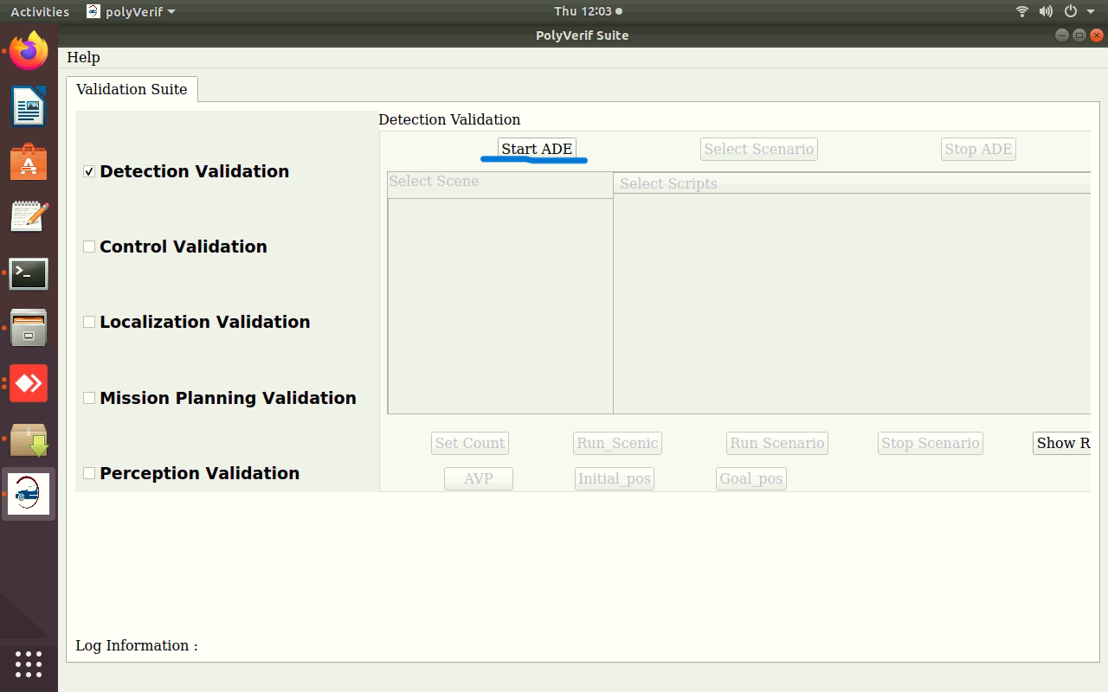

4. Open any web browser and hit localhost:8000

You will see screen like below

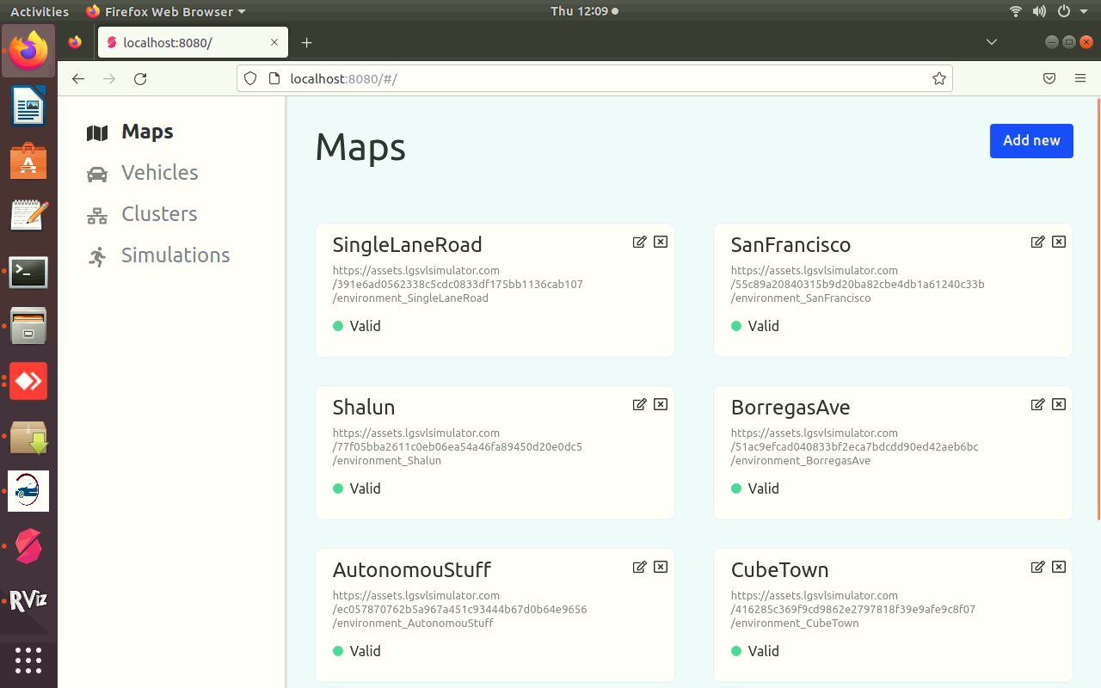

5. open new cmd terminal and hit below command for up local host.

Command: **python3 -m http.server 8000**

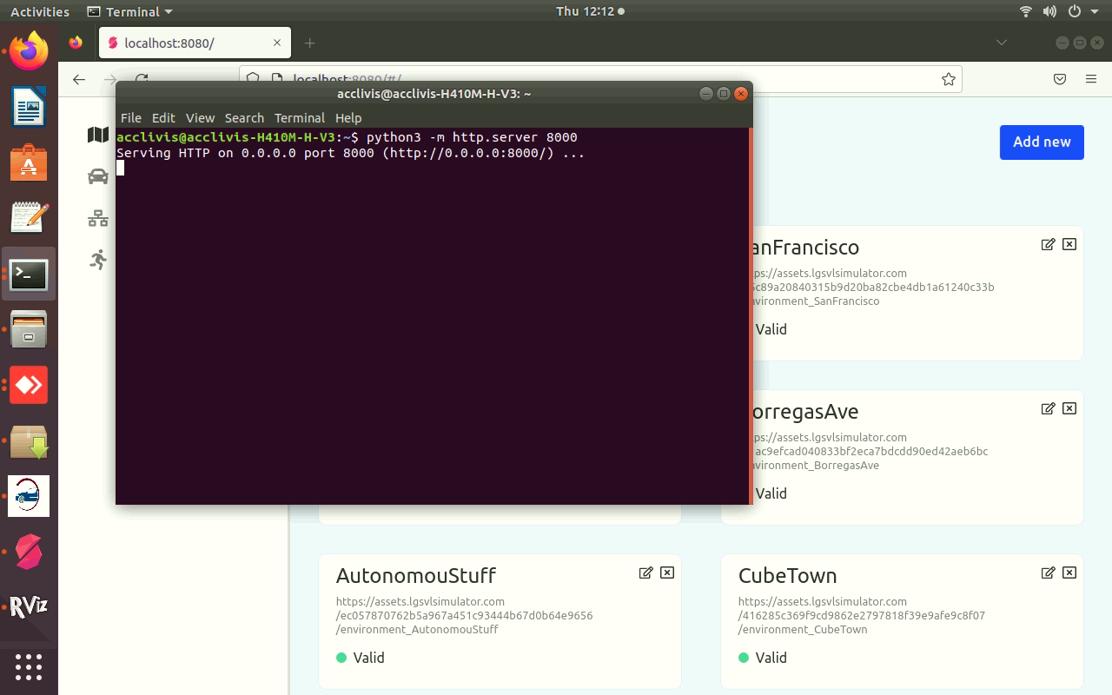

6. Click on Add new button in map section

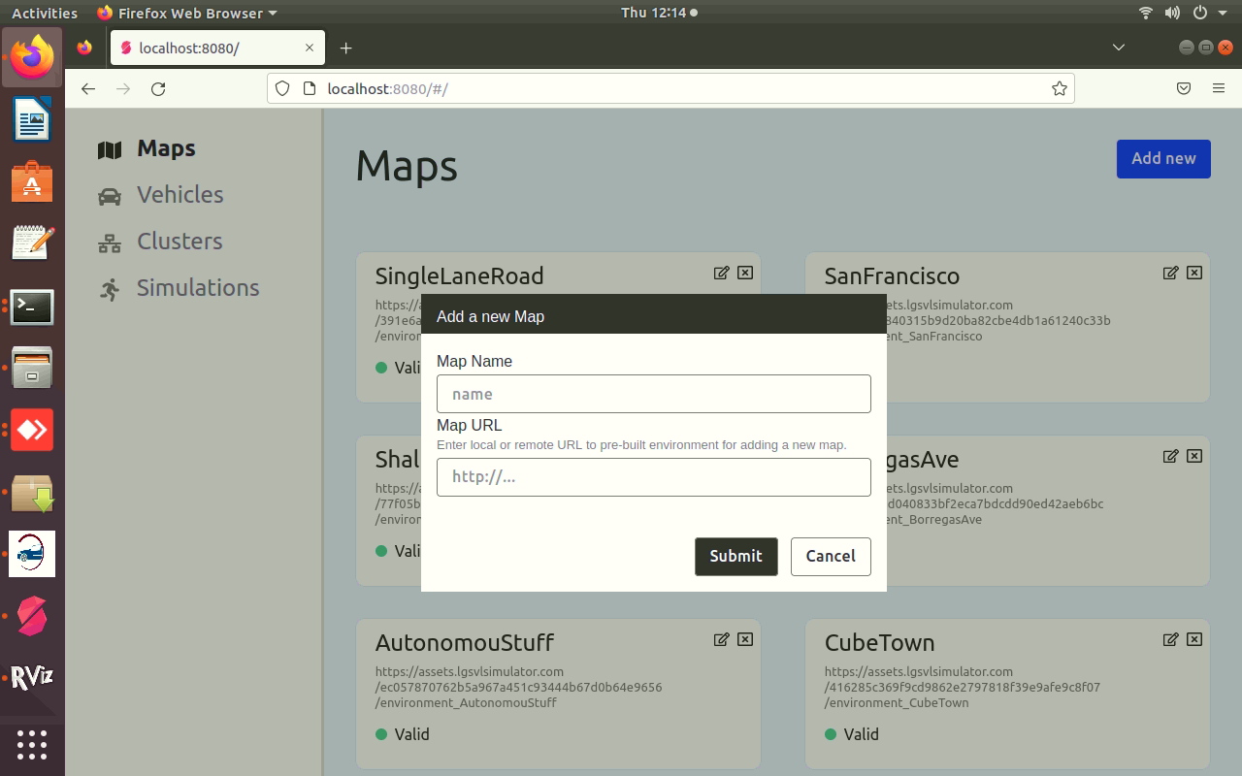

7.Add map name and URL as mention in below image.

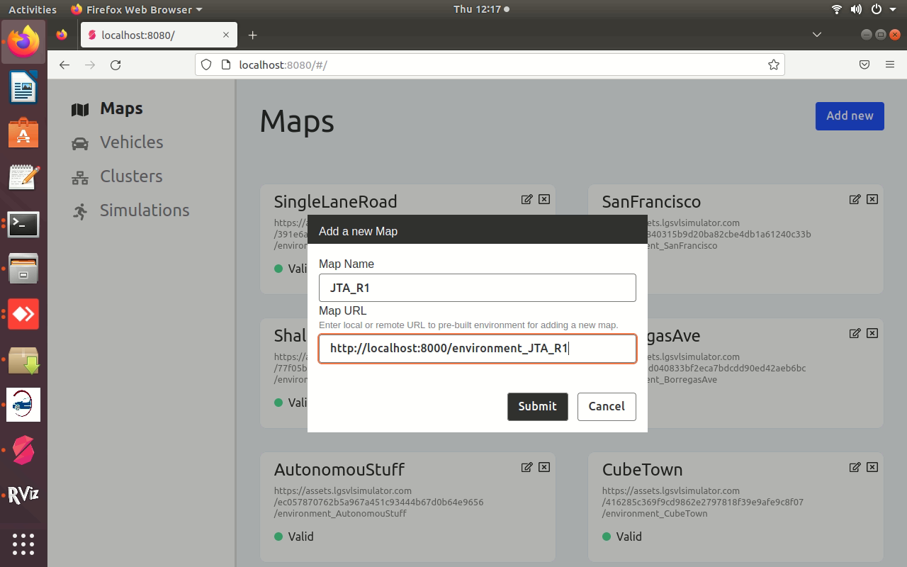

8.After clicking on Submit button you will see map uploaded successfully like below.

