LGSVL Simulator Setup

This document contains the information of Setup and Installation process of the LG Simulator in Linux/Unix

## Lgsvl_Simulator 2020.06

* Please download lgsvl simulator 2020.06 binary for linux64 from the below link -<https://github.com/lgsvl/simulator/releases/tag/2020.06>

Once downloaded, copy/replace lgsvl simulator to the **adehome/lg_sim_06/** directory

* If you want to use our modified lgsvl simulator then you can find into the polyverification repo, below is the path mentioned –

**adehome/lg_sim_06/lgsvlsimulator-linux64-2020.06**

Please follow the below steps-

**$ cd adehome**

**$ cd AutowareAuto**

**$ ade start**

**$ ade enter**

* Ubuntu - Install Vulkan user space library

**$ sudo apt-get install libvulkan1**

* Run Simulator using the below command

**$ sudo ./lg_sim_06/**[**lgsvlsimulator-linux64-2020.06**](https://github.com/lgsvl/simulator/releases/download/2020.06/lgsvlsimulator-linux64-2020.06.zip)**/simulator**

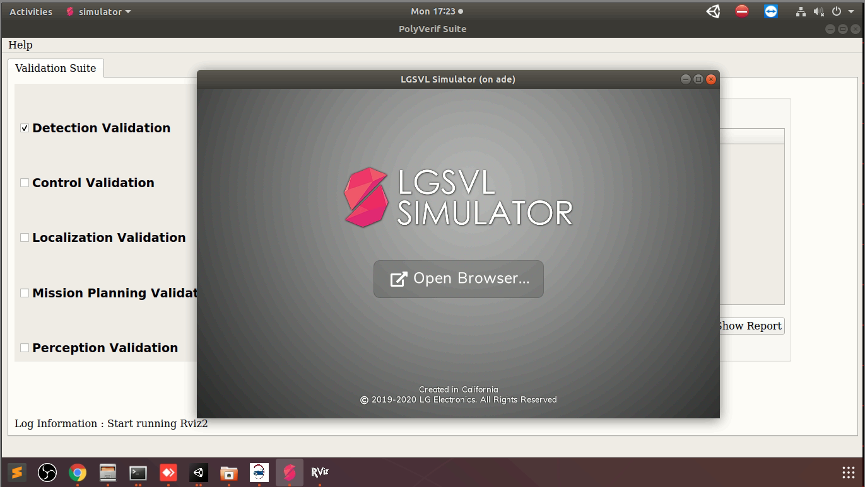

* Then click open browser or open any browser, enter localhost:8080 in address bar

**Note:** If it asked for any registration then register it and login with the same credential.

* Once it is sign-in successfully, you will find the 4-tab in the left corner which are Maps, Vehicles, Clusters, Simulations.

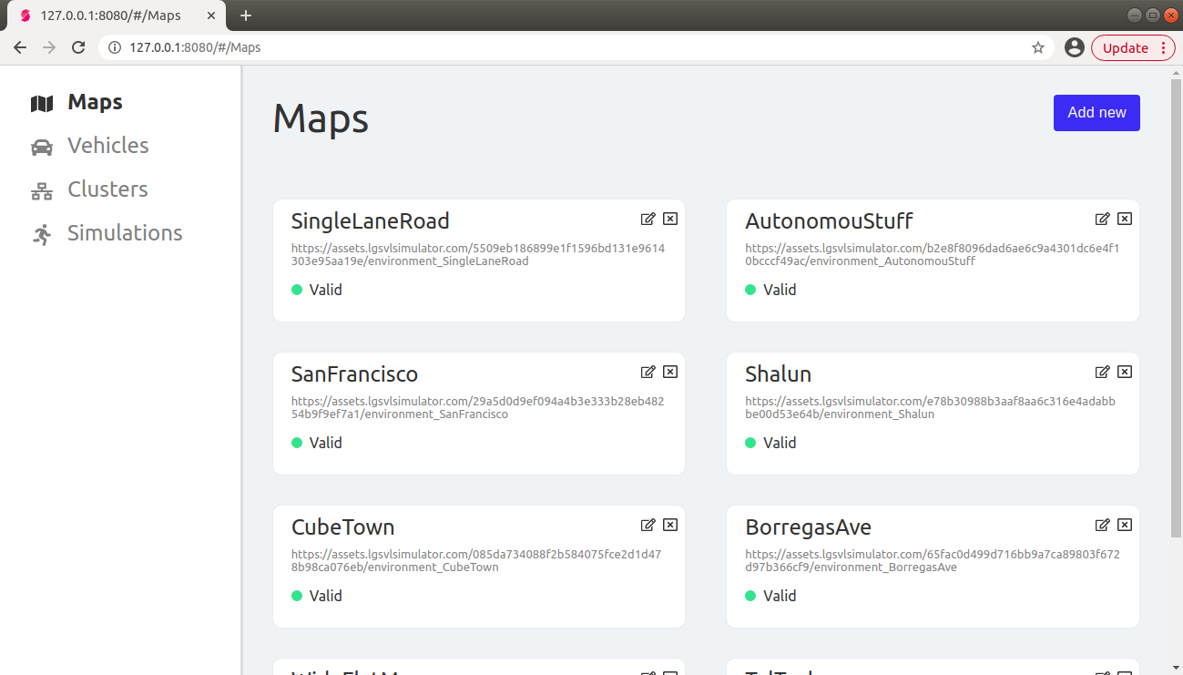

* In the Maps tab, **Add new** map with the URL to an environment asset bundle or use below string to add the TalTech or any other map
  + Name - **TalTech**
  + Asset Bundle String- **https://<path_of_the_TalTech_map_file >/environment_TalTech**

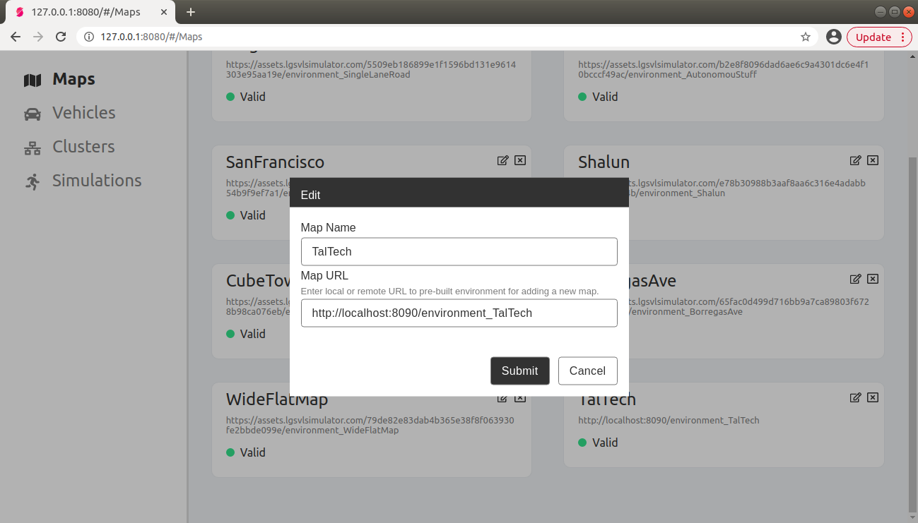

* In the Vehicles tab, **Add new** vehicle with the URL to a vehicle asset bundle or use the below string to add the Lexus

Name - **Lexus2016RXHybrid (Autoware)**

Asset Bundle String- **https://assets.lgsvlsimulator.com/b5acfd17c0f8c31d9f573842ca27a7a4bde7dfd4/vehicle_Lexus2016RXHybrid**

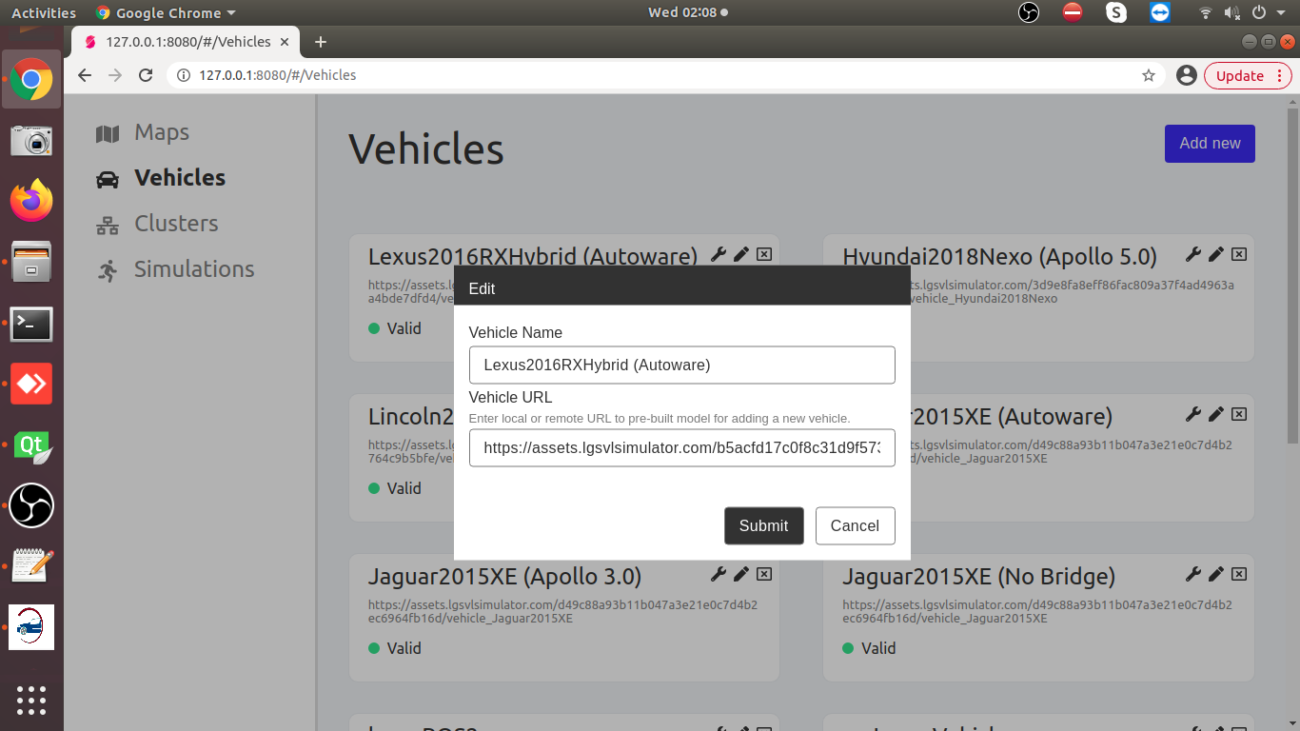

* In the Vehicle tab after adding the vehicle, Click the wrench icon next to the vehicle name

Bridge Type - **ROS2**

Sensors configuration - **Copy string from the sensorConfig.json file**

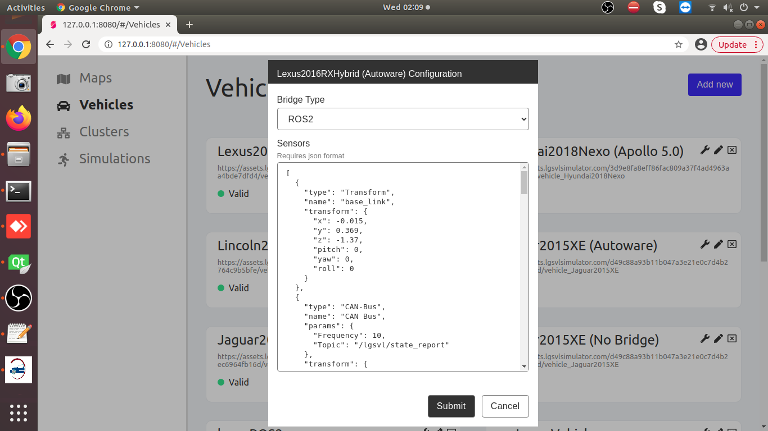

* Click on Simulations tab and create a new Simulation. Give it a name and check the**API Only** option. **Click Submit**

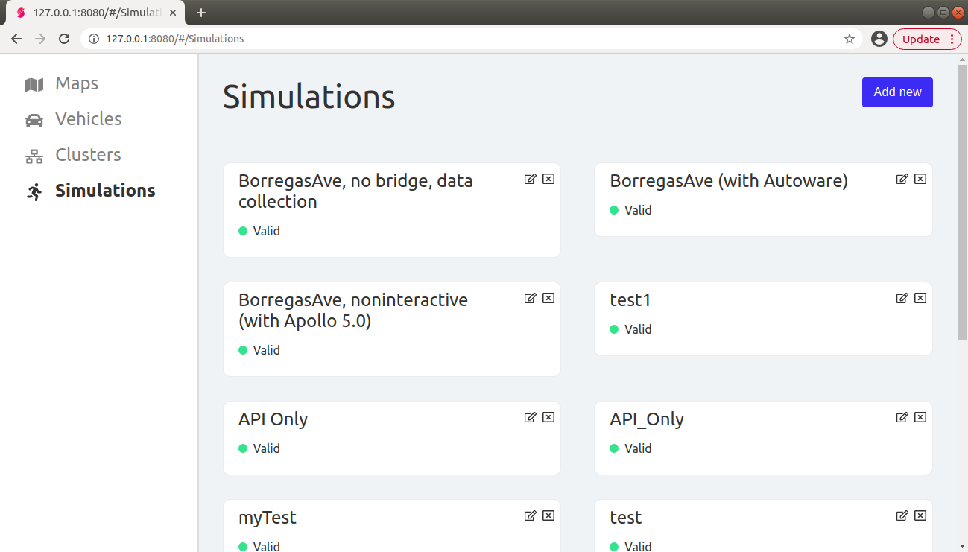

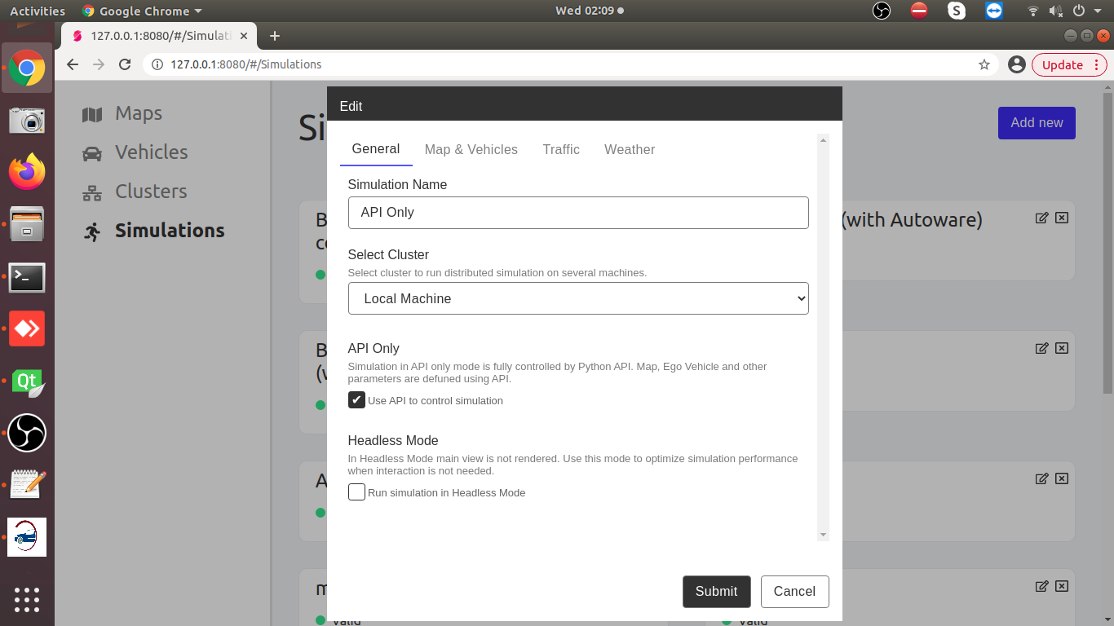

* Select the API_Only simulation from the simulations tab.
* Press the Play Button

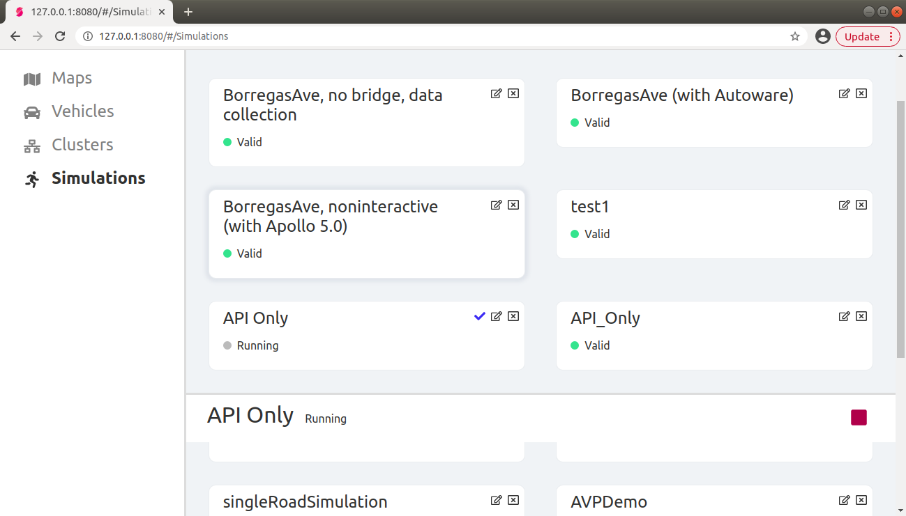

The lgsvl simulator window should now show API_Only on the screen.

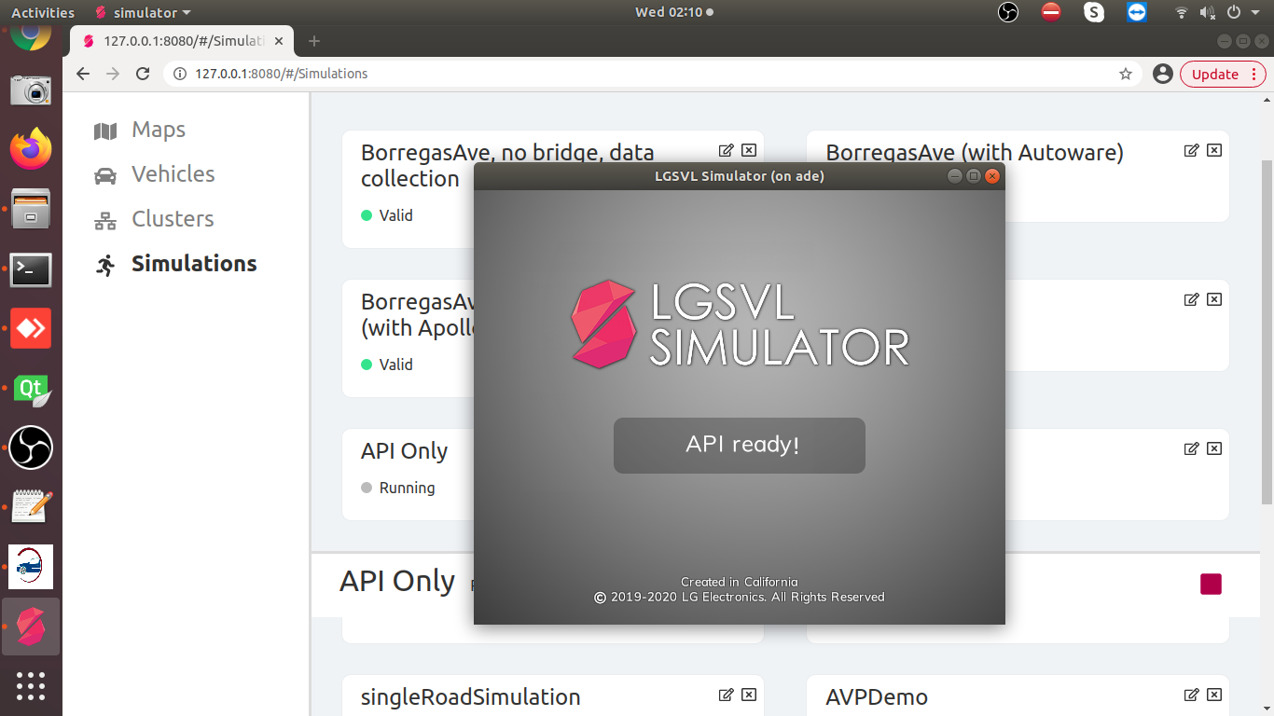

**Note:** While running the simulation through polyVerif suite, the simulator must be in the **API_Only** mode.