Polyverif_SHELL User Guide

This document contains the information of how to run the simulation through the **PolyVerif_Shell.** Once the installation and setup completed you are ready to use the polyVerif framework.

If you have not setup and install the pre-requisite then please follow **Setup_And_Installation** document for the reference.

This framework uses predefined metrics for the validation of the stacks which will be calculated after running the test cases. On the basis of these metrices threshold the success/failure of the stack validated. **/PTS/adehome/PolyVerifShell/**

1. Go to the PolyVerif_Shell directory and run

**$ python PolyVerif_Shell.py test1.xml**

Note: testcase may change while testing like test1.xml as test2.xml… test15.xml

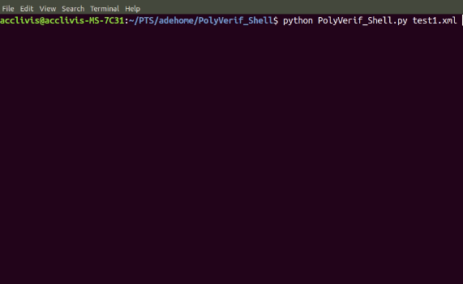

1. Once the command run it will start all the required module for example-
   * + AutowareAuto
     + Perception Stack
     + Lgsvl simulator
     + Rviz
     + Ros2-lgsvl-bridge

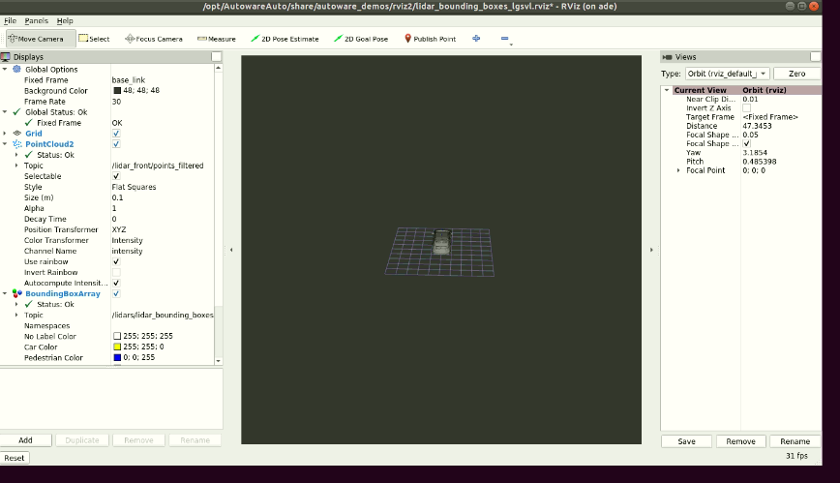

1. Once lgsvl simulator and rviz started, go to the any web browser

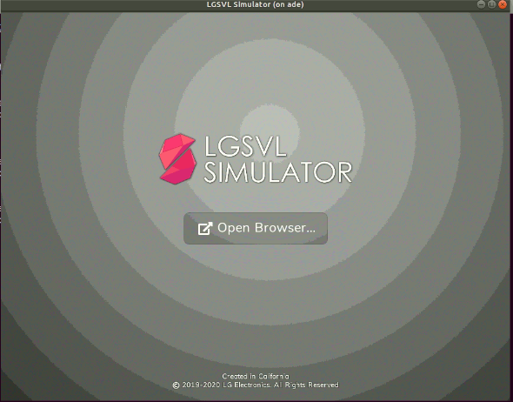

1. Enter localhost:8080 on address bar and hit enter.

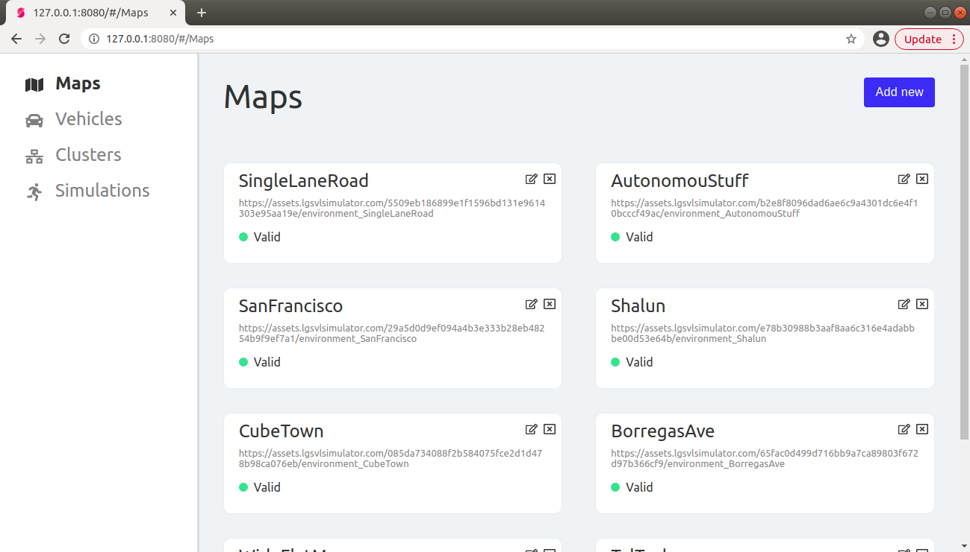

**Note: -** If the lg web page is not open the try below address also on address bar- 127.0.0.1:8080

1. Click on the Simulations tab and select the API_Only.
   1. Click on the Play button

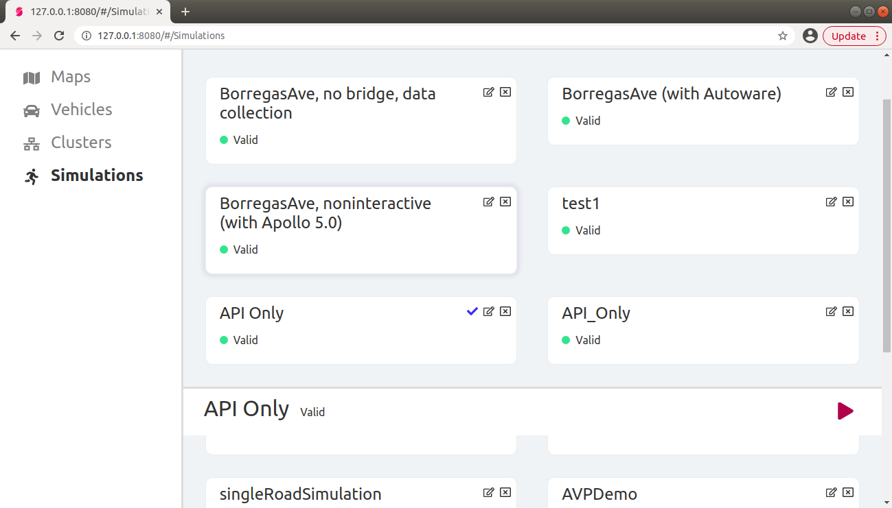

1. Now the simulator is in the **API_Mode**

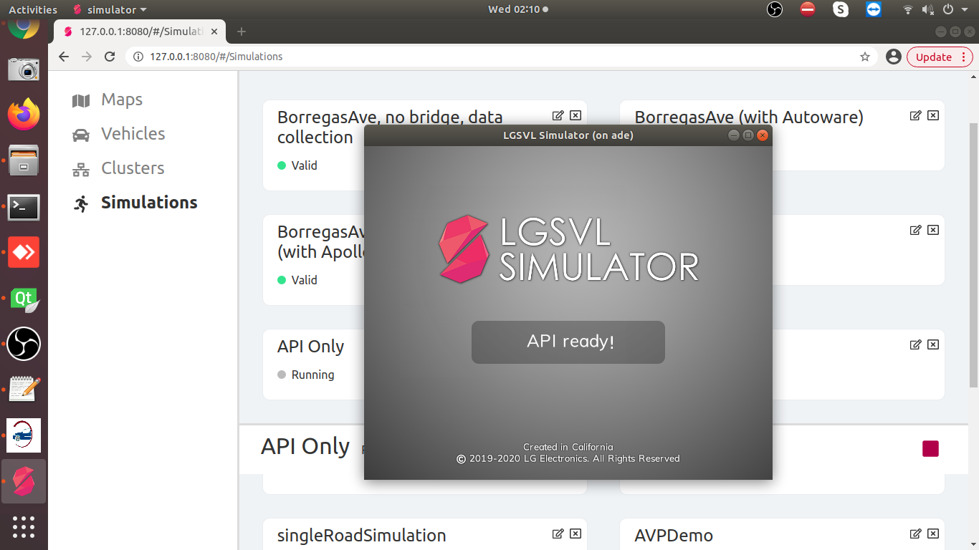

1. Go to LGSVL and Rviz tool Scenario has been started running as selected scene and test case in test1.xml file wait for a while to complete the scenario.

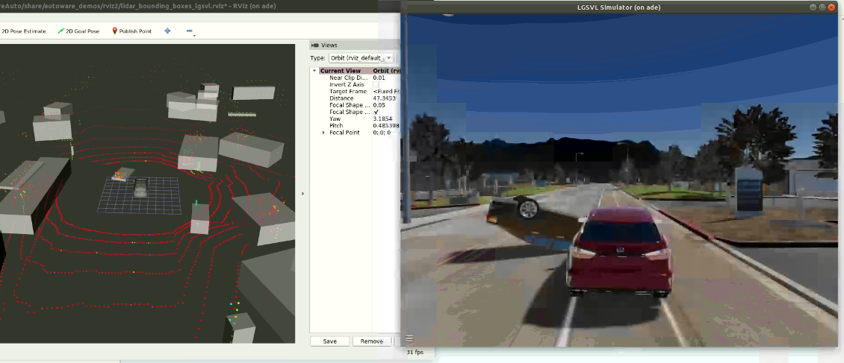

1. Once the simulation is completed go to Linux terminal hit the enter button to save the Scenario reports. It will redirect to another form where you can see the respective simulation reports, it will take some time to process.

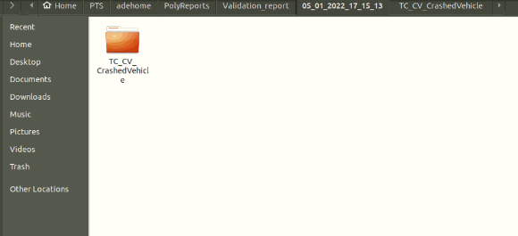

**Note: -**

**Assumptions/Issues:**

* **Run and tested the test cases for the Taltech map only.**
* **If there is only ego vehicle in the simulation then data will not compute.**
* **Sometime rviz crashed but the perception stack is running in the back ground**
* **While scenario run using the scenic, it got hanged while connecting to ros2 bridge. So need to forcefully terminate using Ctrl+C and start again.**

**References:**

* **Lgsvl Simulator -** [**https://github.com/lgsvl/simulator/releases/tag/2020.06**](https://github.com/lgsvl/simulator/releases/tag/2020.06)
* **Scenic -** [**https://scenic-lang.readthedocs.io/en/latest/syntax_guide.html?highlight=facing#specifiers**](https://scenic-lang.readthedocs.io/en/latest/syntax_guide.html?highlight=facing#specifiers)
* **PythonAPI -** [**https://www.svlsimulator.com/docs/python-api/python-api/**](https://www.svlsimulator.com/docs/python-api/python-api/)
* **AutowareAuto avp demo -** [**https://autowarefoundation.gitlab.io/autoware.auto/AutowareAuto/avpdemo.html**](https://autowarefoundation.gitlab.io/autoware.auto/AutowareAuto/avpdemo.html)