Poly-verification suite

13 March 2021

This document contains the information of how to run and setup the Poly-Verification Suit.

Please follow the below steps to run the suite-

## Poly-Verificaton Application Installation

## Keep Following Files at adehome

**PolyReoprts**

**Poly_Suit**

**Test_cases**

## Running Poly-Verificaton Application

1. Go to Poly_Suit directory
2. Open Terminal and run :

**$ ./suit**

1. Select “Digital Schematic Test Suit”
2. Click on **Start ADE** button to the below required components :

It will start and enter in **ade docker** and initiate the **LG Bridge, LG Simulator, Perception Validation Node and Rviz2**

1. Click on the Select Scenario button which will provide you the number of configured scenarios.
2. Select Scene for lgsvl simulator
3. Select any single scenario from the list of scenario

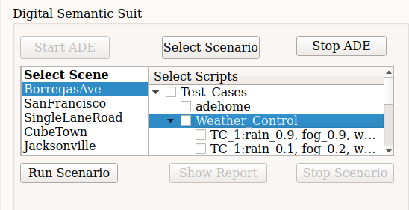

1. Now Click on Run Scenario : It will run scenario and generate report for it in Poly_Report/Validation_report directory.
2. Once the simulation executed, Click on Stop Scenario Button which will shop the other back ground process.
3. Click on Show Report button. It will provide the Report of Perception Validation and shown on to the UI.
4. You can RUN the Simulation multiple times one by one and generate data report.
5. Stop ADE : it will stop LG_Bridge, LGSVL Simulator and rviz

To make changes in Scenario weather pattern :

Ex. make changes in Weather control parameters

1. Open Test_cases -> Weather_Control
2. open config.txt file
3. set your parameters in given pattern ex. : rain_0.9, fog_0.9, wetness_0.9 ,cloudiness_0.9, damage_0.9