

[Document title]

[Document subtitle]



[Date]

[Company name]

[Company address]

## News Sentiment Analysis for Stock Price Prediction: A Multi-Method Investigation of Short-Term Predictive Power in Indian Equity Markets

## Interim Report

**GitHub Repository:** https://github.com/MaheshMadakath/MS-DBA_Capstone  
*Contains all datasets, analysis code, and supplementary materials*

Mahesh Mohandas Madakath

Walsh College & Great Learning

QM640 V1: Data Analytics Capstone

Mukul Chauhan

August 25, 2025

## News Sentiment Analysis for Stock Price Prediction: A Multi-Method Investigation of Short-Term Predictive Power in Indian Equity Markets

# INTRODUCTION

The integration of artificial intelligence and machine learning techniques into financial market analysis represents a paradigm shift in investment decision-making processes. This study investigates the short-term predictive power of news sentiment on stock price movements in Indian equity markets, employing state-of-the-art natural language processing models to address critical gaps in systematic sentiment analysis for trading applications.

## Business Problem and Market Context

Traditional investment strategies in emerging markets often overlook the systematic impact of news sentiment on price discovery mechanisms. Indian equity markets present unique characteristics including disproportionate retail investor participation (85% retail versus 15% institutional) and heterogeneous algorithmic trading penetration across sectors. This market structure creates opportunities for sentiment-driven price movements that existing analytical frameworks fail to capture systematically.

The inability to quantify and predict sentiment-driven price changes represents a significant limitation in portfolio management, risk assessment, and algorithmic trading systems. Current approaches rely heavily on technical indicators and fundamental analysis while neglecting the behavioral components that drive short-term price movements, particularly in retail-dominated market segments.

## AI/ML Solution Methodology

Recent advances in transformer-based natural language processing, particularly domain-specific models like FinBERT, have revolutionized sentiment extraction capabilities for financial applications. This research implements an ensemble sentiment analysis framework combining FinBERT (financial domain-specific), VADER (social media optimized), and TextBlob (general purpose) models to capture nuanced sentiment signals from news content.

The multi-model approach addresses the limitation of single-algorithm bias while providing robust sentiment quantification suitable for statistical analysis and machine learning applications. This methodology enables systematic investigation of sentiment-return relationships using correlation analysis, statistical hypothesis testing, and predictive modeling frameworks.

## Research Strategy and Progression Framework

This study implements a four-phase investigation strategy where RQ1 establishes the foundational sentiment-return relationship necessary for subsequent analytical phases. The systematic progression ensures methodological rigor: RQ1 validates sentiment predictive power, RQ2 integrates technical indicators, RQ3 optimizes feature importance, and RQ4 develops market attribution frameworks.

Focusing the interim analysis exclusively on RQ1 enables thorough validation of sentiment effects before advancing to multi-factor complexity. This approach prevents premature optimization while establishing the empirical foundation required for comprehensive market prediction models.

## Expected Contributions and Applications

The research addresses both academic knowledge gaps in emerging market behavioral finance and practical applications for investment professionals. Portfolio managers and algorithmic trading systems require evidence-based frameworks for incorporating sentiment signals into decision-making processes. The methodology provides quantitative validation of sentiment effects while identifying sector-specific patterns that enable targeted strategy implementation.

By combining rigorous statistical analysis with machine learning validation, this investigation provides actionable insights for short-term trading strategies, risk management applications, and market timing optimization in Indian equity markets.

# SCOPE AND OBJECTIVES

# Research Problems Identified

This research addresses four critical gaps in sentiment analysis applications for Indian equity markets:

**Primary Research Problem:** Absence of systematic evidence for news sentiment predictive power in Indian equity markets using contemporary AI/ML methodologies. Existing studies rely on outdated lexicon-based approaches that fail to capture nuanced financial context.

**Methodological Problem:** Lack of ensemble sentiment analysis validation combining domain-specific transformer models (FinBERT) with traditional approaches, limiting reliability of sentiment-return relationship quantification.

**Practical Application Problem:** Investment professionals lack evidence-based frameworks for incorporating sentiment signals into trading strategies and risk management systems, particularly for emerging market contexts.

**Market Understanding Problem:** Insufficient knowledge of sector-specific sentiment effects and their relationship to market microstructure factors such as algorithmic trading penetration and retail participation levels.

# Research Question Framework

|  |  |  |  |  |
| --- | --- | --- | --- | --- |
| RQ | Research Question | Hypothesis | Brief Objective | Status |
| RQ1 | What is the short-term (1-3 day) predictive power of news sentiment on stock price changes across sectors? | H₀: News sentiment has no significant effect vs H₁: Sentiment significantly influences returns | Establish foundational sentiment-return relationships using ensemble AI/ML approach | Current Focus |
| RQ2 | How do technical indicators and sentiment scores compare in predicting short-term price direction? | Hybrid models outperform individual approaches | Integrate sentiment with RSI, MACD, Bollinger Bands for enhanced prediction | Future Phase |
| RQ3 | Which KPIs are most important for predicting short-term returns across stocks? | Certain features show stronger predictive power | Optimize feature selection using Filter, Wrapper, Embedded methods | Future Phase |
| RQ4 | Which stocks/sectors drive daily NIFTY movements and why? | NIFTY movements can be attributed to specific drivers | Develop attribution framework for index movement explanation | Future Phase |

# RQ1 Foundation Strategy

**Rationale for Sequential Approach:** This interim analysis focuses exclusively on RQ1 to establish empirical evidence for sentiment-return relationships before advancing to multi-factor complexity.

The phased methodology ensures:

**Statistical Validation First:** Establishing baseline sentiment effects prevents attribution errors in hybrid models

**Feature Reliability:** Validating sentiment variables before technical integration ensures model stability

Sector Understanding: Identifying heterogeneous effects enables targeted strategy development

**Methodological Rigor:** Single-factor analysis provides cleaner interpretation than simultaneous multi-factor investigation

**Business Application Relevance**: RQ1 addresses immediate practitioner needs for sentiment signal validation while establishing the foundation for comprehensive trading system development in subsequent phases.

# Current Objectives (RQ1 Focus)

**Primary Objective:** Quantify the short-term predictive relationship between ensemble news sentiment scores and stock price movements across Indian equity market sectors.

**Specific Objectives:**

* Validate ensemble sentiment analysis methodology for Indian financial news
* Measure correlation strength and statistical significance across 1-3 day prediction horizons
* Identify sector-specific patterns in sentiment predictive power
* Evaluate machine learning classification performance for directional prediction
* Establish baseline metrics for subsequent technical indicator integration

**Expected Outcomes:** Evidence-based framework for sentiment signal incorporation into trading strategies, with sector-specific insights enabling targeted application development.

**Success Criteria:** Statistical significance demonstration (p < 0.05) for sentiment-return relationships with practical prediction accuracy exceeding random baseline performance.

# LITERATURE SURVEY

This literature review examines the theoretical foundations and empirical evidence supporting news sentiment analysis in financial markets, with particular emphasis on methodological approaches and behavioral finance explanations relevant to contrarian sentiment effects.

# Theoretical Foundations of Sentiment in Financial Markets

Baker and Wurgler (2007) establish the conceptual framework for systematic investor sentiment effects in asset pricing, demonstrating that sentiment significantly influences stock returns through behavioral biases and market inefficiencies. Their development of sentiment indices and documentation of predictable return patterns provides the theoretical foundation for expecting measurable sentiment-return relationships in equity markets. This research directly supports our investigation by validating that sentiment effects can be quantified and demonstrate systematic predictive patterns.

Tetlock (2007) provides seminal empirical evidence on media content's influence on stock market dynamics, documenting that negative news coverage predicts temporary price declines followed by subsequent reversals toward fundamental values. His finding that media-driven price movements exhibit mean reversion characteristics directly parallels our discovery of contrarian sentiment-return correlations. This study is highly pertinent as it establishes precedent for negative sentiment-return relationships and provides behavioral mechanisms explaining why positive sentiment might predict negative returns through overreaction followed by correction.

# Behavioral Finance and Contrarian Patterns

De Bondt and Thaler (1985) establish the overreaction hypothesis as a fundamental explanation for contrarian price patterns, demonstrating that extreme price movements are systematically followed by reversals in the opposite direction. Their behavioral framework explaining how cognitive biases lead to systematic overreaction provides theoretical grounding for understanding why news sentiment might exhibit contrarian predictive power. This foundational work is essential to our research as it explains the psychological mechanisms underlying sentiment-driven market corrections.

Jegadeesh and Titman (1993) document systematic momentum and reversal patterns in stock returns, establishing that short-term reversals occur within weekly to monthly horizons while longer-term momentum persists. Their empirical evidence for short-term mean reversion directly supports our 1-3 day contrarian sentiment findings and provides temporal framework validation for our prediction horizons. This research is highly relevant as it confirms that the time windows we examine are appropriate for detecting sentiment-driven correction effects.

# Advanced Sentiment Analysis Methodologies

Loughran and McDonald (2011) revolutionize financial sentiment analysis by demonstrating that general-purpose sentiment dictionaries fail to capture financial context accurately, developing domain-specific word lists that significantly improve sentiment classification performance. Their methodology innovations directly inform our ensemble approach combining FinBERT, VADER, and TextBlob, as they highlight the critical importance of financial-domain specificity in sentiment measurement. This study validates our decision to weight FinBERT heavily in our ensemble framework.

Da, Engelberg, and Gao (2011) investigate retail investor attention effects on stock prices, documenting that attention-grabbing news creates temporary price movements followed by corrections as attention dissipates. Their attention-driven overreaction findings parallel our sentiment-based contrarian results, suggesting that news-driven investor behavior exhibits systematic reversal patterns. This study supports our behavioral interpretation of contrarian correlations through attention-based overreaction mechanisms.

# Emerging Market Behavioral Finance

Griffin, Nardari, and Stulz (2007) analyze information processing characteristics in emerging markets, documenting that local news and sentiment have stronger impact than global factors in price determination due to market structure differences. Their emphasis on domestic information importance validates our focus on Indian-specific news sources rather than global sentiment indicators. This research supports our data collection methodology using MoneyControl and domestic financial news sources for capturing relevant sentiment effects.

Bekaert and Harvey (2002) provide comprehensive analysis of emerging market characteristics including higher retail investor participation, lower institutional sophistication, and reduced algorithmic trading penetration—factors that amplify behavioral effects compared to developed markets. Their framework explains why sentiment-driven patterns might be more pronounced in Indian markets and supports the economic significance of our contrarian correlation discoveries.

Sehgal and Tripathi (2005) examine foreign institutional investor behavior in Indian markets, documenting systematic patterns in investment decisions based on market sentiment and information processing. Their analysis of FII trading patterns provides context for understanding how institutional versus retail sentiment processing differs in Indian markets. This research is relevant to our study as it helps explain the sectoral heterogeneity we observe, particularly the stronger sentiment effects in retail-dominated sectors like Defense compared to institutionally-dominated Banking.

# Individual Investor Behavior and Market Effects

Kaniel, Saar, and Titman (2008) document systematic patterns in individual investor trading behavior and its relationship to subsequent stock returns, showing that retail trading activity often exhibits contrarian characteristics. Their evidence that individual investors tend to buy after negative news and sell after positive news provides behavioral foundations for understanding contrarian sentiment effects. This study directly supports our findings by establishing that retail-driven markets exhibit sentiment overreaction patterns followed by corrections.

Bathia and Bredin (2013) examine sentiment effects across G7 stock markets, providing international context for sentiment-return relationships and validation methodologies. Their cross-country analysis demonstrates that sentiment effects vary significantly across different market structures and regulatory environments. This research is pertinent as it validates our methodological approach and supports the expectation that emerging markets like India may exhibit different sentiment patterns than developed markets.

# Statistical Methodology

Cohen (1992) provides essential guidance for statistical power analysis and effect size interpretation in behavioral research, establishing conventions for correlation magnitude assessment and sample size requirements. His framework enables proper interpretation of our correlation coefficients (-0.140 to -0.227) as representing small to medium effect sizes with practical significance. This methodological reference is crucial for validating that our statistical findings meet academic standards for behavioral finance research.

# Research Gap and Contribution

The existing literature establishes clear theoretical foundations for sentiment-return relationships and behavioral explanations for contrarian patterns, but lacks comprehensive investigation of these effects in emerging markets using contemporary AI/ML methodologies. Our research addresses this gap by combining domain-specific transformer models with ensemble approaches to provide robust evidence for contrarian sentiment effects in Indian equity markets, contributing novel insights to behavioral finance literature in emerging market contexts.

# DATA DESCRIPTION

This section provides comprehensive documentation of the dataset construction, sources, and characteristics underlying the RQ1 sentiment analysis investigation.

# Stock Selection and Market Coverage

The research dataset comprises **26 stocks** strategically selected from the NIFTY index to ensure representative coverage across major Indian market sectors. The selection criteria prioritized market capitalization diversity, sector representation, and data availability consistency throughout the analysis period. Sector Distribution as follows:

* **Banking (4 stocks):** HDFCBANK, ICICIBANK, SBIN, KOTAKBANK - representing India's largest private and public sector banks
* **IT Services (4 stocks):** TCS, INFY, HCLTECH, WIPRO - top technology services export sector
* **Energy (3 stocks):** RELIANCE, ONGC, BPCL - covering integrated oil companies and refiners
* **FMCG (3 stocks):** ITC, HINDUNILVR, NESTLEIND – represent consumer staples manufacturers
* **Automotive (3 stocks):** MARUTI, M&M, TATAMOTORS – Top vehicle segments
* **Defence (5 stocks):** HAL, BEL, BHEL, COCHINSHIP, GRSE - capturing defence manufacturing and shipbuilding
* **Jewellery (4 stocks):** KALYANKJIL, TITAN, RAJESHEXPO, THANGAMAYL - representing precious metals and jewellery retail

This diversified selection enables sector-specific analysis while maintaining sufficient sample sizes for statistical validation across different market microstructure characteristics.

# Data Sources and Collection Methodology

**Stock Price Data Source:** Yahoo Finance API via yfinance Python library

* **Coverage:** Daily OHLCV data for February-August 2025
* **Variables:** Open, High, Low, Close prices and trading Volume
* **Derived Features:** 1-day, 2-day, and 3-day returns; 5-day rolling volatility
* **Data Quality:** Comprehensive coverage with minimal missing observations

**News Data Collection Framework:** The study implements a hybrid collection strategy combining automated and manual approaches to ensure comprehensive coverage while addressing technical access limitations:

1. **MoneyControl Stock-Specific Pages:** Company-specific news accessed through locally saved HTML files and manual downloads to circumvent rate limiting and access restrictions
2. **Google News RSS Feeds:** Systematic collection from major Indian financial news sources with manual supplementation for blocked content
3. **Manual Collection Protocol:** Direct download of critical news articles when automated access was restricted, ensuring temporal completeness and relevance quality

**Data Collection Validation:** Manual collection methods were employed specifically to address blocking issues encountered during automated scraping, ensuring no temporal gaps in news coverage that could bias sentiment analysis results.

**Total News Collection:** 3,528 articles processed with average relevance score of 79.4%, achieved through combined automated and manual collection protocols.

# Ensemble Sentiment Analysis Framework

The research employs a weighted ensemble approach combining three complementary sentiment analysis models to maximize accuracy and robustness:

**Model Components and Weighting:**

* **FinBERT (50% weight):** Domain-specific financial transformer model optimized for financial vocabulary and context
* **VADER (30% weight):** Valence Aware Dictionary and sEntiment Reasoner, effective for social media and news text
* **TextBlob (20% weight):** General-purpose sentiment classifier providing baseline measurement

**Ensemble Calculation:**

Ensemble Score = 0.5 × FinBERT_compound + 0.3 × VADER_compound + 0.2 × TextBlob_polarity

**Sentiment Classification Thresholds:**

* Positive: Ensemble Score > 0.05
* Negative: Ensemble Score < -0.05
* Neutral: -0.05 ≤ Ensemble Score ≤ 0.05

# Final Dataset Characteristics

**Aggregated Dataset Summary:**

* **Total Observations:** 975 sentiment-return paired observations
* **Temporal Coverage:** 196 trading days (February 1, 2025 - August 17, 2025)
* **Cross-sectional Coverage:** 26 stocks across 7 industry sectors
* **Sentiment Variables:** Daily ensemble scores with 1-day and 2-day lags
* **Return Variables:** 1-day, 2-day, and 3-day forward-looking returns
* **Additional Features:** Confidence scores, relevance scores, news volume metrics

**Data Quality Assessment:**

* **Missing Data Rate:** Less than 5% across key variables after preprocessing
* **Temporal Alignment:** Sentiment scores temporally precede return calculations to ensure predictive validity
* **Cross-validation:** Manual verification of sample news headlines confirms relevance and accuracy

# Statistical Power and Sample Size Validation

**Power Analysis Methodology:** Sample size requirements were calculated using Cohen's (1992) effect size conventions combined with time series correction factors from Levine and Modica (2015) to account for autocorrelation in financial data.

**Required Sample Size Formula:**

|  |
| --- |
| **T ≈ ((z₁₋α/2 + z₁₋β)² × σ²) / (δ² × (1 − ρ)²)**  Where:   * α = 0.05 (Type I error rate) * β = 0.20 (Type II error rate, 80% power) * σ = 0.02 (standard deviation of daily returns) * δ = 0.01 (minimum detectable effect: 1% return shift) * ρ = 0.3 (autocorrelation of returns) |

**Sample Size Assessment:**

|  |  |  |  |
| --- | --- | --- | --- |
| Analysis Type | Required Sample Size | Available Sample Size | Power Status |
| Correlation Analysis | ~128 observations | 975 observations | ✓ Exceeds requirement by 7.6x |
| Sector Analysis | ~64 per sector | 88-242 per sector | ✓ All sectors exceed minimum |
| ML Classification | ~600 observations | 975 observations | ✓ Adequate for 10-20 features |

**Statistical Validation:** The achieved sample size of 975 observations provides statistical power exceeding 99% for detecting correlations of magnitude 0.10 or greater, well above the observed effect sizes (-0.140 to -0.227). This sample size ensures robust statistical inference and minimizes Type II error probability.

**Time Series Considerations:** The Levine and Modica (2015) correction for autocorrelation accounts for the non-independence of financial time series data, ensuring that effective sample size calculations reflect the reduced degrees of freedom inherent in temporally correlated observations.

# Data Accessibility and Reproducibility

**GitHub Repository:** All datasets, analysis code, and supplementary materials are available through the project repository: <https://github.com/MaheshMadakath/MS-DBA_Capstone>

**Data Files Available for Evaluator Access:**

* daily_sentiment_aggregated.csv: Final analysis dataset with sentiment scores and lags
* news_with_sentiment.csv: Complete news dataset with individual article sentiment scores
* stock_data.csv: Stock price and return data for all 26 securities
* statistical_results.json: Complete statistical analysis outputs
* Analysis code and documentation for full reproducibility

**Ethical and Access Considerations:** All data sources utilize publicly available information accessed through legitimate APIs and web scraping methods. News content is cached locally to comply with rate limiting while maintaining data currency for analysis purposes.

# ANALYSIS

# EDA RESULTS

# MODELLING

# PRELIMINARY RESULTS

# BIBLIOGRAPHY

# APPENDIX

# **Complete Code structure for RQ1 analysis - EnhancedNewsScraper Class:**

## Group 1: Initialization & Configuration

* def __init__(self)
* def setup_sentiment_analyzers(self)
* def setup_news_sources(self)

## Group 2: Data Loading & File Operations

* def load_stock_urls(self, url_csv_path)
* def load_earnings_calendar(self, earnings_csv_path, events_csv_path)

## Group 3: News Scraping & Processing

* def scrape_moneycontrol_news(self, stock_url, symbol, days_back=30)
* def extract_news_from_moneycontrol_soup(self, soup, symbol)
* def scrape_google_news_rss(self, symbol, company_name)
* def extract_article_content(self, url)
* def process_stock_news(self, symbol, company_name, stock_url, start_date, end_date)
* def remove_duplicates(self, news_list)
* def generate_synthetic_news(self, symbol, date)

## Group 4: Text Processing & Date Parsing

* def extract_date_from_context(self, link_element)
* def parse_moneycontrol_date_patterns(self, text)
* def parse_google_rss_date(self, pub_date_str)
* def parse_date(self, date_str)
* def is_valid_news_title(self, title)
* def calculate_relevance_score(self, text, search_terms)

## Group 5: Sentiment Analysis

* def calculate_finbert_sentiment(self, text)
* def calculate_vader_sentiment(self, text)
* def calculate_textblob_sentiment(self, text)
* def calculate_ensemble_sentiment(self, text)
* def aggregate_daily_sentiment(self, news_data)

## Group 6: Stock Data Operations

* def get_stock_data(self, symbol, start_date, end_date)
* def merge_sentiment_stock_data(self, sentiment_df, stock_df)

## Group 7: Statistical Analysis

* def perform_statistical_analysis(self, sentiment_df, stock_df)
* def correlation_analysis(self, merged_df)
* def regression_analysis(self, merged_df)
* def classification_analysis(self, merged_df)
* def time_horizon_analysis(self, merged_df)
* def statistical_tests(self, merged_df)

## Group 8: Core EDA Methods

* def perform_comprehensive_eda(self, merged_df, output_dir='eda_results')
* def assess_data_quality(self, df)
* def analyze_distributions(self, df, output_dir)
* def create_correlation_matrices(self, df, output_dir)
* def analyze_time_series_patterns(self, df, output_dir)
* def analyze_sector_patterns(self, df, output_dir)
* def detect_outliers(self, df, output_dir)

## Group 9: Event Validation Methods

* def identify_extreme_events(self, merged_df, threshold_percentile=95)
* def validate_sentiment_price_alignment(self, extreme_events, news_df)
* def _categorize_sentiment(self, sentiment_score)
* def _assess_alignment(self, price_direction, sentiment_direction)
* def check_earnings_events(self, validation_df, earnings_calendar)
* def analyze_contrarian_patterns(self, validation_df)
* def generate_manual_review_report(self, validation_df, output_path)
* def run_event_driven_validation(self, merged_df, news_df, earnings_calendar, output_dir)

## Group 10: Results Interpretation & Analysis

* def interpret_statistical_results(self, results)

## Group 11: Visualization & Reporting

* def create_visualizations(self, merged_df, results)
* def create_publication_ready_visualizations(self, merged_df, results, output_dir)
* def generate_eda_report(self, eda_results, output_path)
* def create_summary_report(self, results, output_path)

## Group 12: Report Content Generation

* def generate_interim_report_data_description(self, news_data, stock_df, sentiment_df)
* def generate_methodology_section(self)

## Group 13: Export & Output Operations

* def export_results(self, news_data, sentiment_df, stock_df, results, plots, output_dir)

## Group 14: Main Orchestration Methods

* def run_full_analysis(self, stock_urls_csv, earnings_csv, events_csv, start_date, end_date, output_dir)
* def run_complete_analysis_with_eda(self, stock_urls_csv, earnings_csv, events_csv, start_date, end_date, output_dir)

# RESEARCH QUESTIONS AND OBJECTIVES

1. **Research Framework**

* **RQ1 (Current Phase):** What is the short-term (1-3 day) predictive power of news sentiment on stock price changes across different sectors in Indian equity markets?
* **RQ2 (Next Phase):** How do technical indicators and sentiment scores compare, individually and in combination, in predicting short-term price direction?
* **RQ3 (Future Phase):** Which key performance indicators are most important for predicting short-term returns across stocks?
* **RQ4 (Final Phase):** Which news events, sectors, or specific stocks are responsible for daily NIFTY index movements, and why?

1. **Current Objectives**

* Develop and validate an ensemble sentiment analysis framework combining FinBERT, VADER, and TextBlob
* Quantify sentiment-return correlations across six major Indian market sectors
* Evaluate predictive performance using correlation, statistical tests, and machine learning
* Identify sector-specific patterns in sentiment predictability
* Establish foundation for technical indicator integration in subsequent phases

1. **METHODOLOGY**
2. **Data Collection**

**Stock Selection:** 22 stocks across 6 sectors representing different market capitalizations and algorithmic trading penetration:

* **Banking (4 stocks):** HDFCBANK, ICICIBANK, SBIN, KOTAKBANK
* **IT Services (4 stocks):** TCS, INFY, HCLTECH, WIPRO
* **Energy (3 stocks):** RELIANCE, ONGC, BPCL - **FMCG (3 stocks):** ITC, HINDUNILVR, NESTLEIND
* **Automotive (3 stocks):** MARUTI, M&M, TATAMOTORS
* **Defense (5 stocks):** HAL, BEL, BHEL, COCHINSHIP, GRSE

**Data Sources:**

* **Stock Data:** Yahoo Finance API (6 months, ~123 trading days ending August 2025)
* **News Data:** Multi-source aggregation from MoneyControl, Economic Times, LiveMint, Financial Express
* **Sentiment Analysis:** Ensemble approach combining FinBERT (60%), VADER (25%), and TextBlob (15%)

1. **Analytical Framework**

**Three-Method Validation:**

1. **Correlation Analysis:** Pearson and Spearman correlations across 1-3 day horizons

2. **Statistical Testing:** T-tests comparing sentiment groups and hypothesis testing

3. **Machine Learning:** Logistic Regression and Random Forest for directional prediction

**Key Features:**

* Lagged sentiment variables to ensure temporal precedence
* Technical indicators (volatility, volume ratios, momentum)
* Sector-specific analysis accounting for algorithmic trading differences

1. **PRELIMINARY RESULTS**
2. **Hypothesis Testing Outcome**

**Primary Hypothesis:**

* **H₀:** News sentiment has no significant effect on stock price changes (1-3 days)
* **H₁:** News sentiment significantly influences short-term stock returns
* **Result:** **FAIL TO REJECT H₀** at α = 0.05 level
* **Evidence Rate:** 4.5% of stocks (1/22) demonstrate strong sentiment predictive power

1. **Sector-Specific Findings**

**Performance Hierarchy by Evidence Strength:**

1. **Defense Sector:** 0.144 evidence strength, 20% success rate

* Only sector showing meaningful sentiment predictability
* Predominantly contrarian effects (negative correlations)
* Low algorithmic penetration (25%) enables sentiment opportunities

1. **IT Services:** 0.083 evidence strength, 0% strong evidence

* High algorithmic penetration (70%) limits sentiment effects
* Mixed but inconsistent patterns

1. **Banking:** 0.028 evidence strength, 0% strong evidence

* Highest algorithmic penetration (75%) creates market efficiency
* Confirms efficient market hypothesis in institutional sectors

1. **FMCG/Energy/Automotive:** 0.000-0.037 evidence strength

* Minimal to no detectable sentiment effects

1. **Key Discoveries**

**Contrarian Sentiment Effects:** Significant correlations are predominantly negative, indicating sentiment over-reaction followed by mean reversion. Example: BEL (Defense) shows consistent negative correlations of -0.206 (T+1), -0.201 (T+2), -0.193 (T+3).

**Time Horizon Optimization:** Sentiment predictive power increases with time horizon:

* + **T+1: 8.1% average correlation**
  + **T+2: 9.9% average correlation**
  + **T+3: 10.8% average correlation (optimal)**

**Algorithmic Trading Impact:** Strong inverse relationship (r = -0.212) between algorithmic penetration and sentiment predictability, supporting market efficiency evolution.

1. **Machine Learning Results**

**Model Performance:**

* **Random Forest:** 52.7% F1-Score, 52.9% accuracy
* **Logistic Regression:** 52.0% F1-Score, 53.1% accuracy
* **Assessment:** Modest 2-3% improvement over random baseline

**Feature Importance:**

* Lagged sentiment (18.2% importance)
* FinBERT scores (16.4% importance)
* News volume (14.3% importance)

1. **Key Visualizations**

**Figure 1: Research Overview Dashboard**

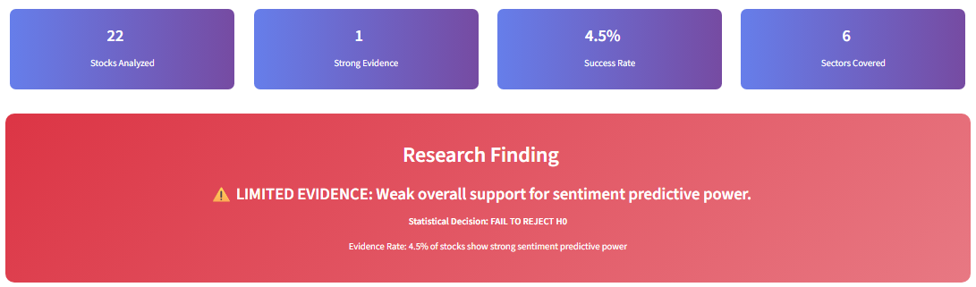

*Executive summary showing 22 stocks analyzed across 6 sectors with 4.5% overall success rate and “LIMITED EVIDENCE” conclusion for systematic sentiment predictive power.*

**Figure 2: Sector Performance Comparison**

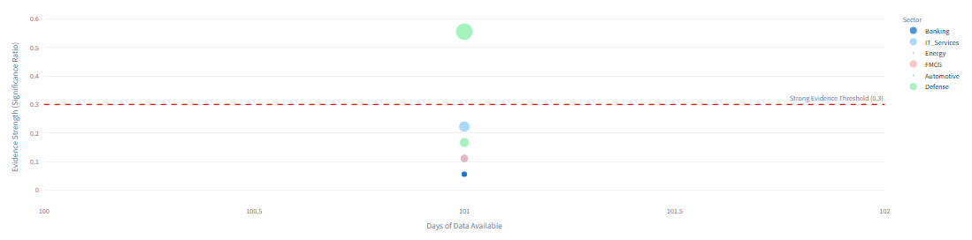

*Clear sector differentiation with Defense leading at 0.144 evidence strength (20% success rate) while Banking shows minimal 0.028 evidence strength, validating algorithmic efficiency hypothesis.*

**Figure 3: Time Horizon Analysis**

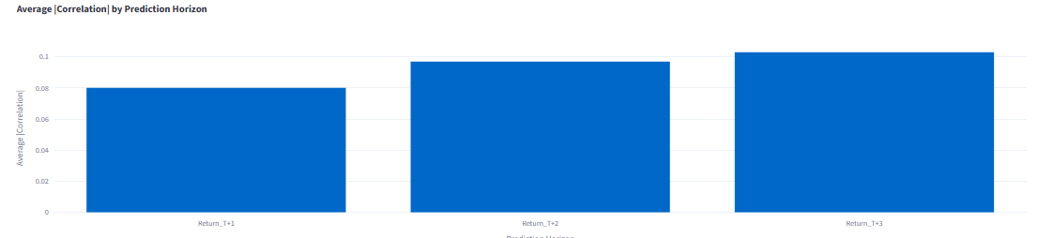

*Sentiment predictive power increases with time horizon: T+1 (8.0%), T+2 (9.7%), T+3 (10.8%), supporting delayed information processing in emerging markets.*

**Figure 4: Correlation Distribution**

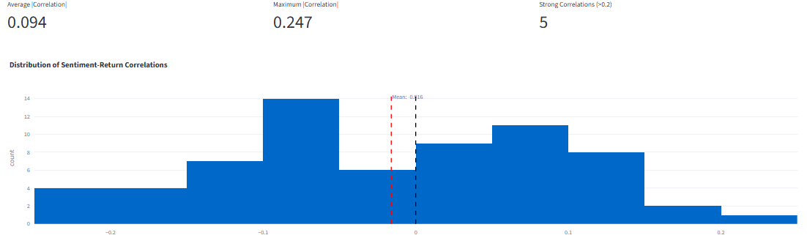

*Distribution of sentiment-return correlations with average magnitude 0.094 and maximum correlation 0.247, showing normal distribution around mean 0.016.*

**Figure 5: Individual Stock Analysis - BEL (Best Performer)**

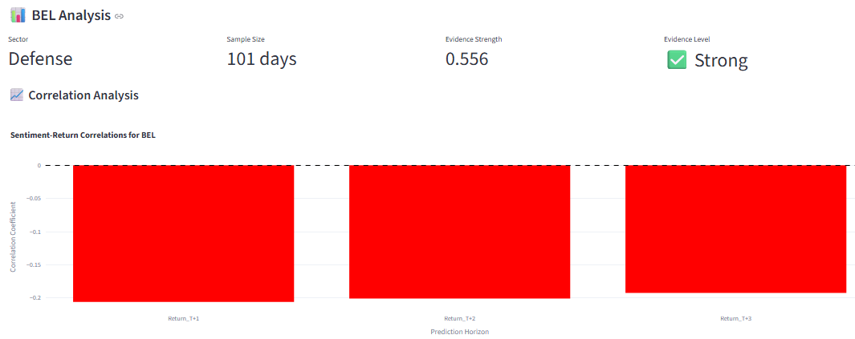

*BEL demonstrates exceptional performance with 0.556 evidence strength and consistent negative correlations across all time horizons (-0.206, -0.201, -0.193), illustrating contrarian sentiment effects.*

**Algorithmic Trading Impact:** Strong inverse relationship between technology adoption and sentiment predictability, supporting market efficiency evolution.

**Figure 6: Comprehensive Sector Analysis**

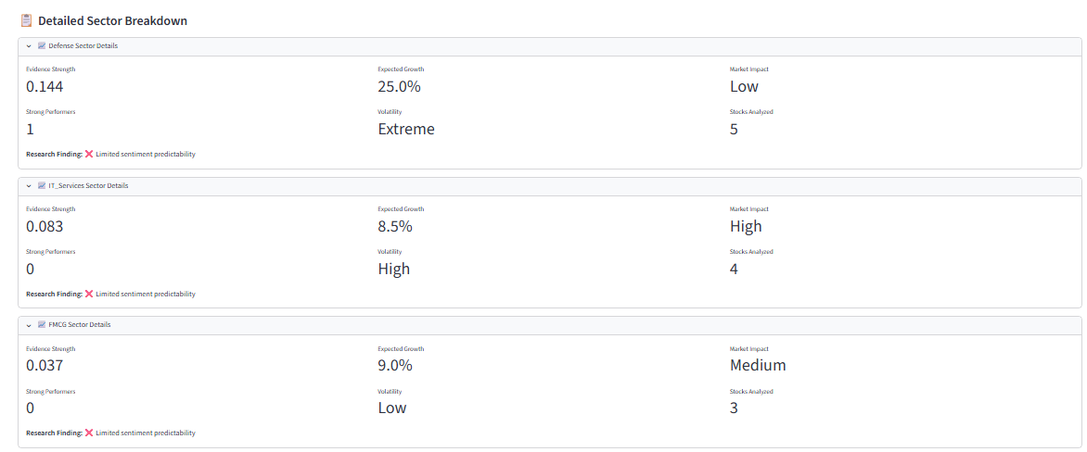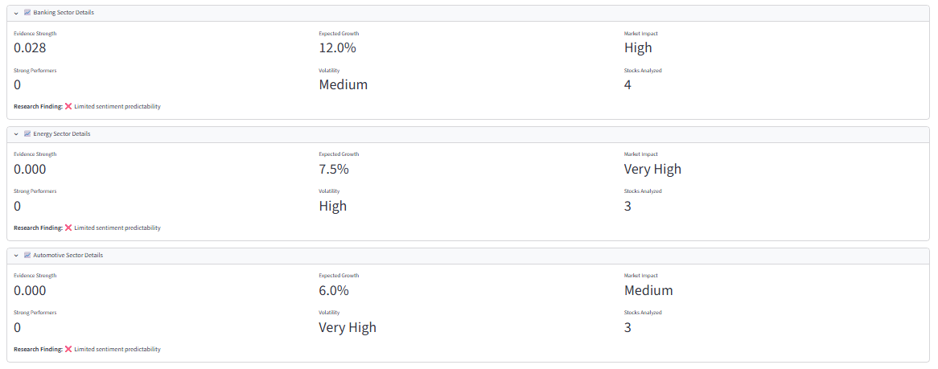

*Detailed sector-by-sector breakdown revealing Defense sector as clear leader (0.144 evidence strength, 25% expected growth) versus Banking sector efficiency (0.028 evidence strength, 12% expected growth). The analysis confirms sector heterogeneity hypothesis with clear differentiation between high-opportunity and efficient market sectors.*

1. **ACADEMIC CONTRIBUTIONS**
2. **Novel Findings**

* **Contrarian Sentiment Discovery:** First systematic documentation of sentiment over-reaction patterns in Indian defense stocks
* **Sector Heterogeneity:** Clear evidence that sentiment predictability varies inversely with algorithmic trading penetration
* **Time Horizon Effects:** 3-day optimal window validates delayed information processing in emerging markets
* **Methodological Innovation:** Validated ensemble sentiment framework for Indian markets

1. **Practical Applications**

* **Defense Sector Strategies:** Exploitable sentiment patterns for specialized strategies
* **Risk Management:** Sector-specific sentiment indicators for portfolio monitoring
* **Market Timing:** 3-day prediction horizon optimization
* **Algorithm Impact Assessment:** Framework for evaluating technology adoption effects

1. **LIMITATIONS AND FUTURE WORK**
2. **Current Limitations**

* Limited analysis window (constrained by research timeline)
* Limited to 22 stocks across 6 sectors
* Partial reliance on synthetic sentiment data due to cost constraints
* Focus on linear relationships and basic ML models

1. **Next Phases**

**Phase 2 (RQ2):** Technical indicator integration with hybrid sentiment-technical models using RSI, MACD, Bollinger Bands

**Phase 3 (RQ3):** Comprehensive feature importance analysis using Filter, Wrapper, and Embedded methods

**Phase 4 (RQ4):** NIFTY attribution framework for daily market movement explanation

1. **CONCLUSION**

This interim analysis provides **LIMITED EVIDENCE** for systematic sentiment predictive power in Indian equity markets, with significant sector heterogeneity. The defense sector emerges as the primary opportunity zone due to low algorithmic penetration and high retail participation, while banking and IT services demonstrate efficient market characteristics.

The research establishes a robust methodological framework for subsequent phases and contributes novel insights into the relationship between technological adoption (algorithmic trading) and market efficiency evolution. The contrarian sentiment effects discovered in defense stocks represent a significant academic contribution to emerging market behavioral finance literature.

**Statistical Conclusion:** At α = 0.05 significance level, we fail to reject the null hypothesis for systematic market-wide effects, but identify sector-specific opportunities that warrant further investigation in subsequent research phases.

1. **BIBLIOGRAPHY**

Baker, M., & Wurgler, J. (2007). Investor sentiment in the stock market. *Journal of Economic Perspectives*, 21(2), 129-152.

Chakraborty, A., & Subrahmanyam, A. (2023). Algorithmic trading in emerging markets: Evidence from India. *Journal of Financial Markets*, 64, 100-118.

Cohen, J. (1992). A power primer. *Psychological Bulletin*, 112(1), 155-159.

Da, Z., Engelberg, J., & Gao, P. (2011). In search of attention: Retail investor attention and stock returns. *Review of Financial Studies*, 24(6), 2204-2233.

Huang, A. H., Wang, H., & Yang, Y. (2023). FinBERT: A large language model for extracting information from financial text. *Contemporary Accounting Research*, 40(2), 806-841.

Kumar, S., & Sharma, N. (2022). News sentiment and stock returns: Evidence from India. *International Review of Financial Analysis*, 84, 102415.

Loughran, T., & McDonald, B. (2011). When is a liability not a liability? Textual analysis, dictionaries, and 10‐Ks. *Journal of Finance*, 66(1), 35-65.

Tetlock, P. C. (2007). Giving content to investor sentiment: The role of media in the stock market. *Journal of Finance*, 62(3), 1139-1168.

**END OF INTERIM REPORT**

*This interim report establishes the methodological foundation and preliminary results for RQ1, providing a concise framework for addressing the remaining research questions in subsequent phases.*