* Extract/Copy the *Executables* folder into your local storage.
* Make sure you have installed java 11 on your pc.
* Move into the *Executables* folder and open a command line window on that folder.
* Run following command (1).
  + *java -jar Distributed_Systems_Project_18-2.8.9.jar --file="inputs/input1.txt"* 
    - There are 4 inputs in the inputs folder.
    - *Input1.txt, input2.txt, input3.txt, original_input.txt*
    - Change the name according to the input file you want to run in the above command *- - file* tag.
* Then open the *frontend* folder.
* Double click on the "*frontend.html*" file. This will start the distributed system and you will be able to see log output on the console window that you run the command (1)
  + **Make sure port 8887 is free on your system.**
* On your browser window you will see visual representation of the distributed system.
* You should see a distributed system as a graph as in following figures. (You can zoom in and out as necessary to see PIDs and NODE NAMES.)

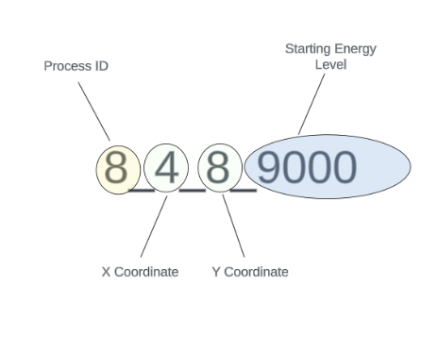How to read the front-end visualization

Cluster of nodes created according to the requirements.

Leader of the cluster

Followers of the leader

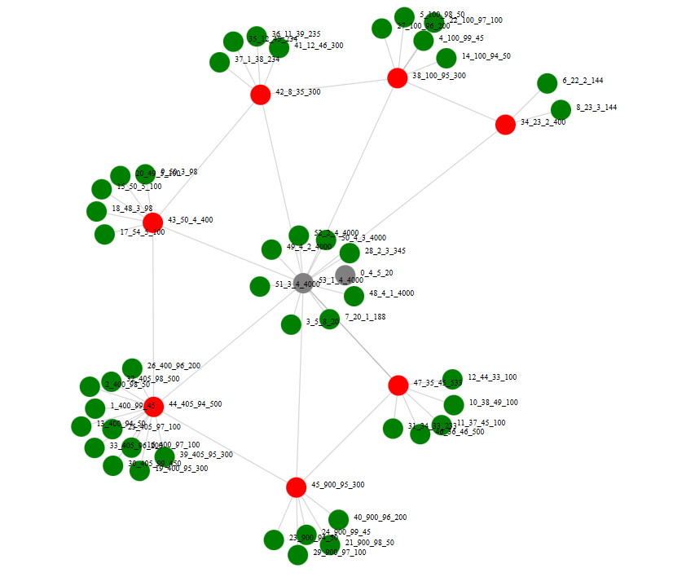Leader Election Visualization

Step - 01

Leader of this cluster is not responding/ ENERGY LEVEL is 0

LEADER PID = 53 (name=53_1_4_4000)

NEXT IDEAL CANDIDATE ACCRODING TO BULLY ALGORITHM IS NEXT HIGHEST PID = 52 (name = 52_2_4_4000)

Step - 02

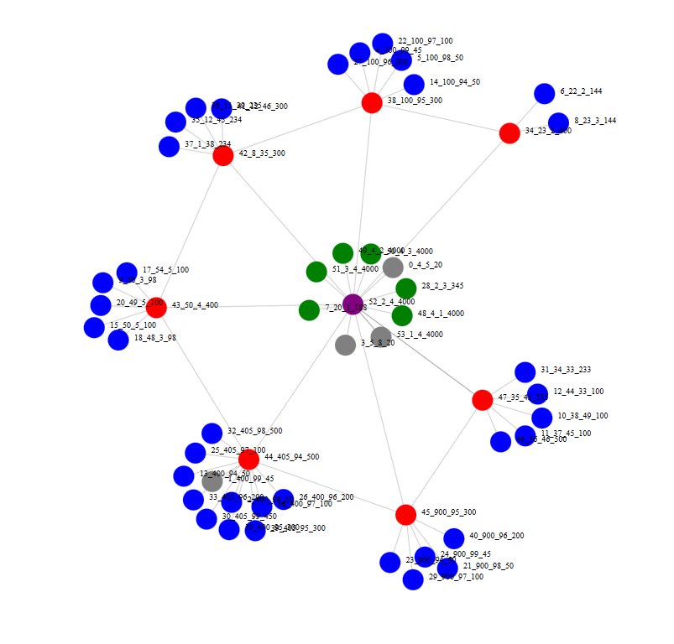

Blue means followers are received ‘BEACON’ message and they know leader is active by receiving ‘BEACON’ message from the leader. Leader will send the beacon message to all the followers in interval of 15 seconds. Followers will assume leader is not responding if ‘BEACON’ message is not received for 20 seconds or not responding to a direct message to a leader within 5 seconds. If they know leader is not responding, then who ever first realize that leader is not responding will start an election (will turn in to purple)

Next ideal candidate (52_2_4_4000) realize leader (53_1_4_4000) is not responding since ‘BEACON’ message not received from the leader (53_1_4_4000)

So, it starts an election (hence purple color) and realize that no process has PID greater than his ID in his group (every node knows who is in their group and assigned PIDs) and he make himself as the leader (hence center of the group – in the next step it will be red color)

Step - 03

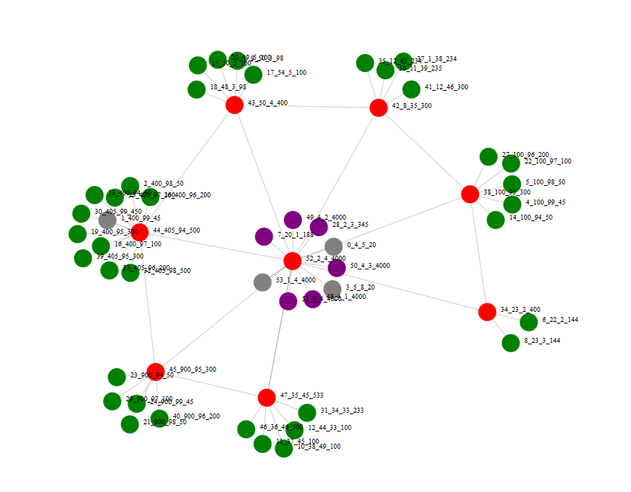

All others in the group will also start the ELECTION since their timers are 0 which triggering an election for next leader when there is no ‘BEACON’ message from the leader.

New leader – 52_2_4_4000 (in red color)

Step - 04

Then new leader will send OK to others and all other followers who have received ELECTION messages from lower PID processes will send the OK message to those processes with lower PIDs.

When process receive an OK message, it will turn into yellow color and withdraw from the ELECTION (will turn into green back again).

p.s - Processes will withdraw from ELECTION even when they received a ‘BEACON’ message or ‘COORDINATOR’ message from new leader.