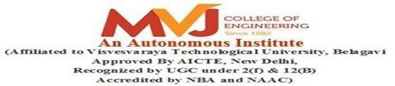

A PROJECT REPORT
ON
LANGUAGE DETECTION USING PYTHON
Submitted in partial fulfillment of requirements for the award of 6th Sem of

BACHELOR OF ENGINEERING IN
ARTIFICIAL INTELLIGENCE AND MACHINE LEARNING

Submitted By:
1MJ22AI037 | ONKAR VISHWAJEET
1MJ22AI039 | PAVANI N R
1MJ22AI043 | RAJATH KUMAR
1MJ22AI044 | RAMYA A

Under the Guidance of

Mrs. Ankitha Misra
Assistant Professor, Department of AIML

DEPARTMENT OF ARTIFICIAL INTELLIGENCE AND MACHINE LEARNING

MVJ COLLEGE OF ENGINEERING
BANGALORE-67 ACADEMIC YEAR 2025-26


MVJ COLLEGE OF ENGINEERING

Near ITPB, Whitefield, Bangalore-67

DEPARTMENT OF ARTIFICIAL INTELLIGENCE AND MACHINE LEARNING

CERTIFICATE

This is to certify that the mini-project work, entitled “LANGUAGE DETECTION USING PYTHON” is a Bonafide work carried out in partial fulfillment for the award of degree of Bachelor of Engineering in Computer Science & Engineering during the academic year 2025-26. It is certified that all the corrections/suggestions indicated for Internal Assessment have been incorporated in the Report. The mini project report has been approved as it satisfies the academic requirements.

Signature of the Guide Signature of the HOD
Mrs. Ankitha Misra Mrs. Susmitha
Assistant Professor, Dept of AIML

Name of examiners: Signature with date: 1.
2.

MVJ COLLEGE OF ENGINEERING

Whitefield, Near ITPB, Bangalore-67

DEPARTMENT OF ARTIFICIAL INTELLIGENCE AND MACHINE LEARNING

DECLARATION
We hereby declare that the entire work titled “LANGUAGE DETECTION USING PYTHON” embodied in this mini project report has been carried out by me during the 6th semester of BE degree at MVJCE, Bangalore under the esteemed guidance of Mrs. Ankitha Misra, Assistant Prof, Dept. of AIML, MVJCE. The work embodied in this dissertation work is original and it has not been submitted in part or full for any other degree in any University.
1MJ22AI037
1MJ22AI039
1MJ22AI043
1MJ22AI044
ONKAR VISHWAJEET
PAVANI N R
RAJATH KUMAR
RAMYA A

Place: Date:

ABSTRACT

With the rapid growth of digital communication and globalization, people frequently interact across different languages and cultures. This increasing diversity presents a challenge in understanding and translating languages instantly and accurately. To address this, Natural Language Processing (NLP) technologies have become crucial, especially for real-time language detection and translation. This project, titled "Language Detection and Translation Web Application", is a demonstration of how such NLP techniques can be implemented in a practical, user-friendly way using modern web technologies.
The project is designed as a web-based application where users can input any text and perform two key operations: detect the language of the entered text and translate it into a different language of their choice. This is particularly useful in situations like interpreting online content, understanding foreign language communication, or assisting users with minimal knowledge of a language.
The backend of the application is built using Python with Flask, a lightweight web framework. It handles the core NLP tasks such as language detection using libraries like langdetect and translation using googletrans, both of which provide accurate results with minimal setup. The frontend is created using HTML, CSS, and JavaScript, offering a clean, responsive, and interactive user interface that can run on any modern web browser.
The application architecture ensures a seamless connection between the user interface and backend processing, using asynchronous calls to provide quick results without page reloads. Users can enter text into a provided text area, click a button to detect the language, and then choose a target language from a dropdown menu to get the translated output.
This project not only demonstrates the application of NLP in solving real-world communication problems but also introduces core concepts in web development and system integration. It showcases how simple tools can be combined to build intelligent applications that bridge language gaps and enhance accessibility for users across the world.

ACKNOWLEDGEMENT

The satisfaction and euphoria that accompany the successful completion of any task would be incomplete without the mention of people who made it possible, success is the epitome of hard work and perseverance, but steadfast of all is encouraging guidance.

So, with gratitude we acknowledge all those whose guidance and encouragement served as beacon of light and crowned our effort with success.

We are thankful to Dr. Ajayan K R, Principal of MVJCE for his encouragement and support throughout the project work.

We are thankful to Mr. Kumar R, Controller Of Examinations, for his encouragement and support throughout the project work.

We are also thankful to Mrs. Susmitha, HOD, CSE Department for his incessant encouragement & all the help during the project work.

We consider it a privilege and honor to express our sincere gratitude to our guide Mrs. Ankitha Misra, Assistant Professor, AIML Department for her valuable guidance throughout the tenure of this project work, and whose support and encouragement made this work possible.

It is also an immense pleasure to express our deepest gratitude to all faculty members of our
department for their cooperation and constructive criticism offered, which helped us a lot during our project work.

Finally, we would like to thank all our family members and friends whose encouragement and support was invaluable.

Thanking You

TABLE OF CONTENTS

Abstract i
Acknowledgement ii
Table of content iii
List of Figures iv
CHAPTER 1: INTRODUCTION 01
CHAPTER 2: LITERATURE SURVEY 02-03
CHAPTER 3: PROBLEM ANALYSIS 04
CHAPTER 4: EXISTING AND PROPOSED SYSTEM 05-06
CHAPTER 5: HARDWARE AND SOFTWARE REQUIREMENTS 07
CHAPTER 6: IMPLEMENTATION 08-09
CHAPTER 7: RESULTS 10-12
CHAPTER 8: APPLICATIONS 13
CHAPTER 9: ADVANTAGES AND DISADVANTAGES 14-15
CONCLUSION 16
FUTURE ASPECTS 17
REFERENCES 18

LIST OF FIGURES

- Home Page 10

- Result Page 11

- Flask Backend 12

CHAPTER 1

INTRODUCTION

Language plays a vital role in human communication, and in a diverse, multilingual world, the ability to understand and translate different languages has become increasingly important. As people interact across countries and cultures, there is a growing demand for intelligent systems that can break down language barriers and make communication more accessible.
Natural Language Processing (NLP), a field within Artificial Intelligence (AI), focuses on enabling machines to understand, interpret, and generate human language. One of the widely used applications of NLP is automatic language detection and translation. These technologies are used in various areas such as global customer support, multilingual websites, social media monitoring, and educational tools.
This project aims to develop a simple yet effective web application that can automatically detect the language of an input text and translate it into another language selected by the user. The system uses Python as the primary programming language and leverages powerful NLP libraries for both detection and translation tasks. The web interface is built using HTML, CSS, and JavaScript, while Flask is used as the backend framework to connect the frontend with the core processing logic.
The primary motivation behind this project is to demonstrate how basic NLP tasks can be implemented in a real-world application using open-source tools and a lightweight technology stack. It also helps in understanding the integration of frontend and backend development, RESTful APIs, and the handling of user input and output in a dynamic web environment.
This report describes the entire development process of the application, including the tools and libraries used, implementation steps, challenges faced, and final results. It serves as a demonstration of how language detection and translation can be automated effectively using modern programming practices and technologies.

CHAPTER 2

LITERATURE SURVEY

PAPER 1: Language Identification in the Wild: A Benchmark for Downstream Applications

AUTHORS: A. Jauhiainen, M. Lui, M. Zampieri, T. Baldwin, K. Lindén

PUBLISHED ON: August 2019

This paper presents a comprehensive benchmark for evaluating language identification systems in real-world settings. The authors explore the limitations of existing models in dealing with noisy, multilingual, and short texts such as those from social media and user-generated content. They introduce a new dataset that mimics real-life scenarios and evaluate various machine learning approaches. The findings highlight that traditional models often fail in complex multilingual environments, and more robust models are required for practical applications.

PAPER 2: Google's Neural Machine Translation System: Bridging the Gap between Human and Machine Translation

AUTHORS: Yonghui Wu, Mike Schuster, Zhifeng Chen, Quoc V. Le, Mohammad Norouzi, et al.

PUBLISHED ON: September 2016

This influential paper describes Google’s switch from phrase-based translation to Neural Machine Translation (NMT). The authors introduce an end-to-end deep learning model based on encoder-decoder architecture with attention mechanism. The model significantly improved translation quality across multiple languages by capturing broader context and reducing translation errors. The paper is considered a landmark in neural translation systems and showcases how deep learning can outperform traditional statistical methods.

PAPER 3: Compact Language Detector 2: Robust Language Identification in 83 Languages
AUTHORS: Google Inc.
PUBLISHED ON: Open-sourced in 2016
This paper/documentation explains the design and performance of CLD2 (Compact Language Detector 2), a fast and efficient language identification library developed by Google. It is widely used in Chrome and other services. CLD2 uses Naive Bayes classifiers trained on large corpora and supports detection of over 80 languages. Though it performs well for larger texts, the paper notes that its accuracy decreases for very short or mixed-language inputs, making it less effective in some real-world use cases.

PAPER 4: Language Detection Using NLP and Machine Learning
AUTHORS: Shalini R., N. S. Nithya
PUBLISHED ON: International Journal of Engineering Research & Technology (IJERT), May 2020
This paper explores various NLP techniques combined with machine learning algorithms to perform language detection. It evaluates multiple classifiers including Support Vector Machines (SVM), Naive Bayes, and Decision Trees using features like character n-grams and word frequency. The study concludes that with appropriate feature extraction and training, even lightweight models can achieve decent accuracy in language identification tasks.

CHAPTER 3

PROBLEM ANALYSIS

In today’s globalized digital landscape, communication across different languages has become an essential need. Despite the widespread use of the internet, language remains a major barrier for users trying to access content or interact with services not available in their native language. While there are tools like Google Translate, they are not always easily integrable into custom applications or tailored for specific user needs.
The problem arises when users need to identify the language of a given text and translate it seamlessly into another language of their choice without switching platforms. Manual language detection and translation are time-consuming, inefficient, and not feasible for real-time applications.
There is a clear need for a simple, intuitive, and efficient system that:
- Automatically detects the language of any given text input.
- Accurately translates the text into a language selected by the user.
- Can be accessed easily through a web interface without complex setup.
Therefore, this project aims to design and develop a web-based application that detects the language of user input using Natural Language Processing (NLP) techniques and then translates it into a target language chosen by the user, providing a real-time, user-friendly, and accurate translation experience.

CHAPTER 4

EXISTING SYSTEM

Currently, there are several tools and platforms available that provide language detection and translation services. Some of the most widely used systems include:
1. Google Translate
A powerful multilingual tool that supports over 100 languages. It provides language detection and translation capabilities through its website and APIs.
2. Microsoft Azure Translator
A cloud-based translation service that supports real-time translation and language identification for enterprise-level applications.
3. Amazon Translate
A neural machine translation service that supports several major languages with real-time translation capabilities.
Language Detection APIs (e.g., langdetect, fastText)
Open-source Python libraries that allow developers to detect the language of a given text input programmatically

PROPOSED SYSTEM

The proposed system is a lightweight, web-based application that performs language detection and translation using Python and Natural Language Processing (NLP) libraries. It allows users to input any text, automatically detects the language, and provides the translated version in the target language selected by the user.
This system is developed using:
- Flask for the backend server
- HTML, CSS, and JavaScript for the frontend
- langdetect for identifying the language of the input text
- translate or similar Python libraries for text translation
The user interface is simple and intuitive, allowing non-technical users to interact with the system without requiring any installation or setup. The application is self-contained and can be deployed locally or hosted on a lightweight cloud platform.

ADVANTAGES OF PROPOSED SYSTEM:

- User-Friendly Interface
The system features a clean and minimalistic design that makes it easy to use even for users with no technical background.
- Customizable and Lightweight
Unlike commercial APIs, this system is open and customizable. Developers can modify the interface, add languages, or extend functionalities without external dependencies.
- No Third-Party API Costs
The solution uses open-source libraries, which eliminates the need for paid API services and makes it ideal for student and research projects.
- Quick Deployment and Offline Use
The system can run on a local server without needing internet access after installation, which makes it suitable for educational environments or limited-network settings.

CHAPTER 5

HARDWARE AND SOFTWARE REQUIREMENTS
  - Hardware Requirements:
- Processor: A high-performance CPU such as Intel i3 or above, or an equivalent AMD Ryzen processor, to handle the computations efficiently.
- RAM: At least 8 GB to ensure smooth handling of large datasets and model training processes.
- Storage: Minimum 256 GB SSD for fast data retrieval, along with additional storage for datasets.
- Display: A standard monitor for visualizing the interface and results.
- Peripherals: Keyboard, mouse, and a stable internet connection for downloading datasets, libraries, and frameworks.
  - Software Requirements:

- Operating System: Windows 10 or later, Ubuntu 20.04, or any Linux distribution.
- Programming Language: Python 3.8 or later for implementing the deep learning model and backend logic.
- Web Framework: Flask for creating the web-based interface.
- Libraries and Tools: langdetect, translate, Flask, request.
- Integrated Development Environment (IDE): PyCharm, Jupyter Notebook, or Visual Studio Code for writing and debugging code.
- Browser: Google Chrome, Mozilla Firefox, or any modern browser for accessing the web application locally.

CHAPTER 6

IMPLEMENTATION

The implementation of the project is divided into three main components: Frontend, Backend, and Language Processing Logic. Each component works together to deliver a smooth user experience for detecting and translating text input.

1. Frontend (User Interface)
Technologies Used: HTML, CSS, JavaScript
- A clean and responsive web page was created where the user can:
- Enter the text in a textbox
- Click on a button to detect the language
- Select a target language from a dropdown
- Click another button to translate the input text
Features:
- Responsive design
- Simple layout
- Real-time feedback with no page reloads (AJAX-style using fetch API)

2. Backend (Flask Server)
Technology Used: Python with Flask Framework
- The Flask app handles:
- Route /detect for language detection
- Route /translate for translating text
- Parsing incoming POST requests
- Returning results in JSON format to the frontend
- The backend processes are lightweight and respond quickly to requests.

3. Language Detection and Translation Logic
Libraries Used:
- langdetect → For detecting the input language
- translate → For translating the text to the selected language
Steps:
- The input text from the user is sent to the server.
- The server detects the language using langdetect.detect().
- If translation is requested, the translate.Translator() is used to convert the input text into the target language.
- The response is sent back and displayed on the webpage.

CHAPTER 7

HOME PAGE:
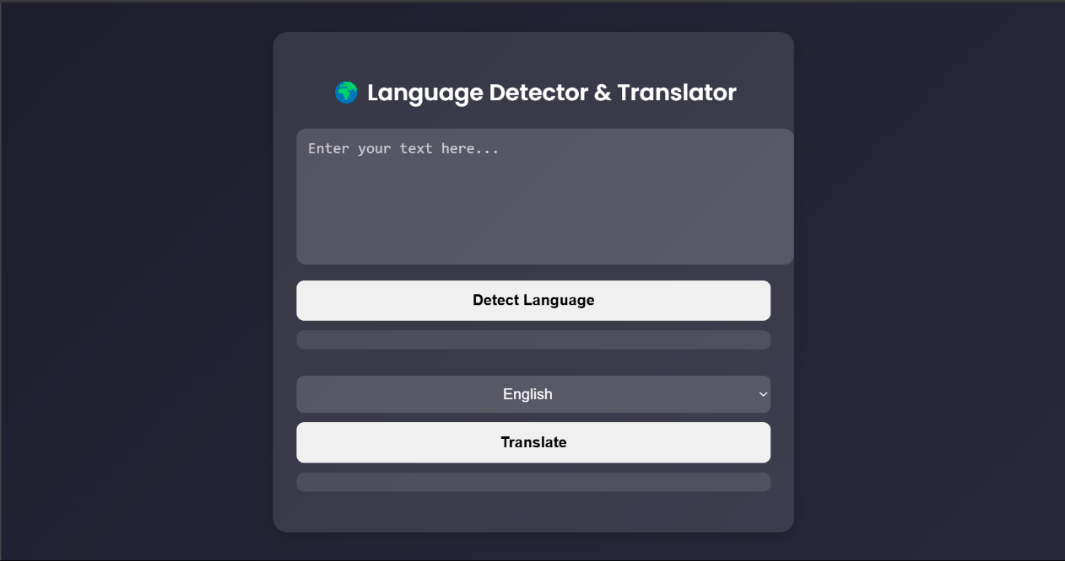
RESULTS

Fig 7.1: Home Page

When the Flask application is executed in the code editor, it redirects you to a localhost server. The homepage is clean, minimal, and easy to use. The app allows the user to input text, detect the language of the text, and then translate it into a desired target language.

RESULT PAGE:
m
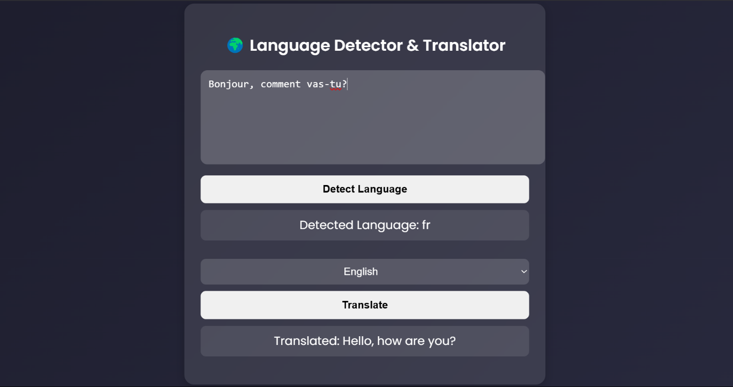

Fig 7.2: Result Page

On the Results page, the inputted text is detected as fr (French) and the user can also translate the text to find out what the actual text was in the language they understand

FLASK BACKEND:
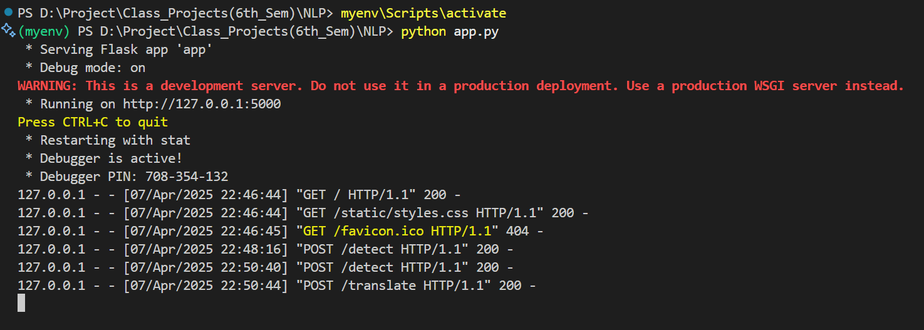
Fig 7.3: Flask Backend

The backend of this project features a Flask application that processes the text by providing it with the detect function and translate function.

CHAPTER 8

APPLICATIONS

The Language Detection and Translation Web App is a lightweight yet powerful tool that finds practical use across a variety of domains where multi-language communication is required. Below are some key application areas:

1. Educational Platforms
Can be integrated into e-learning websites to help students understand content written in unfamiliar languages.
Useful language learning apps to detect and translate phrases for practice.

2. Customer Support & Chatbots
Used in customer service platforms to auto-detect a user’s language and translate responses accordingly.
Improves communication in multi-national service systems.

3. Travel & Tourism
Assists travelers by translating foreign text (e.g., signs, menus) into their native language.
Helpful in mobile apps for tour guides or travel assistants.

4. Blogging and Content Management
Bloggers and content creators can use the tool to detect the original language of user-submitted comments or articles and translate them for moderation or engagement.

CHAPTER 9
ADVANTAGES AND DISADVANTAGES

  - Advantages:

- Multi-Language Support
The app can detect and translate multiple languages with ease using lightweight NLP libraries.

- User-Friendly Interface
Simple, intuitive design ensures smooth interaction for users of all technical levels.

- Real-Time Language Processing
Quick language detection and translation without requiring page reloads or delays.

- Cross-Platform Accessibility
Being a web-based app, it runs on any device with a browser (mobile, tablet, PC).

- Lightweight and Easy to Deploy
Built with Flask and simple Python libraries, it can be deployed quickly on platforms like Heroku or Render.

- Educational and Practical Use
Great for learning environments, customer service, or even travellers needing quick translations.

  - Disadvantages:

- Limited Accuracy for Complex Sentences
Language detection may struggle with very short, ambiguous, or slang-heavy text.
- Dependency on External Libraries
Relies on third-party libraries like langdetect and translate which may have occasional inconsistencies.
- No Voice or Image Input
The system only works with text input and doesn’t support speech or image-based language recognition.
- No Offline Functionality
Requires internet connection as the translation and detection libraries fetch models or services online.
- Limited Customization for Domain-Specific Terms
Not suitable for industry-specific jargon (medical, legal, etc.) without additional training or customization.

CONCLUSION

The Language Detection and Translation Web App successfully demonstrates how Natural Language Processing (NLP) can be used to build simple yet effective tools for real-world applications. The system provides users with the ability to detect the language of any given text and translate it into a target language of their choice, all within a user-friendly and responsive web interface.
By integrating libraries like langdetect and translate within a lightweight Flask framework, the project achieves real-time performance with minimal resource usage. It proves particularly useful in a variety of domains such as education, travel, customer support, and social media, where multilingual communication is essential.
While the current system offers a strong foundation, it also opens the door for future improvements such as integrating speech or image input, adding more language support, and enhancing translation accuracy through the use of advanced machine learning models.
Overall, this project is a practical example of how core NLP techniques can be applied in building accessible and helpful applications that bridge communication gaps across languages.

FUTURE ASPECTS

While the current version of the Language Detection and Translation Web App is functional and serves its purpose, there are several ways it can be improved and expanded in the future:
- Speech-to-Text Integration
Adding voice input support will allow users to speak and get real-time detection and translation, making the app more interactive and inclusive.
- Image-based Text Detection (OCR)
Optical Character Recognition (OCR) can help detect and translate text from uploaded images (like signs, documents, etc.).
- More Language Options
Expanding the number of supported languages will make the tool more versatile and globally usable.
- Context-Aware Translation
Future versions can include context-based translation using AI models like BERT or GPT to improve the quality and accuracy of the output.
- Offline Mode
Introducing offline capabilities using local models or browser storage will allow users to access basic features without internet connectivity.
- Mobile Application Development
Creating Android and iOS versions will expand the accessibility of the tool to mobile users.
- Text-to-Speech Output
Giving users the ability to listen to the translated text can enhance usability for visually impaired users or in pronunciation learning.
- Translation History & Save Feature
Users can view and save their previous translations for future reference or educational purposes.

REFERENCES

    - Lui, M., & Baldwin, T., “langid.py: An Off-the-shelf Language Identification Tool,” Proceedings of the ACL 2012 System Demonstrations, 2012.
    - Joulin, A., Grave, E., Bojanowski, P., Mikolov, T., “Bag of Tricks for Efficient Text Classification,” Proceedings of the 15th Conference of the European Chapter of the Association for Computational Linguistics, 2017.
    - Abouelnaga, Y., & Al-Kabbany, A., “A Hybrid Deep Learning Model for Automatic Language Identification,” International Journal of Advanced Computer Science and Applications (IJACSA), 2020.
    - Tiedemann, J., “Parallel Data, Tools and Interfaces in OPUS,” Proceedings of the 8th International Conference on Language Resources and Evaluation (LREC), 2012.
    - Schwenk, H., & Douze, M., “Learning Joint Multilingual Sentence Representations with Neural Machine Translation,” arXiv preprint arXiv:1704.04154, 2017.
    - Lison, P., & Tiedemann, J., “OpenSubtitles2018: Statistical Rescoring of Sentence Alignments in Large, Noisy Parallel Corpora,” Proceedings of the Eleventh International Conference on Language Resources and Evaluation (LREC), 2018.
    - Devlin, J., Chang, M. W., Lee, K., & Toutanova, K., “BERT: Pre-training of Deep Bidirectional Transformers for Language Understanding,” arXiv preprint arXiv:1810.04805, 2018.
    - Bahdanau, D., Cho, K., & Bengio, Y., “Neural Machine Translation by Jointly Learning to Align and Translate,” arXiv preprint arXiv:1409.0473, 2014.
    - Wu, Y., Schuster, M., Chen, Z., et al., “Google’s Neural Machine Translation System: Bridging the Gap between Human and Machine Translation,” arXiv preprint arXiv:1609.08144, 2016.
    - Pedregosa, F., Varoquaux, G., Gramfort, A., et al., “Scikit-learn: Machine Learning in Python,” Journal of Machine Learning Research, 2011.

