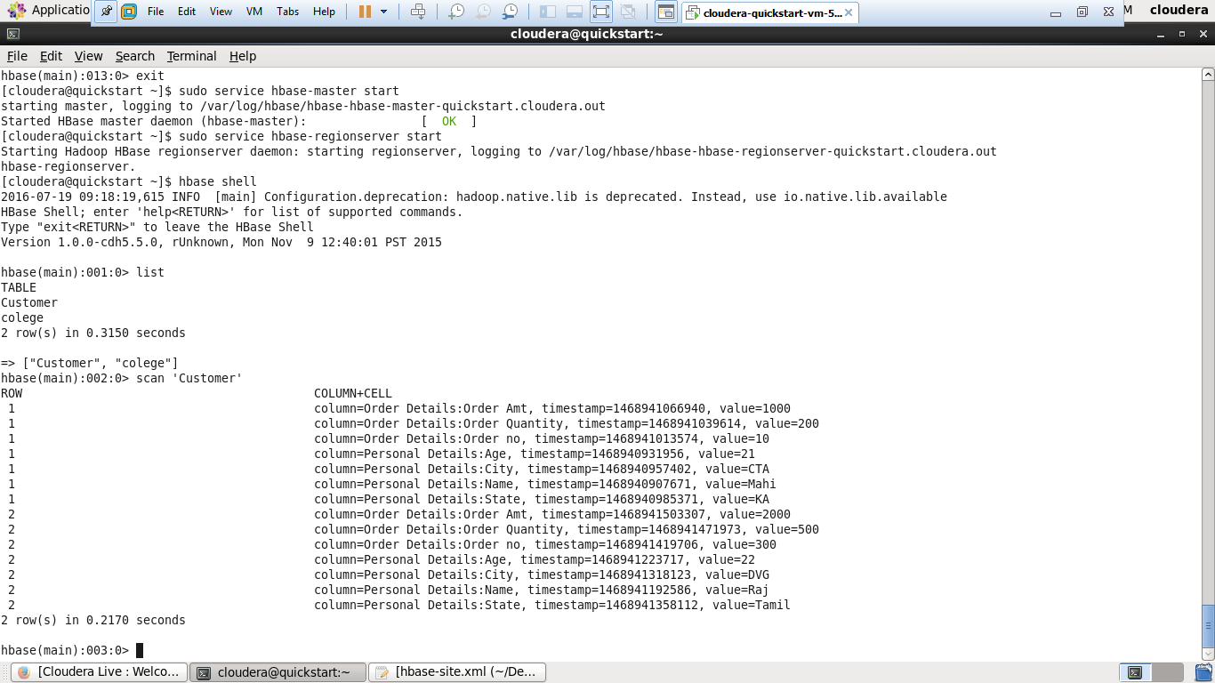
1. Create the table customer with two column families
• Personal details and order details as column families
• Create a unique number as row key (ssn/Adhar no.,etc)
• Insert at least 10 records to each column
• Insert following values for personal details column family
Name, age, city, state
• Insert following values for order details column family
Order no., order quantity, and order amount
• Use put command to insert the values for each record.
• Use get command, to retrieve all the records of single customer.

