select * from emp where salary=(select max(salary) from emp);

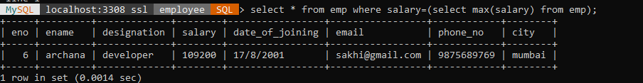

select * from emp where salary=109200;



alter table emp add column department varchar(30);

select * from emp;

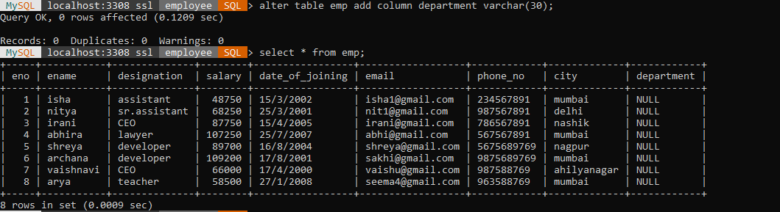

update emp set department='bcs' where eno=1;

update emp set department='bca' where eno=2;

Query OK, 1 row affected (0.0114 sec)

update emp set department='mca' where eno=3;

Query OK, 1 row affected (0.0134 sec)

update emp set department='mcs' where eno=4;

Query OK, 1 row affected (0.0144 sec)

update emp set department='bcs' where eno=5;

update emp set department='bcom' where eno=6;

Query OK, 1 row affected (0.0131 sec)

update emp set department='ba' where eno=7;

Query OK, 1 row affected (0.0130 sec)

update emp set department='bcs' where eno=8;

Query OK, 1 row affected (0.0147 sec)

select * from emp;

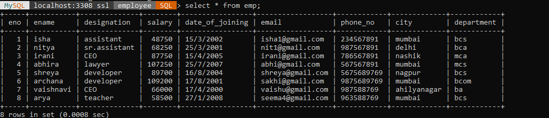

select count(*), department from emp group by department;



select department,sum(salary) as total_salary from emp group by department;

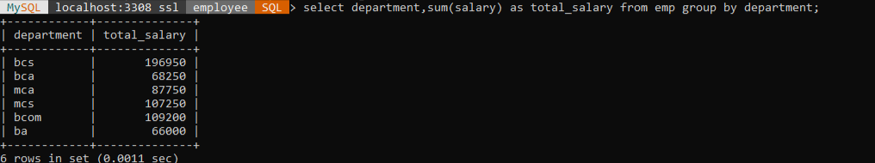

select ename,department from emp group by department,ename;

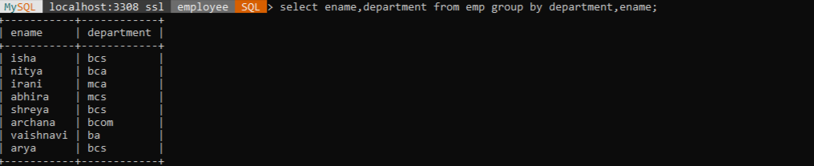

select sum(salary) as salry, department from emp group by department;

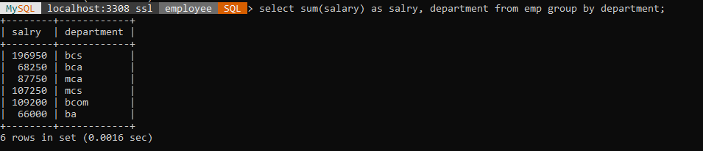

SELECT * FROM emp WHERE salary = (SELECT MIN(salary) FROM emp WHERE city IN ('Pune', 'Mumbai') AND (ename LIKE '%a%' OR ename LIKE '%i%'));

