1. Create a RDB in 3 NF with appropriate data types and Constraints. Emp(eno ,ename ,designation ,salary, Date_Of_Joining) Dept(dno,dname ,loc) The relationship between Dept & Emp is one to not be NULL, salary must be greater than 0 . many. Constraints: Primary Key, ename should

Create database:

create database relationship;

use relationship;

create table:

create table dept(dno int primary key,dname varchar(20),loc varchar(10));

insert values:

insert into dept values(101,'computer','pune');

insert into dept values(102,'computer science','mumbai');

insert into dept values(103,'Quality','mumbai');

select * from dept;

+-----+------------------+--------+

| dno | dname | loc |

+-----+------------------+--------+

| 101 | computer | pune |

| 102 | computer science | mumbai |

| 103 | Quality | mumbai |

+-----+------------------+--------+

create table emp(eno int primary key,ename varchar(20),designation varchar(20),salary int,date_of_joining varchar(20),dno int references dept(dno));

insert into emp values(1,'Mr.Advait','Assistant',54000,'23/03/2002',101);

insert into emp values(2,'Mr.Roy','ceo',50000,'15/06/2019',102);

insert into emp values(3,'Mr.Abhay','manager',60000,'10/06/2013',102);

insert into emp values(4,'Mr.Raghav','manager',420000,'01/03/2003',103);

select * from emp;

+-----+-----------+-------------+--------+-----------------+-----+

| eno | ename | designation | salary | date_of_joining | dno |

+-----+-----------+-------------+--------+-----------------+-----+

| 1 | Mr.Advait | Assistant | 54000 | 23/03/2002 | 101 |

| 2 | Mr.Roy | ceo | 50000 | 15/06/2019 | 102 |

| 3 | Mr.Abhay | manager | 60000 | 10/06/2013 | 102 |

| 4 | Mr.Raghav | manager | 420000 | 01/03/2003 | 103 |

+-----+-----------+-------------+--------+-----------------+-----+

1. Add column phone_No into Emp table with data type int.

alter table emp add column phone_no int(11);

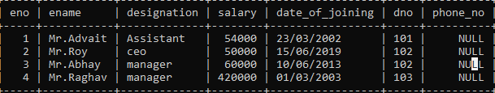

2.update phone details.

update emp set phone_no=123456789 where eno=1;

update emp set phone_no=987654327 where eno=2;

update emp set phone_no=234564327 where eno=3;

update emp set phone_no=876564327 where eno=4;

select * from emp;

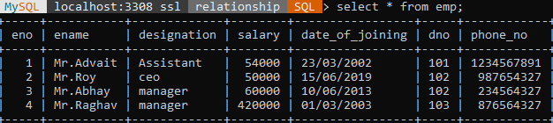

3.Delete the details of Employee whose designation is ‘Manager’.

delete from emp where designation='manager';

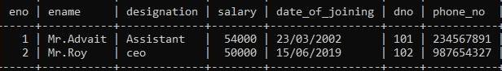

4.Display the count of employees department wise

select count(eno),dname from emp,dept where emp.dno=dept.dno group by dname;

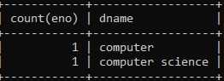

5. Display the name of employee who is ‘Manager’ of “Account Department”

select ename from emp,dept where emp.dno=dept.dno and designation='manager' and dname='Account';

Empty set (0.0007 sec)

6. Display the name of department whose location is “Pune” and “Mr. Advait” is working in it

select dname from dept ,emp where dept.dno=emp.dno and loc='pune' and ename='Mr.Advait';

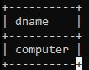

7. Display the names of employees whose salary is greater than 50000 and “Quality”. department is

select ename from emp,dept where emp.dno=dept.dno and salary>50000 and dname='Quqlity';

Empty set (0.0010 sec)

OR

select ename from emp,dept where emp.dno=dept.dno and salary>50000 and dname='computer';

+-----------+

| ename |

+-----------+

| Mr.Advait |

+-----------+

1 row in set (0.0008 sec)

8. Update Dateofjoining of employee to ‘15/06/2019’ whose department is ‘computer science’ and name is “Mr. Roy’.

update emp set date_of_joining='15/06/2019' where ename='Mr.Roy' and dno in(select dno from dept where dname='computer science');

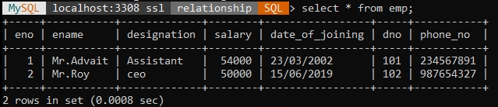

*********************************************************************************************************************

********************************************************************************************************************

Q2.Consider the following entities and their relationships. Create aRDB in 3 NF with appropriate data types and Constraints. [15 Marks]

Sales_order (ordNo, ordDate)

Client (clientNo, ClientName, addr)

The relationship between Client & Sales_order is one-to-many.

Constraints: - Primary Key, ordDate should not be NULL

create table client1(cno varchar(10) primary key,cname varchar(20),addr varchar(20));

desc client1;

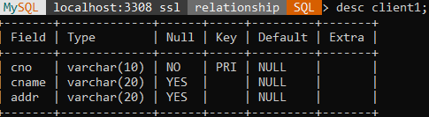

insert into client1 values('CN001','Abhay','Pune');

insert into client1 values('CN002','Patil','Pune');

insert into client values('CN003','Mr.Roy','Pimpri');

insert into client1 values('CN004','Raj','Mumbai');

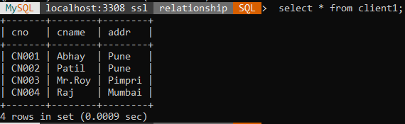

create table sales_order(ordno int primary key,ordDate varchar(23) not null,cno varchar(10) references client(cno));

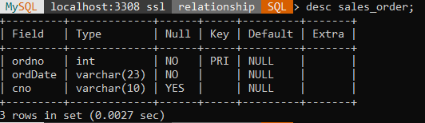

insert into sales_order values(1,'23/06/2015','CN001');

insert into sales_order values(2,'09/03/2019','CN002');

insert into sales_order values(3,'09/08/2009','CN004');

insert into sales_order values(4,'09/08/2019','CN002');

select * from sales_order;

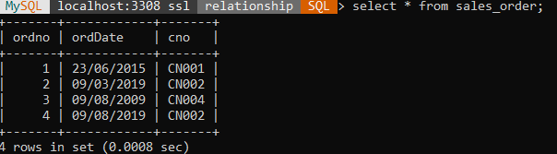

1. Add column amount into sales_amt table with data type float.

alter table sales_order add amount float;

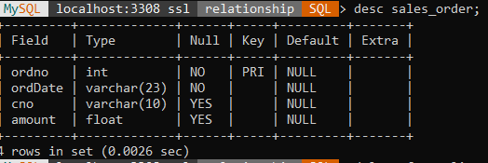

1. Delete the details of the clients whose names start with ‘A’ character.

delete from client1 where cname like'A%';

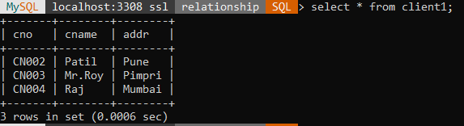

1. Delete sales order details of client whose name is “Patil” and order date is “09/08/2019”

delete from sales_order where ordDate='09/08/2019'and cno in(select cno from client1 where cname='Patil');

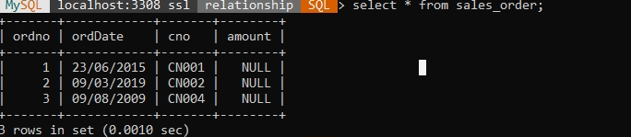

1. Change order date of client_No ‘CN001’ ‘18/03/2019’.

update sales_order set ordDate='18/03/2019' where cno='CN001';

select * from sales_order;

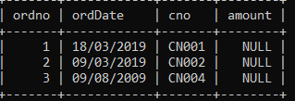

1. Delete all sales_record having order date is before ‘10 /02/2018’

delete from sales_order where ordDate<'18/10/2019';

select * from sales_order;

Empty set (0.0009 sec)

1. ) Update the address of client to “Pimpri” whose name is ‘Mr. Roy’

update client1 set addr='pimpri'where cname='Mr.Roy';

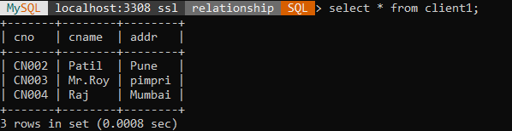

1. diplay totals orders beween 1jan2022 to 31 jan 2022

select count(*) as total from client1 ,sales_order where client1.cno=sales_order.cno and ordDate between '09/03/2019' and '23/06/2015';

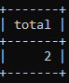

1. diplay totals sale amount beween 1jan2022 to 31 jan 2022

SELECT SUM(amount) AS total_sales FROM sales_order WHERE ordDate BETWEEN '23/06/2015' AND '09/03/2019';

+-------------+

| total_sales |

+-------------+

| NULL |

+-------------+

9. diplay total no of customers from pune location

select * from client1 where addr='pune';

+-------+-------+------+

| cno | cname | addr |

+-------+-------+------+

| CN002 | Patil | Pune |

+-------+-------+------+

1 row in set (0.0007 sec)

******************************************************************************************************************************

Q3. Consider the following entities and their relationships. Create a RDB in 3 NF with appropriate data types and Constraints. Hospital (hno ,hname , city, Est_year, addr) Doctor (dno , dname , addr, Speciality,salary) The relationship between Hospital and Doctor is one to Many Constraints: 5 Primary Key, Est_year should be greater than 1990

Create table:

create table hospital(hno int primary key,hname varchar(20),city varchar(20),est_year numeric(4) check(est_year>1990),addr varchar(20));

desc hospital;

+----------+--------------+------+-----+---------+-------+

| Field | Type | Null | Key | Default | Extra |

+----------+--------------+------+-----+---------+-------+

| hno | int | NO | PRI | NULL | |

| hname | varchar(20) | YES | | NULL |

| city | varchar(20) | YES | | NULL | |

| est_year | decimal(4,0) | YES | | NULL |

| addr | varchar(20) | YES | | NULL | |

+----------+--------------+------+-----+---------+-------+

insert values:

insert into hospital values(101,'balaji','pune',1993,'kharadi road');

insert into hospital values(103,'vedant','mumbai',1993,'dharavi');

insert into hospital values(104,'ruby','pimpri',1993,'kharadi road');

insert into hospital values(105,'birla','chinchwad',1993,'tyr');

insert into hospital values(106,'qw','pune',1993,'kalptaru');

select * from hospital;

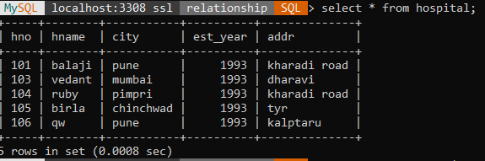

create table doctor(dno int primary key,dname varchar(20),addr1 varchar(20),speciality varchar(20),hno int references hospital(hno));

desc doctor;

+------------+-------------+------+-----+---------+-------+

| Field | Type | Null | Key | Default | Extra |

+------------+-------------+------+-----+---------+-------+

| dno | int | NO | PRI | NULL | |

| dname | varchar(20) | YES | | NULL | |

| addr1 | varchar(20) | YES | | NULL | |

| speciality | varchar(20) | YES | | NULL | |

| hno | int | YES | | NULL | |

+------------+-------------+------+-----+---------+-------+

insert into doctor values(1,'dr.joshi','pune','skin',104);

insert into doctor values(2,'dr.mane','nashik','surgeon',103);

insert into doctor values(3,'dr.patil','pune','gynecologist',101);

insert into doctor values(4,'dr.Raghav','pune','skin',105);

insert into doctor values(5,'dr.Abhay','mumbai','internist',104);

insert into doctor values(6,'dr.joshi','pune','surgeon',106);

insert into doctor values(7,'dr.Riya','pune','skin',103);

insert into doctor values(8,'dr.Gawade','pune','head',104);

select * from doctor;

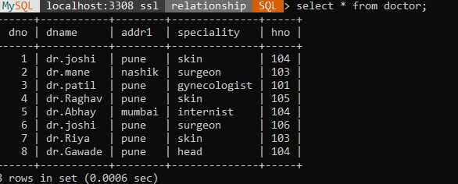

1. Delete addr column from Hospital table

alter table hospital drop column addr1;

Can't DROP 'addr1'; check that column/key exists

1. Display doctor name, Hospital name and specialty of doctors from “Pune City”

select dname,hname,speciality from doctor,hospital where doctor.hno=hospital.hno and city='pune';

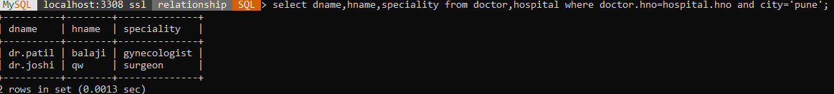

1. Display the names of the hospitals which are located at “Pimpri” city

select hname from hospital,doctor where doctor.hno=hospital.hno and city='pimpri';

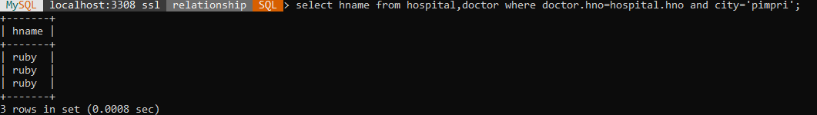

1. Display the names of doctors who are working in “Birla” Hospital andcity name is “Chinchwad”

select dname from doctor,hospital where doctor.hno=hospital.hno and hname='birla' and city='chinchwad';



1. Display the specialty of the doctors who are working in “Ruby” hospital.

select speciality from hospital,doctor where doctor.hno=hospital.hno and hname='ruby';

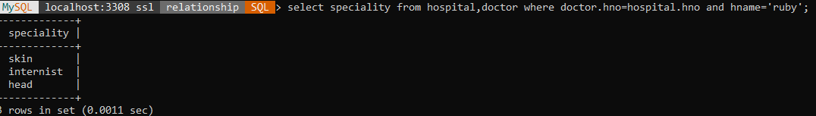

1. Give the count of doctor’s hospital wise which are located at “Pimple Gurav”.

select hname,count(dno) from doctor,hospital where doctor.hno=hospital.hno and addr='kharadi road' group by hname;

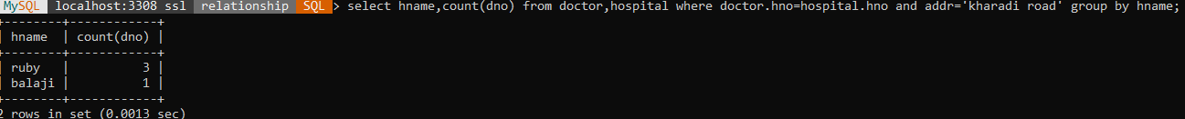

1. Update an address of Doctor to “Pimpri” whose hospital is “Ruby clinic”

update doctor set addr1='pimpri' where hno in(select hno from hospital where hname='ruby');

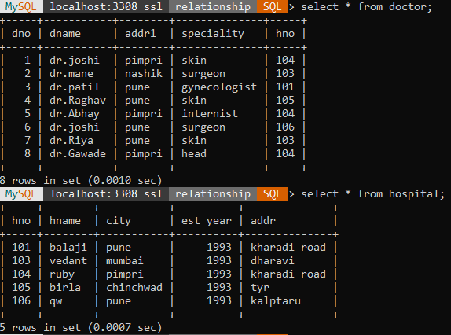

1. display doctor details whose speciality is Heart Surgen and whole belong to hospital from pune

SELECT d.* FROM Doctor d WHERE d.Speciality = 'Surgeon' AND d.hno IN (SELECT h.hno FROM Hospital h WHERE h.city = 'Pune' );

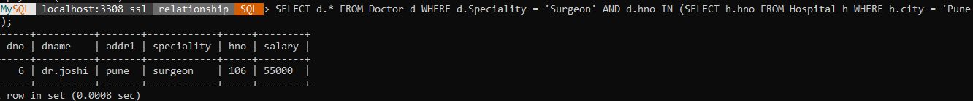

1. Update an address of hospital to “Pimpri” whose hospital is estableshed in “2000”

UPDATE hospital SET addr = 'Pimpri' WHERE est_year = 2000;

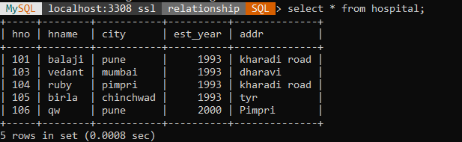

1. .Display Total salary of all doctors hopitalwaise

SELECT h.hname AS hospital_name, SUM(d.salary) AS total_salary

-> FROM doctor d

-> JOIN hospital h ON d.hno = h.hno

-> GROUP BY h.hname;

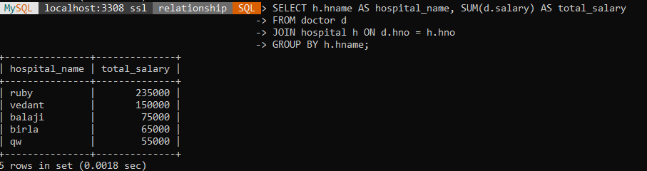

1. Display annual salary of doctor who live in Pune

SELECT dname, salary * 12 AS annual_salary FROM doctor WHERE addr1 = 'Pune';

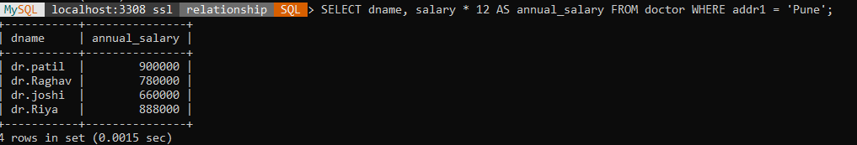

**************************************************************************************************************************

Q4. Consider the following entities and their relationships. Create a RDB in 3 NF with appropriate data types and Constraints.

Project (pno, pname, start_date, budget, status)

Department (dno, dname, HOD, loc) 1 The relationship between Project and Department is Many to One. Constraint: Primary key. Project Status Constraints:

C –Completed,

P -Progressive,

I –Incomplete

Create table:

create table project(pno int primary key,pname varchar(20),sdate date,budget int,status varchar(20) check(status in('c','i','p')));

desc project;

+--------+-------------+------+-----+---------+-------+

| Field | Type | Null | Key | Default | Extra |

+--------+-------------+------+-----+---------+-------+

| pno | int | NO | PRI | NULL | |

| pname | varchar(20) | YES | | NULL | |

| sdate | date | YES | | NULL | |

| budget | int | YES | | NULL | |

| status | varchar(20) | YES | | NULL | |

+--------+-------------+------+-----+---------+-------+

Insert values:

insert into project values(1,'abc','09-3-20',2300000,'c');

insert into project values(2,'xyz','01-4-18',200000,'i');

insert into project values(2,'xyz','01-4-18',200000,'i');

insert into project values(3,'st','23-7-27',1200000,'p');

insert into project values(4,'vb','12-2-20',600000,'c');

insert into project values(5,'qrt','16-1-23',3400000,'p');

select * from project;

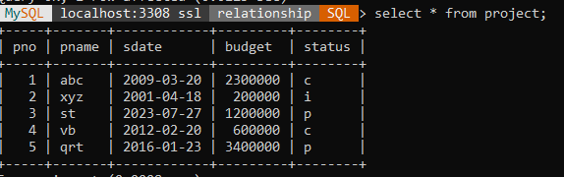

create table department(dno int primary key,dname varchar(20),hod varchar(20),loc varchar(20),pno int references project (pno));

desc department ;

+-------+-------------+------+-----+---------+-------+

| Field | Type | Null | Key | Default | Extra |

+-------+-------------+------+-----+---------+-------+

| dno | int | NO | PRI | NULL | |

| dname | varchar(20) | YES | | NULL | |

| hod | varchar(20) | YES | | NULL | |

| loc | varchar(20) | YES | | NULL | |

| pno | int | YES | | NULL | |

+-------+-------------+------+-----+---------+-------+

insert into department values(101,'computer','desai','pune',1);

insert into department values(102,'commerce','mane','pune',2);

insert into department values(103,'computer','kadam','pune',3);

insert into department values(104,'engineering','sam','pune',4);

select * from department;

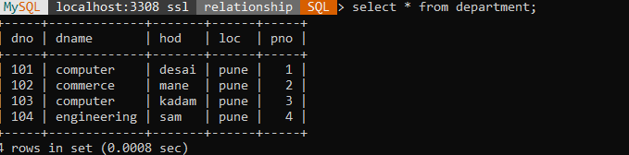

1. Drop loc column from department table

alter table department drop column loc;

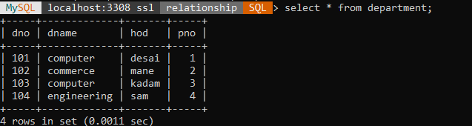

1. Display the details of project whose start_date is before one month and status is “Progressive”

select * from project where sdate>'12-2-20' and status='p';

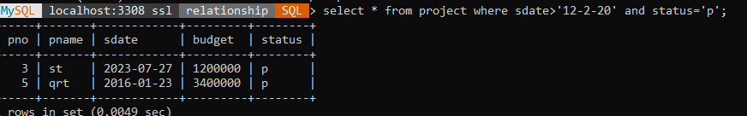

1. Display the names of project and department who are worked on projects whose status is ‘Completed

Select pname,dname,hod from department,project where department.pno= project.pno and project.status='c';

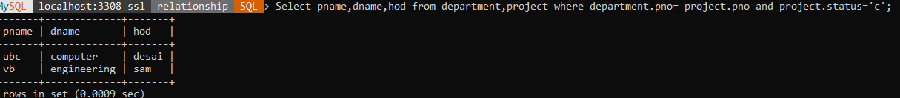

1. Display total budget of each department.

Select sum(budget),dname from department,project where department.pno=project.pno group by dname;

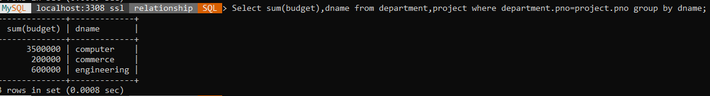

1. Display incomplete project of each department.

select pname,status ,count(department.dno) from department,project where department.pno=project.pno and project.status='i' group by status,pname;



1. Display all project working under 'Mr.Desai'.

Select pname from department,project where department.pno=project.pno and hod= 'desai';

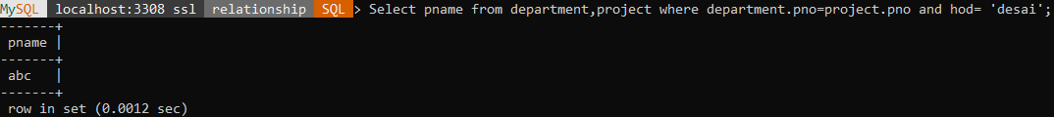

1. Display department wise HOD.

select dname,hod from department,project where department.pno=project.pno order by dname;

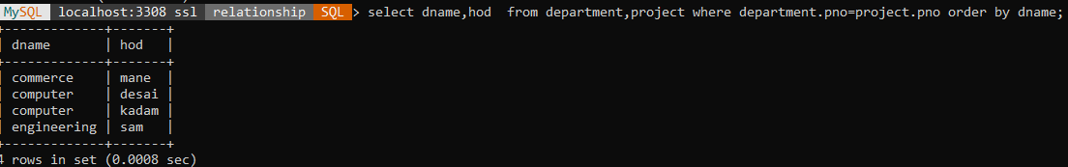

1. Display project details where project name start with A and whose budget is >10000 in descending order

SELECT * FROM Project

WHERE pname LIKE 'A%' AND budget > 10000

ORDER BY budget DESC;

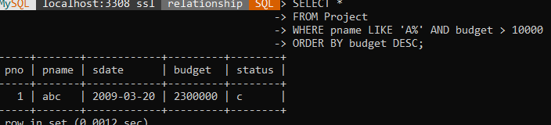

1. Display the project detials whose having highest budget

SELECT *FROM Project

WHERE budget = (SELECT MAX(budget)

FROM Project);

