Q1.Consider the following Entities and Relationship Politicians (pno, pname, telephone_no) Party (party_code, party_name) Relation between Politicians and Party is Many to One. Constraint: Primary key.

Create table:

create table party(p_code int primary key, p_name varchar(255));

insert values:

insert into party values(101,'bjp');

insert into party values(102,'congress');

insert into party values(103,'shivsena');

insert into party values(104,'rashtravadi');

select * from party;

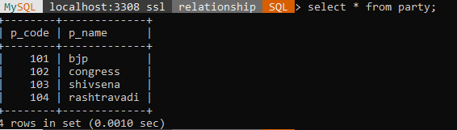

create table politician(po_no int primary key,po_name varchar(30),tele_no varchar(12),p_code int references party(p_code));

insert into politician values(1,'modi','987654321',101);

insert into politician values(2,'rao','987654567',102);

insert into politician values(3,'pawar','676654567',103);

insert into politician values(4,'fadanvis','676656786',101);

insert into politician values(5,'sule','987656786',104);

select * from politician;

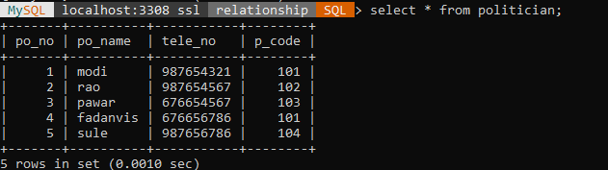

1. Display party names in ascending order.

select p_name from party order by p_name asc;

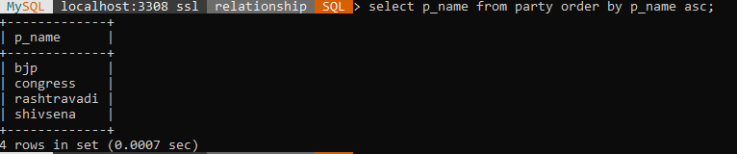

2Find the party who is having less number of members than ‘Congress’ party.

select min(p_name) from politician,party where politician.p_code=party.p_code and p_name='congress';



1. Display party wise politician name with details.

Select p_name,po_name from politician,party where politician.p_code=party.p_code order by p_name,po_name asc;

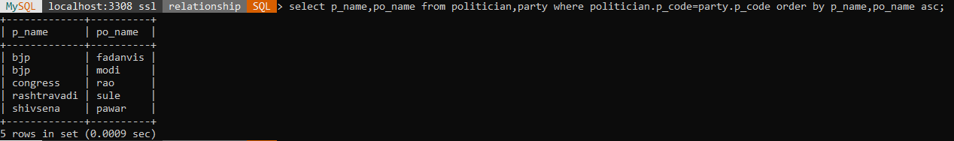

1. Display the party name with the details of politicians whose name include “Rao”.

Select p_name,po_name from politician,party where po_name like 'rao%' and politician.p_code=party.p_code;



1. Whichparty has maximum politicians

select max(p_name) from politician,party where politician.p_code=party.p_code;

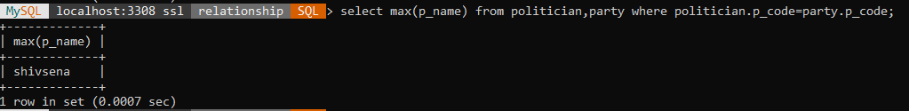

****************************************************************************************************************************************

Q2 Consider the following Entities and Relationships Person (pno, person_name, birthdate, income) Area (area_name, area_type) Relation between Person and area is Many to One.

create table person(pno int primary key,birth_date varchar(255),income int);

insert into person values(101,'21/4/2012',90000);

insert into person values(102,'31/4/2019',150000);

insert into person values(103,'11/5/2011',250000);

insert into person values(104,'26/6/2016',300000);

insert into person values(105,'16/7/2020',2000000);

select * from person;

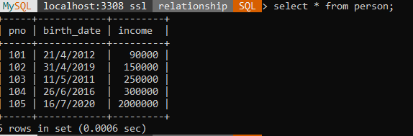

alter table person add column p_name varchar(255);

update person set p_name='nita' where pno=101;

update person set p_name='gita' where pno=102;

update person set p_name='minal' where pno=103;

update person set p_name='sneha' where pno=104;

update person set p_name='vidya' where pno=105;

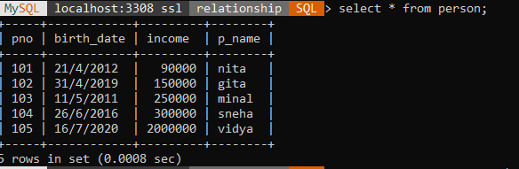

create table area(a_name varchar(255),a_type varchar(255),pno int references person(pno));

insert into area values('downtown','commercial',101);

insert into area values('uptown','mixed',102);

insert into area values('urban','recidential',103);

insert into area values('stubern','commercial',104);

insert into area values('stubern','recidential',102);

select * from area;

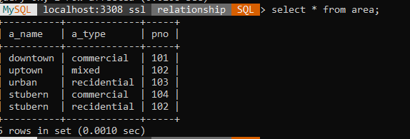

1. Display persons having income less than 1 lakhs in uptown Area.

select p_name from person,area where person.pno=area.pno and a_name='uptown' and income<100000;

Empty set (0.0009 sec)

1. Display name of each area.

select a_name from area,person where person.pno=area.pno group by a_name;

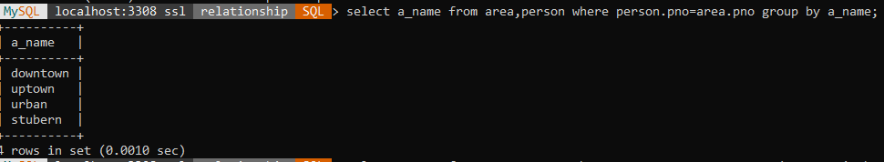

1. Display persons details from ‘Urban’ area.

select p_name from person,area where person.pno=area.pno and a_name='urban';

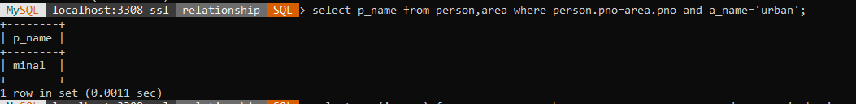

1. Display the details of area having population greater than that of in Pune.

select max(income),a_name from person,area where person.pno=area.pno and a_name='urban' group by a_name;

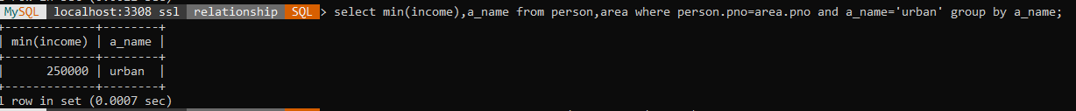

1. Display details of person from each area having minimum income.

select * from person where income=(select max(income) from person);

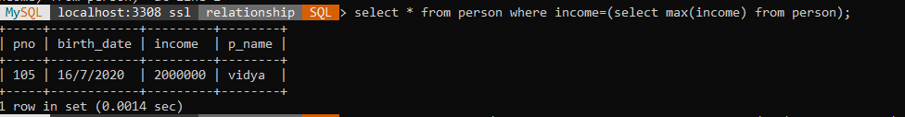

********************************************************************************************************************************************

Q3. Consider the following Entities and Relationships Donor (donor_no, donor_name, city) Blood_Donation(bid,blood_group,quantity,date_of_collection) Relation between Donor and Blood_Donation is One to Many. Constraint: Primary key, blood_group should not be null.

create table donar(d_no int primary key,d_name varchar(255),city varchar(255));

insert into donar values(11,'vidya','pune');

insert into donar values(22,'sakshi','mumbai');

insert into donar values(33,'minal','dubai');

insert into donar values(44,'shital','maharashtra');

select * from donar;

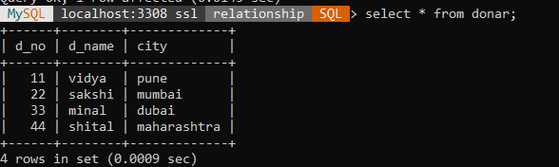

create table blood_donation(bid int primary key,b_group varchar(255),quantity decimal(5,2),date_of_collection varchar(255),d_no int references donar(d_no));

insert into blood_donation values(1,'A+',2,'12/3/2013',11);

insert into blood_donation values(2,'B+',2,'22/4/2014',22);

insert into blood_donation values(3,'AB+',1,'31/7/2016',11);

insert into blood_donation values(4,'O-',3,'21/9/2022',33);

insert into blood_donation values(5,'O+',5,'11/11/2020',44);

select * from blood_donation;

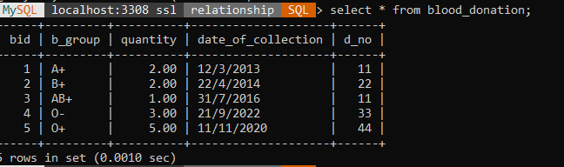

1. Display total blood quantity collected on 25th December 2013.

Select sum(quantity)from blood_donation where date_of_collection='21/9/2022';

+---------------+

| sum(quantity) |

+---------------+

| 3.00 |

+---------------+

1. Display total blood donated by each donor.

select d_name,sum(quantity) from blood_donation,donar where blood_donation.d_no=donar.d_no group by d_name;

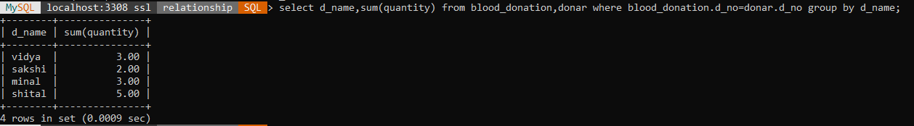

3. Display Donor details having blood group 'A+tve'.

Select d_name,city from donar, blood_donation where donar .d_no= blood_donation .d_no and b_group= 'A+';

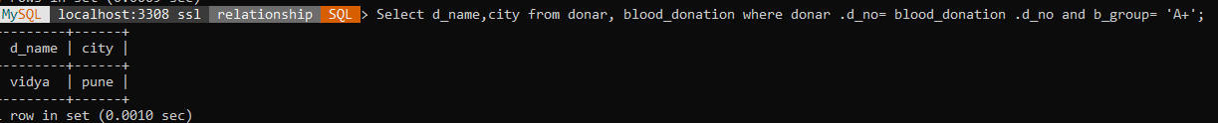

1. Display the donor who has donated blood more than two times.

Select d_name from donar, blood_donation where donar.d_no=blood_donation.d_no and blood_donation. d_no>=2;

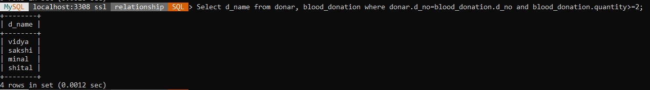

1. Displaythe donor information with blood group whose city name contains “id ” in it.

Select d_name,city,b_group from donar,blood_donation where donar.d_no=blood_donation.d_no and city like '%id%';

Empty set (0.0007 sec)

********************************************************************************************************************************************

Q4. Consider the following Entities and Relationship Branch (bno, bname, bcity, assets) Account (acc_no ,balance) Relation between Branch and Account is One to Many.

create table branch(bno int primary key,bname varchar(255),bcity varchar(255),assets decimal (15,2));

insert into branch values(101,'badoda','pune',100000);

insert into branch values(102,'sahakari','mumbai',2000000);

insert into branch values(103,'rbi','kolhapur',2500000);

insert into branch values(104,'nationl','nagar',4500000);

select * from branch;

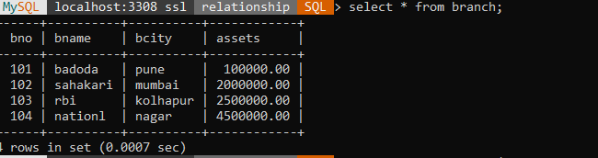

create table account(acc_no int primary key,balance int,bno int references branch(bno));

insert into account values(12345,6789542,101);

insert into account values(98345,987653,102);

insert into account values(23456,675437,103);

insert into account values(78643,987443,101);

insert into account values(65432,776543,104);

select * from account;

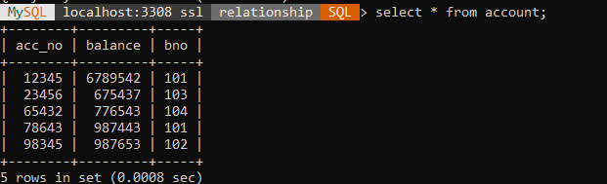

1. Find the maximum account balance of each branch.

Select max(balance),bname from branch,account where branch.bno=account.bno group by bname;

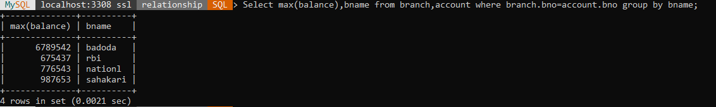

2. Find branches where average account

balance is more than 30000.

Select avg(balance) from branch,account where branch.bno=account.bno and balance>30000;

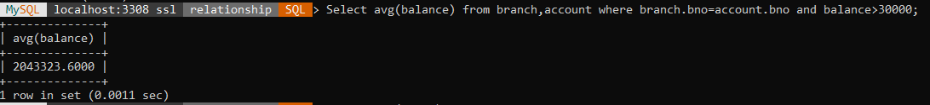

3. Find names of all branches that have assets value greater than that of each branch in ‘pune’.

Select max(assets),bname from branch,account where branch.bno=account.bno and bcity='pune' group by bname;



4. Decrease 3% balance on account whose balance is greater than 100000.

Update account set balance=balance-balance*0.03 where balance >3000;

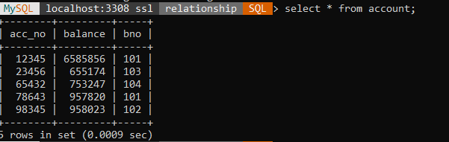

5. Display details of branchwhose city starts from ‘A’.

select * from branch where bcity like 'p%';

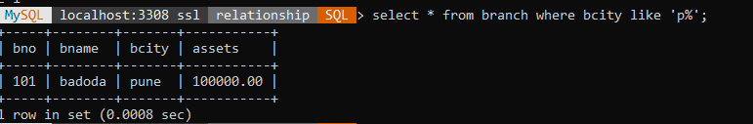

***********************************************************************************************************************************

Q5.**Considerthe following Entities and Relationships**

**Branch** (bname ,bcity ,assets)

**Loan** (loan_no, amount)

Relation between Branch and Loan is **One to Many**.

**Constraint:** Primary key, amount and assets should be > 0.

**Branch** (bname ,bcity ,assets)

**Loan** (loan_no, amount)

create table branchh (bno int primary key,bname varchar(10),bcity varchar(10),asets int constraint aschk check(asets>0));

Insert into branchh values(101,'DYP','Mumbai',20000);

Insert into branchh values(102,'boi','pune',30000);

Insert into branchh values(103,'sbi','delhi',36000);

Insert into branchh values(104,'rbi','nashik',66000);

select * form branchh;

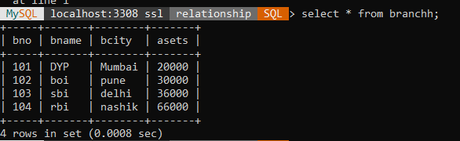

Create table loan(l_no int primary key,amount int constraint abc check(amount>0),bno int references branch(bno));

Insert into loan values(301,2341,101);

Insert into loan values(302,3341,201);

Query OK, 1 row affected (0.0135 sec)

Insert into loan values(303,5467,103);

Insert into loan values(304,5467,104);

Insert into loan values(305,6754,101);

Insert into loan values(306,8776,102);

select * from loan;

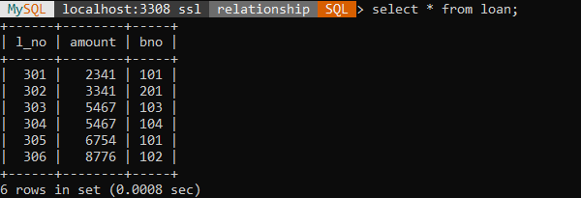

1. Display total loan amount given by DYP branch.

Select amount,bname from branchh, loan Where branchh.bno=loan.bno and bname='DYP';

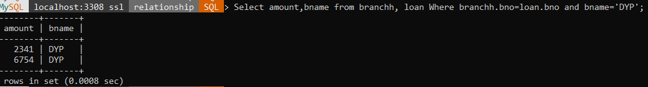

1. Find total number of loans given by each branch.

Select bname,count(*) from branchh, loan Where branchh.bno=loan.bno group by bname;

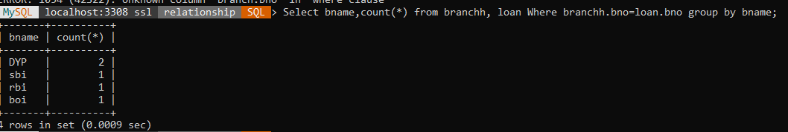

1. Find the name of  branch that have maximum assets located in Mumbai.

Select bname,bcity from branchh, loan Where branchh.bno=loan.bno and asets=(select max(asets) from branchh where bcity='Mumbai');

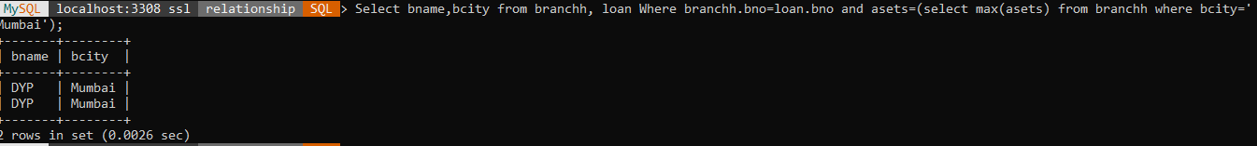

1. Display loan details in descending order of their amount.

select * from branchh,loan where branchh.bno=loan.bno order by amount desc;

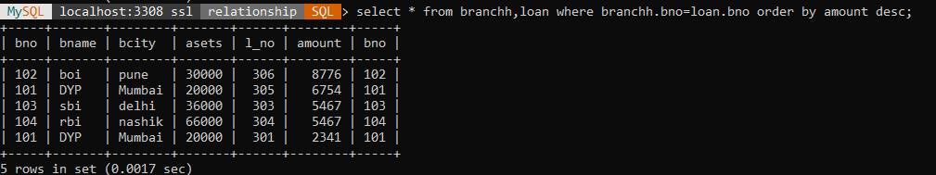

1. Display all branches located in Mumbai, Pune and Nasik.

select bname,bcity from branchh,loan where branchh.bno=loan.bno and bcity in ('Mumbai','Pune','Nashik');

