**Setup up configuration parameters and start/stop MongoDB**

For starting and stopping the MongoDB server, we need only the *bin/mongod.exe*, which is the daemon process executable for MongoDB. In short, it is the executable which starts up the MongoDB Server.

For starting up, we need to provide the parameters for executable, which i call it here as config parameters or params.

We can setup the config parameters using the two ways

* Using command line options or
* Using config file

**Using command line options**

With use of these command line options, we configure mongo daemon process. Basically, there lots of options we can specify but i will  give only those which required for this tutorial.

Following are someof them-

**–dbpath <path> :**the existent directory path, which is required to store data files. this is most important option we need to specify, Note that, the directory path you are providing should exists otherwise process won’t start. If this path contains spaces then put all its path in double qoutes. e.g. –dbpath “c:\Program Files”

**–logpath <log-file-path>:**the existent file path, used by mongo daemon process,for flush out loggs instead of in standard console. If this path contains spaces then put all its path in double qoutes

**–port <port> :**port no. where mongod process listen for connection from client, it defaults to 27017 if not specified

**Note** : While using the command prompt on some Windows OS like windows 7 or Windows server 2008, Run it with administrator privileges as shown as follows

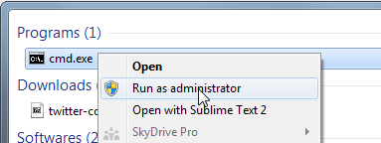

Use the following commands to start the server process

Change to *bin* directory

|  |  |
| --- | --- |
|  | cd C:\Program Files\MongoDB\Server\3.2\bin |

now type following command to start the mongod process

|  |  |
| --- | --- |
|  | mongod --dbpath C:\Program Files\MongoDB\Server\data --port 27017 |

While starting, Windows firewall may block the process as shown as follows

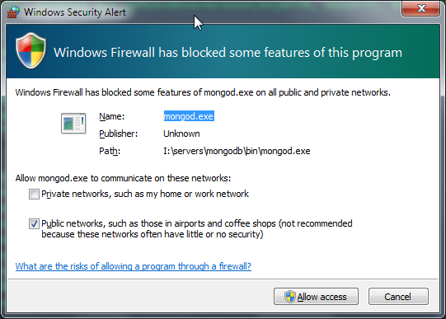

Click “Allow access“to proceed. After successful execution of command, it will show logging info in standard console itself as shown follows

If you specify the logpath option, then logging will direct to that log file instead of showing up on standard console

$> mongod --dbpath C:\Program Files\MongoDB\Server\data --port 27017 --logpath <path>mongod.log

**Using the config file**

Instead of specifying command line option, we can specify same with use of file, which i call it here as config file Config file is just text file, containing the parameters in the *key=value* form and each one is specified on the every line of file In this, we basically provide path to file (which contains the configurations) as command line option as “-f” or “–config” Following is the snippet for the config file

|  |  |
| --- | --- |
| 1  2  3  4  5 | #This is an example config file for MongoDB  #basic  dbpath = C:\Program Files\MongoDB\Server\data  port = 27017  logpath = C:\Program Files\MongoDB\Server\logs\mongo.log |

You can save this file with any extension, but specify full path with extension, while stating process as shown in following commands. From command prompt, you will use either of following

1)mongod -f C:\Program Files\MongoDB\Server \config\mongodb.conf

or

mongod --config C:\Program Files\MongoDB\Server \config\mongodb.conf

**Import data into the collection**

EX:

**C:\Program Files\MongoDB\Server\3.2\bin>mongoimport --db test --collection restaurants --drop --file primer-dataset.json**

2016-01-28T11:06:14.741-0500 connected to: localhost

2016-01-28T11:06:14.743-0500 dropping: test.restaurants

2016-01-28T11:06:16.315-0500 imported 25359 documents

Note: The [mongoimport](https://docs.mongodb.org/manual/reference/program/mongoimport/" \l "bin.mongoimport" \o "(in mongodb-manual v3.2)) connects to a [mongod](https://docs.mongodb.org/manual/reference/program/mongod/" \l "bin.mongod" \o "(in mongodb-manual v3.2)) instance running on localhost on port number 27017.