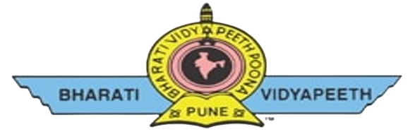
BHARTI VIDYAPEETH’S JAWAHARLAL NEHRU
INSTITUTE OF TECHNOLOGY
ACADEMIC YEAR -2023-24
PROJECT TOPIC:
ATM MACHINE MANAGEMENT SYSTEM USING OOP C++
GUIDED BY
Mrs. Pawar R.S
COURSE: OOP C++
COURSE CODE: 22316
BY
CLASS: SYCM (B)
- Raskar Mahesh (48)
- Pawar Sumit (01)
- More Sarthak (39)
- Gandhi Shashwat (31)
- Shingavi Neel (43)

