Hotel Revenue & Operations Dashboard
Operational Summary Report
Mahesh Sambare | Portfolio Project | Data: Hotel Booking Demand Dataset (2018–2020)

1. Project Overview
This dashboard analyses 99,196 cleaned hotel bookings across two properties; a City Hotel and a Resort Hotel spanning July 2018 to August 2020. The objective was to move past a static KPI display and surface the commercial and operational relationships that actually drive decisions in a hotel revenue management and front office setting: channel profitability, cancellation risk, guest reliability, and room allocation behaviour.
Pipeline: raw booking data was cleaned in Python, loaded into a SQLite database, queried with six targeted SQL aggregations, and visualised in Power BI.

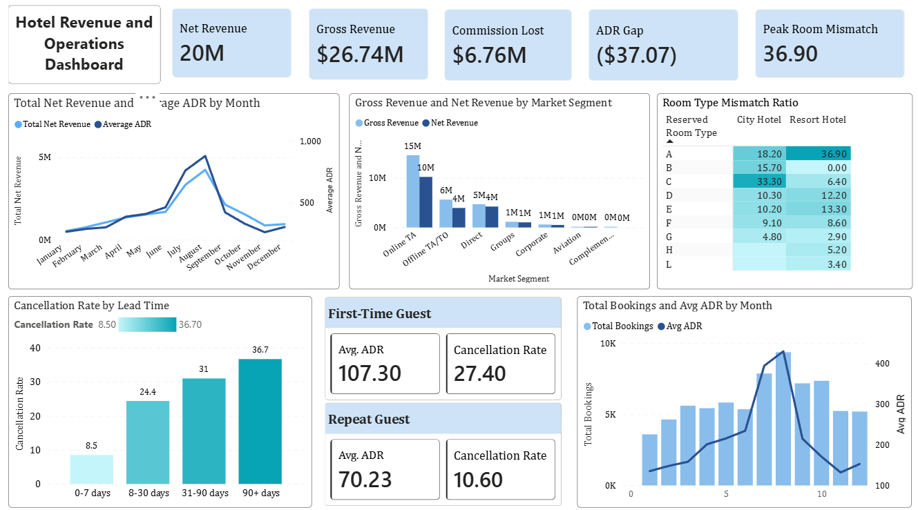

2. Headline Metrics
Metric | Value
Bookings analysed (post-cleaning) | 99,196
Gross revenue (before commission) | $26.74M
Net revenue (after commission) | $20.0M
Total commission cost across all channels | $6.76M
Overall cancellation rate | 26.8%
Online TA: bookings / cancellation rate / commission cost | 56,899 / 34.6% / $4.38M
Direct: bookings / cancellation rate | 13,663 / 14.6%
Peak room type mismatch (Resort Hotel, Corporate) | 50.2%
Repeat guest cancellation rate vs. first-time | 10.6% vs 27.4%

3. Key Insights & Recommendations

3.1 Online TA: the channel that costs us twice
Online TA drives more volume than any other segment; 56,899 bookings but it's also our most expensive and least reliable channel. We pay a flat 30% commission on every booking, and 34.6% of them cancel before arrival, more than double Direct's 14.6% cancellation rate. Net effect: $4.38M lost to commission alone over the period, a meaningful share of it on bookings that never converted to a stay in the first place.
Modelled against this dataset, shifting just 10% of OTA volume to Direct (5,700 bookings) would save roughly $670K in commission and avoid an estimated 1,100+ cancellations, the dual benefit of lower acquisition cost and higher booking reliability in one move.
Recommendation
- Prioritise Direct-channel growth in marketing spend allocation.
- Tighten enforcement on semi-flexible OTA cancellation terms; bookings with hotel-discretion cancellation policies.
- Have accounts payable actively reconcile that applicable cancellation and no-show fees are being captured, not waived by default.

3.2 Lead time predicts cancellation risk, but rate structure determines the actual exposure
Cancellation rate rises sharply with lead time: 8.5% for bookings inside a week of arrival, climbing to 36.7% beyond 90 days, nearly 12,000 cancelled bookings in that bucket alone, averaging $114.83 ADR each. The mechanism is straightforward: long-lead bookings typically capture our best available rate, but a late cancellation on one of these leaves us reselling that room on short notice, with no guarantee the date still has the demand to absorb it.
The real exposure sits specifically on refundable long-lead bookings, non-refundable bookings retain the revenue regardless of cancellation, so the risk there is closer to a forecasting and inventory-timing problem than a P&L hit. One flag worth raising directly with reservations: Non-Refund-coded bookings in this dataset show a 95% cancellation rate, concentrated in Group and Offline TA bookings at City Hotel; high enough to suggest this may reflect group-block adjustment patterns rather than individual guest behaviour, and worth a direct conversation before drawing further conclusions.
Recommendation
- Tighten refundable rate availability on high-confidence, high-forecast dates; lead with non-refundable inventory where occupancy confidence is already strong.
- Preserve refundable options selectively, on softer-demand dates where flexibility still drives conversion.
- Investigate the non-refund / 95% cancellation pattern directly with reservations before drawing further conclusions.

3.3 Repeat guests under-monetised in the channel that costs us least
Repeat guests book at a lower average rate ($70.23 vs. $107.30) but cancel at less than half the rate of first-timers (10.6% vs. 27.4%) on a realised-revenue basis, a more dependable segment than the headline ADR suggests. Yet only 5.5% of Direct bookings (758 of 13,663) come from repeat guests; the larger concentration of repeat business; 1,536 bookings currently sits in Corporate, a segment we don't control the rate strategy on the same way.
Recommendation
- Sustain CRM/loyalty investment, but redirect tactical focus toward migrating known repeat guests into Direct with targeted rate codes and packages.
- Every repeat guest moved from a commissioned or corporately-negotiated channel into Direct compounds the existing reliability advantage with a commission saving.

3.4 Room type mismatch tracks with overbooking strategy, not service failure
Mismatch rate is highest in Resort Hotel Corporate (50.2%) and Group bookings at both properties (33.9–34.5%) a pattern more consistent with deliberate overbooking of high-confidence categories and contracted block rebalancing than front-desk error. This dataset doesn't distinguish pre- and post-rebalancing allocation, so the operational read can't be fully confirmed from the numbers alone.
Recommendation
- Validate this pattern against actual PMS allocation logs and review-score data before treating mismatch rate as a problem metric.
- If guest upgrades are driving the Corporate/Group mismatch numbers, that may be a satisfaction lever worth surfacing rather than a defect to correct.

3.5 Pricing lags demand rather than leading it
ADR and booking volume both peak in July–August ($133.51 and $144.30 ADR against 7,867 and 9,364 bookings respectively) and trough in winter ($68–78 ADR, Jan/Nov/Dec), but rate movement consistently trails volume movement month over month, pricing appears reactive to realised demand rather than anticipatory.
Recommendation
- Shift toward a forward pricing calendar that begins raising rates 4–6 weeks ahead of historical peak booking pace.
- Validate against competitive set ADR data first; if current pricing is deliberately conservative to protect occupancy against a softer comp set, that changes the calculus.

4. Data Quality & Cleaning Notes
The following data quality issues were identified and corrected during cleaning, rather than ignored:
- 41,191 exact duplicate rows removed from the original 141,947-row file.
- Negative or unexplained zero ADR values (outside genuine complimentary stays) treated as data entry errors and excluded.
- One extreme ADR outlier ($5,400 vs a next-highest value of $510) capped to the dataset median rather than deleted outright.
- 90 records where reservation status and cancellation flag disagreed were resolved by treating reservation status as the authoritative field.
- Bookings with zero guests or zero nights stayed were excluded, as these cannot generate room revenue.
Full cleaning logic, SQL queries, and the Power BI file are available in the accompanying GitHub repository.

