# ACKNOWLEDGEMENT

It gives us immense pleasure to express our deepest sense of gratitude and sincere thanks to our highly respected and esteemed guide Mr. **Sanjay Kumar Yadav** for his valuable guidance, encouragement and help for completing this project work. His useful suggestions for this whole work and co-operative behavior are sincerely acknowledged.

We would like to express our sincere thanks to Er. **Rajan Karmacharya** (Lecturer) for giving us the opportunity to undertake this project. We would also like to thank Mr. **Jeetendra Manandhar** (Head of Department) for whole hearted support.

We are also grateful to our teachers for their constant support and guidance. At the end we would like to express our sincere thanks to all our friends and others who helped us directly or indirectly during this project work.

Babish Shrestha (15170/074)

Dipesh Bhujel (15174/074)

Luja Manandhar (15182/074)

Mahesh Singh Madai (15184/074)

# ABSTRACT

|  |
| --- |
| Internet of things is new technology. It generally refers to the communication between things like technological devices, sensors, actuators and peoples with unique identifiers. Internet of things improves day to day activities of the users by minimizing the time things to be done. However, IOT is made for the people and used by them for many reasons such as health, business technology innovations and mainly in our case, it is used to control the devices in the campus by using sensors and internet connections.  When the devices on the office are automated, they can control the activities being done in the smart office. An office can be the hub for the automation and thereby increasing the productivity of the work as lot of time is saved by the automation. The main objective of this project is to describe a comprehensive concept called Smart Office by providing a comprehensive overview of the IoT scenario and reviews it’s enabling technologies and to come up with methods to design some of the components of the office periphery with smart devices to simplify the works being done in the campus.  ***Keywords****: Internet of things, wireless sensor network, SmartOffice, IP address* |
|  |

ACKNOWLEDGEMENT i

ABSTRACT ii

Chapter 1: Introduction 1

1.1 Background: 1

1.2 Problem Statement: 1

1.3 Objective 2

1.4 Requirement Analysis and Feasibility: 2

1.4.1 Requirement Analysis: 2

1.4.2 Feasibility Analysis: 3

1.5 System Requirement- Hardware and Software Platform: Hardware Requirement: 4

Software Requirement: 4

Chapter 2: Literature Review 1

2.1 Background 1

2.2 History 1

Chapter 3: System Development 3

3.1 Project Tools 3

3.2 System Analysis 3

3.3 System Design 3

3.3.1 Waterfall Model: 3

3.3.2 System Architecture 4

3.4 Testing: 5

Chapter 4: Result Analysis 6

4.1 Results 6

4.2 Limitation and Future Enhancement: 9

4.4 Conclusion: 10

References 11

Figure 1 Waterfall Model 3

Figure 2 SmartOffice System Architecture 4

Figure 3 Sample of IP Address Assignment 8

Figure 4 Smartphone Simulation 8

Figure 5 IoT Monitor 9

Figure 6 Simulation of Automation of Window 9

# Chapter 1: Introduction

## Background:

IOT technology provides a means to transfer new innovations about industry, agriculture and energy distribution by adding important information with the help of sensors. According to Cisco there are a number of companies and research organizations which provides the impacts of IOT on the internet and the economy in the next five or ten years. In the research that had been done by Morgan Stanley states that more than 24 billion devices will be connected to the internet in the year of 2019. The Hawaii Company also predicts that100 billion IOT connections will be performed in the year of 2025.In economic concern McKinsey Global Institute indicates that the economic impacts of the IOT in the global will be as much as $3.9 to $11.1 trillion by 2025.

Things: things are physical objects that own ability to connect to the internet; it consists of several objects like: building, sensors, actuators and network connections that allow these objects to collect information and interchange data among them. Furthermore, things can have unique address that enables them to connect to the internet. [1]

On the other hand, the Internet is the network of network, which is used for communication among billions of people in the world.

Definition of the internet of things: It is a network that consists of different objects which has the capability to organize things automatically, it also has ability to share information and give reactions and actions towards the environment.

Internet of things (IOT) is a network which allows objects and users to communicate each other by giving a unique address to every object to identify which users are accessing to what resource of the network easily. It also describes a world of network in which every object is connected to the network so that data can be shared. Everybody already has a smart phone, but a phone is not smart rather it helps its user to make smarter decisions.

## Problem Statement:

The task of manually switching on and off any device in any workspace can be tedious and the office personnel can lose their valuable time on that. This decreases the efficiency in the daily office operation. So, a system is needed to automate the real objects around them so that those objects could be controlled through smartphone or laptop at the palm of their hands.

## 1.3 Objective

The objectives of IoT based automated system are listed below:

* Automate the real world objects that are present the office
* Control the objects through handheld devices like Smartphone or Laptop
* Enhance the office network through automation

## 1.4 Requirement Analysis and Feasibility:

### 1.4.1 Requirement Analysis:

Before starting the development of the new system, different requirements are taken into consideration. As our project is solely based on automation of things in the office, the requirement analysis is done concentrating on various aspects of extensive real world objects that are present in the office. The requirement analysis is done with following outline:

#### 1.4.1.1 Study of Existing System:

The manual operation of the real world objects around us is very time consuming and may not increase the efficiency in day to day operation of the office. The office and its system was studied through the inspection of the office and finally, the objects that needed to be automated were figured out.

#### 1.4.1.2 Source of Data Collection:

* **Office Visit:**

It is certain that the information about existing systems is best understood if they are observed in real world situations. This moreover enhances the practical approach while studying about any dedicated matter. Karkhana office was visited and .the requirement was studied.

* **Internet:**

The internet always is equipped with myriad of information and ideas. To conclude the study and revise the ending, internet was used in order to understand better about the database and its various aspects. We took reference to online platforms for making the database more smooth and systematic. [1]

### 1.4.2 Feasibility Analysis:

Feasibility Analysis is an assessment of the practicality of a proposed project. It provides the degree of viability of a proposed project. A feasibility analysis helps us determine the value of the proposed project, determine whether or not there is a market for the proposed project, determine if the proposed project is financially viable, and eventually, decide whether or not it is worth investing time and money into the proposed project. In short, a feasibility analysis evaluates the projects potential for success. Following Feasibility Analysis was performed prior to working on the project:

#### 1.4.2.1 Operational Feasibility:

The IoT based application solves problem faced by the office personnel that was underlined as the problem statement. The people can easily save a lot of time as the stuffs around the offices are fully automated through internet.

#### 1.42.2 Economic Feasibility:

The IoT based application is available and easily accessible when once installed on the computer which makes it economically feasible as the owners can control the system through their smartphones or Laptop.

#### 1.4.2.3 Technical Feasibility:

The IoT based application is technically feasible; complies with current technology, including both the hardware and the software. The computer application is supported by almost all latest computers with minimum hardware and software requirement.

#### 1.4.2.4 Legal Feasibility:

Feasibility Implementation of this project does not violate any rules or standards defined by the government of Nepal or any principles internationally. The concepts implemented and literatures defined are noted with their respective references. The concept is based solely on the analysis of team members, thus does not violate any copyright act. In regards of programming and logic, it is based on the team concept and we own the copyright for the codes and logic. The project does not violate any national or international laws and is legally feasible.

#### 1.4.2.5 Schedule Feasibility:

A time and resource schedule was produced in the early stages of the project with careful planning and risk management. According to the schedule, it was evident that the project could be completed as planned within the timeframe required.

## 1.5 System Requirement- Hardware and Software Platform: **Hardware Requirement:**

* 512 RAM or higher
* Dual Core processor or higher
* USB port
* Input Device: Mouse Keyboard
* Output Device: Monitor

### Software Requirement:

* OS: Windows XP/7/8/10, Linux

# Chapter 2: Literature Review

## 2.1 Background

IOT technology provides a means to transfer new innovations about industry, agriculture and energy distribution by adding important information with the help of sensors. According to Cisco there are a number of companies and research organizations which provides the impacts of IOT on the internet and the economy in the next five or ten years. In the research that had been done by Morgan Stanley states that more than 24 billion devices will be connected to the internet in the year of 2019. The Hawaii Company also predicts that100 billion IOT connections will be performed in the year of 2025.In economic concern McKinsey Global Institute indicates that the economic impacts of the IOT in the global will be as much as $3.9 to $11.1 trillion by 2025.

An office space equipped with IoT devices, and thus connected to the internet, is often referred to as a “smart office”. It represents an intelligent ecosystem which relies on a number of connected devices that, in general, monitor, control, and manage various operations and working conditions. [2]

The Internet of Things sees everyday objects being connected to the internet, allowing them either to be controlled remotely, or to collect and share data and communicate without a human being involved. IoT in the workplace can involve a variety of hardware and technologies such as smart devices, robots, and artificial intelligence to improve efficiency and create new business opportunities.

Making devices and objects in the workplace more intelligent and able to communicate could make workers happier and more effective, and also make it easier to measure productivity by using real-time data. In addition, it could make staff more efficient by using the artificial intelligence embedded in these devices to automate basic queries and tasks. [3]

## 2.2 History

The Internet of Things, as a concept, wasn’t officially named until 1999. One of the first examples of an Internet of Things is from the early 1980s, and was a Coca Cola machine, located at the Carnegie Melon University. Local programmers would connect by Internet to the refrigerated appliance, and check to see if there was a drink available, and if it was cold, before making the trip.

By the year 2013, the Internet of Things had evolved into to a system using multiple technologies, ranging from the Internet to wireless communication and from micro-electromechanical systems (MEMS) to embedded systems. The traditional fields of automation (including the automation of buildings and homes), wireless sensor networks, GPS, control systems, and others, all support the IoT.

Simply stated, the Internet of Things consists of any device with an on/off switch connected to the Internet. This includes almost anything you can think of, ranging from cellphones to building maintenance to the jet engine of an airplane. Medical devices, such as a heart monitor implant or a biochip transponder in a farm animal, can transfer data over a network and are members the IoT. If it has an off/on switch, then it can, theoretically, be part of the system. The IoT consists of a gigantic network of internet connected “things” and devices. Ring, a doorbell that links to your smart phone, provides an excellent example of a recent addition to the Internet of Things. Ring signals you when the doorbell is pressed, and lets you see who it is and to speak with them. [4]

The Internet of Things, or IoT, is growing by leaps and bounds, with millions of new sensors and devices going online every month. If you feel like you’ve been hearing a lot about it recently, that’s probably because, despite a fairly long history, the Internet of Things has only just been able to truly start taking off, empowered by cheap, low-power components, widespread Internet connectivity, and a lot of interest on both the corporate and the consumer side. We’re looking at everything from smart toasters to smart cities, from RFID tags on supply chains to medical monitoring implants, from learning thermostats to self-driving cars. Where did it all come from though? How did we go from having basically nothing connected to the Internet to having more connected devices than people on earth? While it’s far from comprehensive, the timeline below should give you a general idea of where IoT has come from and where it’s headed in the future. [5]

# Chapter 3: System Development

## 3.1 Project Tools

* CISCO Packet Tracer: used for designing the network and the code
* MS-Word: used for documentation

## 3.2 System Analysis

The proposed system that we developed will be efficient in terms of time consuming and ease access as the personnel in the office can control the system with their smartphone or the laptop device.

In General, our proposed system will be made from CISCO Packet tracer: A software for designing and simulating the computer networks. The proposed system is simple, interactive and has user-friendly interface such that even those with little knowledge of computer can easily operate it.

## 3.3 System Design

### 3.3.1 Waterfall Model:

Waterfall model is an example of a Sequential model. In this model, the software development activity is divided into different phases and each phase consists of series of tasks and has different objectives. [16]

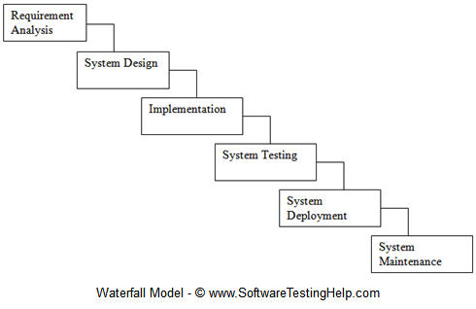

Figure 1 Waterfall Model

### 3.3.2 System Architecture

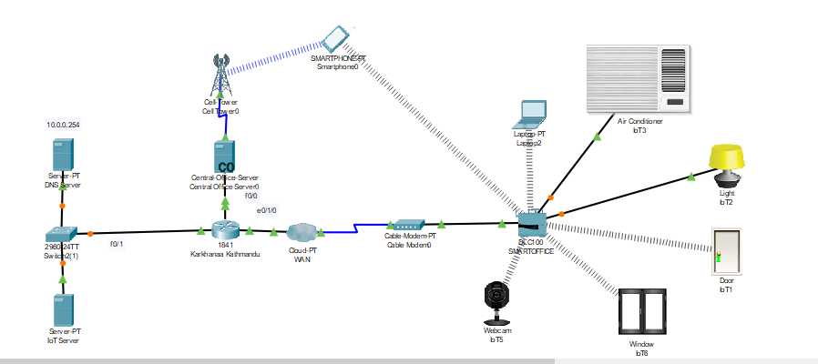

Figure 2 SmartOffice System Architecture

Devices used for design

|  |  |  |
| --- | --- | --- |
| **NO:** | **Device** | **Function** |
| 1 | Router(1841) | It connects cellular network and smart office to each other |
| 2 | Cable modem | Is used to connect IOT gateway to the cloud and vice versa |
| 3 | IOT gateway | It registers smart devices and assigns an ip address to them |
| 4 | IOE server | Controls the smart IOE devices registered on it and brings a variety of server functions |
| 5 | Central office server | Is used to connect a cell tower to the router and the router to the cell tower for transferring of information. |
| 6 | Fan | Used to ventilate the smart office |
| 7 | Webcam | Is a smart device used to Control smart Office activities |
| 8 | Smart Light | Provides light for the smart office by using smart light devices |
| 9 | Smart Door | Connects to the IOT gateway and brings some main important functions based events in the smart office. |
| 10 | Cell Tower | It is a cellular mechanism that brigs controlling and accessing office services from remote. |
| 11 | Smart Window | It is used to control the window remotely with smart phone connected to a wireless internet This decreases the carbon monoxide, carbon dioxide, hydrogen and helium and it increases oxygen to get fresh air which is good for health. |

[7]

## 3.4 Testing:

**3.4.1 Unit Testing**

Unit testing is a software testing method by which individual units of source code, sets of one or more computer program modules together with associated control data, usage procedures, and operating procedures, are tested to determine whether they are fit for use. Intuitively, one can view a unit as the smallest testable part of an application.

**3.4.2 Integration Testing**

Integration testing (sometimes called integration and testing, abbreviated I&T) is the phase in software testing in which individual software modules are combined and tested as a group. It occurs after unit testing and before system testing.

# Chapter 4: Result Analysis

4.1 Results

After designing the system, final design of the SmartOffice is as shown below



The end devices can be monitored using the Smartphone connected to the cell tower or the Laptop connected to the DLC Controller.

The functions of each devices are explained below:

**The DNS server** provides an access to the hosted website on the IOT server not by IP address but a username.

**The IOT server** stores all the sensed data from the office and give users an authorized access to the resources by entering username and password.

**IOT Gateway** controls the activities of the smart devices connected to it; It gets an internet connection by using an IP address from the ISP server automatically after associating Ethernet cable and coaxial cable of the cloud (WAN) to allow services to pass through it. It registers smart devices and assigns an ip address to them. All the wireless connected smart devices to the IOT gateway like: webcam, window and door obtain an IP address automatically from the ISP router via the cloud (WAN).

**The central office server** gets all IP information from the ISP automatically after configuring DHCP server, DNS server and default router on the ISP router .It can also be used to connect a cell tower to the router and the router to the cell tower for transferring of information between them.

**IOT server:** IT brings services to the connected devices after the IOE server is enabled .Smart devices can access their services from the web server by using their respected ip addresses after the hypertext transfer protocol of the server is started. In other words, the smart devices can be accessed by using the ip address of the IOT server. It associates IOE smart devices to the IOT gateway with the ip address of the IOE server. In general, it controls the devices connected to it.

**DNS server:** It provides services to registered devices after the DNS server is enabled and made it to state, then all the connected devices directly or indirectly accesses the services by using the domain name of the DNS server (ioe.org) and starts their communication. It is connected to the switch by suing straight through cable.

**IOT cloud (WAN).** First, the interfaces of the cloud (WAN) for the coaxial cable and Ethernet cable are enabled to associate the two interfaces and allow the information pass through it. It Transfers the information collected by the smart devices from the smart office environment and sends it to the IOT server for storage. Ip addresses assigned to the smart devices by the IOT gateway pass via the cloud.

**Cellular tower**: It is used to access and control the office services from remote.

It communicates to the central office server by using a coaxial cable interface. It gets data from the router (2911) via crossover cable.

**ISP (internet service provider).** It proves the internet services to smart campus, particularly to the smart office. The DHCP server is configured on this device and it assigns an IP address to every connected device, whether it is smart or not dynamically.

**Smartphone:** is used to access the smart devices through the web by using (www.ioe.org). Then all the devices which connect to the home gateway. It can also be controlled all the smart office IOE devices from remote with internet connection. It is very close and connected to the cell-tower. [7]

The router configuration was done using the Packet Tracer where DNS Server, IoT server and the DLC controller had to be given the IP address and also a establish a DHCP pool of IP address so that the end devices would get the IP address automatically.

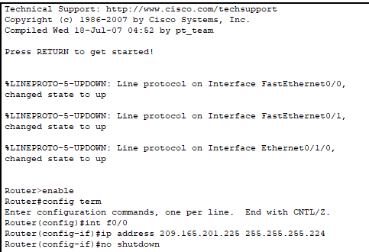

Figure 3 Sample of IP Address Assignment

**Final Output**

The project can be verified through the IoT monitor which contains all the IoT devices connected to the DLC controller.

The simulation of controlling things through smartphone is shown using CISCO Packet Tracer.

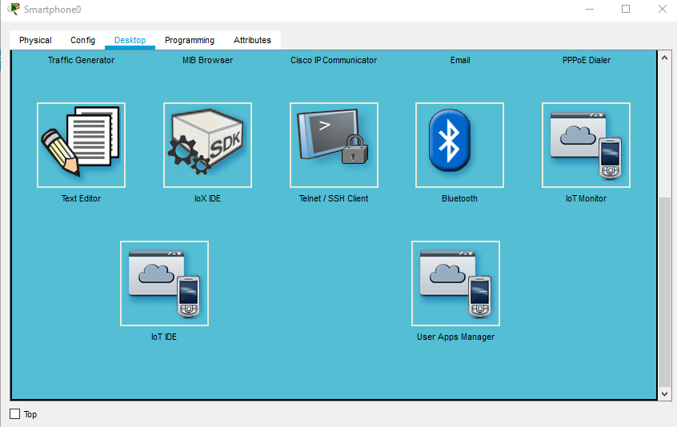

Figure 4 Smartphone Simulation

On clicking the Desktop option, IoT monitor is chosen which show a list of end devices connected to the controller.

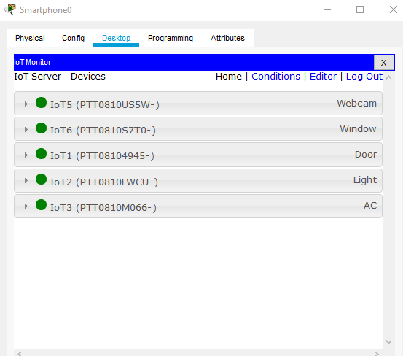

Figure 5 IoT Monitor

On clicking the on button, the window opens (right side of the figure)

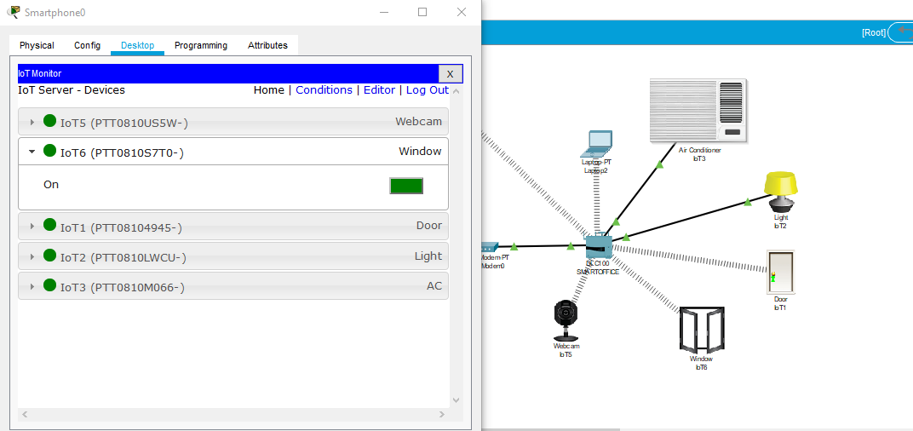

Figure 6 Simulation of Automation of Window

## 4.2 Limitation and Future Enhancement:

In this section, we discuss about the limitations of IoT based SmartOffice. Though this project could be a great assistance for office staffs to control the stuffs with their smartphones. However, the limitation is that not everything can be automated. Plus, the system can be hacked and the device can be automated by anonymous person and it can bring some problems. System security is the limitation and we intend to improve security in the coming days.

## 4.4 Conclusion:

In conclusion, IoT based SmartOffice project intends to bring the taste to automation in the offices and enable the devices to be controlled and monitor the real world objects present in the office. This project work is to investigate the concept of the internet of things and its relevance in office context. Internet of things is a new technology that is used for the interconnection of the devices with the help of the internet connection. It enables the devices to sense and monitor devices remotely. It has been shown how to successfully build a smart office that will contain progressed ICT'S to consequently screen and control each activity and events inside a campus using IoT smart devices.