Rahul Kumar

Senior IT Manager

Work Experience

Skills

Education

Senior IT manager with experience leading teams to ship customer-focused features and products that have delivered over $30M of business value throughout my career. Looking for an opportunity to leverage that skillset to join a growing company at the ground-floor.
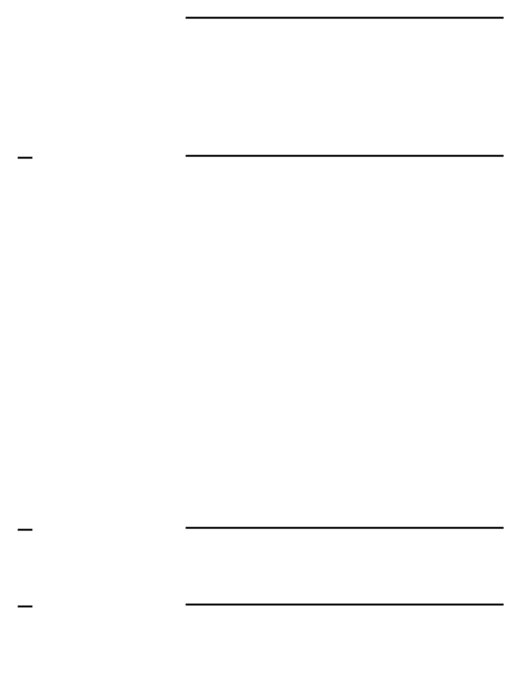

Los Angeles, CA 90002

(123) 456-7890

rk_1876@gmail.com

LinkedIn
Github

Straight Arrow Products

Senior IT Manager

January 2016 - current, Pittsburgh, PA

- Oversaw computer systems, hardware, network security, and infrastructure services as the company grew from $5M to $25M in annual revenue

- Worked closely with senior management to scope and build new features and applications which enabled 100% year over year revenue growth

- Set up and maintained WMS & Amazon scanners which allowed for 100% data redundancy and no loss of production data

- Working closely with other team leaders led the budgeting process for all IT related projects

- Performed regular maintenance and improvement of network servers to improve application speed by 70% during my tenure

Rimkus

IT Infrastructure Manager

September 2012 - January 2016, Los Angeles, CA

- Led and delivered the infrastructure capability transformation for cloud and internal systems with a focus on user-experience and performance for an application with 2,000,000 concurrent users

- Evaluated and implemented right-fit industry products and technologies and led adoption of those technologies within the company

- Ensured the IT Infrastructure team completed 100% of customer tickets on-time by removing roadblocks and leading prioritization eﬀorts

- Automated repetitive, manual tasks to save the organization over 200 hours of manual eﬀort each month

- SQL

- Python

- AWS

- Network security

- Network infrastructure

UCLA

Bachelor of Science, Information Science

2008 - 2012, Los Angeles, CA

