Performance Evaluation of Double Basin V shape Solar Still

**Karuna Dhruv Bilakhia1,**

1 Assistant Professor

Atharva College of Engineering,Mumbai

[karunaverma12041992@gmail.com](mailto:karunaverma12041992@gmail.com)

**Mahesh Thakur Harishankar,**

2 Student, Information technology Engineering,

Atharva College of Engineering,Mumbai

Maheshthakur9152@gmail.com

**Dhruv surti Hitendra,**

Student, Information technology Engineering,

Atharva College of Engineering,Mumbai

dhruvsurti2006[@gmail.com](mailto:Karunaverma12041992@gmail.com)

**Abstract**

More than 70 million deaf people around the world use sign languages to communicate. Sign language allows them to learn, work, access services, and be included in the communities.

It is hard to make everybody learn the use of sign language with the goal of ensuring that people with disabilities can enjoy their rights on an equal basis with others.So, the aim is to develop a user-friendly human computer interface (HCI) where the computer understands the American sign language This Project will help the dumb and deaf people by making their life easy.To create a computer software and train a model using CNN which takes an image of hand gesture of American Sign Language and shows the output of the particular sign language in text format converts it into audio format.

**Keywords: Sign language toText&audio**

# **Introduction**

American sign language is a predominant sign language Since the only disability D&M people have been communication related and they cannot use spoken languages hence the only way for them to communicate is through sign language. Communication is the process of exchange of thoughts and messages in various ways such as speech, signals, behavior and visuals. Deaf and dumb(D&M) people make use of their hands to express different gestures to express their ideas with other people. Gestures are the nonverbally exchanged messages and these gestures are understood with vision. This nonverbal communication of deaf and dumb people is called sign language.In our project we basically focus on producing a model which can recognise Fingerspelling based hand gestures in order to form a complete word by combining each gesture. The gestures we aim to train are as given in the image on left side

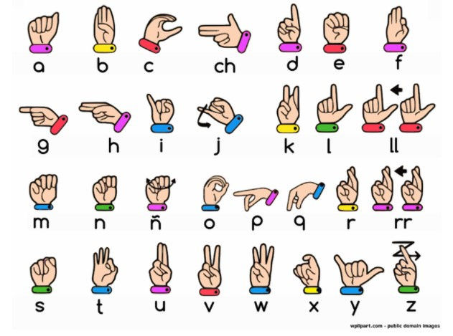

**2.Literature Review**

**Mahesh Kumar N B1 Assistant Professor (Senior Grade),**

**Bannari Amman Institute of Technology,**

**Sathyamangalam, Erode, India (2018):**

This paper shows the sign language recognizing of 26 hand gestures in Indian sign language using MATLAB. The proposed system contains four modules such as: pre-processing and hand segmentation, feature extraction, sign recognition and sign to text. By using image processing the segmentation can be done. Otsu algorithm is used for segmentation purposes Some of the features are extracted such as Eigen values and Eigen vectors which are used in recognition. The Linear Discriminant Analysis (LDA) algorithm was used for gesture recognition and recognized gestures are converted into text and voice format. The proposed system helps to dimensionality.

**2.2**

**Translation of Sign Language Finger-Spelling to Text**

**using Image Processing**

**-by**

**Krishna Modi**

**Mukesh Patel School of Technology and Management Engineering JVPD Scheme Bhaktivedanta Marg, Vile Parle (W),**

**Mumbai-400 056(2013)**

In This proposed system, they intend to recognize some very basic elements of sign language and to translate them to text. Firstly, the video shall be captured frame-by-frame, the captured video will be processed and the appropriate image will be extracted, this retrieved image will be further processed using BLOB analysis and will be sent to the statistical database here the captured image shall compared with the one saved in the database and the matched image will be used to determine the performed alphabet sign in the language. Here, they will be implementing only

American Sign Language Finger-spellings, and They will construct words and sentences with them. With the proposed method, they found that the probability of Obtaining desired output is around **93% which** is sufficient and Can be enough to make it suitable to be used on a larger scale For the intended purpose.

**2.3**

**Sign Language to Text and Speech Conversion**

**-By Bikash K. Yadav**

**Sinhgad College of Engineering, Pune, Maharashtra(2020)**

Sign language is one of the oldest and most natural forms of language for communication. Since most people do not know sign language and interpreters are very difficult to come by, They have come up with a real-time method using Convolution Neural Network (CNN) for fingerspelling based American Sign Language (ASL). In Their method, the hand is first passed through a filter and after the filter has applied the hand is passed through a classifier that predicts the class of the hand gestures. Using Their approach, They are able to reach a model accuracy of 95.8% **2.4**

**Sign Language to Text and Speech Translation in Real Time Using Convolutional Neural Network-by Ankit Ojha Dept. of ISE**

**JSSATE Bangalore, India .**

Creating a desktop application that uses a computer’s webcam to capture a person signing gestures for American sign language (ASL), and translate it into corresponding text and speech in real time. The translated sign language gesture will be acquired in text which is farther converted into audio. In this manner they are implementing a finger spelling sign languagetranslator. To enable the detection of gestures, they are making use of a Convolutional neural network (CNN). A CNN is highly efficient in tackling computer vision problems and is capable of detecting the desired features with a high degree of accuracy upon sufficient training. The modules are image acquisition, hand region segmentation and hand detection and tracking hand posture recognition and display as text/speech. A finger spelling sign language translator is obtained which has an accuracy of **95%**

**2.5**

**CONVERSION OF SIGN LANGUAGE TO TEXT AND SPEECH USING MACHINE LEARNING TECHNIQUES**

**Author : Victorial Adebimpe Akano(2018)**

Communication with the hearing impaired (deaf/mute) people is a great challenge in our society today; this can be attributed to the fact that their means of communication (Sign Language or hand gestures at a local level) requires an interpreter at every instance. To convert ASL signed hand gestures into text as well as speech using unsupervised feature learning to eliminate communication barrier with the hearing impaired and as well provide teaching aid for sign language.Sample images of different ASL signs were collected using the Kinect sensor using the image acquisition toolbox on MATLAB. About five hundred (500) data samples (with each sign count five and ten (5-10)) were collected as the training data. The reason for this is to make the algorithm very robust for images of the same database in order to reduce the rate of misclassification. The combination FAST and SURF with a KNN of 10 also showed that unsupervised learning classification could determine the best matched feature from the existing database. In turn, the best match was converted to text as well as speech. The introduced system achieved a **92%** accuracy of supervised feature learning and **78%**of unsupervised feature learning

**2.6 An Improved Hand Gesture Recognition Algorithm based on**

**image contours to Identify the American Sign Language**

**-by Rakesh Kumar**

**Department of Computer Engineering & Applications, GLA University,Mathura(2021)**

this paper proposed a recognition and classification of hand gesture to identify the correct denotation with maximum accurateness for standard American Sign Language. The proposal intelligently used the information based on image contours to identify the character's representation of hand gesture. The proposal optimizes the performance overhead through identifications of 17 characters and 6 symbols based on image contours and convexity measurement of Standard American Sign Language without using complex algorithms and specialized hardware devices. Accuracy measurement done through simulation, which shows how their proposal provides more accuracy with minimum complexity in comparison to other state-of-the-art works. The average accuracy is **86%** overall.

1. **Methodology**

**I. Experimental Setup**

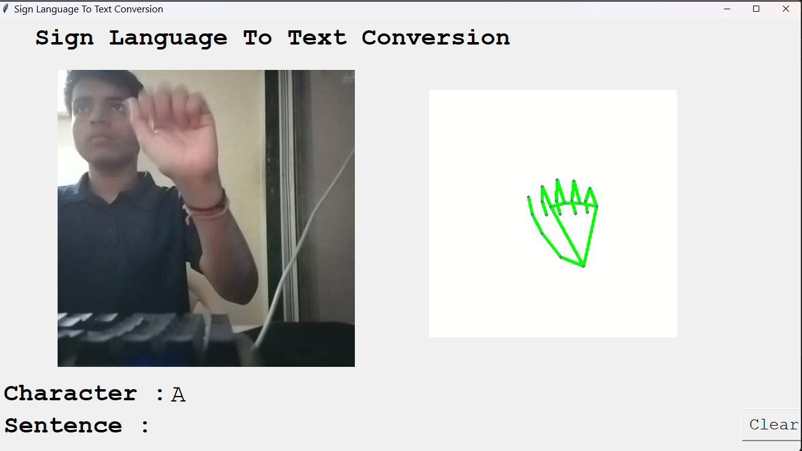

Figure 1 : Experimental Setup

The development of Signova followed a structured approach, starting with data collection and preprocessing. A dataset of sign language gestures was gathered from publicly available sources and custom-recorded videos. To enhance the model’s accuracy, the data was preprocessed by resizing images, normalizing pixel values, and applying augmentation techniques such as rotation, flipping, and contrast adjustments. For gesture recognition, a Convolutional Neural Network (CNN) was trained to classify different signs. Alternatively, pre-trained models like MobileNetV2 or MediaPipe Hands were explored to improve efficiency and accuracy. Transfer learning was applied to adapt these models to the specific dataset, ensuring better recognition even with a limited number of training samples. Real-time recognition was achieved by integrating OpenCV for video capture and implementing hand-tracking techniques. The model detected and classified gestures dynamically, converting them into corresponding text representations. To further improve usability, a text-to-speech module was integrated using gTTS or pyttsx3, allowing the recognized gestures to be converted into spoken words.A user-friendly interface was developed using frameworks like Tkinter, Flask, or Streamlit, making the application accessible and interactive. The system was tested with real users to evaluate accuracy and usability. Based on feedback, the model was fine-tuned, addressing false detections and optimizing performance. For deployment, efforts were made to ensure the application could run on both computers and mobile devices. Future improvements include expanding the dataset with additional sign language variations, implementing LSTM for recognizing continuous gestures, and optimizing the model for mobile use with TensorFlow Lite.

**II. Experimental Procedure:**

#### **1. Data Collection**

A dataset of sign language gestures was collected from public sources and custom-recorded videos. Custom gestures were recorded using a high-resolution camera under different lighting conditions to ensure diversity in the dataset. Each recorded sign was labeled with its corresponding text representation.

#### **2. Data Preprocessing**

All images and video frames were resized to a fixed dimension for consistency. Pixel values were normalized to enhance model learning. Data augmentation techniques such as rotation, flipping, and brightness adjustments were applied to improve model robustness against variations in hand positioning and lighting.

#### **3. Model Training**

A Convolutional Neural Network (CNN) was used to classify gestures. In some experiments, pre-trained models like MobileNetV2 and MediaPipe Hands were used to enhance recognition accuracy. The dataset was split into training and validation sets in an 80:20 ratio. The model was trained using categorical cross-entropy as the loss function and Adam optimizer for better convergence. Hyperparameters such as learning rate, batch size, and number of epochs were tuned to achieve optimal performance.

#### **4. Real-Time Gesture Recognition**

A real-time recognition system was implemented using OpenCV for video capture. The trained model was integrated with OpenCV to detect and classify hand gestures dynamically. To improve tracking, techniques like contour detection and bounding box segmentation were tested. Various environmental conditions (lighting, background clutter, and hand orientations) were introduced to assess the robustness of the system.

#### **5. Text and Speech Conversion**

Recognized gestures were mapped to corresponding words or letters. The output text was displayed on the screen, and a text-to-speech module using gTTS or pyttsx3 was implemented to provide audio output. The accuracy of text conversion was evaluated by comparing predicted outputs with ground truth labels.

#### **6. Testing and Evaluation**

The system was tested on new, unseen gestures to measure its accuracy and efficiency. A group of users, including those familiar with sign language, was asked to interact with the system and provide feedback. Performance metrics such as accuracy, precision, recall, and latency were recorded. The system’s ability to handle real-world variations was tested, and failure cases were analyzed for improvement.

#### **7. Model Optimization and Deployment**

Based on testing results, the model was fine-tuned by adjusting hyperparameters and increasing dataset diversity. The final model was optimized for deployment, ensuring real-time processing efficiency. For better usability, a graphical user interface (GUI) was developed using Tkinter, Flask, or Streamlit, making it accessible to non-technical users.

#### **8. Future Enhancements**

The experiment concluded with planned improvements, including expanding the dataset with more sign language variations, integrating LSTM networks for dynamic sentence recognition, and optimizing the model for mobile devices using TensorFlow Lite.

4o

**III.Results and Discussion**

The experiments were conducted between 9 am and 5 pm, during which the still was connected to a solar water heater. Figure 2 illustrates the outcomes of the tests performed over a span of 7 days, commencing from 02/05/2022 to 08/05/2022. The initial water level was set at 50 mm. The experiment commenced with the transfer of hot water from the storage tank to the still, maintaining the water level at 50 mm. Productivity is more in v shape double basin compare to v shape single basin.Figure.3 shows the laboratory report, for parameters like pH, TDS, Hardness and EC values, for input saline tap water v/s output distillate water, it is observed that the output collected is under the acceptable limit.

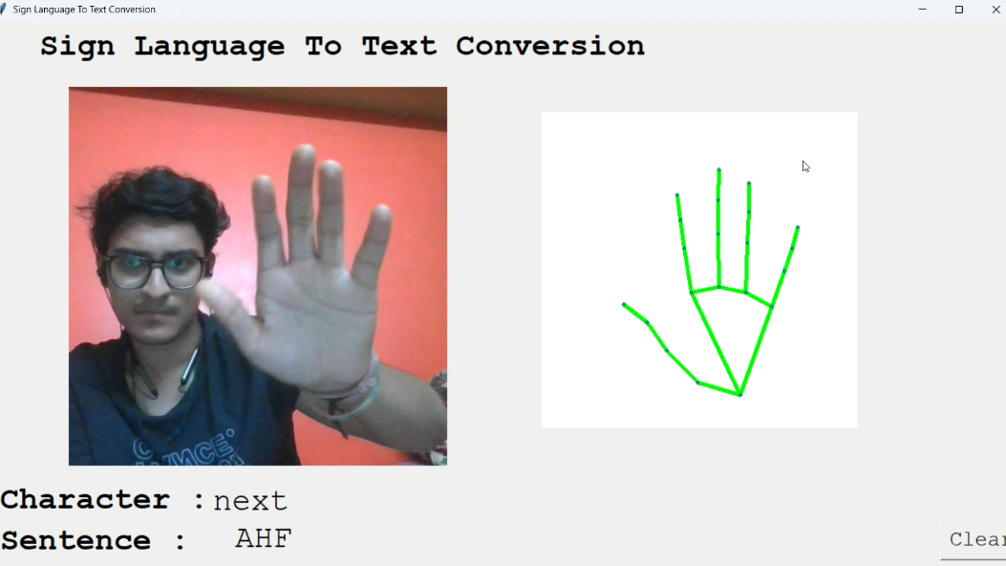

Figure 2: Comparison of result

Figure 3: Test report

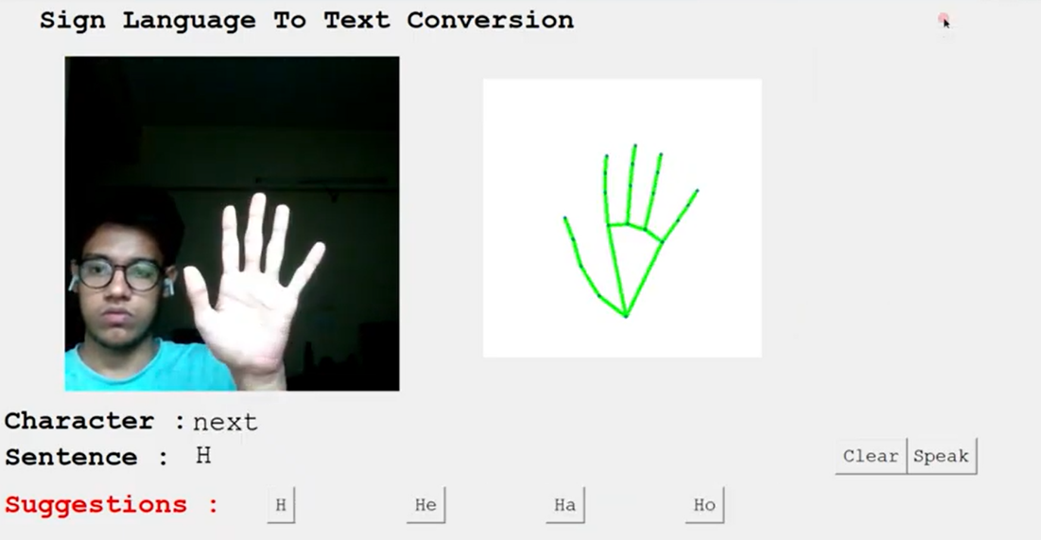

**3. Conclusion**

Finally, we are able to predict any alphabet[a-z] with **97%** Accuracy (with and without clean background and proper lightning conditions) through our method. And if the background is clear and there is good lightning condition then we got even **99%** accurate results.

In Future work we will make one android application in which we implement this algorithm for gesture prediction

**References**

[1][ijaerv13n9_90.pdf (ripublication.com)](https://www.ripublication.com/ijaer18/ijaerv13n9_90.pdf)

[2][Translation of Sign Language Finger-Spelling to Text using Image Processing (ijcaonline.org)](https://research.ijcaonline.org/volume77/number11/pxc3891313.pdf)

[3][Sign Language to Text and Speech Conversion (ijariit.com)](https://www.ijariit.com/manuscripts/v7i3/V7I3-1560.pdf)

[4][Sign Language to Text and Speech Translation in Real Time Using Convolutional Neural Network – IJERT](https://www.ijert.org/sign-language-to-text-and-speech-translation-in-real-time-using-convolutional-neural-network)

[5][(PDF) Conversion of Sign Language To Text And Speech Using Machine Learning Techniques (researchgate.net)](https://www.researchgate.net/publication/335433017_Conversion_of_Sign_Language_To_Text_And_Speech_Using_Machine_Learning_Techniques)

[6] [An Improved Hand Gesture Recognition Algorithm based on image contours to Identify the American Sign Language - IOPscience](https://iopscience.iop.org/article/10.1088/1757-899X/1116/1/012115)