CONTENT INTAKE PORTAL
Technical Architecture Documentation
Prepared by: Mahesh Vullingala | Date: August 5, 2026
Repository: github.com/MaheshVullingala/content-intake | Production: self-hosted on org RHEL 9 VM (internal)

1. Executive Summary
The Content Intake Portal is a web application that replaces ad-hoc email/spreadsheet requests for new marketing web pages with a structured, auditable workflow. A stakeholder fills out a form describing the page they need (banner, overview, key benefits, features, customer stories, and six other optional content sections), and the request is automatically routed to the right specialist teams — Editorial, Brand, SEO, and Design — who work on it in parallel. Once every required team has signed off, the request is handed to the Web Team for implementation and publishing.
The system is built on Next.js and the Supabase stack (Postgres database, authentication, and file storage), with an optional AI-assisted content generation feature backed by Anthropic's Claude API. The application and the full Supabase stack are self-hosted on the organization's own RHEL 9 virtual machine via Docker Compose, rather than relying on external hosting providers. Access is role-based — ten distinct roles, from Stakeholder through Super Admin — and every table in the database enforces row-level security, so users can only see and edit what their role permits.
This document describes how the system is built: its technology stack, data model, authentication and security model, and the content approval workflow. It is intended for engineering handoff and technical review; a companion status/readiness summary can be produced separately if needed.

2. Technology Stack
Layer | Technology | Notes
Frontend framework | Next.js 14.2.35 (App Router) | Single-page app pattern — one root component manages view state; no client-side router
UI library | React 18.3.1 | Function components with hooks throughout
Styling | Custom CSS + inline styles | Monochrome palette with teal (#14b8a6) accent; Rubik font
Database | Postgres (self-hosted, Docker) | 12 tables, Row-Level Security enabled on every one
Authentication | GoTrue (self-hosted, Docker) | Email + password; same Supabase Auth engine, run in-house
File storage | Supabase Storage (self-hosted, Docker) | “attachments” bucket, backed by a disk volume on the VM
API gateway | Kong (self-hosted, Docker) | Routes requests to GoTrue / PostgREST / Storage — the Supabase API surface
AI content generation | Anthropic Claude API | Cloud-hosted; called only from a server-side proxy route, never directly from the client
Email | Nodemailer over SMTP | Optional; built against Office 365 / generic SMTP; off by default
Hosting | Org RHEL 9 VM — Docker Compose | 4 vCPU / 16GB RAM / 150GB; Nginx reverse proxy handles TLS termination
Scheduled jobs | systemd timer / cron | Sweeps for queued email notifications every 5 minutes; replaces Vercel Cron

3. System Architecture
The application and its entire backend — Next.js, Postgres, GoTrue (Auth), PostgREST, Storage, and the Kong API gateway that fronts them — run as Docker containers on a single organization-owned RHEL 9 virtual machine (4 vCPU / 16GB RAM / 150GB), orchestrated with Docker Compose. Nginx sits in front as a reverse proxy and terminates TLS. Only two external, cloud-hosted dependencies remain: the Anthropic Claude API (AI Assist) and, optionally, an outbound SMTP relay for email notifications.
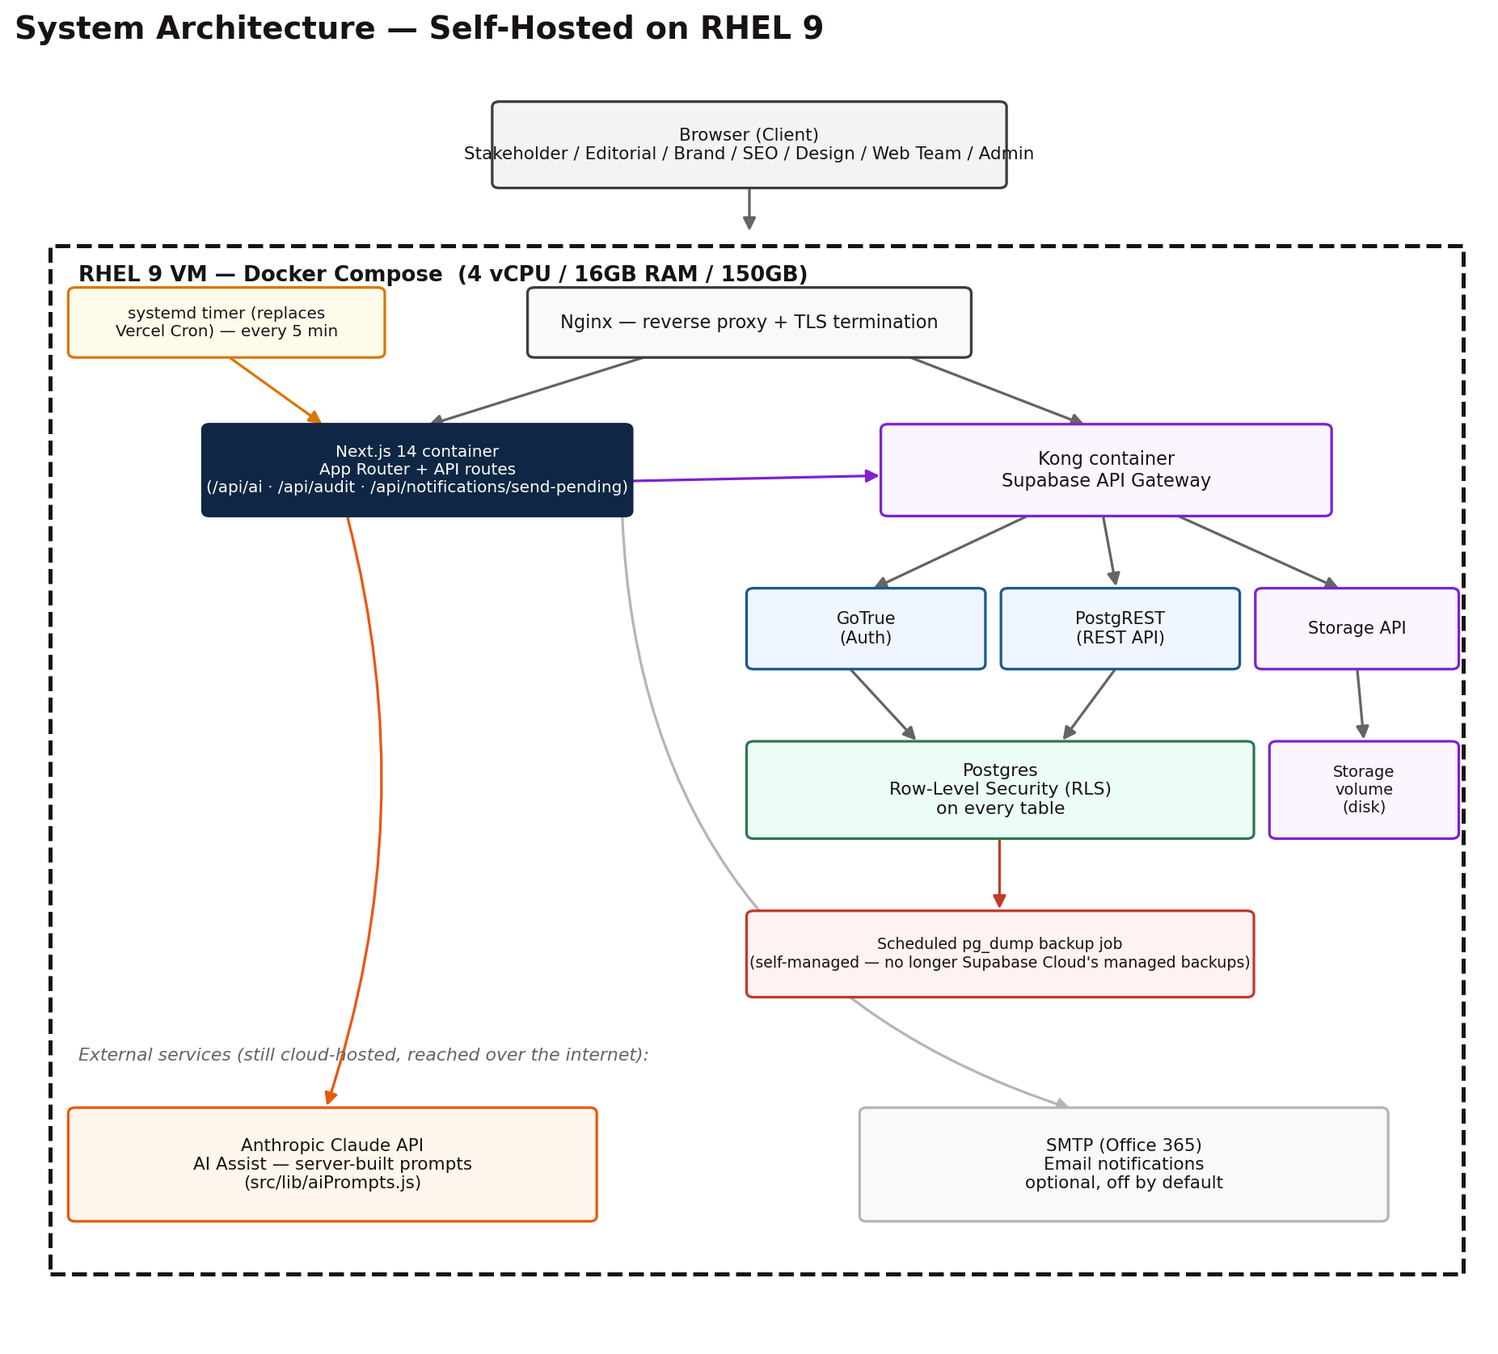
Figure 1 — System architecture: self-hosted stack on the RHEL 9 VM, plus external services
The browser talks to Nginx, which routes application traffic to the Next.js container and Supabase-API traffic to Kong. Kong forwards to GoTrue, PostgREST, or Storage as appropriate, all of which sit in front of the same Postgres instance. Because the browser holds a session token (not a service-role key), every read and write it makes is still subject to Postgres row-level security — the Next.js API layer exists for defense-in-depth on a few sensitive operations (calling the Claude API, writing audit log entries, sending queued emails), not because the client is otherwise unrestricted.
Moving off managed cloud hosting shifts two responsibilities onto the organization that Supabase Cloud and Vercel previously handled: database backups (a scheduled pg_dump job, shown in Figure 1, replaces Supabase Cloud's managed backups) and the deployment pipeline (a git pull plus docker compose build/up on the VM replaces Vercel's git-triggered auto-deploy).

4. Data Model
The schema has 12 tables, all with row-level security enabled. The central table is requests, which stores every content field for a page request as flat columns (with JSONB arrays for repeatable items like benefit cards or FAQ rows).
Table | Purpose
users | Extends Supabase Auth with role, department, and can_assign; linked to auth.users via auth_id
requests | The core content request record — page type, status fields, and every section's content (banner, overview, key benefits, features, etc.)
tasks | One row per team per request (editorial/brand/seo/design/web); tracks status, assignment, and question/answer threads
comments | Request-level comment and return-for-revision thread
attachments | Request-level file uploads (legacy path)
task_attachments | Task-level file uploads — how Brand and Design teams deliver images
status_history | Audit trail of status transitions on a request
notifications | In-app notification feed per user, with an email_sent flag
audit_log | Security/action audit trail: user, role, action, entity, old/new value, IP, session, and role-impersonation state
settings | Global app settings — idle-timeout minutes, email-notifications toggle
content_change_requests | Post-publish edit proposals that require full review (reason, changed fields, approval status)
char_limit_overrides | Admin-configurable character limits per field, overriding the built-in defaults

The requests table carries two status fields side by side: a legacy status column reflecting an earlier linear review flow, and the overall_status column that actually drives the current parallel-task workflow described in Section 6. New development should treat overall_status as authoritative.

5. Authentication, Roles & Security

5.1 Authentication
Users sign in with email and password via Supabase Auth. A public.users row (linked by auth_id) carries the application-level role and profile; a brand-new user starts with role = “pending” and sees a waiting screen until an admin assigns a role — unless they self-register with a @cadence.com email address, which is granted the Stakeholder role automatically (enforced both in the UI and at the database level).

5.2 Roles
Ten roles are defined: super_admin, admin, pending, stakeholder, editorial_team, brand_team, seo_team, design_team, web_team, plus two legacy roles (editorial_qa, design_qa) retained from an earlier version of the workflow. Admins can grant a can_assign flag to specific team members, letting them assign tasks to teammates rather than only working their own queue.

5.3 Row-Level Security
Every table enforces Postgres row-level security keyed off the caller's real session token — not a shared API key — so permissions are enforced by the database itself, not just by the UI. A small number of SECURITY DEFINER functions (get_user_role(), get_user_id(), get_user_can_assign(), check_web_team_unlock(), link_auth_id_by_email()) provide narrow, auditable exceptions for specific cross-cutting checks, rather than opening any table's policies broadly.

5.4 Other security measures
- Content-Security-Policy, X-Frame-Options, X-Content-Type-Options, Strict-Transport-Security, Referrer-Policy, and Permissions-Policy headers on every response. The CSP's allowed Supabase origin is derived from the live NEXT_PUBLIC_SUPABASE_URL at build time rather than hardcoded, so it doesn't silently break if the Supabase project changes.
- Server-side input sanitization (strips HTML tags, javascript: protocol, inline event handlers, and data: URIs) before any text payload is saved.
- File upload validation: MIME-type allowlist, file-size limit, and a check that the file extension actually matches the declared MIME type.
- /api/ai and /api/audit both verify the caller's identity server-side (never trust a client-supplied user ID) and are rate-limited.
- Idle-session auto-logout, with a configurable timeout (default 5 minutes) and a 60-second warning before sign-out.
- An admin “View as” role-impersonation mode for testing other roles' views, with impersonation state recorded in the audit log rather than silently swapped.

6. Content Request Workflow
Once submitted, a request moves through a parallel task model rather than a single linear queue: instead of waiting for one team to finish before the next one starts, Editorial, Brand, SEO, and Design all work on their piece of the request at the same time, and the Web Team is only unlocked once every required team has finished.
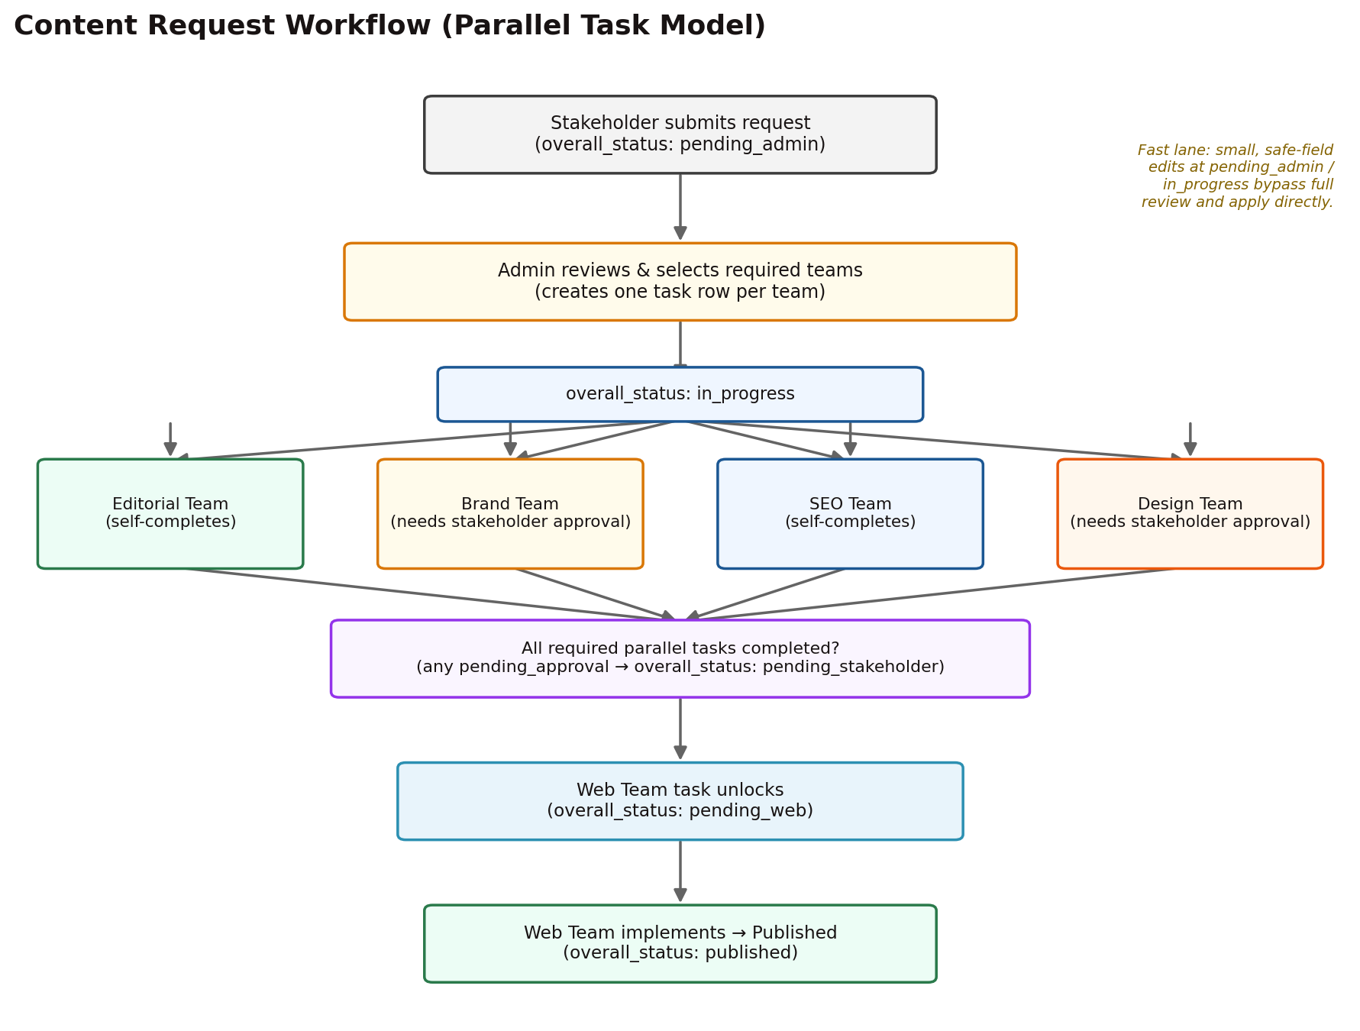
Figure 2 — Content request workflow: parallel task assignment through publish

6.1 Steps
- A stakeholder submits a request. It starts in overall_status “pending_admin.”
- An admin reviews it and selects which teams are actually required for this page (not every page needs Brand or SEO work). One task row is created per selected team; the Web Team's task starts locked, all others start pending. Status moves to “in_progress.”
- Editorial, Brand, SEO, and Design work in parallel. Editorial and SEO team members mark their own task complete directly. Brand and Design team tasks require an explicit stakeholder approval step before being marked complete — while any task is awaiting that approval, overall_status shows “pending_stakeholder.”
- Once every required parallel task reaches “completed,” a database function automatically unlocks the Web Team's task and notifies Web Team members. Status moves to “pending_web.”
- The Web Team implements the page and marks it complete. Status moves to “published.”

6.2 Fast lane for small edits
Not every stakeholder change needs to restart the full review cycle. If a request is still at “pending_admin” or “in_progress,” and every changed field is on a pre-approved safe list (excludes links/URLs and SEO location fields) and the edit is small (measured by edit distance, capped at 25 characters changed), the edit applies immediately without going back through review. Anything larger, riskier, or made after that stage goes through a full change-request review instead.

6.3 Post-publish edits
Edits requested after a page has been published are captured as a content_change_requests record (reason, the specific fields changed, and an approval status) and reviewed by an admin before being applied — unless they qualify for the fast lane above.

7. Content Model
Every request is one of four page types, and each page type has its own set of applicable sections — some always required, some optional, some not applicable to that page type at all.
Page Type | Always Required | Notes
Product | Banner, Overview | Full section set available (all 10 sections)
Solutions | Banner, Overview | Same section set as Product
Glossary | Banner | Overview is optional rather than required; lighter-weight page
On-demand Webinar | Banner | Overview section does not apply to this page type at all

The 10 sections are: SEO Meta Data, Banner, Overview, Key Benefits, Features/Applications, Customer Stories, Promo Section, Related Content (max 3 cards), Resources (video carousel, mixed media, featured resources, news & blogs), Related Products, and Training & Support (three fixed, pre-filled cards). Each section has a matching form component and a live preview component, so stakeholders see an approximation of the finished page as they fill it in. The Features/Applications section supports four different layouts — list, horizontal tabs, vertical tabs, or a data table — chosen per request.
Character limits are enforced per field against the values a stakeholder is typing, with admin-overridable defaults stored in the char_limit_overrides table, so limits can be tuned without a code change.

8. AI-Assisted Content Generation
An “AI Assist” button is available on supported fields and sections, calling a Next.js API route that proxies to Anthropic's Claude API. All prompt construction happens server-side: the client sends only structured data (which section, which mode, the current text, a direction, or a product brief) and never a raw prompt string. This closes a vulnerability present in an earlier version, where the client controlled the system prompt sent to the model — effectively an open proxy that any authenticated user could redirect.
Three modes are supported: improving existing text, following a written direction, or generating fresh content from a structured product brief (product name, audience, unique selling point, page goal, and an optional “Verified Proof Points” field). The system prompt explicitly instructs the model never to invent statistics, benchmark numbers, or certifications that weren't supplied — if no proof points are given, it's told to describe capabilities qualitatively rather than fabricate a number. The route is authentication-gated and rate-limited server-side.

9. Notifications
An in-app notification feed covers task assignment, task completion, approvals, questions and answers, priority changes, the Web Team unlock event, publishing, and content-change submissions. Email notifications are optional and off by default, gated by both environment configuration and an admin-controlled setting; the implementation targets generic SMTP so it works against Office 365 or an internal relay. On the RHEL 9 VM, a systemd timer (or an equivalent cron entry) sweeps for queued, unsent notification emails every five minutes, calling the same /api/notifications/send-pending endpoint that Vercel Cron used to trigger, authenticated with a shared CRON_SECRET.

10. Deployment & Infrastructure

10.1 Host
- A single organization-owned RHEL 9 virtual machine: 4 vCPU / 16GB RAM / 150GB disk — sized with headroom for Docker plus the full self-hosted stack (Postgres, GoTrue, PostgREST, Storage, Kong, Next.js, Nginx).
- Docker + Docker Compose orchestrate every service as a container; Nginx runs as a reverse proxy in front of both the Next.js app and the Kong API gateway, and terminates TLS (certificate from the org's internal CA or Let's Encrypt, depending on network exposure).

10.2 Deployment process
- Code is still developed and version-controlled in the GitHub repository. Releasing to the VM is a pull-and-rebuild: git pull on the VM, then docker compose build followed by docker compose up -d to roll the updated containers, replacing Vercel's automatic git-triggered deploy.
- Required environment variables move from Vercel's project settings to a .env file (or equivalent secrets store) read by Docker Compose on the VM: the internal Supabase URL/keys (now pointing at the local Kong gateway instead of a *.supabase.co domain), ANTHROPIC_API_KEY, and SUPABASE_SERVICE_ROLE_KEY (server-only, used by the audit and notification-sweep routes).
- Optional environment variables: SMTP_HOST / SMTP_PORT / SMTP_SECURE / SMTP_USER / SMTP_PASSWORD / SMTP_FROM for email, CRON_SECRET to authenticate the scheduled notification sweep, and NEXT_PUBLIC_APP_URL for building links inside emails.

10.3 New operational responsibilities
Self-hosting trades Vercel/Supabase Cloud's managed infrastructure for direct control, at the cost of taking on the operational tasks they used to handle:
- Database backups — a scheduled pg_dump job (or equivalent) must be set up and monitored; Supabase Cloud's automatic managed backups no longer apply.
- OS and container patching, disk space and log monitoring, and certificate renewal for TLS.
- Uptime/monitoring and alerting for the VM and each container, previously provided implicitly by Vercel's and Supabase's platforms.
- No automated test runner or linter is currently configured. A client-side “Fill Test Data” utility can populate every applicable section of a request with placeholder content in one click, to speed up manual QA passes.

11. Administrative Capabilities
- User & role management — assign roles, grant the can_assign flag for task delegation within a team.
- Task setup — choose which teams are actually required for a given request before work begins.
- Character limit overrides — tune per-field limits without a code deployment.
- Global settings — idle-timeout duration, email-notifications on/off.

End of document.

