NETWORKWALKS

PENETRATION TESTING REPORT
MEDIROZA GENERAL HOSPITAL
W4-PM-FINAL | CYBERSECURITY | NETWORKWALKS

Project Information | Details
Pentester Name | Mahesh Yaramala
Program / Batch | Cybersecurity Program | B083 – NetworkWalks
Date | 02 October 2026
Client / Target | Mediroza General Hospital | https://medirozahospital.com
Assessment Type | Black-box penetration testing & vulnerability assessment
Authorization | Written authorization provided for the controlled educational lab
Milestones | M1 Initial Access | M2 Data Extraction | M3 Critical Data Exposure | M4 Report

CONFIDENTIAL — AUTHORISED PERSONNEL ONLY

1. Liability Disclaimer
All activities documented in this report were performed within the authorized NetworkWalks educational lab scope and against the specified Mediroza General Hospital target. No social engineering or denial-of-service testing was performed. Security testing techniques must only be applied to systems for which explicit authorization exists.

2. Introduction
This report documents the Week 4 Mediroza General Hospital penetration-testing practical completed during the NetworkWalks internship program. The assessment followed the project milestones defined in the supplied Week 4 brief: obtain initial access and three confidential patient reports, recover access to the protected files, identify the critical data exposure on the server, and document the results in a professional penetration-testing report.
The practical demonstrated an attack chain beginning with web reconnaissance and an authentication weakness, followed by recovery of protected PDF reports, metadata analysis, discovery of an exposed legacy directory, and analysis of an accessible database backup containing staff salary and shareholder information.

3. Scope and Methodology
Item | Details
Client | Mediroza General Hospital
Target | https://medirozahospital.com
Assessment | Full black-box penetration test
Duration | 5 days
Testing scope | Target domain only
Social engineering | Not performed
Denial of service | Not performed
Authorization | Written authorization granted for the lab

3.1 Methodology
- Conduct reconnaissance and identify exposed application entry points.
- Analyze the patient authentication mechanism and its response behavior.
- Test application input handling and demonstrate the authentication weakness.
- Access the restricted patient portal and retrieve the three assigned reports.
- Extract PDF password hashes and recover the passwords using John the Ripper.
- Decrypt the three reports using qpdf and verify successful access.
- Inspect PDF metadata for operational information and additional attack paths.
- Investigate the exposed /old/ directory and retrieve the accessible SQL backup.
- Analyze the backup contents for employee salary and shareholder records.
- Document evidence, impact, risk, and remediation recommendations.

3.2 Tools Used
Tool | Purpose
Kali Linux | Controlled penetration-testing environment
Firefox | Web application testing and evidence collection
curl | Reconnaissance of robots.txt
John the Ripper | PDF password recovery
qpdf | PDF decryption
ExifTool | PDF metadata analysis
grep / sed | Inspection of the exposed SQL backup

4. Activities Performed

4.1 Milestone 1 — Initial Access
The first stage focused on reconnaissance, exposed entry points, authentication behavior, and controlled access to the restricted patient area.
Reconnaissance command:
curl https://medirozahospital.com/robots.txt
The robots.txt response exposed the /patient/, /staff/, and /old/ paths. The /patient/ path was used to locate the patient login interface.
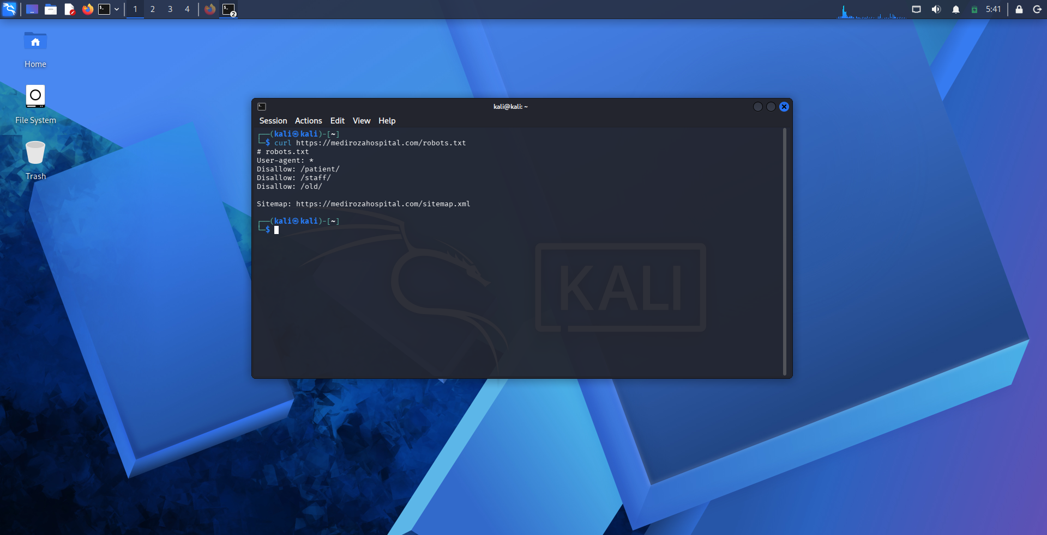
Evidence: M1 — robots.txt reconnaissance and exposed paths
The patient login page returned an authentication-specific response. This behavior was then tested with crafted input in the authorized lab.
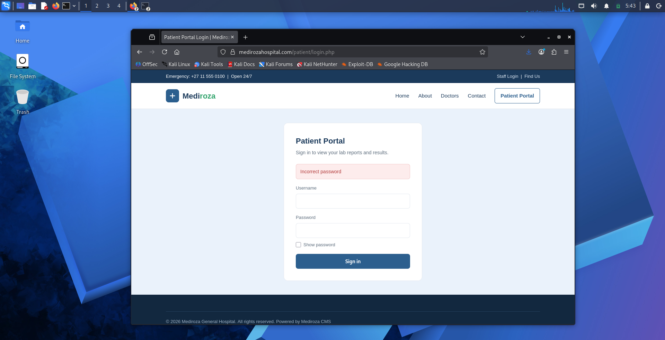
Evidence: M1 — Patient portal authentication response

4.1.1 Authentication Bypass
The username parameter was tested for SQL injection. The following crafted input was used in the authorized lab:
admin' --
The application accepted the crafted input and provided access to the restricted patient portal. This demonstrated an authentication-bypass condition caused by unsafe handling of user input.
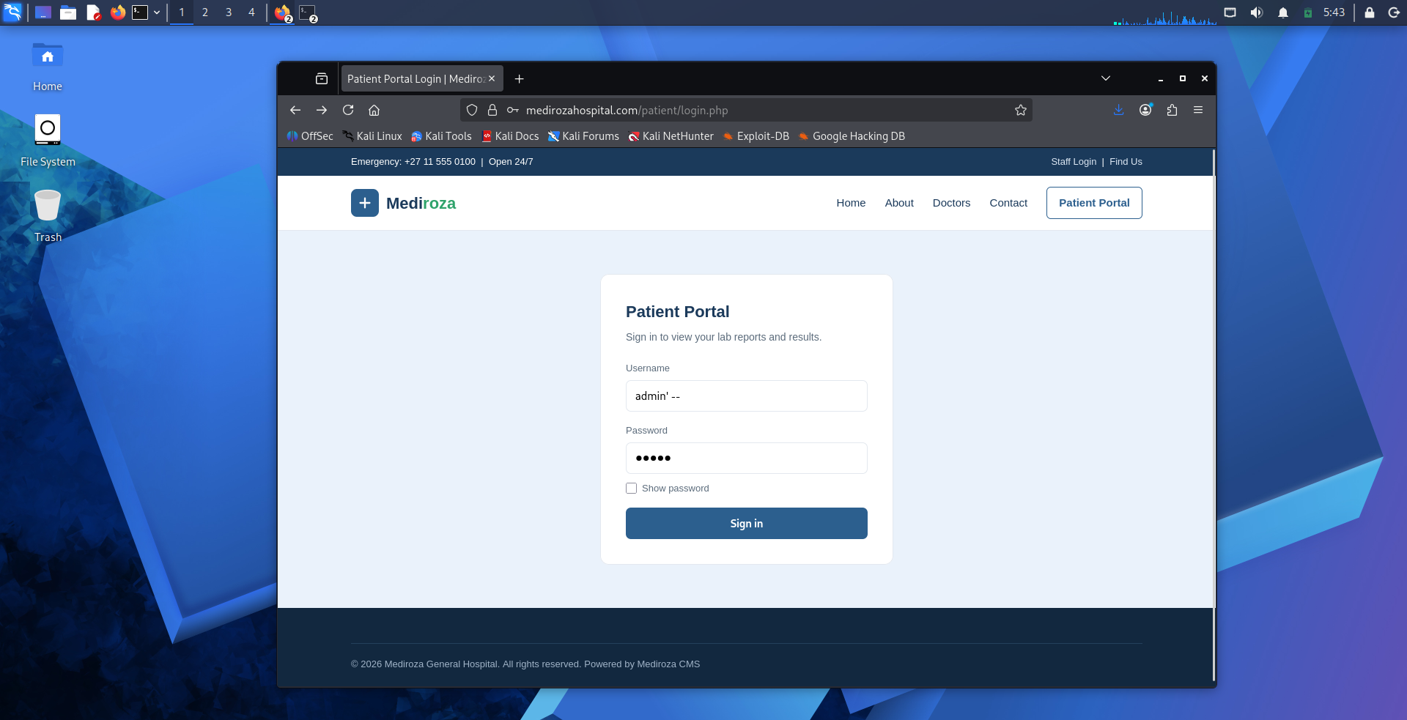
Evidence: M1 — SQL injection authentication-bypass input
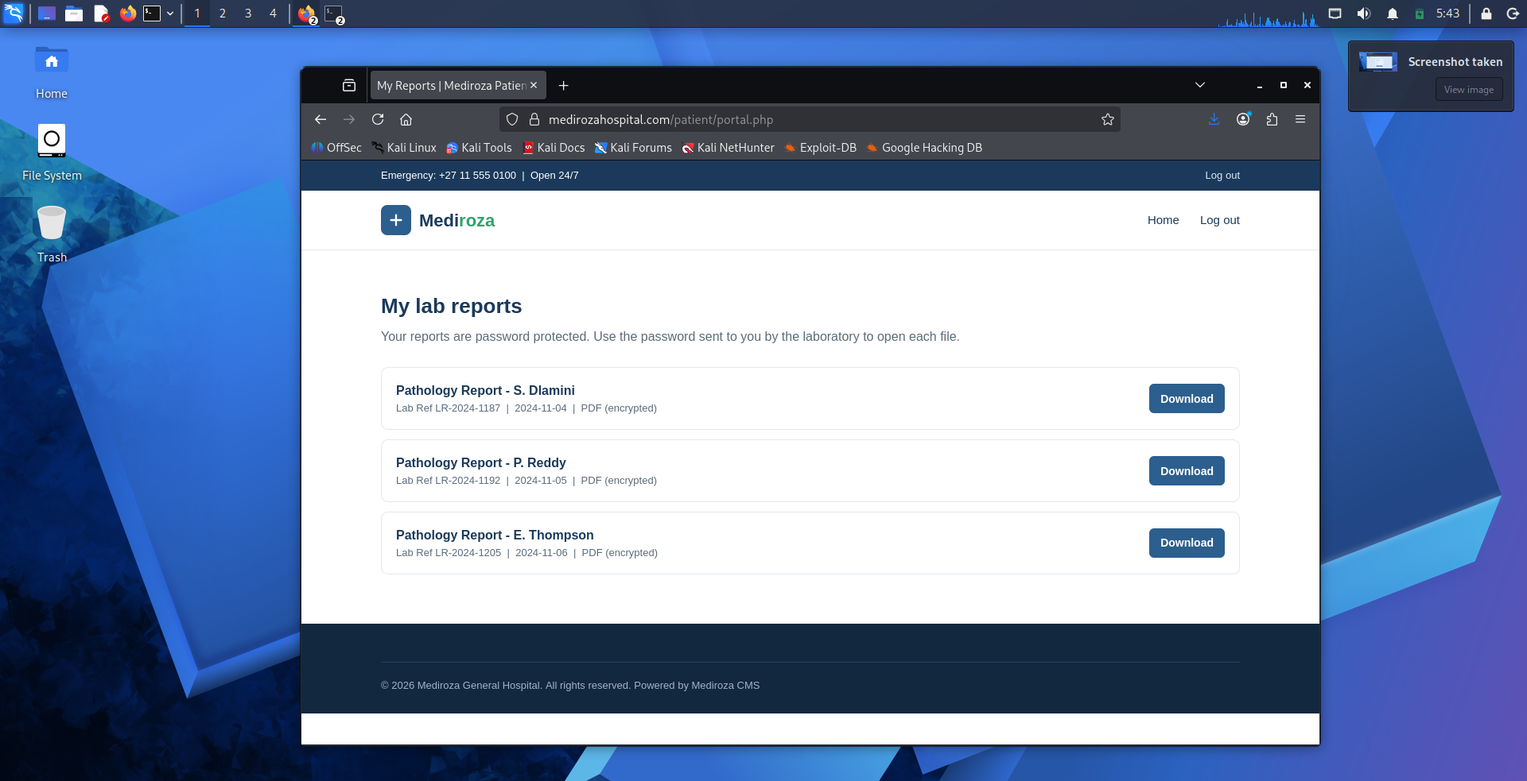
Evidence: M1 — Successful access to the patient portal
The portal displayed three encrypted pathology reports. These were retrieved as the required M1 deliverable.

4.2 Milestone 2 — Data Extraction
The three retrieved reports were password-protected PDF files. PDF hashes were extracted and processed with John the Ripper using the Kali Linux wordlist. All three password hashes were successfully recovered.
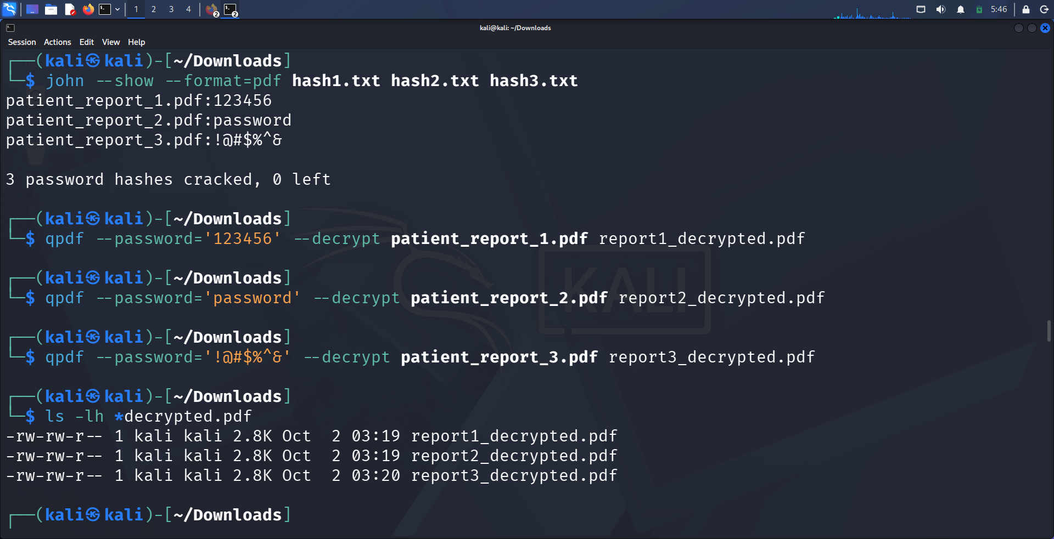
Evidence: M2 — Password recovery and successful PDF decryption commands
The recovered passwords were then supplied to qpdf to create decrypted copies of the three reports. The terminal evidence confirms the creation of report1_decrypted.pdf, report2_decrypted.pdf, and report3_decrypted.pdf.

M2 Result
File | Password Recovery | Decryption Result
patient_report_1.pdf | Recovered | Successful
patient_report_2.pdf | Recovered | Successful
patient_report_3.pdf | Recovered | Successful

For data-minimization purposes, plaintext passwords are not repeated in the report body; the supplied terminal evidence contains the exact recovered values.

4.3 Milestone 3 — Critical Data Exposure
Metadata analysis of the third decrypted report revealed an internal operational comment referencing a legacy database backup directory.
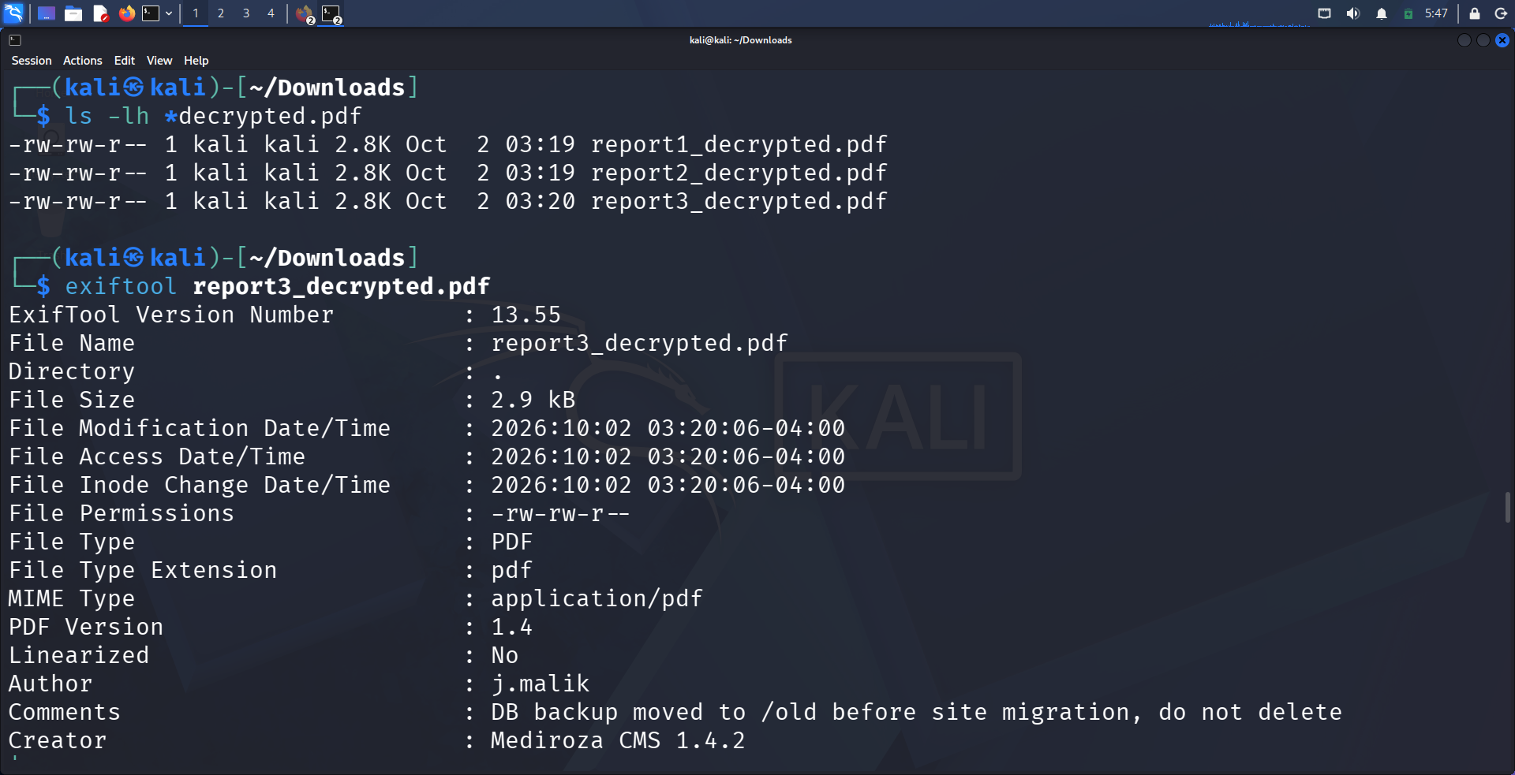
Evidence: M3 — PDF metadata revealing the /old/ database-backup clue
The metadata contained the comment: “DB backup moved to /old before site migration, do not delete”. This provided a direct lead to the exposed legacy directory.

4.3.1 Exposed Legacy Directory
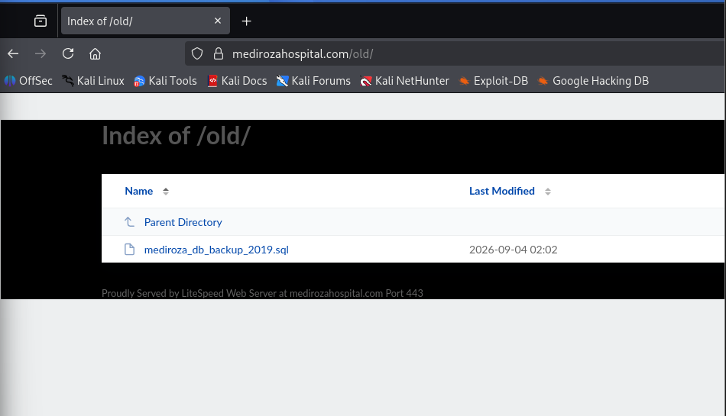
Evidence: M3 — Directory listing exposing mediroza_db_backup_2019.sql
The /old/ directory was accessible through the web server and exposed a database backup file. The backup was downloaded and analyzed directly as text, without importing it into a database server.

4.3.2 Employee Salary Exposure
The exposed SQL backup contained a staff table with employee names, job titles, departments and a monthly_salary_zar field. The supplied evidence demonstrates that salary records were directly present in the publicly accessible backup.
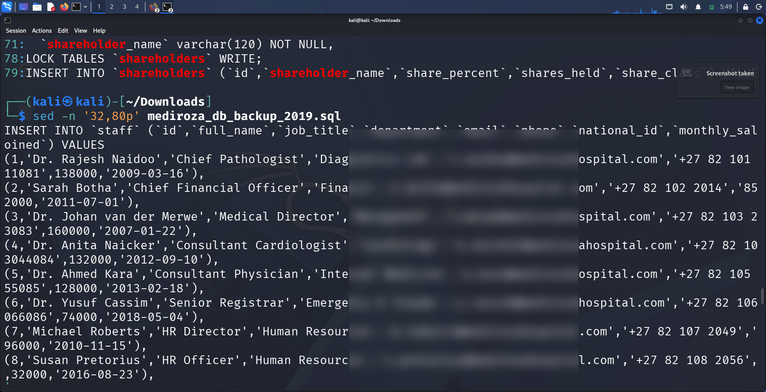
Evidence: M3 — Exposed staff records containing monthly salary data (sensitive contact/ID fields redacted)

Employee Salary Summary
ID | Employee | Role | Monthly Salary (ZAR)
1 | Dr. Rajesh Naidoo | Chief Pathologist | 138,000
2 | Sarah Botha | Chief Financial Officer | 152,000
3 | Dr. Johan van der Merwe | Medical Director | 160,000
4 | Dr. Anita Naicker | Consultant Cardiologist | 132,000
5 | Dr. Ahmed Kara | Consultant Physician | 128,000
6 | Dr. Yusuf Cassim | Senior Registrar | 74,000
7 | Michael Roberts | HR Director | 96,000
8 | Susan Pretorius | HR Officer | 32,000
9 | Jameel Malik | IT Systems Administrator | 58,000
10 | Thabo Molefe | Network Engineer | 46,000
11 | Nomvula Khumalo | Registered Nurse | 34,000
12 | Lerato Mokoena | Registered Nurse | 33,000
13 | Bongani Ndlovu | Registered Nurse | 35,000
14 | Zanele Mahlangu | Nursing Sister | 42,000
15 | Kagiso Sithole | Pharmacist | 61,000
16 | Naledi Zulu | Pharmacy Assistant | 26,000
17 | Themba Nkosi | Radiographer | 44,000
18 | Palesa Radebe | Radiographer | 43,000
19 | Deepak Pillay | Lab Technologist | 41,000
20 | Kavitha Govender | Lab Technician | 35,000
21 | Dr. Suresh Moodley | Consultant Radiologist | 130,000
22 | Dr. Fatima Patel | Pediatrician | 118,000
23 | Nisha Singh | Physiotherapist | 48,000
24 | Dr. Vikram Chetty | Anaesthetist | 135,000
25 | David Smith | Facilities Manager | 52,000
26 | Karen O'Connor | Billing Administrator | 29,000
27 | James Wilson | Security Supervisor | 27,000
28 | Linda Fourie | Receptionist | 19,000
29 | Peter van Wyk | Procurement Officer | 38,000
30 | Andile Mbeki | Ward Clerk | 21,000

4.3.3 Shareholder Data Exposure
The same database backup contained a shareholders table with shareholder names, ownership percentages, shares held and share classes.
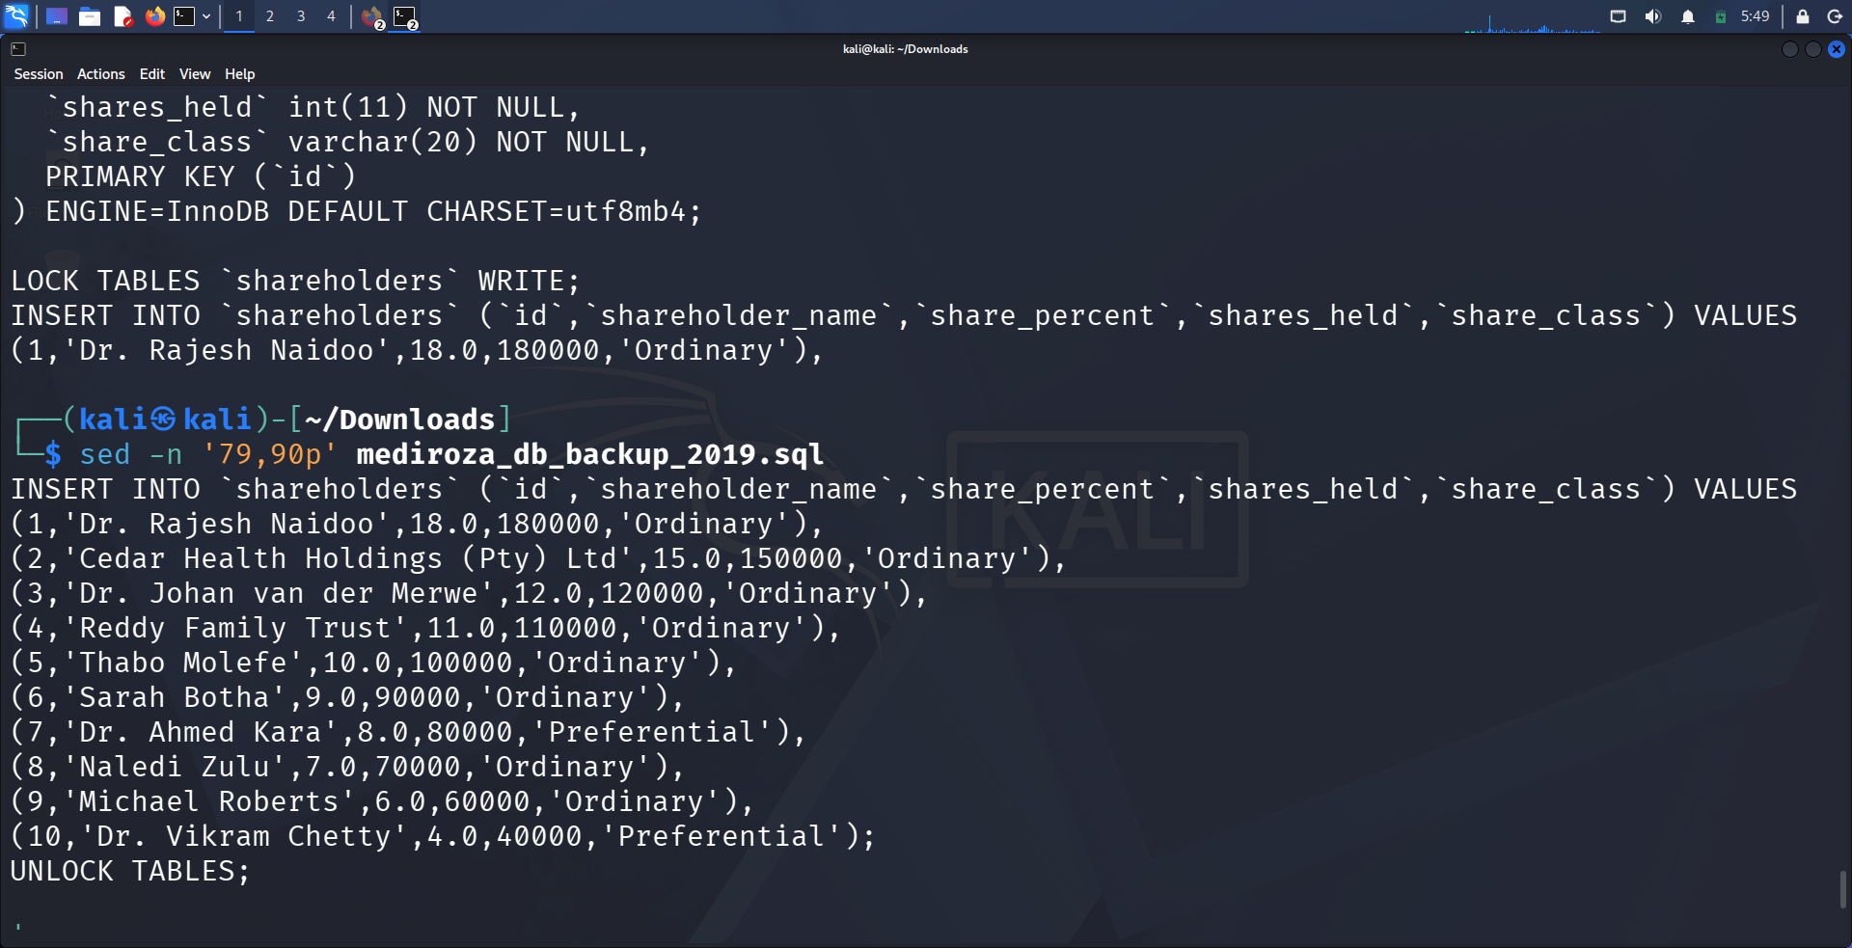
Evidence: M3 — Exposed shareholder records in the SQL backup
ID | Shareholder | Share % | Shares Held | Class
1 | Dr. Rajesh Naidoo | 18% | 180,000 | Ordinary
2 | Cedar Health Holdings (Pty) Ltd | 15% | 150,000 | Ordinary
3 | Dr. Johan van der Merwe | 12% | 120,000 | Ordinary
4 | Reddy Family Trust | 11% | 110,000 | Ordinary
5 | Thabo Molefe | 10% | 100,000 | Ordinary
6 | Sarah Botha | 9% | 90,000 | Ordinary
7 | Dr. Ahmed Kara | 8% | 80,000 | Preferential
8 | Naledi Zulu | 7% | 70,000 | Ordinary
9 | Michael Roberts | 6% | 60,000 | Ordinary
10 | Dr. Vikram Chetty | 4% | 40,000 | Preferential

5. Findings and Proof of Exploitation
ID | Finding | Risk | Summary | Proof
F-01 | SQL Injection Authentication Bypass | Critical | The patient login accepted crafted SQL input and allowed access to the restricted patient portal. | Patient login + successful portal evidence.
F-02 | Weak PDF Password Protection | High | All three retrieved PDF password hashes were successfully recovered using a dictionary-based password attack. | John the Ripper output + successful qpdf decryption evidence.
F-03 | Sensitive PDF Metadata Disclosure | Medium | A PDF metadata comment disclosed the location of a legacy database backup directory. | ExifTool output showing the /old clue.
F-04 | Publicly Accessible Database Backup | Critical | The /old/ directory exposed mediroza_db_backup_2019.sql directly through the web server. | Browser directory-listing screenshot.
F-05 | Employee Salary and Shareholder Data Exposure | Critical | The exposed backup contained staff salary records and shareholder ownership information. | SQL backup analysis and staff/shareholder evidence.

5.1 Attack Chain
robots.txt → patient login → SQL injection bypass → patient reports → password recovery → PDF metadata → /old/ → SQL backup → staff salaries & shareholder data

6. Risk Analysis / Impact
Risk ratings below are assigned to the demonstrated weaknesses based on the access obtained, the sensitivity of the affected information, and the ability to chain the weaknesses during the authorized assessment.
# | Risk / Finding | Rating | Potential Impact
1 | SQL injection authentication bypass | Critical | Restricted patient portal access and retrieval of confidential reports.
2 | Weak PDF password protection | High | Recovered passwords enabled access to encrypted patient reports.
3 | Sensitive PDF metadata disclosure | Medium | Internal operational information revealed a further server location.
4 | Exposed database backup | Critical | Unauthenticated access to a legacy SQL database backup.
5 | Employee and shareholder data exposure | Critical | Confidential compensation and ownership information was disclosed.

7. Recommendations
- Use parameterized queries/prepared statements for all database operations and eliminate direct SQL construction from user-controlled input.
- Implement robust server-side authentication and validate all authentication inputs.
- Use strong, randomly generated passwords for encrypted documents and avoid predictable password patterns.
- Remove unnecessary internal metadata and operational comments from externally accessible documents.
- Remove database backups and legacy files from public web directories and store them outside the web root.
- Protect backups with strong access controls and encryption at rest.
- Review legacy directories and public file listings regularly for accidental information exposure.
- Apply least-privilege access controls to sensitive employee and corporate information.
- Establish secure backup retention and deletion procedures so obsolete backups are not left accessible.
- Perform periodic authorized vulnerability assessments and penetration tests after remediation.

8. Conclusion
The Week 4 assessment demonstrated a complete, evidence-backed attack path against the authorized Mediroza General Hospital target. The testing began with simple reconnaissance and progressed through an authentication weakness, protected-file access, metadata analysis, legacy-directory discovery, and exposure of a database backup containing sensitive organizational information.
The exercise also demonstrated the importance of treating vulnerabilities as a chain rather than isolated events. The authentication weakness enabled access to reports; the reports provided metadata; the metadata pointed to a legacy directory; and the directory exposed a database backup containing sensitive data.
All testing was performed within the authorized educational scope. The evidence included in this report is based on the screenshots and terminal results collected during the practical.

9. Evidences Collected
☑ M1 — robots.txt reconnaissance screenshot
☑ M1 — Patient portal authentication response screenshot
☑ M1 — SQL injection authentication-bypass input screenshot
☑ M1 — Successful patient portal access screenshot
☑ M1 — Three encrypted patient reports displayed in the portal
☑ M2 — John the Ripper password-recovery and qpdf evidence
☑ M2 — Three decrypted PDF files confirmed in the Downloads directory
☑ M3 — ExifTool metadata showing the /old database-backup clue
☑ M3 — /old/ directory listing exposing the SQL backup
☑ M3 — Employee salary records from the exposed backup
☑ M3 — Shareholder records from the exposed backup

10. Evidence Appendix
Appendix A — Reconnaissance evidence
Appendix B — Authentication-bypass evidence
Appendix C — Patient portal evidence
Appendix D — PDF recovery/decryption evidence
Appendix E — Exposed legacy directory
Appendix F — Staff salary evidence (sensitive fields redacted)
Appendix G — Shareholder evidence

— End —
Mahesh Yaramala
Cybersecurity Intern | NetworkWalks
Program: Cybersecurity Program | Week: 04 | Batch: B083

