Contents

**Installation Guide** 1

**Required components:** 1

**Hardware Circuitry** 1

**User Manual** 3

**Set up (First Time)** 3

**Getting Help Menu** 3

**Updating Phone number** 4

**Sounding Alarm** 4

**Door Status check** 5

**Switching off alarm** 5

**Arm/Disarm alarm** 5

**Installation Guide**

**Warning: Sim Card is not included with the hardware. Please use own sim card.**

**Required components:**

1. Raspberry Pi 3B+
2. GSM Module SIM900A
3. Buzzer
4. ESP8266-01S WIFI module
5. Magnetic door sensor
6. Jumper cables
7. WIFI Router
8. CH340 UART to USB Adapter

**Hardware Circuitry**

**Raspberry Pi to GSM Module Circuit (USB to UART)**

1. Insert UART to USB into the specified USB port on the Raspberry Pi

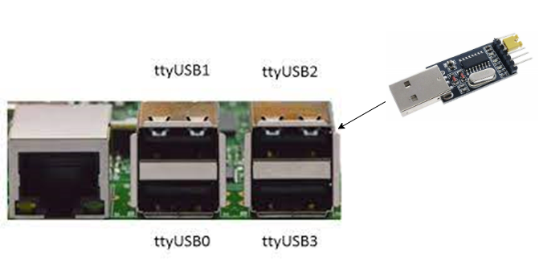

*Figure 10.4 Inserting UART To USB Adapter to Server*

1. Connect the jumper cable according to the diagram below

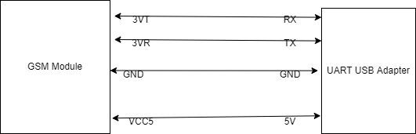

*Figure 10.5 Connection between GSM Module and Rasp Server*

**Raspberry Pi & Buzzer connection**

1. Connect the red cable (+) of the buzzer to the GPIO pin 17 & black cable to the GND

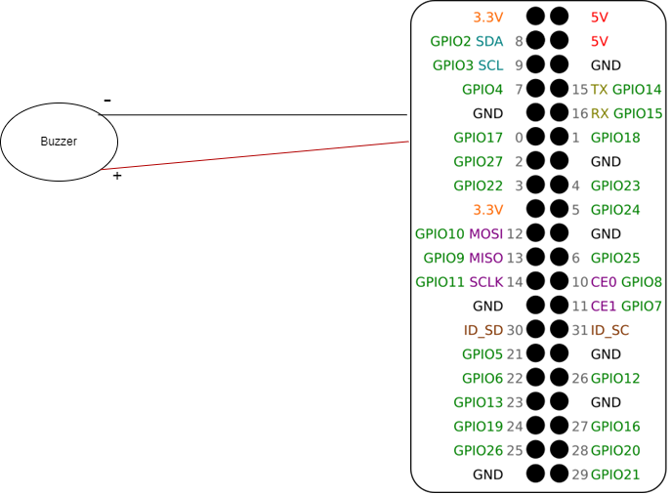

*Figure 10.6 Buzzer connection to the Rasp Server*

1. On the WIFI Module, using the jumper cables connect
2. WIFI Module 3.3V to Power board 3.3V
3. WIFI Module GND to Power board GND
4. WIFI Module GPIO0 to any side of the magnetic door sensor
5. Other side of magnetic door sensor to the Power board GND
6. Connect 9V battery to power board

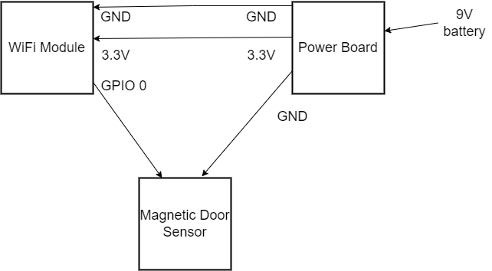

*Figure 10.7 Connection between WIFI module, door sensonr & Power board*

**System Start Up**

1. Power up the Router first. Wait for 1 minute for the router to set up automatically.
2. Power up the Raspberry Pi.
3. Power up the WIFI module via the button on the power board

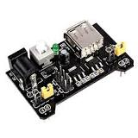

*Figure 10.8 Power Board*

**User Manual**

**Warning: Sim Card is not included with the hardware. Please use own sim card.**

**Set up (First Time)**

1. Send “Help” to sim number. System must return “Number not registered”

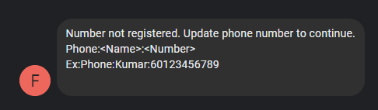

*Figure 10.9 Registration Request Message*

1. Register number following the example given “Phone:Kumar:60123456789”. Must add the country code (+60) for Malaysia
2. System will confirm phone number update

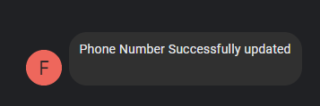

*Figure 10.10 Registration Success Message*

**Getting Help Menu**

1. Send “Help” to sim number. System will send Help Menu.

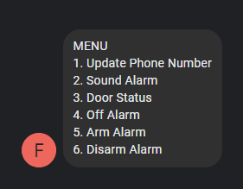

*Figure 10.11 Help Menu Message*

**Updating Phone number**

1. Send Phone:<Name>:<Phone Number with Country code> to system. E.g Phone:Kumar:60123456789



*Figure 10.12 Updating Phone number Message*

1. If successfully updated, system will reply success.



*Figure 10.13 Updating Phone number success message*

**Sounding Alarm**

1. To trigger buzzer/alarm, send “Sound Alarm” message to system.

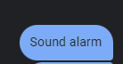

*Figure 10.14 Sound Alarm Message*

1. System will trigger the buzzer and acknowledge the user.



*Figure 10.15 Alarm Triggered Message*

**Door Status check**

1. To check the door status whether open or close, user should send “Door Status” command to system.

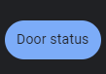

*Figure 10.16 Door Status Request Message*

1. System will reply door status (open/close)



*Figure 10.17 Door Status Open Message*



*Figure 10.18 Door Status Close Message*

**Switching off alarm**

1. To switch off buzzer/alarm, user should send “Off alarm” to the system

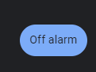

*Figure 10.19 Off Alarm Request Message*

1. System will reply “Alarm Stopped”



*Figure 10.20 Alarm Stopped Success Message*

**Arm/Disarm alarm**

1. This is to set the system to arm or disarm. This will trigger the intrusion alert if the door is open.
2. User should send “Arm alarm” to the system to arm and “Disarm alarm” to disarm.

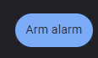

*Figure 10.21 Arm Alarm Request Message*

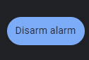

*Figure 10.22 Disarm Alarm Request Message*

1. User will receive acknowledgement depending on the request.



*Figure 10.23 Alarm Arm Success Message*



*Figure 10.24 Alarm Disarmed Success Message*

1. When alarm is armed, if door sensor is open, system will trigger the intrusion alert.



*Figure 10.25 Intrusion Detection Message*

1. User can switch off the trigger by sending “Off alarm”. The door must be closed else the alarm will be triggered again.