JAVA PROGRAMING

PROGRAM-1:

import java.io.*;

import java.util.Scanner;

class Bankaccount

{

int amount,cash;

void deposit(){

System.out.println("enter the amount");

Scanner sc=new Scanner(System.in);

amount=sc.nextInt();

System.out.println("the amount is:"+amount);

}

void withdrawl(){

}

}

public class savings extends Bankaccount

{

void withdrawl()

{System.out.println("eneter the cash");

Scanner mt=new Scanner(System.in);

cash=mt.nextInt();

System.out.println("the withdrawl cash="+cash);

int balance=amount-cash;

System.out.println("the balance="+balance);

if(balance<=100){

System.out.println("the balance is not sufficient");

}

else{

System.out.println("the balance is there");

}

}

public static void main(String[] args)

{

Bankaccount B=new Bankaccount();

B.withdrawl();

savings s=new savings();

s.deposit();

s.withdrawl();

}

}

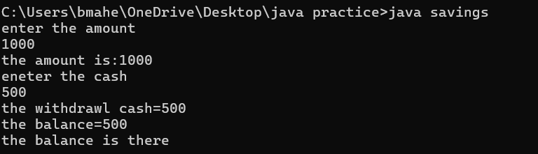

PROGRAM-2:

import java.io.*;

import java.util.Scanner;

class Person{

String f_name,l_name,get_emp;

void getfirstname(){

System.out.println("enter the first name:");

Scanner s=new Scanner(System.in);

String f_name=s.next();

System.out.println("the first name:"+f_name);

}

void getlastname(){

System.out.println("enter the last name:");

}

}

public class Employee extends Person{

void getemployeed(){

System.out.println("enter the employee_position:");

Scanner id=new Scanner(System.in);

String get_emp=id.next();

System.out.println("the employee work:"+get_emp);

}

void getlastname(){

System.out.println("enter the last name:");

Scanner sc=new Scanner(System.in);

String l_name=sc.next();

System.out.println("the last name:"+l_name);

}

public static void main(String[] args){

Employee e=new Employee();

e.getfirstname();

e.getlastname();

e.getemployeed();

}

}

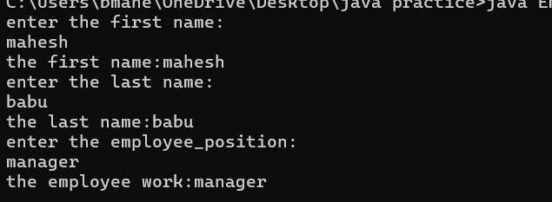

PROGRAM-3:

import java.io.*;

import java.util.Scanner;

class shape

{

int r=5;

void getperimeter()

{

System.out.print("your perimeter");

}

void getarea()

{

System.out.println("your area");

}

}

public class circle extends shape

{

double are,peri;

void getperimeter()

{

peri=2*3.14*r;

System.out.println("your perimeter"+peri);

}

void getarea()

{

are=3.14*r*r;

System.out.println("your area"+are);

}

public static void main(String args[])

{

circle s=new circle();

s.getperimeter();

s.getarea();

}

}

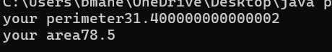

PROGRAM-4:

import java.io.*;

import java.util.Scanner;

class vehicle

{

String make,model,fueltype;

int year,distance;

}

class truck extends vehicle

{

void fuc()

{

System.out.println("TRUCK : -");

make="iron";

model="tata";

year=2005;

fueltype="disel";

distance=50;

System.out.println("MAKE:-"+make);

System.out.println("MODEL:-"+model);

System.out.println("YEAR:-"+year);

System.out.println("FUEL_TYPE:-"+fueltype);

}

}

class car extends vehicle

{

void fuc1()

{

System.out.println("CAR : -");

make="iron";

model="rollsroyce";

year=2007;

fueltype="disel";

System.out.println("MAKE:-"+make);

System.out.println("MODEL:-"+model);

System.out.println("YEAR:-"+year);

System.out.println("FUEL_TYPE:-"+fueltype);

}

}

public class motorcycle extends vehicle

{

void fuc2()

{

System.out.println("MOTOR CYCLE : -");

make="iron";

model="duke";

year=2009;

fueltype="petrol";

System.out.println("MAKE:-"+make);

System.out.println("MODEL:-"+model);

System.out.println("YEAR:-"+year);

System.out.println("FUEL_TYPE:-"+fueltype);

}

public static void main(String args[])

{

truck a=new truck();

car b=new car();

motorcycle c=new motorcycle();

a.fuc();

b.fuc1();

c.fuc2();

}

}

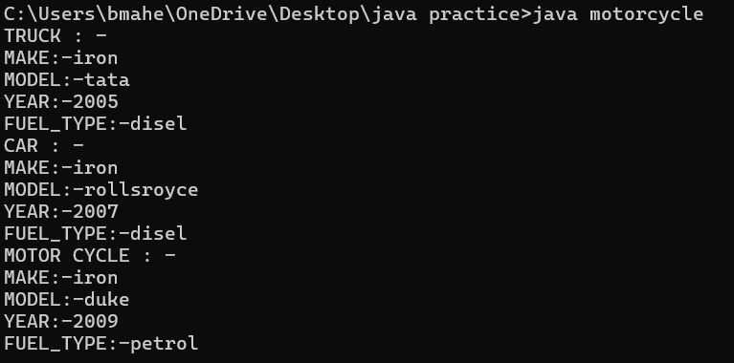

PROGRAM-5:

import java.io.*;

import java.util.Scanner;

class company

{

String name,address,jobtitle;

int salary;

}

class manager extends company

{

void fuc()

{

System.out.println("MANAGER : -");

name="goutham";

address="hyderabad";

salary=500000;

jobtitle="EXECUTIVE MANAGER";

System.out.println("NAME:-"+name);

System.out.println("ADRESS:-"+address);

System.out.println("SALARY:-"+salary);

System.out.println("JOB_TITLE:-"+jobtitle);

}

}

class developper extends company

{

void fuc1()

{

System.out.println("DVELOPPER : -");

name="Sanker";

address="NELLORE";

salary=300000;

jobtitle="PROJECT DEVELOPPER";

System.out.println("NAME:-"+name);

System.out.println("ADRESS:-"+address);

System.out.println("SALARY:-"+salary);

System.out.println("JOB_TITLE:-"+jobtitle);

}

}

class programer extends company

{

void fuc2()

{

System.out.println("PROGRAMMER : -");

name="teju";

address="chinthapalli";

salary=200000;

jobtitle="PROGRAM MANAGER";

System.out.println("NAME:-"+name);

System.out.println("ADRESS:-"+address);

System.out.println("SALARY:-"+salary);

System.out.println("JOB_TITLE:-"+jobtitle);

}

}

class employe extends company

{

void fuc3()

{

System.out.println("EMPLOYEE : -");

name="mahesh";

address="karempudi";

salary=100000;

jobtitle="EMPLOYEE`HEAD";

System.out.println("NAME:-"+name);

System.out.println("ADRESS:-"+address);

System.out.println("SALARY:-"+salary);

System.out.println("JOB_TITLE:-"+jobtitle);

}

public static void main(String args[])

{

manager a=new manager();

developper b=new developper ();

programer c=new programer ();

employe d=new employe();

a.fuc();

b.fuc1();

c.fuc2();

d.fuc3();

}

}

