**Task**

Your task is to implement a simple hotel booking manager in Java, as a microservice API. The number of rooms should be configurable, and it should expose the following methods:

1.      A method to store a booking. A booking consists of a guest name, a room number, and a date.

2.      A method to find the available rooms on a given date.

3.      A method to find all the bookings for a given guest.

**Guidance**

1.      Use only in-memory data structures; do not use a database.

2.      Do not use any framework or libraries in your solution.

3.      Provide tests with your solution (you may use libraries for the tests).

4.      Your solution should build with Maven or Gradle.

5.      Do not need to take into account the booking cancellation and guest check out.

6. Test cases as comprehensive as possible.

7.      Please share github link of your solution with us.

**Extra credit**

Make your solution thread-safe.

**Implementation:**

**Assumption:**

1. Spring Boot is utilized for the deployment instead of embedded tomcat server.
2. Single room allocation is defined for the guest.
3. Room number limit is defined but it didn’t maintain number length and order
4. Date format followed is YYYY-MM-DD
5. Since the ‘Checkin’ module is alone implemented here, the below exception scenarios are handled now.

* Booking the same room for the same day twice is prohibited.
* On exceeding the booking room limit in the same day
* Booking date should be present or future date
* Booking failed for the input details

The error message will be same as the scenario will need to invoke ‘findRoom’ Api to resolve it

**Output:**

1. **Save booking For Current Date:**

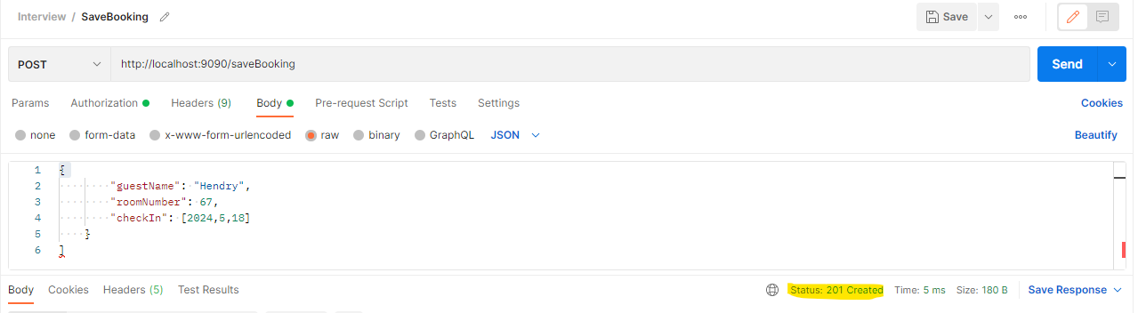

**Double Booking the Same Room [Exceptional Scenario]:**

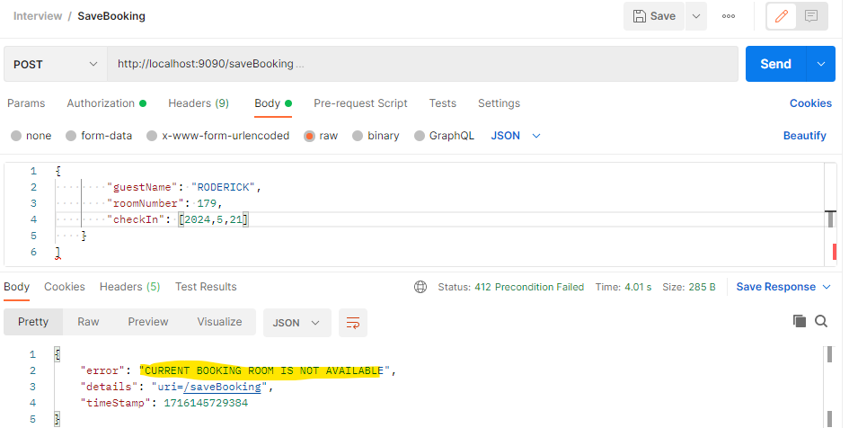

**Booking is done for the past date [Exceptional Scenario]:**

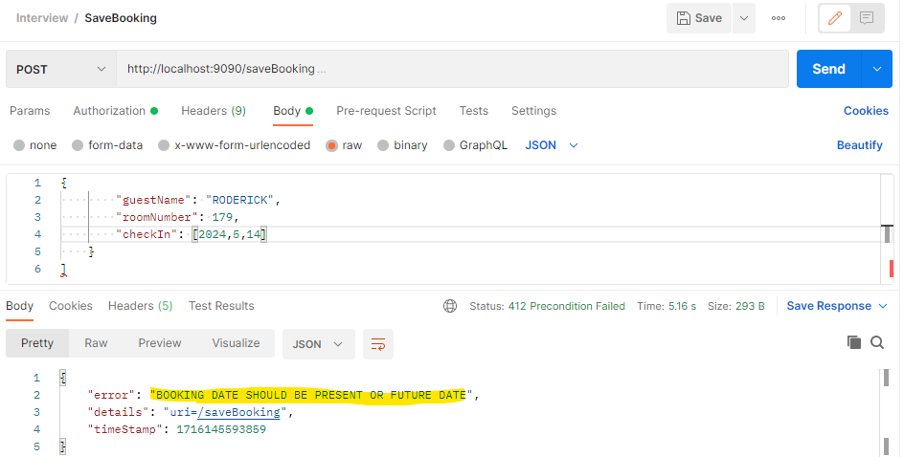

**All Rooms Are Booked [Exceptional Scenario]**

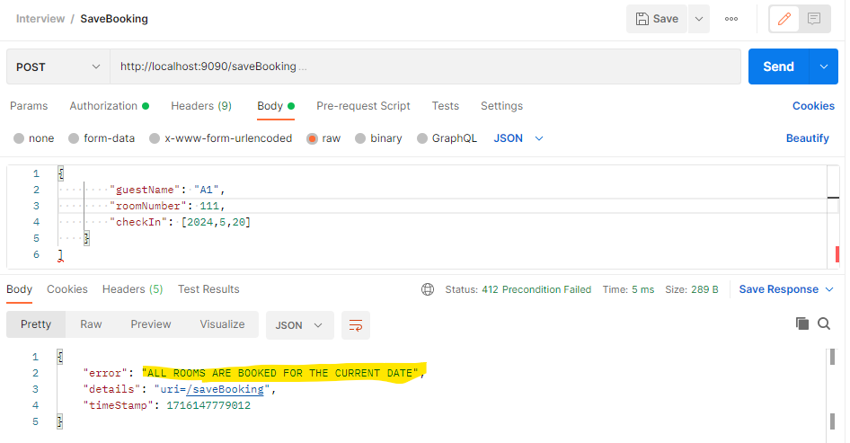

1. **Retrieve Room Availability by Date** 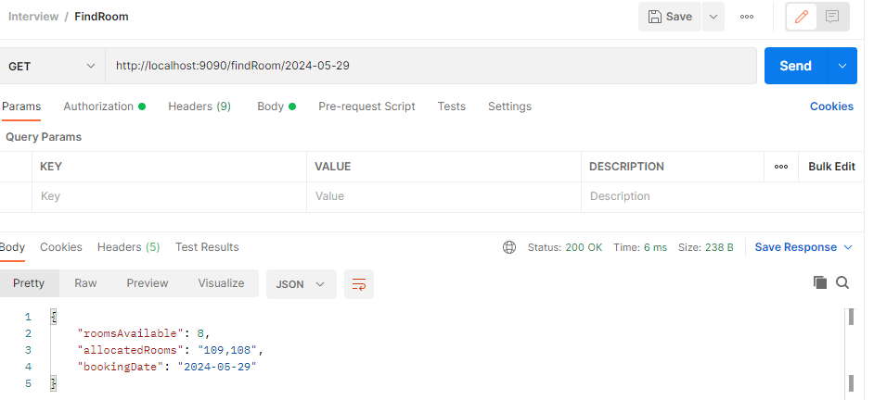

**Retrieve Room Availability for Future Dates:**

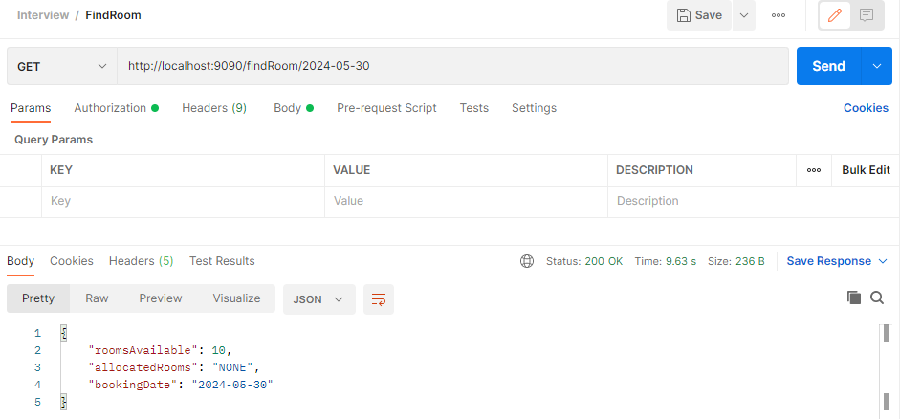

1. **Retrieve Booking Details**