**Task – 01:**

**Object Detection:**

In this task, I’ve taken initially 10 images and applied some data augmentation steps to increase the data.

Later, I’ve labelled all the image dataset manually with the person and dog labels.

I’ve taken a pre-trained model of object detection and then trained the same model with the current dataset which I’ve generated with some hyper-parameter of 100 epochs.

The re-trained model will be stored in runs/detect/weights/best.pt

Taking this model as reference, we will be making predictions.

While predicting the detections I’ve listed the model.predict(classes=[1]) which represents to display only “person” class detections.

The results are as following:

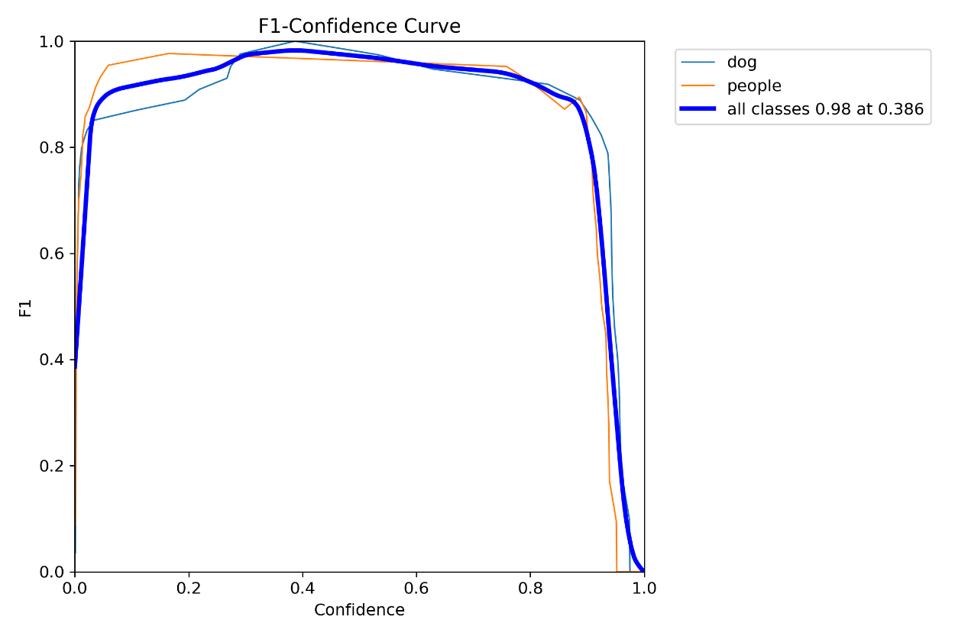

P-Curve and R-Curve:

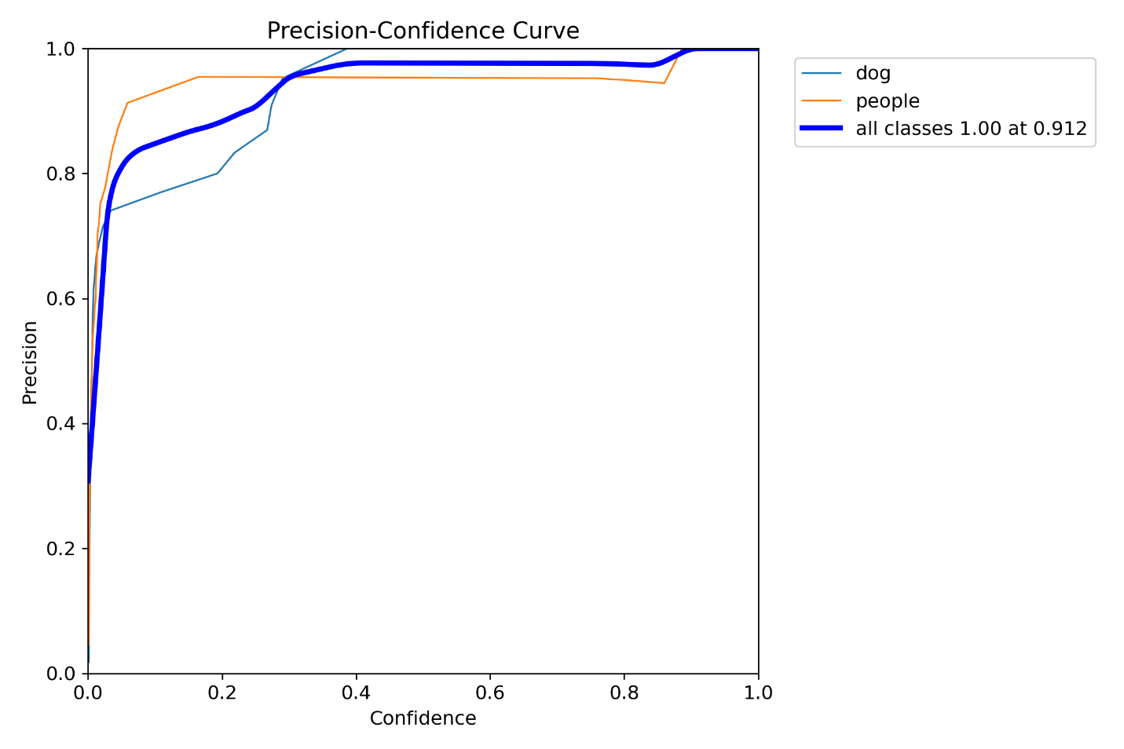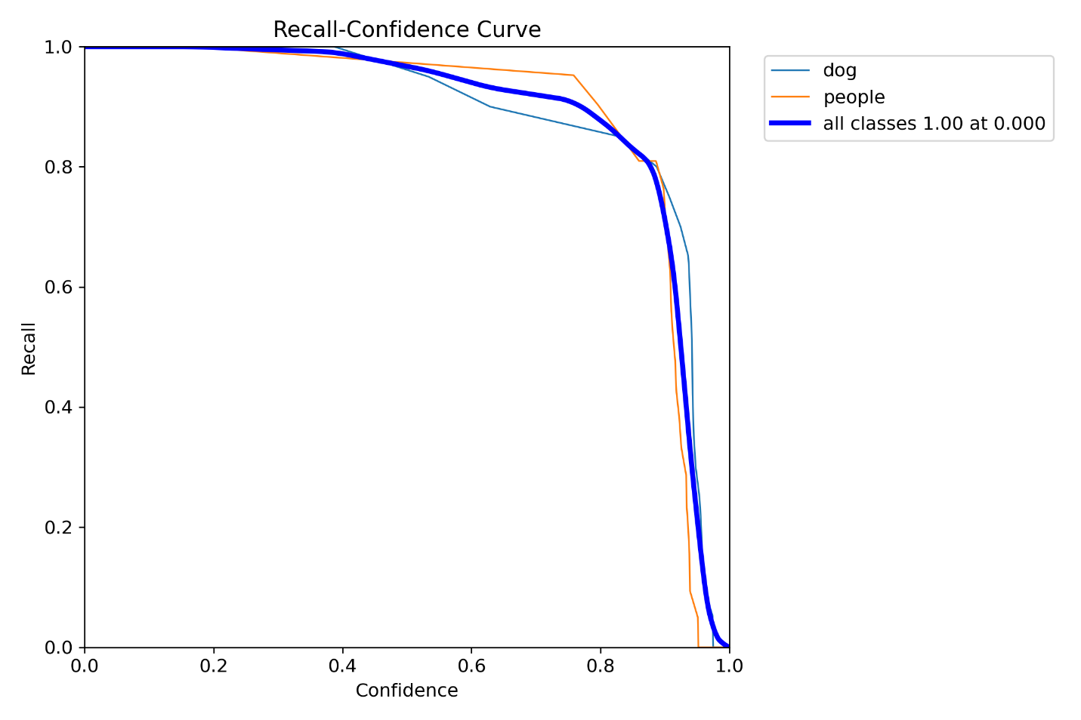

PR-Curve:

