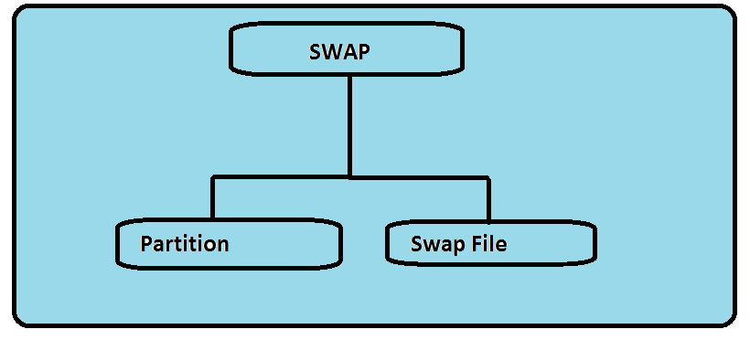

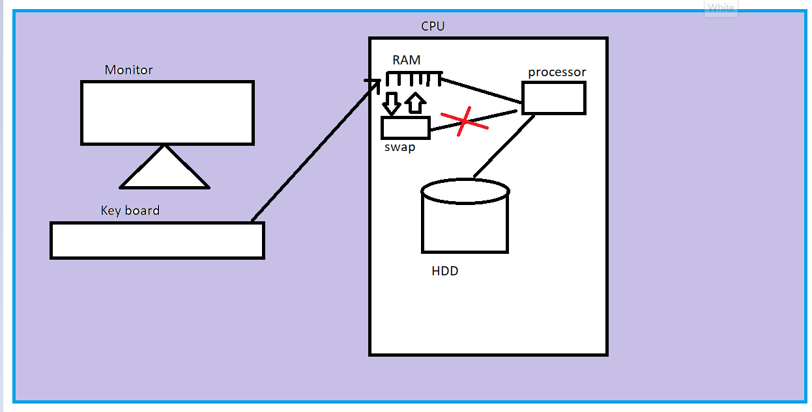

Method 1:

Partition:

Step 1:

Create new partition with system id 82.
Step 2: update to kernel using below command.
Partprobe /dev/sdc*
Step 3. Keep your partition in swap format
Mkswap /dev/sdc*
Step 4. Enable or on the swap partition
Swapon /dev/sdc*
Step 5. Make entry in /etc/fstab for access after reboot also
Vi /etc/fstab
/dev/sdc* swap swap defaults 0 0

Method 2:
Swap file

[root@SW080DAVKM2 ~]# dd if=/dev/zero of=/swapfile bs=1M count=8k
8192+0 records in
8192+0 records out
8589934592 bytes (8.6 GB) copied, 9.86213 s, 871 MB/s
[root@SW080DAVKM2 ~]# mkswap /swapfile
mkswap: /swapfile: warning: don't erase bootbits sectors
on whole disk. Use -f to force.
Setting up swapspace version 1, size = 8388604 KiB
no label, UUID=e66359c7-b1fd-4c95-a84b-3f60a2efea3f
[root@SW080DAVKM2 ~]# chown -R root:root /swapfile
[root@SW080DAVKM2 ~]# chmod 0600 /swapfile
[root@SW080DAVKM2 ~]# swapon /swapfile
[root@SW080DAVKM2 ~]# free -m
total used free shared buffers cached
Mem: 7673 7540 132 0 55 6232
-/+ buffers/cache: 1253 6419
Swap: 8191 0 8191
[root@SW080DAVKM2 ~]# vi /etc/fstab
[root@SW080DAVKM2 ~]# more /etc/fstab | grep swap
/swapfile swap swap defaults 0 0

[root@SL080DAVNAV ~]# free -m
total used free shared buffers cached
Mem: 3823 3611 211 0 141 2874
-/+ buffers/cache: 596 3226
Swap: 0 0 0

How to clear the swap ?
Procedure 1:
You must have enough physical memory available on the system before initiating the following commands.

Swapoff –a
Swapon –a

Procecdure 2:

Sync; echo 3 /proc/sys/vm/drop_caches
Clears the page cache,dentries and inodes.

drop_caches
Setting this value to 1, 2, or 3 causes the kernel to drop various combinations of page cache and slab cache.
1 The system invalidates and frees all page cache memory.
2 The system frees all unused slab cache memory.
sync; echo 2 > /proc/sys/vm/drop_caches
sync; echo 2 > /proc/sys/vm/drop_caches

3 The system frees all page cache and slab cache memory.

Recommended is 1: echo 1 > /proc/sys/vm/drop_caches

If you want to make the priority of swap usage by system, use the following command. High priority will be use more by system. High=10 low= -10.
[root@client ~]# swapon -p 10 /var/swapfile

Redhat recommendations of swap allocation:

Amount of RAM in the system | Recommended swap space | Recommended swap space if allowing for hibernation
⩽ 2 GB | 2 times the amount of RAM | 3 times the amount of RAM
> 2 GB – 8 GB | Equal to the amount of RAM | 2 times the amount of RAM
> 8 GB – 64 GB | At least 4 GB | 1.5 times the amount of RAM
> 64 GB | At least 4 GB | Hibernation not recommended

Additional note about swap,cache and buffer.
some jobs struck in swap, how you will haddle?

swap usage is 2 GB

forcefully move them out from swap to ram but make sure RAM has 2 GB free space to allocate room for them.
if ram has 2 GB space then execute below command

swapoff -a
swapon -a

Cache memory = recently executed jobs information
buffer memory = executing or waiting for other job to complete

cache always improves your server performance.
task 1 executed job name is = prasadjob completion time 1 min
task 2 executed job name is = cp
task 3 executed job name is = ls
task 4 executed job name is = prasadjob completion time 10 sec

anytime you can clear cache memory ? yes we can clear but there will be slow performance for upcoming jobs

echo 1 > /proc/sys/vm/drop_caches inactive cache or buffer space
which are in in-active
echo 2 > /proc/sys/vm/drop_caches inode and buffer space
echo 3 > /proc/sys/vm/drop_caches active/in-active everything will get clear

