- How to install mysql server
- Which package require in linux machine to connect through remotely.
- What is the difference between % and localhost in user administration.
- What is the default path of mysql database?
- What is the default confiruration file in linux?
- What is the default database engine used in mysql?
- How to list out current connections list?
- How to list out current processes list?
- How to list out users privilages?

6. what is the default database engine used in mysql?
Ans: MySQL 5.5 and later, the default storage engine is InnoDB. The default storage engine for MySQL prior to version 5.5 was MyISAM.
Current: InnoDB
Previous: MyISAM

SHOW ENGINES\G

List of storage engines
MySQL supported storage engines:
- InnoDB
- MyISAM
- Memory
- CSV
- Merge
- Archive
- Federated
- Blackhole
- Example

How to list out current connection list?
Show status like '%onn%’;
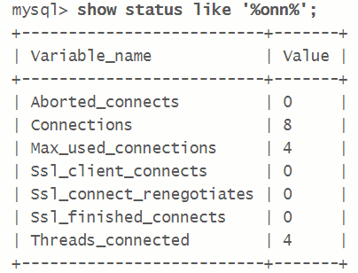
How to list out current processes list?
Show processlist;
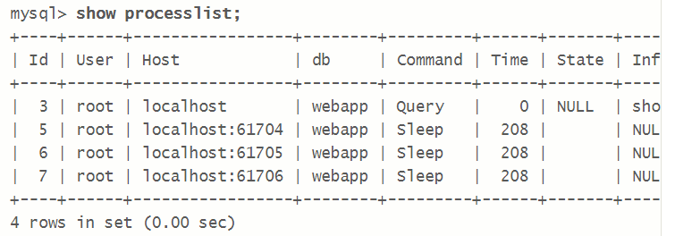

Create User without specify privileges.
CREATE USER 'jeffrey'@'localhost' IDENTIFIED BY 'mypass';

Create User with select privileges.
GRANT select ON altipay_idf.* TO 'sajeev'@'%' IDENTIFIED BY 'S@jeev!2#';
mysql> GRANT select,insert,delete ON altipay_idf.* TO 'ashims'@'%' IDENTIFIED BY 'Ashim$@123';
Query OK, 0 rows affected (0.00 sec)

EFOr

GRANT ALL PRIVILEGES ON altipay_idf.* TO 'altipay_idf'@'%.altifin.com' IDENTIFIED BY 'Q2g*l3k';

To see the privileges of specific user.
SHOW GRANTS FOR 'root'@'localhost';
SHOW GRANTS FOR 'ashims'@'%';
SHOW GRANTS FOR 'ashims';

select * from mysql.user where User='ashims';

SET PASSWORD FOR 'tom'@'localhost' = PASSWORD('foobar');
SET PASSWORD FOR 'altipay_idf'@'%' = PASSWORD('');

error:
blocked because of many connection errors; unblock with 'mysqladmin flush-hosts'"
Temporary Solution:
Execute below command in root console(not in mysql console)
mysqladmin flush-hosts -h 192.168.68.89 -u root –p
Then login to mysql console for increase “max_connect_errors”
SET GLOBAL max_connect_errors=10000;
Query OK, 0 rows affected (0.00 sec)

mysql> FLUSH PRIVILEGES;
show variables like 'max_connect_errors';
or
select @@global.max_connect_errors;
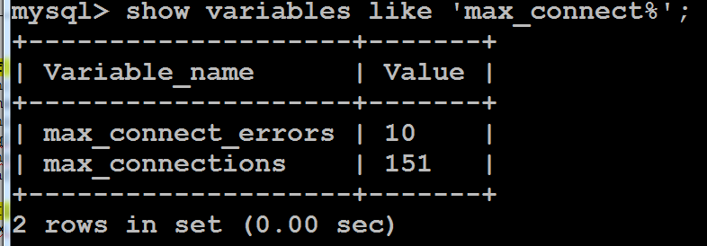
Permanent Solution:
Vi /etc/my.cnf
Add below line into [mysqld]
max_connect_errors=10000
then restart the mysqld service.

2. ERROR 1045 (28000): Access denied for user
Answer: 1. May be there is no password set for that user and your trying with password option like mysql –u altipay_idf –p

here are a number (large) of possibilities. First, try the obvious. Try logging in without a password. If that works, then IMMEDIATELY set a password for root. If it doesn't, then make sure you are entering the password EXACTLY as you set it. Be careful of special characters. Also try using your hostname, i.e. mysql -h xxxxx -u root -p. You show in your initial message that you are having mysql request your password. If you are trying to enter your password on the command line (mysql -u root -pxxxxxxx) make sure there is NOT a space between the -p and the password. If none of these help, and they may not for various reasons, then follow the instructions you noted for replacing a lost password.
Or

GRANT ALL PRIVILEGES ON altipay_idf.* TO 'altipay_idf'@'%.altifin.com' IDENTIFIED BY 'Q2g*l3k';
Plush privileges;
% replace individual IPs or host name

mysql> FLUSH PRIVILEGES;
Query OK, 0 rows affected (0.00 sec)

- Login as a root user
# mysql -uroot (we can login with out password)
- Create DB.
Create database testdb;
- Show the Database Lists.
Show databases;

- Delete database;
Drop database testdb;
- Shifting one dataset to another db.
Use testdb;
- How to see list of user and host access.
SELECT User FROM mysql.user;
select User,Host from mysql.user;
- 7.How to set the password for mysql user.
SET PASSWORD FOR 'ssasidharan'@'%' = PASSWORD('S$@si@123');
FLUSH PRIVILEGES;

- determine which database is selected?
SELECT DATABASE();
- show open database connections
show status
or
show status like ‘conn%’;
show status like ‘%conn%’;

- MySQL show processlist
show processlist;
- determine which user logged in ?
SELECT USER();
or
SELECT CURRENT_USER();

Error:

MySQL ERROR 1133 (42000): Can’t find any matching row in the user table
Execute below query and login again.
FLUSH PRIVILEGES;

# /etc/init.d/mysql stop
# mysqld_safe --skip-grant-tables &
# mysql -u root

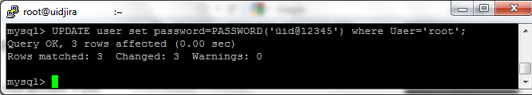
# /etc/init.d/mysql stop
# /etc/init.d/mysql start
# mysql -u root –p

FLUSH PRIVILEGES;
SET PASSWORD FOR root@'localhost' = PASSWORD('xxxxxxxx');
Resetting the New password

mysqladmin -u root -h localhost password ws8dr8as3

My SQL DB backup

backup: # mysqldump -u root -p[root_password] [database_name] > dumpfilename.sql

restore:# mysql -u root -p[root_password] [database_name] < dumpfilename.sql

2. Backup multiple databases:
# mysqldump -u root -ptmppassword --databases bugs sugarcrm > bugs_sugarcrm.sql

3. Backup all the databases:
# mysqldump -u root -ptmppassword --all-databases > /tmp/all-database.sql

1. Restore a database
# mysql -u root -ptmppassword

mysql> create database sugarcrm;
Query OK, 1 row affected (0.02 sec)

# mysql -u root -ptmppassword sugarcrm < /tmp/sugarcrm.sql

# mysql -u root -p[root_password] [database_name] < dumpfilename.sql
Grant the admin privilages to normal user

UPDATE mysql.user SET Grant_priv='Y', Super_priv='Y' WHERE User='root';
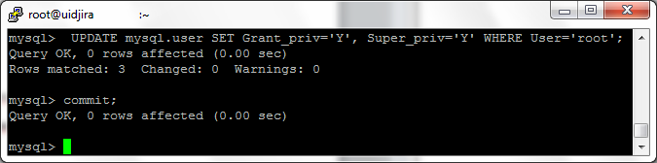
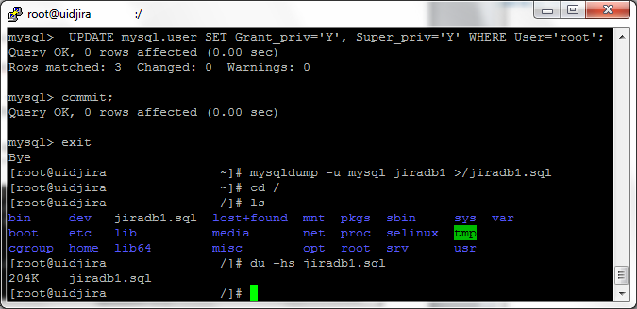

$ mysql -u root –p
Add a database called books
mysql> CREATE DATABASE books;

mysql> create database prasadbabudb;
Query OK, 1 row affected (0.00 sec)
Now database is created. Use a database with use command:
mysql> USE books;
Now create a table called authors with name, email and id:
mysql> CREATE TABLE authors (id INT, name VARCHAR(20), email VARCHAR(20));
Display your table name just created:
mysql> SHOW TABLES;

mysql> INSERT INTO authors (id,name,email) VALUES(1,"Vivek","xuz@abc.com");
Output:
Query OK, 1 row affected (0.00 sec)
Add few more rows:
mysql> INSERT INTO authors (id,name,email) VALUES(2,"Priya","p@gmail.com");
INSERT INTO authors (id,name,email) VALUES(3,"Tom","tom@yahoo.com");
Now display all rows:
mysql> SELECT * FROM authors;
Output:
+------+-------+---------------+
| id | name | email |
+------+-------+---------------+
| 1 | Vivek | xuz@abc.com |
| 2 | Priya | p@gmail.com |
| 3 | Tom | tom@yahoo.com |
+------+-------+---------------+
3 rows in set (0.00 sec)

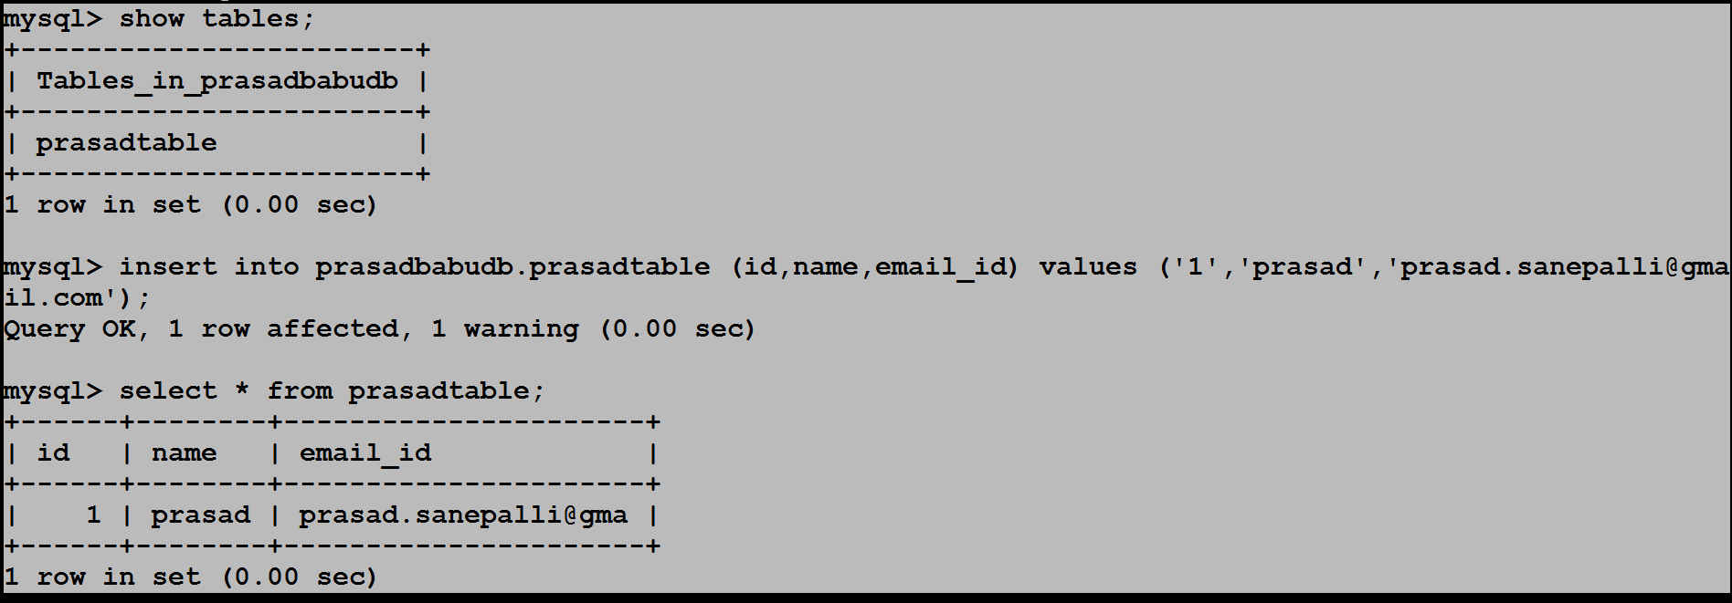
mysql> select * from prasadtable;
+------+--------+----------------------+
| id | name | email_id |
+------+--------+----------------------+
| 1 | prasad | prasad.sanepalli@gma |
| 2 | raja | raja.sanepalli@gmail |
+------+--------+----------------------+
2 rows in set (0.00 sec)

mysql> update prasadtable set email_id='sanepalli.raja@gmail.com' where id='2' and name='raja';
Query OK, 1 row affected, 1 warning (0.00 sec)
Rows matched: 1 Changed: 1 Warnings: 1

mysql> select * from prasadtable;
+------+--------+----------------------+
| id | name | email_id |
+------+--------+----------------------+
| 1 | prasad | prasad.sanepalli@gma |
| 2 | raja | sanepalli.raja@gmail |
+------+--------+----------------------+
2 rows in set (0.00 sec)
How to backup single table

mysql> create table prasadtable_backup_prasad as select * from prasadtable;
Query OK, 2 rows affected (0.01 sec)
Records: 2 Duplicates: 0 Warnings: 0

mysql> show tables;
+---------------------------+
| Tables_in_prasadbabudb |
+---------------------------+
| prasadtable |
| prasadtable_backup_prasad |
+---------------------------+
2 rows in set (0.00 sec)

mysql>

mysql> drop database [Database_Name];
8. How to delete a table ?
mysql> drop table [Table_Name];
To create the accounts with GRANT, use the following statements:

shell> mysql --user=root mysql
mysql> GRANT SELECT,INSERT,UPDATE,DELETE,CREATE,DROP
-> ON bankaccount.*
-> TO 'custom'@'localhost'
-> IDENTIFIED BY 'obscure';
mysql> GRANT SELECT,INSERT,UPDATE,DELETE,CREATE,DROP
-> ON expenses.*
-> TO 'custom'@'whitehouse.gov'
-> IDENTIFIED BY 'obscure';
mysql> GRANT SELECT,INSERT,UPDATE,DELETE,CREATE,DROP
-> ON customer.*
-> TO 'custom'@'server.domain'
-> IDENTIFIED BY 'obscure';

The three accounts can be used as follows:

The first account can access the bankaccount database, but only from the
local host.

The second account can access the expenses database, but only from the
host whitehouse.gov.

The third account can access the customer database, but only from the host
server.domain.

> Mogens Melander wrote:
>>
>> GRANT CREATE,INSERT,DELETE,UPDATE,SELECT PRIVILEGES ON pauldb.*
>> TO poul@localhost IDENTIFIED BY 'mysecretpassword';
>>
>> On Tue, May 8, 2007 13:57, sunisundar wrote:
>>>
>>> how to create new username n password in mysql using commands.
>>>
>>> followed these steps::
>>> mysql> create database pauldb;
>>> Query OK, 1 row affected (0.00 sec)
>>>
>>> #
>>> # Now we create the user paul and give him full
>>> # permissions on the new database
>>> mysql> grant CREATE,INSERT,DELETE,UPDATE,SELECT on pauldb.* to
>>> paul@localhost;
>>> Query OK, 0 rows affected (0.00 sec)
>>>
>>> #
>>> # Next we set a password for this new user
>>> #
>>> mysql> set password for paul = password('mysecretpassword');
>>> Query OK, 0 rows affected (0.00 sec)
Set password for Prasad = password (‘srajamma’);

21-03-2014

mysql> SHOW VARIABLES LIKE 'max_allowed_packet';
+--------------------+---------+
| Variable_name | Value |
+--------------------+---------+
| max_allowed_packet | 1048576 |
+--------------------+---------+
1 row in set (0.01 sec)

Vi /etc/my.cnf
[mysqld]
max_allowed_packet=2051999

restart mysql service

Change Mysql Data store path:
stop Mysql service
# service mysql stop
Copy the mysql content to new path with preserving attributes.
# cp -arp /var/lib/mysql /home/mysql
Changes in /etc/my.cnf
my.cnf
[mysqld]
datadir=/home/mysql
socket=/home/mysql/mysql.sock
# Disabling symbolic-links is recommended to prevent assorted security risks
symbolic-links=0
# Settings user and group are ignored when systemd is used (fedora >= 15).
# If you need to run mysqld under a different user or group,
# customize your systemd unit file for mysqld according to the
# instructions in http://fedoraproject.org/wiki/Systemd
user=mysql
# Semisynchronous Replication
# http://dev.mysql.com/doc/refman/5.5/en/replication-semisync.html
# uncomment next line on MASTER
;plugin-load=rpl_semi_sync_master=semisync_master.so
# uncomment next line on SLAVE
;plugin-load=rpl_semi_sync_slave=semisync_slave.so
# Others options for Semisynchronous Replication
;rpl_semi_sync_master_enabled=1
;rpl_semi_sync_master_timeout=10
;rpl_semi_sync_slave_enabled=1
# http://dev.mysql.com/doc/refman/5.5/en/performance-schema.html
;performance_schema
[mysqld_safe]
log-error=/var/log/mysqld.log
pid-file=/var/run/mysqld/mysqld.pid
[client]
socket=/home/mysql/mysql.sock
how to find out table utilized space:

SELECT table_schema, table_name, table_rows ROWS, CONCAT(ROUND(data_length / ( 1024 * 1024 ), 2), 'M') DATA_SIZE, CONCAT(ROUND(index_length / ( 1024 * 1024 ), 2), 'M') INDEX_SIZE FROM information_schema.TABLES ORDER BY data_length DESC INTO OUTFILE '/tmp/altipay_idf-tablespace.txt';
Query OK, 362 rows affected (2.45 sec)
Reset password for single user
mysql> select host,user,password from mysql.user;
+---------------+------------+-------------------------------------------+
| host | user | password |
+---------------+------------+-------------------------------------------+
| localhost | root | *E96155FE811F71D9A2DE376D3994685394541A1A |
| Nagios-server | root | |
| 127.0.0.1 | root | |
| localhost | | |
| Nagios-server | | |
| % | prasad | *B91F9F1D64E54E34314426E6F1E5602F2733A5FF |
| % | test | |
| % | test1 | *E96155FE811F71D9A2DE376D3994685394541A1A |
| % | test2 | *E96155FE811F71D9A2DE376D3994685394541A1A |
| localhost | test3 | *ACBA4AFB78C53C7587A5086A08A6A10D24130B92 |
| localhost | raja | |
| % | prasadbabu | *E96155FE811F71D9A2DE376D3994685394541A1A |
| % | srinath | *676243218923905CF94CB52A3C9D3EB30CE8E20D |
+---------------+------------+-------------------------------------------+
13 rows in set (0.00 sec)

mysql> update mysql.user set password=PASSWORD('srajamma') where user='prasad';
Query OK, 1 row affected (0.00 sec)
Rows matched: 1 Changed: 1 Warnings: 0

mysql> select host,user,password from mysql.user;
+---------------+------------+-------------------------------------------+
| host | user | password |
+---------------+------------+-------------------------------------------+
| localhost | root | *E96155FE811F71D9A2DE376D3994685394541A1A |
| Nagios-server | root | |
| 127.0.0.1 | root | |
| localhost | | |
| Nagios-server | | |
| % | prasad | *E96155FE811F71D9A2DE376D3994685394541A1A |
| % | test | |
| % | test1 | *E96155FE811F71D9A2DE376D3994685394541A1A |
| % | test2 | *E96155FE811F71D9A2DE376D3994685394541A1A |
| localhost | test3 | *ACBA4AFB78C53C7587A5086A08A6A10D24130B92 |
| localhost | raja | |
| % | prasadbabu | *E96155FE811F71D9A2DE376D3994685394541A1A |
| % | srinath | *676243218923905CF94CB52A3C9D3EB30CE8E20D |
+---------------+------------+-------------------------------------------+
13 rows in set (0.00 sec)
Grant privileges on database
mysql> grant ALL privileges on prasadbabudb.* to 'prasad'@'%';
Query OK, 0 rows affected (0.00 sec)

mysql> show grants for 'prasad'@'%';
+-------------------------------------------------------------------------------------------------------+
| Grants for prasad@% |
+-------------------------------------------------------------------------------------------------------+
| GRANT USAGE ON *.* TO 'prasad'@'%' IDENTIFIED BY PASSWORD '*B91F9F1D64E54E34314426E6F1E5602F2733A5FF' |
| GRANT ALL PRIVILEGES ON `prasadbabudb`.* TO 'prasad'@'%' |
+-------------------------------------------------------------------------------------------------------+
2 rows in set (0.00 sec)

Difference between drop and truncate

Drop: Full table will delete
Truncate: using truncate only table content will delete
DROP command deleting the table and its structure from the data base.
DROP TABLE tbl_user;
DELETE command used for deleting the records from the table,and it removing the table space which is allocated by the data base, and returns number of rows deleted.
DELETE FROM tbl_user WHERE id = 1;
TRUNCATE command is also delete the records but it doesn't delete the table space which is created by the data base, and does not return number of deleted rows.
TRUNCATE TABLE tbl_user;
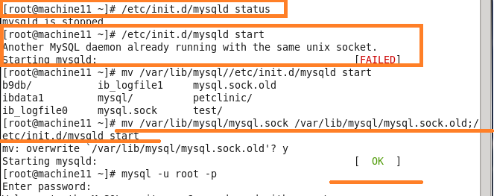

Reset the root password through safe mode
MySQL safe mode lets you change system settings without using the root password.
- Start up safe mode
sudo mysqld_safe --skip-grant-tables
You may need to type Enter twice.
- Log into MySQL as root:
mysql -u root
- Change to the mysql database, which handles the settings for MySQL itself:
use mysql;
- Update the password for the root user:
update user set password=PASSWORD("the new password you want to use") where User='root';
mysql> update mysql.user set password=PASSWORD('Srajamma@123') where user='root';
- Refresh the MySQL user privileges:
flush privileges;
- Exit MySQL:
exit
If this doesn't work, you can try force the application to quit by pressing CTRL-C on your keyboard.

Running commands without entering into database
[root@m4 log]# mysql -u root -e "create database app"
[root@m4 log]# mysql -u root -e "show databases"
+--------------------+
| Database |
+--------------------+
| information_schema |
| app |
| mysql |
| test |
+--------------------+
[root@m4 log]#

