ITA0613
Machine Learning
Name : A.MAHESH
Reg No : 192424139

Program 11: Credit Score Classification
from sklearn.datasets import load_breast_cancer
from sklearn.model_selection import train_test_split
from sklearn.ensemble import RandomForestClassifier
from sklearn.metrics import accuracy_score

data = load_breast_cancer()

X_train, X_test, y_train, y_test = train_test_split(
data.data,
data.target,
test_size=0.3,
random_state=42
)

model = RandomForestClassifier()

model.fit(X_train,y_train)

y_pred = model.predict(X_test)

print("Credit Score Classification Accuracy:")
print(accuracy_score(y_test,y_pred))

Output:
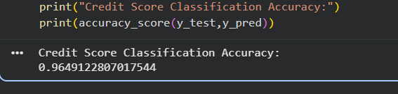

Program 12: Iris Flower Classification using KNN
from sklearn.datasets import load_iris
from sklearn.model_selection import train_test_split
from sklearn.neighbors import KNeighborsClassifier
from sklearn.metrics import accuracy_score

iris = load_iris()

X_train, X_test, y_train, y_test = train_test_split(
iris.data,
iris.target,
test_size=0.3,
random_state=42
)

knn = KNeighborsClassifier(n_neighbors=5)

knn.fit(X_train,y_train)

y_pred = knn.predict(X_test)

print("Accuracy:")
print(accuracy_score(y_test,y_pred))

OUTPUT:
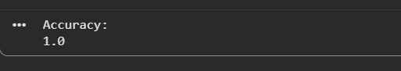

Program 13: Car Price Prediction
import pandas as pd
from sklearn.linear_model import LinearRegression

data = pd.DataFrame({
'Year':[2018,2019,2020,2021,2022],
'Price':[500000,600000,700000,800000,900000]
})

X = data[['Year']]
y = data['Price']

model = LinearRegression()

model.fit(X,y)

pred = model.predict([[2023]])

print("Predicted Car Price:")
print(pred[0])

OUTPUT:
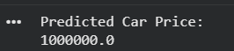

Program 14: House Price Prediction
import pandas as pd
from sklearn.linear_model import LinearRegression

data = pd.DataFrame({
'Area':[1000,1200,1500,1800,2000],
'Price':[30,40,50,60,70]
})

X = data[['Area']]
y = data['Price']

model = LinearRegression()

model.fit(X,y)

pred = model.predict([[1600]])

print("Predicted House Price:")
print(pred[0])
OUTPUT:
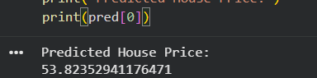

Program 15: Iris Flower Classification using Naive Bayes
from sklearn.datasets import load_iris
from sklearn.model_selection import train_test_split
from sklearn.naive_bayes import GaussianNB
from sklearn.metrics import accuracy_score

iris = load_iris()

X_train,X_test,y_train,y_test = train_test_split(
iris.data,
iris.target,
test_size=0.3,
random_state=42
)

model = GaussianNB()

model.fit(X_train,y_train)

y_pred = model.predict(X_test)

print("Accuracy:")
print(accuracy_score(y_test,y_pred))

OUTPUT:
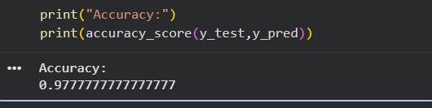

Program 16: Compare Different Classification Algorithms
from sklearn.datasets import load_iris
from sklearn.model_selection import train_test_split
from sklearn.neighbors import KNeighborsClassifier
from sklearn.tree import DecisionTreeClassifier
from sklearn.naive_bayes import GaussianNB
from sklearn.linear_model import LogisticRegression
from sklearn.metrics import accuracy_score

iris = load_iris()

X_train, X_test, y_train, y_test = train_test_split(
iris.data,
iris.target,
test_size=0.3,
random_state=42
)

models = {
"KNN": KNeighborsClassifier(),
"Decision Tree": DecisionTreeClassifier(),
"Naive Bayes": GaussianNB(),
"Logistic Regression": LogisticRegression(max_iter=200)
}

for name, model in models.items():
model.fit(X_train, y_train)
pred = model.predict(X_test)
print(name, "Accuracy:", accuracy_score(y_test, pred))

OUTPUT:
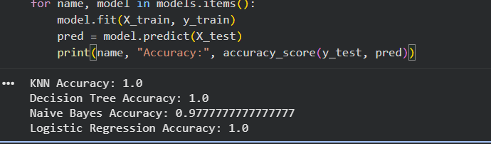

Program 17: Mobile Price Prediction
import pandas as pd
from sklearn.ensemble import RandomForestRegressor

data = pd.DataFrame({
'RAM':[2,4,6,8,12],
'Storage':[32,64,128,128,256],
'Price':[10000,15000,20000,25000,40000]
})

X = data[['RAM','Storage']]
y = data['Price']

model = RandomForestRegressor(random_state=42)

model.fit(X,y)

prediction = model.predict([[8,128]])

print("Predicted Mobile Price:")
print(prediction[0])
OUTPUT:
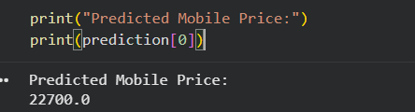

Program 18: Perceptron Based IRIS Classification
from sklearn.datasets import load_iris
from sklearn.model_selection import train_test_split
from sklearn.linear_model import Perceptron
from sklearn.metrics import accuracy_score

iris = load_iris()

X_train, X_test, y_train, y_test = train_test_split(
iris.data,
iris.target,
test_size=0.3,
random_state=42
)

model = Perceptron()

model.fit(X_train, y_train)

y_pred = model.predict(X_test)

print("Accuracy:")
print(accuracy_score(y_test, y_pred))

OUTPUT:
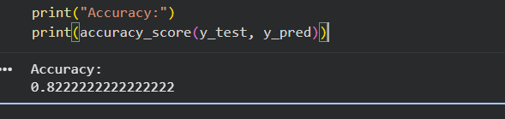
Program 19: Bank Loan Prediction using Naive Bayes
import pandas as pd
from sklearn.naive_bayes import GaussianNB

data = pd.DataFrame({
'Income':[20,30,40,50,60],
'Age':[25,35,45,30,50],
'Loan':[0,0,1,1,1]
})

X = data[['Income','Age']]
y = data['Loan']

model = GaussianNB()

model.fit(X,y)

prediction = model.predict([[55,40]])

print("Loan Prediction:")
print("Approved" if prediction[0] == 1 else "Rejected")
OUTPUT:
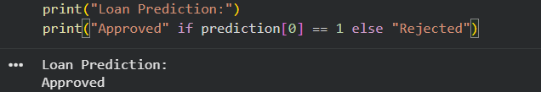

Program 20: Future Sales Prediction
import pandas as pd
from sklearn.linear_model import LinearRegression

data = pd.DataFrame({
'Month':[1,2,3,4,5,6,7,8,9,10],
'Sales':[100,120,130,150,170,180,200,210,230,250]
})

X = data[['Month']]
y = data['Sales']

model = LinearRegression()

model.fit(X,y)

future_month = [[12]]

prediction = model.predict(future_month)

print("Predicted Sales for Month 12:")
print(prediction[0])
OUTPUT:
