AI POWERED AUTONOMOUS COCONUT HARVESTING SYSTEM
Dr. Madhu B.K^{*1}, Mahesh S^{*2}, Syeda Umme Haani^{*3}, S Mohammed Maaz^{*4}, Akshatha G^{*5}
¹Dean & Professor, Department of Computer Science and Engineering, Vidya Vikas Institute of Engineering and Technology, Mysuru, Karnataka, India.
^{2,3,4,5} Final-year B.E. Students, Department of Computer Science and Engineering, Vidya Vikas Institute of Engineering and Technology, Mysuru, Karnataka, India.
ABSTRACT
Manual coconut harvesting depends on climbers working at heights of 15 to 25 metres, and growers have no digital record of which trees are ready to harvest. This paper presents an AI powered coconut harvesting system (Veraxis), a full-stack digital twin platform that turns drone survey imagery into a structured, queryable plantation model and drives a simulated climbing robot to harvest it. A YOLOv8 tree detector processes survey tiles laid out by a configurable flight planner; GPS-proximity matching with a 4 m radius assigns permanent tree identities and mission-scoped observations; a second YOLOv8 model classifies close-up coconuts as Mature, Potential or Premature and writes immutable inventory snapshots; and a nearest-neighbour planner builds immutable harvest missions. The robot is a deterministic, event-driven simulation with a frozen state machine, battery model and WebSocket telemetry, so real hardware would replace only the engine. The contribution is the integration rather than any new network or learning rule: a digital twin that keeps a plantation as a persistent, queryable object and evaluates the complete workflow, from survey tiles to a finished harvest, end to end. In our tests the engine reproduced identical traces in 100 of 100 randomised missions with no illegal state transition, nearest-neighbour routes were 5.6 to 9.2 percent longer than optimal for 5 to 8 trees, and re-survey matching created no duplicate trees for position errors up to about 1 m. The robot remains simulated and field trials are future work.
Keywords: Digital Twin, Precision Agriculture, Coconut Harvesting, YOLOv8, Robot Simulation, WebSocket Telemetry
- INTRODUCTION
Coconut is a major plantation crop, yet harvesting it has changed little in decades. The dominant method is a human climber carrying a knife up an unprotected trunk, which is physically dangerous and increasingly hard to staff because fewer young workers are willing to take up the work. A second problem is informational: plantations are usually run from memory or paper, with no canonical list of trees, no position for each, no fruit count per tree and no record of past harvests. The grower therefore cannot easily answer the central economic question of which trees are worth visiting now. This work addresses both problems with one system, named Veraxis. Its key design decision is to split sensing between two actors with different strengths. A drone gives cheap, wide-area, top-down coverage and is used only to find and locate trees. A climbing robot gives close-up views of the canopy and is used to judge ripeness, which a top-down view from altitude cannot do reliably. Keeping the two tasks in two separate detectors lets each model be retrained or replaced without touching the other. The contribution of this work is not a new detection algorithm, loss function or network architecture: the detectors are standard YOLOv8 models, and the routing heuristic and state-machine pattern are established techniques. The contribution is the integration itself: a digital twin architecture that combines YOLOv8-based perception with autonomous mission planning and evaluates the full harvesting workflow end to end, treating the plantation as a persistent, queryable object rather than a one-off detection result. The main contributions of this work are:
•Development of a digital twin platform for autonomous coconut harvesting that keeps the plantation as a persistent, queryable object rather than a one-off detection result. The platform includes permanent tree identities built from GPS-proximity matching (a 4 m Haversine radius) with a mission-scoped observation history, a farm-pixel twin viewer that shares one coordinate function between the tile mosaic, tree overlay and robot layer, and immutable inventory snapshots and harvest missions.
•Integration of YOLOv8-based real-time perception into the platform. A one-class tree detector processes drone survey tiles, a three-class ripeness classifier (Mature, Potential, Premature) processes close-up images, and both use the lightweight YOLOv8n network with its anchor-free decoupled head and C2f-style feature fusion [2], so each detector can be retrained or replaced without touching the other.
•Evaluation of the complete harvesting workflow under reproducible simulated harvesting scenarios: a full pipeline run from survey tiles to a finished harvest, deterministic replay of the simulated engine over 100 randomised missions (identical traces in 100 of 100), and exhaustive legality checks of all 64 ordered state-machine transitions.
•Analysis of detection accuracy and operational efficiency: precision, recall and mAP on held-out validation splits with an interpretation of the per-class error structure, routing quality of the nearest-neighbour planner against exact-optimal and 2-opt references (5 to 100 trees), matching resilience under re-survey position error, and engine throughput.
- RELATED WORK
Single-stage detectors in the YOLO family frame detection as one regression problem and run in real time [1], and the Ultralytics YOLOv8 implementation [2] is widely used for agricultural targets. Fruit detection in orchards with deep networks has been studied for crops such as mango and other tree fruit [3], [4]; those systems concentrate on counting and yield estimation from imagery rather than on closing the loop to a harvesting actor. The digital twin idea, a persistent virtual counterpart of a physical asset that is kept in step with it [5], motivates our choice to make the plantation a permanent, queryable object instead of a one-off detection result. On the planning side, ordering a set of stops to minimise travel is the travelling salesman problem. The nearest-neighbour heuristic is simple and fast but not optimal, and its worst-case behaviour has been analysed [6]; two-exchange (2-opt) local search [7] is a standard way to obtain a stronger reference tour. For control, we model the robot as a finite state machine in the spirit of statecharts [8], and we stream its state to clients with the WebSocket protocol [9] so that live position does not require polling.
- SYSTEM ARCHITECTURE
Veraxis is arranged in the horizontal bands of Fig.~1. The physical world is at the top, where a drone surveys the plantation and a climbing robot harvests it. Below that lie a client tier, a Next.js and React application that presents data and emits intents; an edge tier that serves that application and hosts the backend container; a backend service that runs the business logic; and a data tier that stores the result. The two machine-learning models are loaded in-process inside the backend container, state lives in a managed serverless PostgreSQL database reached through SQLAlchemy, and survey and inspection imagery is kept as files in object storage rather than as database rows.
The backend is the only component in which a business decision is made; the client renders what it is given and never computes eligibility, route order, inventory totals or state transitions. The backend keeps the same discipline internally, separating thin API routers, which only translate between HTTP and the domain modules, from the modules that hold the rules: the flight planner and tree matcher that turn survey tiles into permanent tree identities, the harvest planner that orders the eligible trees, the state machine that is the sole writer of robot status, the simulation engine and scheduler that advance the robot, and the analytics service that summarises a completed run. A single executor for harvest-mission completion is shared by the operator command path and the simulation run loop, so a mission driven by the robot and a mission driven by hand cannot diverge.

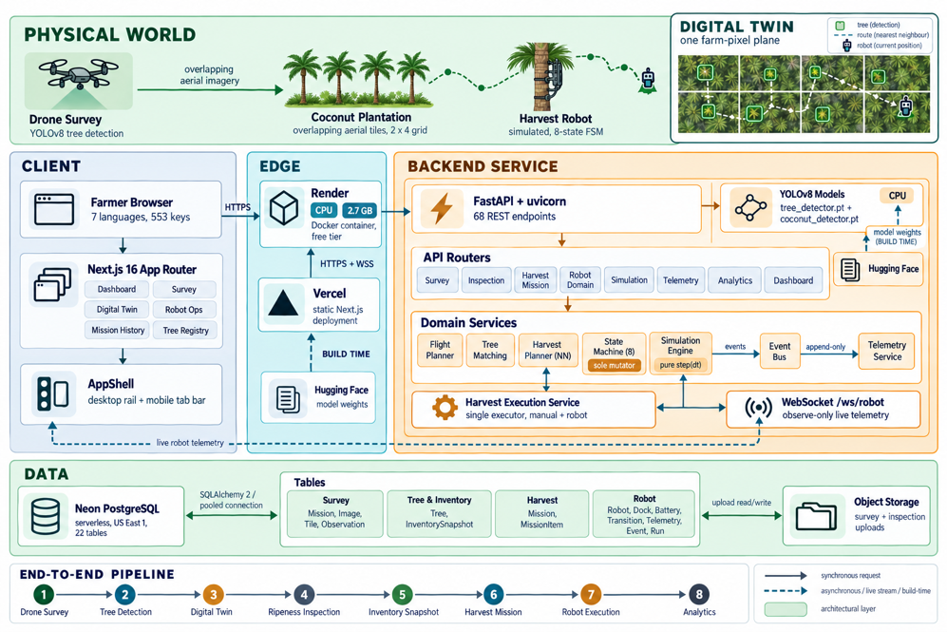
Figure 1: System architecture and end-to-end telemetry path. The bands run from the physical world at the top through the client and edge tiers to the backend service and the data tier below; the dashed arrow is the live telemetry channel back to the client, the digital-twin inset is a magnification of the plantation, and the strip along the foot is the eight-stage pipeline that these components implement end to end.

The robot subsystem is deliberately split into three concerns. Route planning (which trees, in what order) belongs to the harvest planner. Movement planning (the farm-pixel trajectory between stops) belongs to a pure, stateless navigator. Execution (advancing time, updating position, battery and state) belongs to the simulation engine and its scheduler, the only components that mutate live robot state. Because the contract with the outside world is the HTTP command set plus the WebSocket telemetry frame, a physical robot could replace the simulation engine and leave every other component unchanged. The same separation principle applies to perception: the tree detector runs on wide-area drone survey tiles and the ripeness classifier on close-up inspection images, and they share no code path, no thresholds and no storage, so either can be retrained or replaced on its own. A single coordinate function places the tiles, the tree boxes and the robot marker in the same farm-pixel plane, so the three cannot drift apart.

- METHODOLOGY
A. Survey ingestion and flight planning
A survey mission is created from a folder of drone images. A simulated Flight Planner owns the coverage geometry through an explicit configuration (rows, columns, origin corner, traversal pattern and row/column spacing). The grid is never inferred from the number of images: fewer images than planned positions leave positions empty, and more images than positions raise a validation error (HTTP 422). Positions are visited in boustrophedon (lawnmower) order, and each position stores its grid row and column, capture order and image size on the survey tile. Our demonstration survey uses eight tiles in a 2×4 grid.

B. Tree detection
Each tile is passed to a YOLOv8 tree detector with a single class and an inference confidence threshold of 0.4. Detections are stored as raw bounding boxes per tile. They are not trees yet: a detection becomes a tree only after matching.

C. Permanent tree identity
A detection's GPS position is generated from the mission base coordinate, the tile's grid position and the box centre offset, using a ground scale derived from the tile footprint (a spacing of 0.001 degrees, about 111 m, so roughly 0.054 m per pixel for a 2048-pixel tile). Matching uses the Haversine distance: a detection within 4 m of an existing tree reuses it, otherwise a new tree is created with a write-once identifier (TREE-0001, TREE-0002, ...). A hybrid score weights GPS proximity at 0.7 and bounding-box geometry at 0.3 to choose between candidates. Every detection is also stored as a TreeObservation holding the tile, the pixel position, the bounding box and the confidence. Observations are mission-scoped and never overwritten, and each tree points to one representative observation chosen by a fixed rule: highest confidence, then closest to the tile centre, then newest mission.
D. Digital twin and farm-pixel coordinates
The twin lays tiles out by their persisted grid row and column in a continuous mosaic with a small configurable seam gap (Fig. 2). It does not stitch or warp images. A single function computes the farm-pixel position of every tile, and the tree overlay and the robot layer use the same function, so a tree box and the robot marker always agree. GPS remains backend metadata. The viewer uses Pointer Events for pan and pinch zoom, viewport culling and zoom-dependent detail, and selecting a tree opens a read-only details drawer.
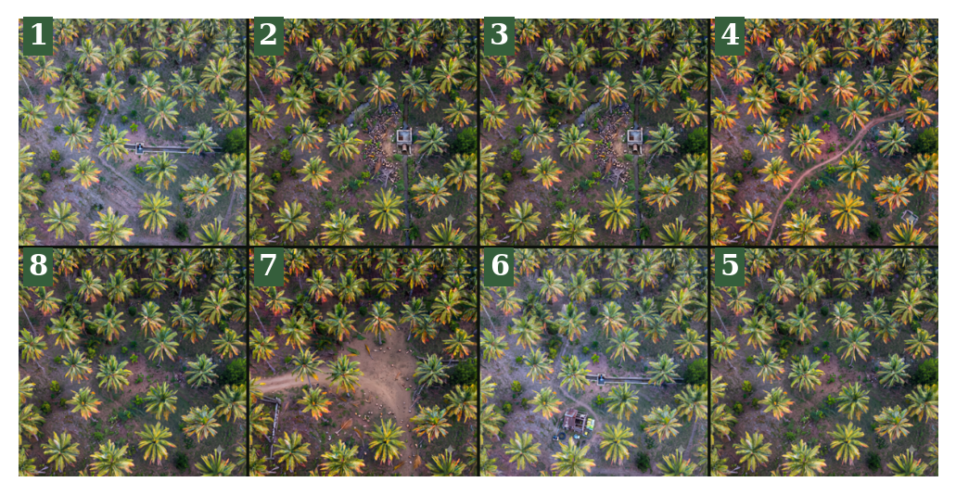
Figure 2: Farm mosaic of the eight demonstration survey tiles in boustrophedon capture order (numbers 1 to 8). Tiles are placed from persisted grid coordinates rather than stitched, so the same coordinate function grounds the tree overlay and the robot layer exactly as shown.
E. Ripeness inspection and inventory
For one tree, close-up images are uploaded as an inspection session and passed to a second YOLOv8 model with three classes (Mature, Potential, Premature) and a confidence threshold of 0.25. Labels are stored in lowercase and aggregated by a direct group-by into an InventorySnapshot with total, mature, potential and premature counts. A snapshot is immutable and unique per inspection. A new scan creates a new snapshot and repoints the tree's current-inventory pointer, so inventory is replaced on every scan, never accumulated, and history is preserved.
F. Harvest planning
The planner reads each tree's latest snapshot and selects trees that are active, have an inventory and contain at least one coconut of the requested type (mature, potential, premature or all). Trees already in a live mission are excluded. Selected trees are ordered by nearest neighbour starting from the depot, with candidates processed in ascending tree-id order and ties resolved by a strict comparison, so the order is reproducible. The result is an immutable harvest mission with one item per tree and a unique constraint that prevents a tree from appearing twice.

G. Robot simulation, state machine and telemetry
The simulation engine advances a context by one fixed step through a pure function, step(dt), with no clock, database or randomness. Movement is linear interpolation between waypoints in farm-pixel space. At each tree the robot climbs (2 s), scans (2 s) and harvests (3 s) in simulated time, then moves on; at the end it returns to the dock. Battery drains only in active states at 1/60 percent per simulated second, which gives about 1 percent per real second at the default 60× speed, and when the level reaches the low threshold (20 percent by default) the engine diverts to the dock. Robot status is held in eight states (Idle, Moving, Climbing, Scanning, Harvesting, Returning, Error, Docked). A state machine with a frozen transition table is the only component allowed to change the persisted status; every operational state may fault into Error, and Error may recover only to Returning or Idle (Fig. 3). The scheduler drives the engine against wall-clock time at a configurable speed factor and publishes each tick's events to an event bus. A telemetry service appends one telemetry row per tick and one event row per event, and a WebSocket gateway broadcasts the same frames to any number of observe-only clients. When a run ends, one summary record is written with distance, battery use, recharge count, harvest timing and a deterministic mission score equal to 100×completion×(0.5+0.5×battery economy)×a status factor (1.0 completed, 0.5 aborted, 0.2 failed).
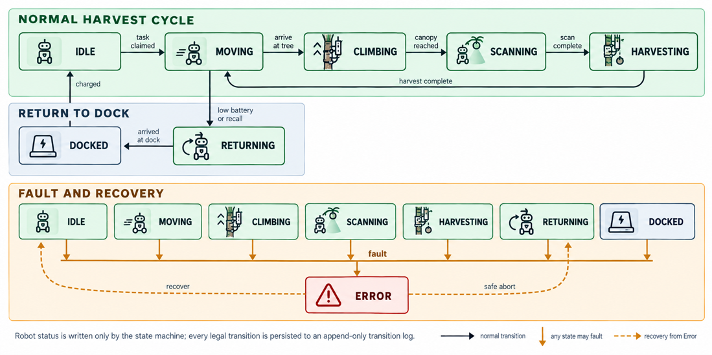
Figure 3: Robot state machine with the frozen legal transitions. The state machine is the only component that may write robot status; the seventeen legal edges are the complete set of the sixty-four ordered state pairs, and since every operational state can fault into ERROR and ERROR recovers only to RETURNING or IDLE, no run can enter an undefined state.
- EXPERIMENTAL SETUP
Two kinds of evidence are reported. First, the two YOLOv8 detectors were trained on public image datasets published on Roboflow under the CC BY 4.0 licence: a single-class coconut tree dataset for the tree detector and a three-class coconut maturity dataset for the ripeness model, with 10,343 images (9,048 training, 865 validation, 430 test) in the tree set and 7,297 images (6,384 training, 618 validation, 295 test) in the maturity set: the maturity validation split contains 971 Premature, 632 Potential and 346 Mature instances. All training and inference hyperparameters were taken from the checkpoints' recorded configuration and are summarised in Table 1. Measured on the same machine with the models running on the CPU, a single 640 px image is processed in about 56 ms by the tree detector and about 66 ms by the ripeness detector (median of 20 timed runs after 10 warm-up runs), which is fast enough to keep the inspection interaction responsive. The trained weights are hosted publicly on Hugging Face (insenix/tree_detector and insenix/coconut_detector).
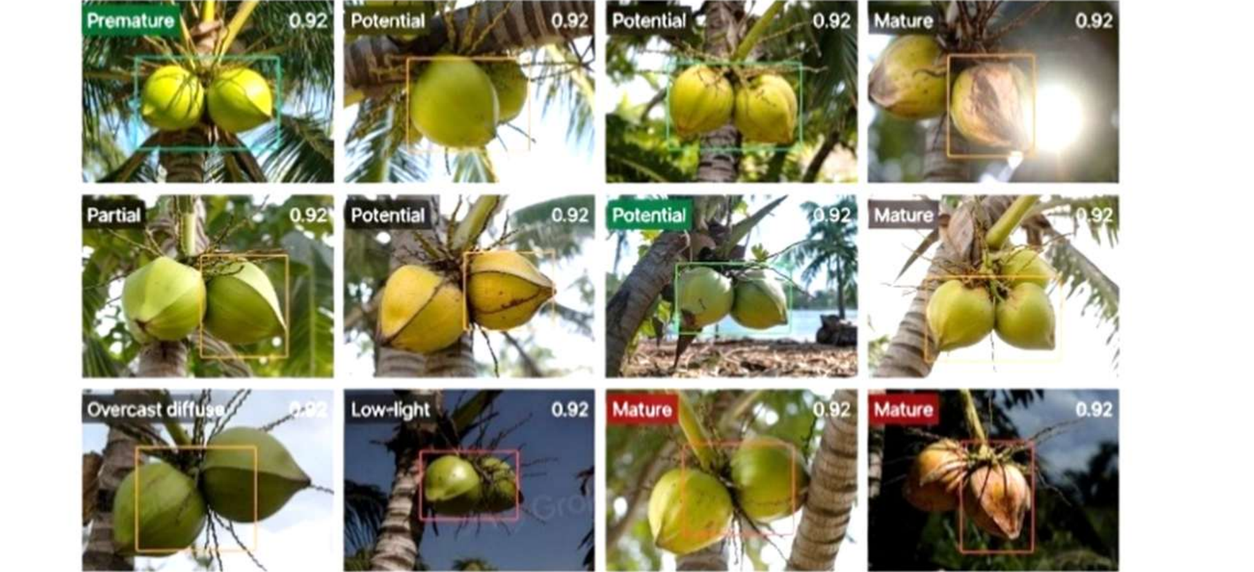
Figure 4: Sample images and bounding-box annotations from the public coconut datasets (Roboflow previews), showing examples of the tree and ripeness labels. The variation in lighting and viewpoint across these samples is why lighting conditions appear in the limitations.
Second, the backend logic that does not depend on the weights was evaluated with a reproducible script (experiments.py, fixed random seeds, run against the project's own modules). It covers: E1, determinism of the engine over 100 random missions of 3 to 12 trees, comparing SHA-256 hashes of the full event and state trace across two runs; E2, routing quality of the nearest-neighbour planner against the exact optimum (5 to 8 trees, 100 instances each) and against a 2-opt reference (10 to 100 trees); E3, exhaustive legality of all 64 ordered state pairs; E4, engine invariants and battery diversion; E5, boustrophedon order for 16 grid and origin configurations; E6, tree matching under re-survey position error using the real matching code on a SQLite database; and E7, engine throughput. Tree positions in E1 to E4 and E7 are random on a 4100×4100 farm-pixel field with the dock at the origin, and E6 uses 60 synthetic trees at least 8 m apart. These are simulation experiments and not field measurements.
- RESULTS AND DISCUSSION
A. Detector configuration and accuracy
Table 1. Detector training and inference configuration (all values from the checkpoints' recorded training configuration)
Setting | Tree detector | Ripeness detector
Classes | tree (1) | Mature, Potential, Premature (3)
Dataset | Public tree dataset (Roboflow, CC BY 4.0) | Public maturity dataset (Roboflow, CC BY 4.0)
Base weights | COCO-pretrained YOLOv8n | COCO-pretrained YOLOv8n
Parameters | 3,011,000 (6.2 MB weights) | 3,011,400 (6.2 MB weights)
Epochs | 50 | 50
Image size | 640 px | 640 px
Batch size | 16 | 16
Optimizer | auto (Ultralytics default) | auto (Ultralytics default)
Learning rate | lr0 0.01, lrf 0.01 | lr0 0.01, lrf 0.01
Momentum / weight decay | 0.937 / 0.0005 | 0.937 / 0.0005
Warm-up epochs | 3 | 3
Loss gains | box 7.5, cls 0.5, dfl 1.5 | box 7.5, cls 0.5, dfl 1.5
Augmentation | Ultralytics defaults: HSV colour jitter, scale and translate jitter, horizontal flip, mosaic | Ultralytics defaults: HSV colour jitter, scale and translate jitter, horizontal flip, mosaic
Training hardware | Authors' local machine | Authors' local machine
Inference confidence | 0.40 | 0.25
Metric IoU | 0.5 and 0.5:0.95 | 0.5 and 0.5:0.95

Table 2. Detection accuracy on each model's held-out validation split
Model / class | Precision | Recall | mAP@0.5 | mAP@0.5:0.95
Tree detector | 0.841 | 0.843 | 0.877 | 0.539
Ripeness: all classes | 0.760 | 0.747 | 0.783 | 0.587
Ripeness: Mature | 0.637 | 0.607 | 0.631 | 0.430
Ripeness: Potential | 0.794 | 0.791 | 0.860 | 0.715
Ripeness: Premature | 0.848 | 0.842 | 0.858 | 0.617

The two detectors reach competitive accuracy on their held-out validation splits: 0.841 precision and 0.877 mAP@0.5 for the tree detector, and an average of 0.760 precision and 0.783 mAP@0.5 for the three ripeness classes. The confusion matrices (Fig. 5) show that most ripeness errors are missed detections (boxes predicted as background, 30 to 35 percent of ground-truth coconuts) rather than cross-class swaps, and the tree detector likewise reports no background region as a tree. The precision-recall curves of both models are shown in Fig. 6. The structure of the errors is consistent with the class composition of the validation data. The ripeness split contains 971 Premature, 632 Potential and 346 Mature instances, so Mature is both the least represented and the least visually distinct class: a partly turned coconut closely resembles a Potential one. The confusion matrix reflects this, allocating Mature's errors between missed detections and a small number of Potential swaps, which is why Mature's precision (0.637) and recall (0.607) trail the other two classes, while Potential and Premature, with more training instances and more distinct colour cues, reach 0.860 and 0.858 mAP@0.5. Missed detections also dominate the overall error budget: closing that gap, for example with higher input resolution or more inspection images captured per tree, is more promising than refining class decision boundaries. The tree detector performs its easier task by construction: one class of large, high-contrast, isolated targets in top-down imagery, which yields a clean diagonal with no background false positives. A further reason for the absolute level of both scores is the detectors' architecture: because YOLOv8's anchor-free detection strategy predicts each box directly from a single point and its decoupled head aggregates features across scales (the C2f-style fusion), localization remains stable for coconuts of very different apparent sizes and under the illumination variation present in both datasets [2]. Both models work from the same pretrained YOLOv8n base because this lightweight variant matches the target's small search space: adequate localization quality at a scale trainable from scratch on a few thousand images without overfitting.

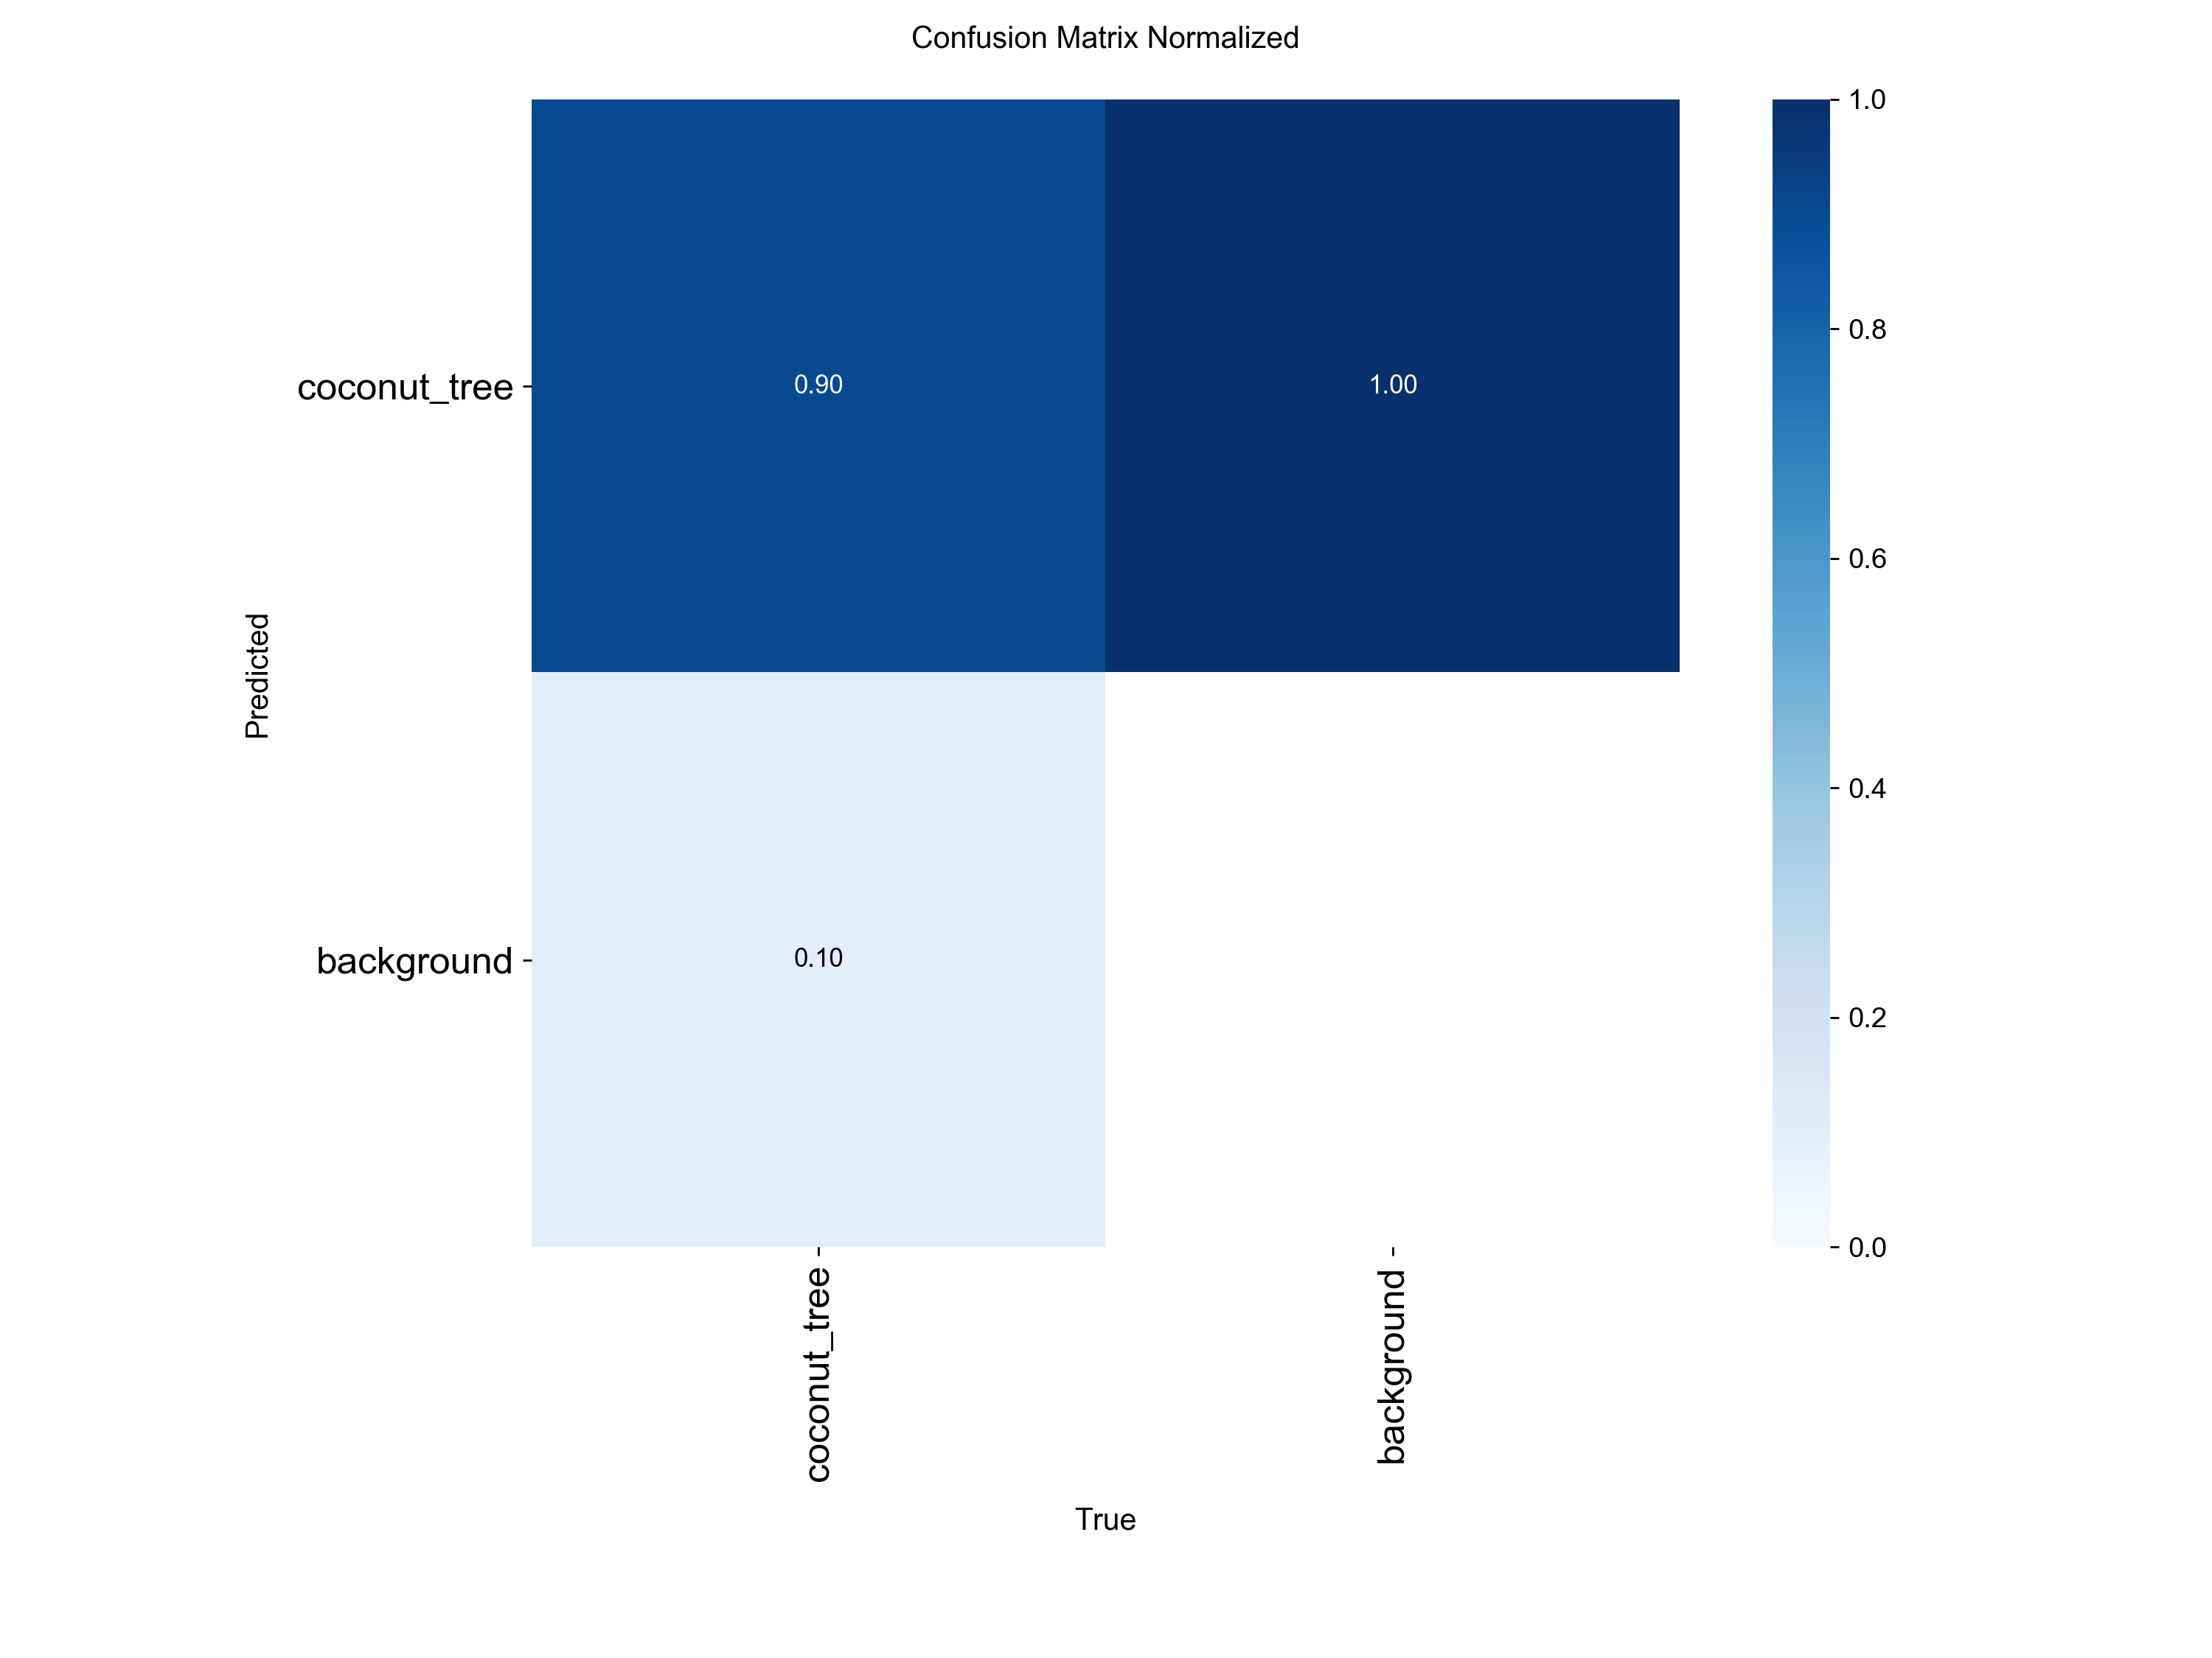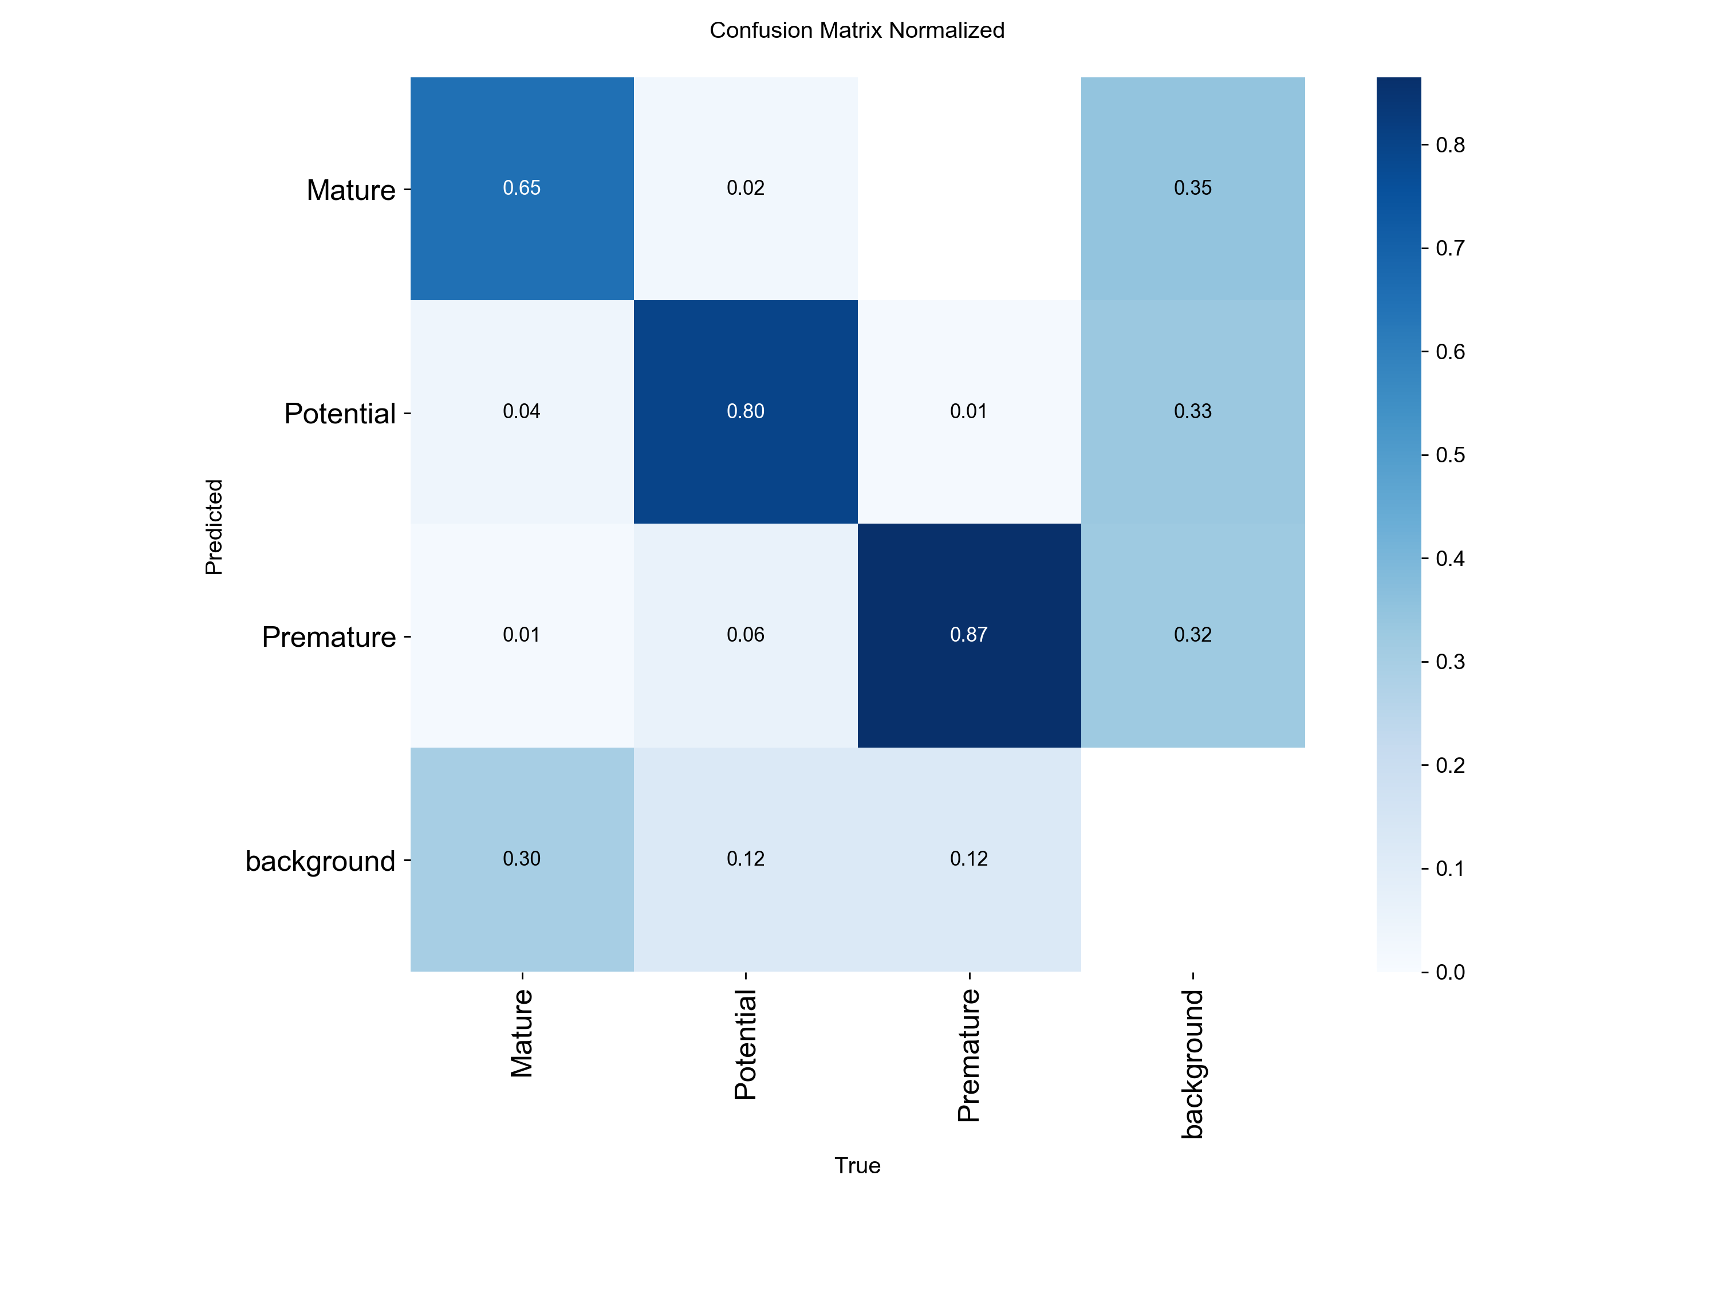
Figure 5: Normalised confusion matrices on the held-out validation splits: (left) tree detector, 90 percent diagonal mass with no background false positives; (right) ripeness detector, where most off-diagonal mass lies in the background column (missed detections).
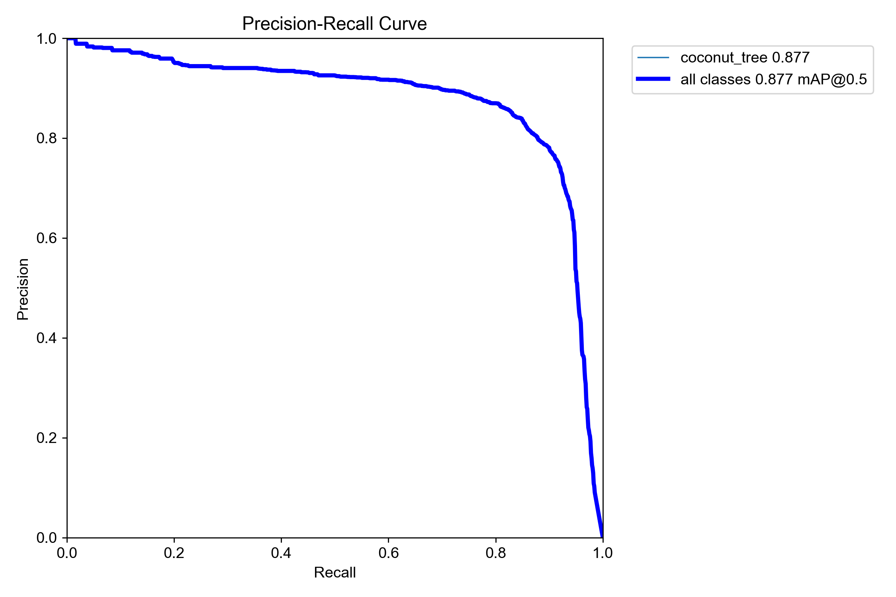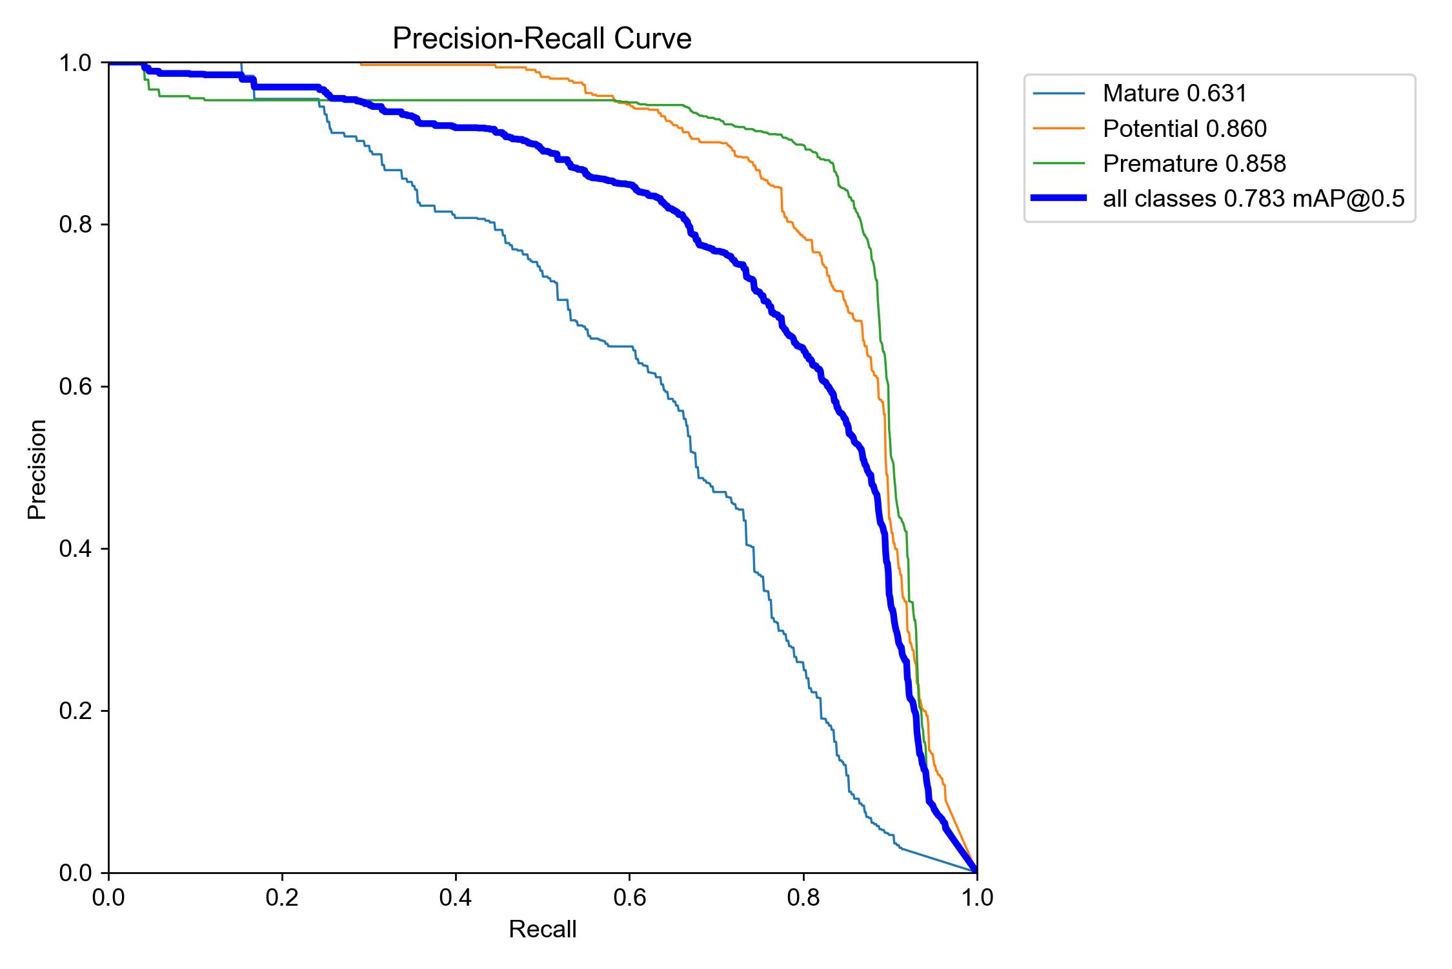
Figure 6: Precision-recall curves on the held-out validation splits. (Left) tree detector, AP 0.877 at IoU 0.5. (Right) ripeness detector per class: Potential 0.860, Premature 0.858, Mature 0.631 - Mature trails because it is the least represented class and visually resembles Potential.

B. End-to-end functional run
Accuracy alone does not show whether the pieces work together, so a full workflow was executed on a freshly reset database and recorded during the final audit: eight survey images produced eight tiles and 243 tree detections, which became 243 permanent trees; re-running matching reused the existing trees instead of creating duplicates. The one-to-one correspondence is not a coincidence: because the planner positions tiles on a fixed grid and each tree's detections fall on exactly one tile, every detection contributes to exactly one permanent tree. One inspected tree yielded 32 detected coconuts (3 Mature, 2 Potential, 27 Premature) and an inventory snapshot. A harvest mission for one eligible tree with three expected coconuts was started, the simulated robot navigated, harvested three coconuts and returned to the dock, the mission completed, and a run record with timeline, per-tree activity and log was produced. Over the WebSocket, two simultaneous clients received frames, the number of telemetry rows matched the number of frames for the run, and a disconnecting client did not stop the run.

C. Determinism and state-machine correctness
Table 3. Simulation engine and state machine checks
Check | Result
E1: identical event and state trace over two runs (random missions) | 100 / 100
E3: legal / illegal ordered state pairs | 17 / 47 of 64
E3: self-transitions allowed | 0
E3: operational states that can fault to Error | 7 of 7
E4: illegal transitions attempted by the engine | 0 in 100 missions
E4: missions ending finished and Docked | 100 / 100
E4: missions with non-increasing battery | 100 / 100
E4: missions harvesting every tree (others diverted by low battery) | 88 / 100
E4: mean state transitions per tree | 4.4
Battery drain at default 60× speed | 1.0% per real second
The engine produced byte-identical traces in every trial. This happens by construction: step(dt) is a pure function with no clock, database or randomness, and the fixed random seeds drive every randomised decision, so the deterministic replay property is what allows runs to be regression-tested without a clock. The engine never requested an illegal transition because every request passed through the transition table. In the stress test at the lowest speed (1 farm-pixel per simulated second) with 10 to 40 trees, the low-battery rule triggered in all four cases and the robot ended Docked, but with the battery at 0.0 percent each time (Table 4 shows the harvested counts). The fixed 20 percent threshold therefore does not guarantee arrival with reserve when the dock is far away, and a distance-aware return threshold is an obvious improvement.
Table 4. Battery-low diversion stress test (speed 1.0 px per simulated second)
Trees | Plan length (px) | Harvested | Final state | Final battery (%)
10 | 29,935 | 2 | DOCKED | 0.0
20 | 36,815 | 2 | DOCKED | 0.0
30 | 72,290 | 1 | DOCKED | 0.0
40 | 90,398 | 1 | DOCKED | 0.0

D. Routing quality
Table 5. Nearest-neighbour tour length (round trip from the dock)
Trees | Reference | NN excess mean (%) | NN excess max (%) | Random order
5 | exact optimum | 5.56 | 20.89 | 1.33×
6 | exact optimum | 5.92 | 28.79 | 1.47×
7 | exact optimum | 8.63 | 30.31 | 1.55×
8 | exact optimum | 9.24 | 28.02 | 1.66×
10 | 2-opt reference | 10.14 | – | 1.72× (vs NN)
20 | 2-opt reference | 14.42 | – | 2.28× (vs NN)
50 | 2-opt reference | 15.0 | – | 3.83× (vs NN)
100 | 2-opt reference | 16.69 | – | 5.33× (vs NN)
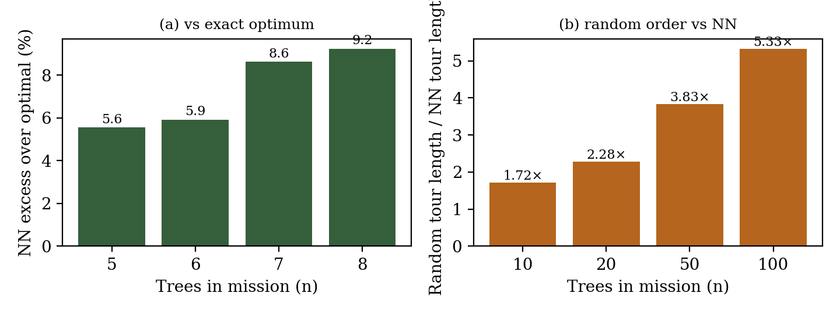
Figure 7: (a) Excess tour length of nearest neighbour over the exact optimum for 5 to 8 tree missions (mean and worst case): the excess grows as the greedy early decisions accumulate; (b) length of a random visiting order relative to nearest neighbour for 10 to 100 tree missions: without spatial grouping the random order degrades far faster.
Nearest neighbour was on average 5.6 to 9.2 percent longer than the exact optimum for 5 to 8 trees, with a worst case of 30.3 percent, and its excess over a 2-opt reference grew from 10.1 percent at 10 trees to 16.7 percent at 100 trees. A random visiting order was 1.7 to 5.3 times longer than nearest neighbour as missions grew. The growth pattern in Fig. 7 is explained by how greedy selection works: nearest neighbour always takes the locally closest stop, which is near-optimal while early choices are cheap, but every early decision is locked in, so as the tour grows the accumulated cost of those irreversible early excursions rises, which is exactly the behaviour the Rosenkrantz bound analysis [6] predicts. The random order degrades far faster because it carries no spatial grouping at all - each hop ignores the clustering of the previous one. Nearest neighbour is therefore a sound first choice: it is explainable, deterministic and far better than an unordered visit, but a 2-opt pass would remove a further 10 to 17 percent of travel and is a low-cost extension.
E. Tree matching under re-survey error
Table 6. Re-survey matching with 60 trees spaced at least 8 m apart
Error (px) | Error (m, per axis) | Trees after survey 1 | Trees after re-survey | Duplicates
0 | 0.0 | 60 | 60 | 0
10 | 0.54 | 60 | 60 | 0
20 | 1.09 | 60 | 60 | 0
40 | 2.17 | 60 | 71 | 11
80 | 4.34 | 60 | 79 | 19
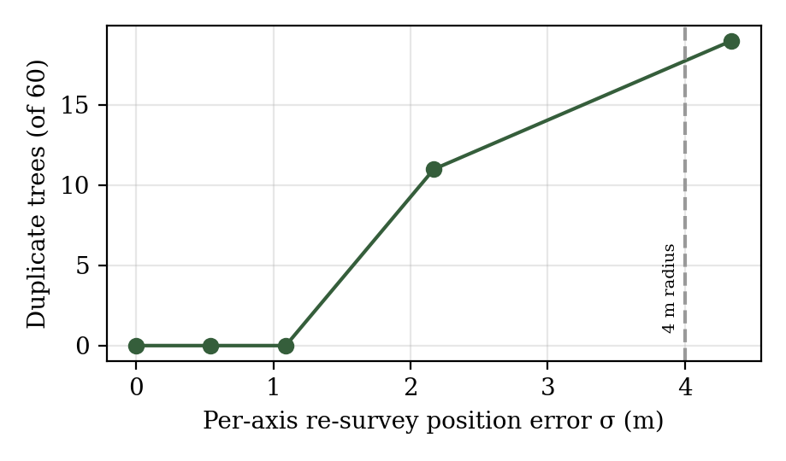
Figure 8: Duplicate trees created by the 4 m matching radius when a re-survey displaces tree positions (per-axis error in pixels and metres); 0 duplicates up to 1.09 m, 11 at 2.17 m, 19 at 4.34 m.
Survey 1 produced exactly the 60 true trees (no false merges), and a re-survey with per-axis error up to about 1.1 m created no duplicates. At 2.2 m and 4.3 m the rule created 11 and 19 duplicates, which matches what a fixed 4 m radius implies for a two-dimensional Gaussian error: as the per-axis error grows, an increasing fraction of re-sampled positions lands farther than 4 m from the original tree, so the probability that a displacement breaks the merge radius rises with the error size. The result also exposes the rule's main assumption: trees closer than 4 m are merged. In a preliminary run with trees placed freely at random, 14 of 60 trees were merged for that reason. Coconut palms are normally planted at wider spacing, typically around 7.5 to 9 m [10], so the 4 m radius is suitable for typical plantations but should be reduced for very dense plots.
F. Throughput and engineering observations
The remaining results measure cost rather than correctness. In our test environment the engine ran at about 114,575 to 119,599 one-second steps per second on a single CPU core, more than 800 times the 60 steps per second needed to run in real time at the default 60× speed, so simulation cost is negligible next to database round-trips. The latter dominated the deployed system: the managed serverless PostgreSQL adds a round-trip floor of roughly 2 s per request, a batched update of 302 rows took about 80 s, and replacing a per-tree query loop (about 600 sequential queries) with two grouped aggregates reduced the tree-summary endpoint from a hang beyond 20 s to about 3 s. These observations are from the development log of the project and were not measured under a controlled benchmark.
- LIMITATIONS AND FUTURE WORK
The robot is simulated and no physical climbing hardware has been integrated, so mechanical grasping, trunk climbing and sensing noise are not evaluated. All detector accuracy comes from public datasets captured under conditions we do not control: the images include daylight and mixed weather but no night-time or irrigation-dusk footage, accuracy may drop on locally captured plantation imagery, and the ripeness validation split is small (618 images, 1,949 instances). The datasets cover coconut palms only, so the tree detector would not transfer to other plantation species without retraining and new labels. GPS positions are generated from a base coordinate and the tile grid rather than read from real geotags, which means absolute positions are synthetic although relative geometry is consistent; the matching radius also assumes palms are planted further apart than 4 m, which is typical for coconut [10] but not guaranteed for every plot, and real GPS error will add measurement noise on top of the simulation study in Table 6. The routing experiments use random positions rather than surveyed plantations, so tour-length conclusions are indicative rather than field measurements. The system supports one farm and one robot, has no authentication, and renders tree overlays with DOM elements, which performs well at about 300 trees but will need canvas rendering or stronger culling for thousands. Future work includes field validation of both detectors on locally captured images, real geotagging and RTK positions, a distance-aware battery return rule, 2-opt route refinement, post-harvest verification scans, multi-robot and multi-farm support, and replacing the simulation engine with a physical robot that satisfies the same telemetry and command contract.
- CONCLUSION
Veraxis shows that a plantation can be treated as a persistent digital asset: drone tiles become permanent, deduplicated trees; close-up scans become immutable inventory; and a planner turns inventory into a reproducible harvest mission executed by a robot whose behaviour is owned entirely by the backend. Separating tree detection from ripeness inspection, and route planning from movement planning and execution, keeps both layers independently replaceable: either detector or the entire simulated robot can be swapped without touching the rest. The experiments confirm deterministic simulation, a respected state machine, nearest-neighbour routing that is acceptable but improvable, and duplicate-free matching for re-survey errors up to about 1 m. Future work will focus on large-scale field validation, multi-camera close-up perception for the inspection pass, adaptive harvesting strategies under varying environmental conditions, and the physical integration of the climbing robot.
ACKNOWLEDGEMENTS
The authors thank their project guide Dr. Madhu B.K, the Department of Computer Science and Engineering and the management of Vidya Vikas Institute of Engineering and Technology Mysuru for their guidance and support.
- REFERENCES
- J. Redmon, S. Divvala, R. Girshick and A. Farhadi, "You Only Look Once: Unified, Real-Time Object Detection," Proceedings of the IEEE Conference on Computer Vision and Pattern Recognition (CVPR), 2016, pp. 779-788.
- G. Jocher, A. Chaurasia and J. Qiu, "Ultralytics YOLOv8," Ultralytics, 2023. [Online]. Available: https://github.com/ultralytics/ultralytics
- A. Koirala, K. B. Walsh, Z. Wang and C. McCarthy, "Deep Learning for Real-Time Fruit Detection and Orchard Fruit Load Estimation: Benchmarking of 'MangoYOLO'," Precision Agriculture, vol. 20, no. 6, pp. 1107-1135, 2019.
- S. Bargoti and J. Underwood, "Deep Fruit Detection in Orchards," Proceedings of the IEEE International Conference on Robotics and Automation (ICRA), 2017, pp. 3626-3633.
- M. Grieves and J. Vickers, "Digital Twin: Mitigating Unpredictable, Undesirable Emergent Behavior in Complex Systems," Transdisciplinary Perspectives on Complex Systems, Springer, 2017, pp. 85-113.
- D. J. Rosenkrantz, R. E. Stearns and P. M. Lewis II, "An Analysis of Several Heuristics for the Traveling Salesman Problem," SIAM Journal on Computing, vol. 6, no. 3, pp. 563-581, 1977.
- G. A. Croes, "A Method for Solving Traveling-Salesman Problems," Operations Research, vol. 6, no. 6, pp. 791-812, 1958.
- D. Harel, "Statecharts: A Visual Formalism for Complex Systems," Science of Computer Programming, vol. 8, no. 3, pp. 231-274, 1987.
- Fette and A. Melnikov, "The WebSocket Protocol," RFC 6455, Internet Engineering Task Force (IETF), Dec. 2011. [Online]. Available: https://datatracker.ietf.org/doc/html/rfc6455
- M. K. Nair, "Coconut Cultivation Practices," Indian Council of Agricultural Research – Central Plantation Crops Research Institute (ICAR-CPCRI), Kasaragod, India, Jul. 1989. [Online]. Available: https://cpcri.gov.in/filemgr/webfs/publication/pamphlet1e_july1989.pdf

