**#PYTHON test**

1. What are the basic data types available in Python?  
  
 1.list (it will store items in ordered ->[ ] )

2.tuple (it will store items in ordered but immutable -> ( ) )

3.set (it does not allow duplicates and unordered -> { } )

4.dict (it stores data in key and value pairs, {‘name’:’mahesh’})

5.int ( whole numbers )

6.str (it is a text)

2. Write a simple for loop to iterate through a list of numbers from 1 to 10.

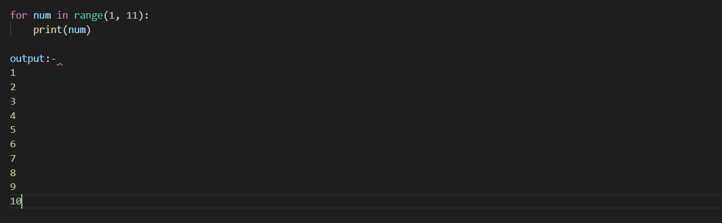

3. Explain how an if-elif-else block works in Python.

* We use if-elif-else block conditionally to execute the statement’s

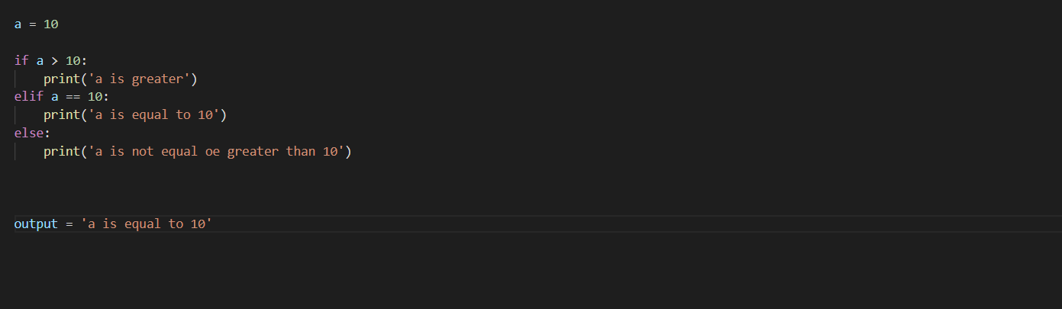

* if statement checks the condition first

*elif statement checks additional conditions if the above one’s are not true

*else statement will execute if all the above statement’s are not true

4. What is the syntax of a while loop in Python?

*while <condition>:

Execute code

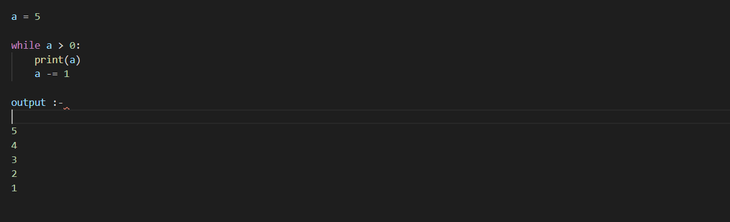

5. What does the range() function do in Python?

* Range function generates sequence of numbers, where we can send zero or upto three arguments

*range(start, stop, stop)

6. How do you get the current date and time in Python?

* we have an inbuilt python module called datetime, by using that we can get the current date time by importing

7. Explain the concept of call by value and call by reference. How does Python handle function arguments?

* CALL BY VALUE :- calling a function with direct values is called call by value

* CALL BY REFERENCE :- calling a function with reference’s is called call by reference

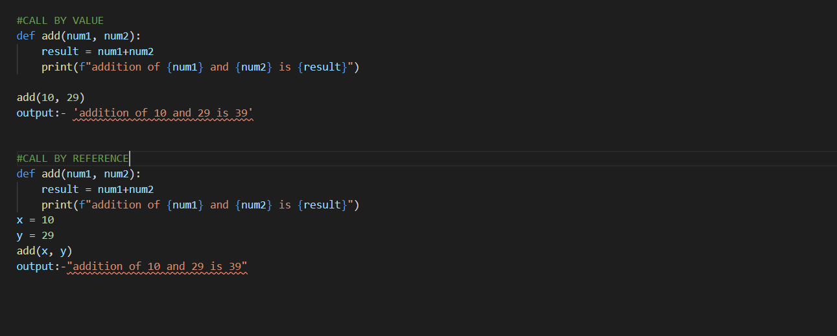

8. How do you define a function in Python with a sample example.

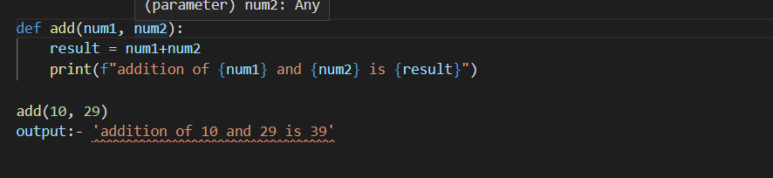

9. Define a class in Python and create an object of that class.

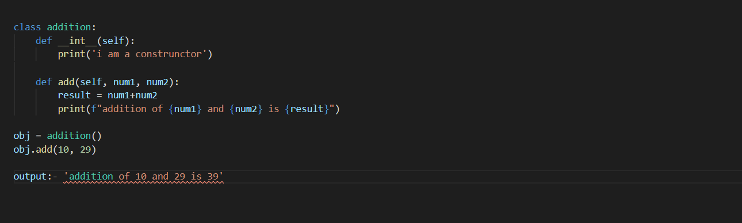

10. Explain inheritance in Python with an example.

*Inheritance is inheriting the methods and attributes from another class

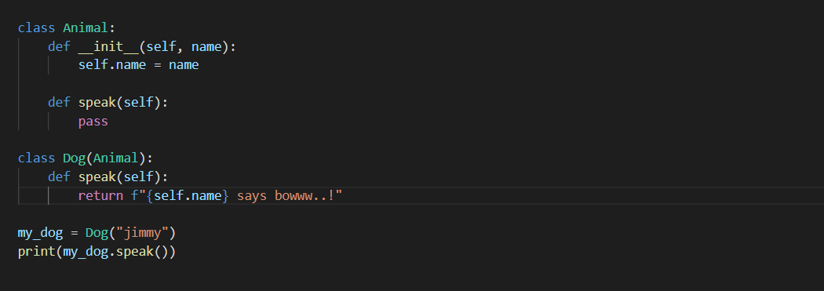

11. What are mutable and immutable types in Python? Give examples.

* Mutable types are of which are changeable after creation, list, dict and set are mutable

*Immutable types are of which are not changeable after creation, int, str and tuple’s are immutable

12. Write a program to find the sum of all even numbers in a list using a for loop.

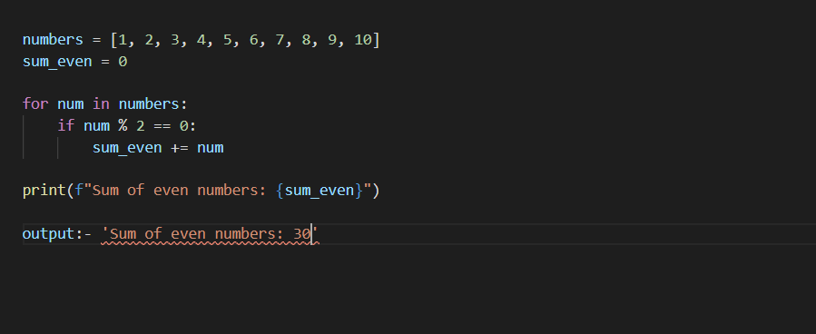

13. Explain nested if statements with an example.

*Nested if is nothing but having an if statement inside another if statement is called nested if

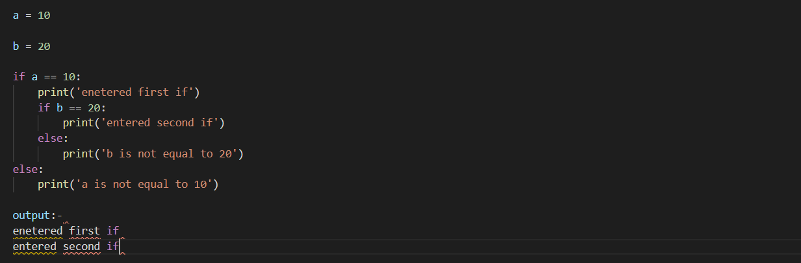

14. How can you use a while loop to implement a basic countdown timer?

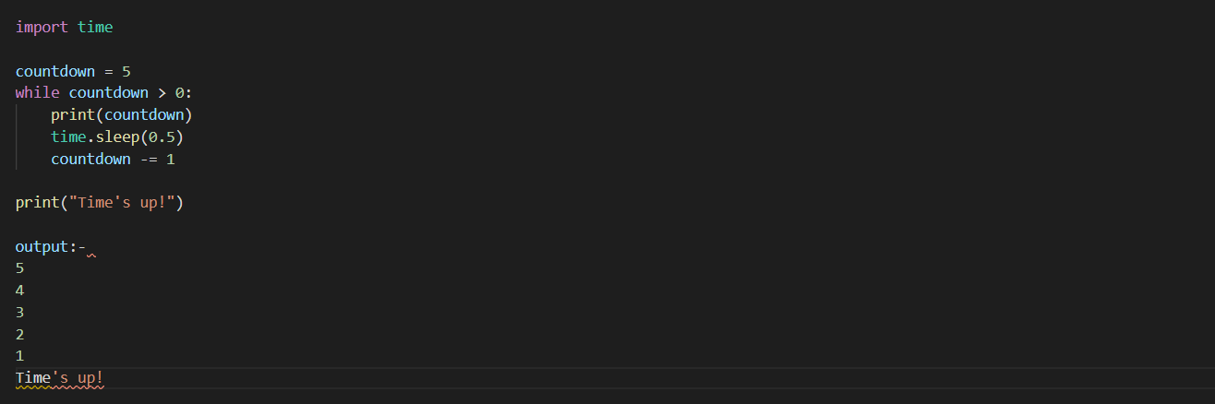

15. Explain how you can use the range() function with a step value.

* Range function will take step value to control the increment in the loop

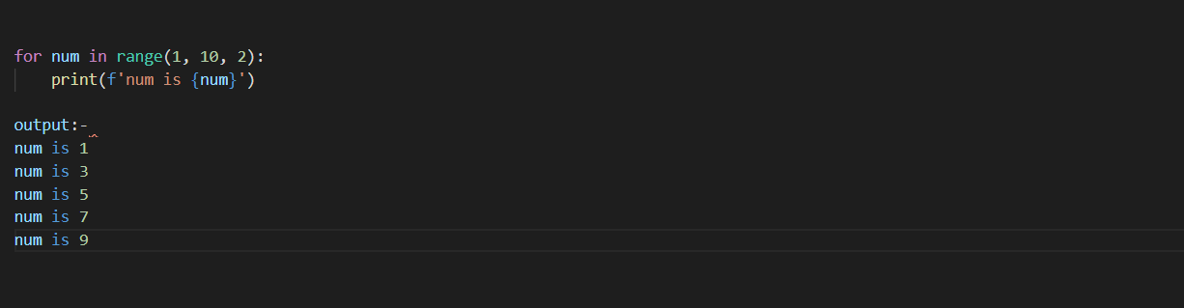

* In the above example we have defined start as 1 and stop as 10 and step as 2
* So it will skip the 2nd occurring number with in the range