**Task2_Analysis Report**

1. **Set the number of threads to 90 with ramp up period of 900 ms with a scheduled time of 900 ms**

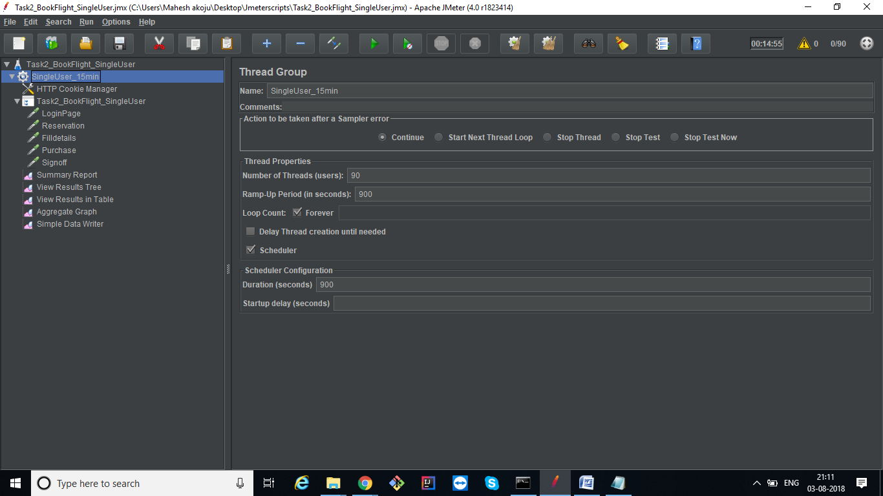

**Summary report**

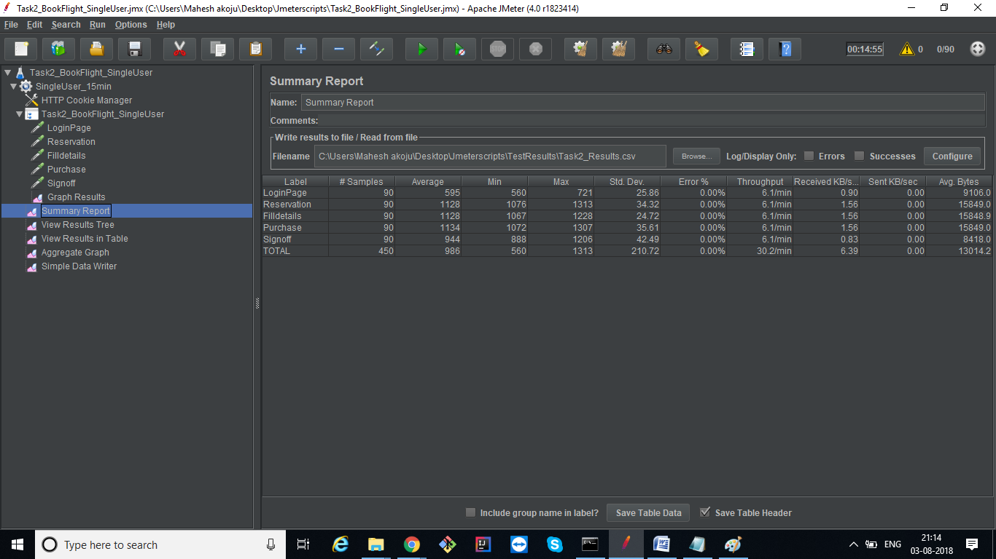

**Results Tree**

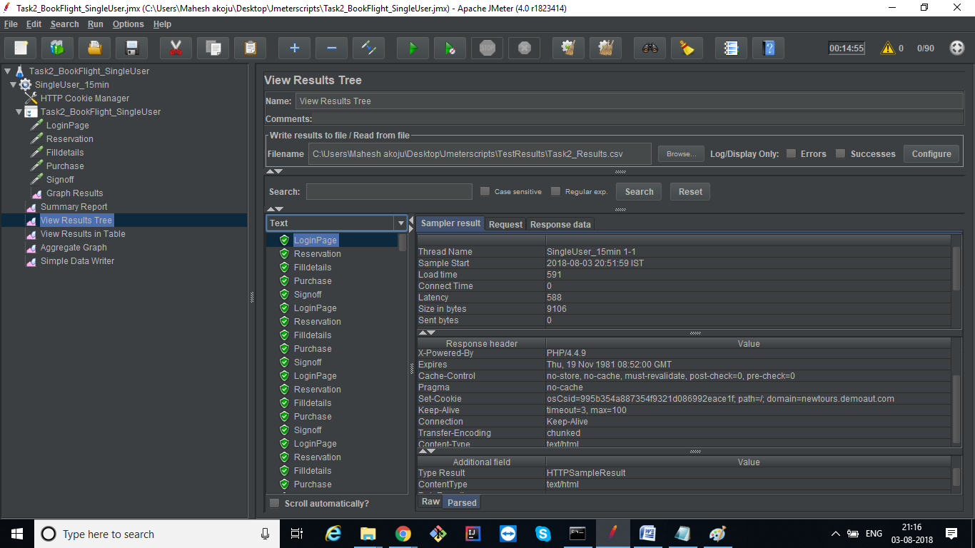

**Results in Table**

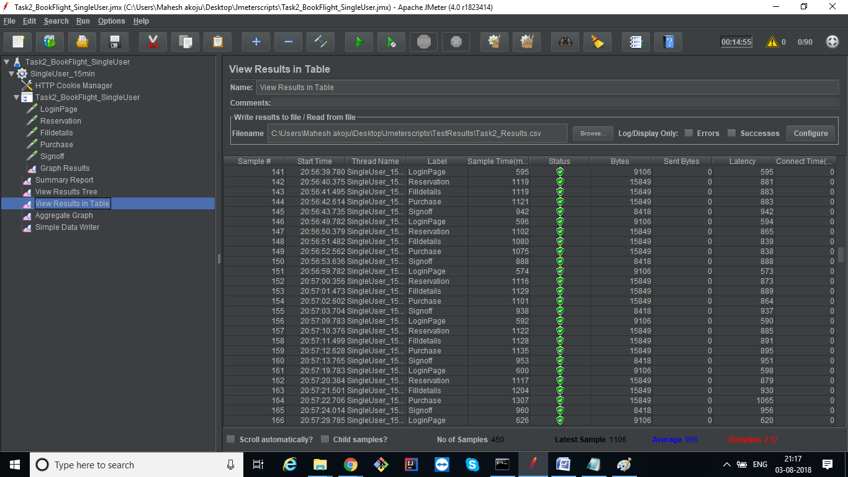

**Aggregate Graph**

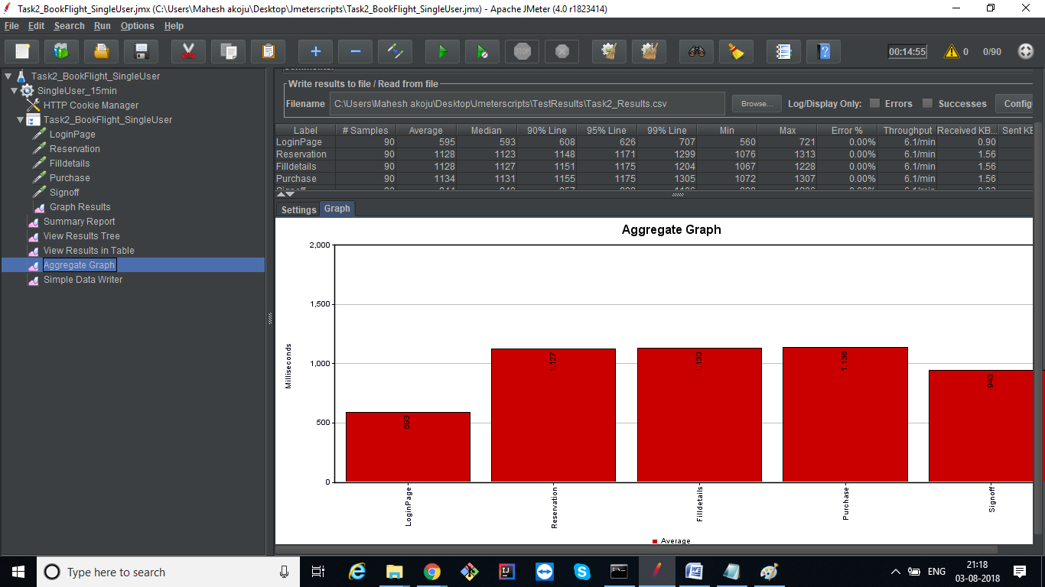

**Results Report**

1533309719757,591,LoginPage,200,OK,SingleUser_15min 1-1,text,true,,9106,0,1,1,588,0,0

1533309720349,1122,Reservation,200,OK,SingleUser_15min 1-1,text,true,,15849,0,1,1,886,0,0

1533309721471,1124,Filldetails,200,OK,SingleUser_15min 1-1,text,true,,15849,0,1,1,884,0,0

1533309722596,1136,Purchase,200,OK,SingleUser_15min 1-1,text,true,,15849,0,1,1,896,0,0

1533309723733,956,Signoff,200,OK,SingleUser_15min 1-1,text,true,,8418,0,1,1,954,0,0

1533309729764,593,LoginPage,200,OK,SingleUser_15min 1-2,text,true,,9106,0,1,1,591,0,0

1533309730359,1121,Reservation,200,OK,SingleUser_15min 1-2,text,true,,15849,0,1,1,884,0,0

1533309731482,1117,Filldetails,200,OK,SingleUser_15min 1-2,text,true,,15849,0,1,1,879,0,0

1533309732604,1137,Purchase,200,OK,SingleUser_15min 1-2,text,true,,15849,0,1,1,894,0,0

1533309733743,944,Signoff,200,OK,SingleUser_15min 1-2,text,true,,8418,0,1,1,943,0,0

1533309739764,583,LoginPage,200,OK,SingleUser_15min 1-3,text,true,,9106,0,1,1,581,0,0

1533309740349,1125,Reservation,200,OK,SingleUser_15min 1-3,text,true,,15849,0,1,1,884,0,0

1533309741475,1131,Filldetails,200,OK,SingleUser_15min 1-3,text,true,,15849,0,1,1,889,0,0

1533309742610,1111,Purchase,200,OK,SingleUser_15min 1-3,text,true,,15849,0,1,1,874,0,0

1533309743720,935,Signoff,200,OK,SingleUser_15min 1-3,text,true,,8418,0,1,1,933,0,0

1533309749764,574,LoginPage,200,OK,SingleUser_15min 1-4,text,true,,9106,0,1,1,573,0,0

1533309750338,1114,Reservation,200,OK,SingleUser_15min 1-4,text,true,,15849,0,1,1,874,0,0

1533309751453,1121,Filldetails,200,OK,SingleUser_15min 1-4,text,true,,15849,0,1,1,881,0,0

1533309752574,1152,Purchase,200,OK,SingleUser_15min 1-4,text,true,,15849,0,1,1,906,0,0

1533309753725,953,Signoff,200,OK,SingleUser_15min 1-4,text,true,,8418,0,1,1,951,0,0

1533309759762,593,LoginPage,200,OK,SingleUser_15min 1-5,text,true,,9106,0,1,1,592,0,0

1533309760356,1148,Reservation,200,OK,SingleUser_15min 1-5,text,true,,15849,0,1,1,902,0,0

1533309761504,1143,Filldetails,200,OK,SingleUser_15min 1-5,text,true,,15849,0,1,1,901,0,0

1533309762648,1125,Purchase,200,OK,SingleUser_15min 1-5,text,true,,15849,0,1,1,887,0,0

1533309763775,950,Signoff,200,OK,SingleUser_15min 1-5,text,true,,8418,0,1,1,947,0,0

1533309769765,593,LoginPage,200,OK,SingleUser_15min 1-6,text,true,,9106,0,1,1,591,0,0

1533309770358,1121,Reservation,200,OK,SingleUser_15min 1-6,text,true,,15849,0,1,1,883,0,0

1533309771479,1127,Filldetails,200,OK,SingleUser_15min 1-6,text,true,,15849,0,1,1,887,0,0

1533309772607,1140,Purchase,200,OK,SingleUser_15min 1-6,text,true,,15849,0,1,1,898,0,0

1533309773748,946,Signoff,200,OK,SingleUser_15min 1-6,text,true,,8418,0,1,1,944,0,0

1533309779766,560,LoginPage,200,OK,SingleUser_15min 1-7,text,true,,9106,0,1,1,560,0,0

1533309780327,1092,Reservation,200,OK,SingleUser_15min 1-7,text,true,,15849,0,1,1,851,0,0

1533309781419,1114,Filldetails,200,OK,SingleUser_15min 1-7,text,true,,15849,0,1,1,877,0,0

1533309782533,1132,Purchase,200,OK,SingleUser_15min 1-7,text,true,,15849,0,1,1,894,0,0

1533309783666,939,Signoff,200,OK,SingleUser_15min 1-7,text,true,,8418,0,1,1,937,0,0

1533309789766,589,LoginPage,200,OK,SingleUser_15min 1-8,text,true,,9106,0,1,1,588,0,0

1533309790355,1127,Reservation,200,OK,SingleUser_15min 1-8,text,true,,15849,0,1,1,889,0,0

1533309791485,1126,Filldetails,200,OK,SingleUser_15min 1-8,text,true,,15849,0,1,1,890,0,0

1533309792612,1160,Purchase,200,OK,SingleUser_15min 1-8,text,true,,15849,0,1,1,909,0,0

1533309793773,953,Signoff,200,OK,SingleUser_15min 1-8,text,true,,8418,0,1,1,952,0,0

1533309799767,607,LoginPage,200,OK,SingleUser_15min 1-9,text,true,,9106,0,1,1,604,0,0

1533309800374,1121,Reservation,200,OK,SingleUser_15min 1-9,text,true,,15849,0,1,1,882,0,0

1533309801496,1140,Filldetails,200,OK,SingleUser_15min 1-9,text,true,,15849,0,1,1,897,0,0

1533309802637,1124,Purchase,200,OK,SingleUser_15min 1-9,text,true,,15849,0,1,1,887,0,0

1533309803763,938,Signoff,200,OK,SingleUser_15min 1-9,text,true,,8418,0,1,1,938,0,0

1533309809767,592,LoginPage,200,OK,SingleUser_15min 1-10,text,true,,9106,0,1,1,591,0,0

1533309810360,1135,Reservation,200,OK,SingleUser_15min 1-10,text,true,,15849,0,1,1,894,0,0

1533309811498,1136,Filldetails,200,OK,SingleUser_15min 1-10,text,true,,15849,0,1,1,894,0,0

1533309812634,1134,Purchase,200,OK,SingleUser_15min 1-10,text,true,,15849,0,1,1,893,0,0

1533309813767,947,Signoff,200,OK,SingleUser_15min 1-10,text,true,,8418,0,1,1,946,0,0

1533309819769,611,LoginPage,200,OK,SingleUser_15min 1-11,text,true,,9106,0,1,1,610,0,0

1533309820381,1129,Reservation,200,OK,SingleUser_15min 1-11,text,true,,15849,0,1,1,891,0,0

1533309821510,1128,Filldetails,200,OK,SingleUser_15min 1-11,text,true,,15849,0,1,1,890,0,0

1533309822638,1129,Purchase,200,OK,SingleUser_15min 1-11,text,true,,15849,0,1,1,886,0,0

1533309823768,946,Signoff,200,OK,SingleUser_15min 1-11,text,true,,8418,0,1,1,944,0,0

1533309829769,589,LoginPage,200,OK,SingleUser_15min 1-12,text,true,,9106,0,1,1,586,0,0

1533309830359,1136,Reservation,200,OK,SingleUser_15min 1-12,text,true,,15849,0,1,1,893,0,0

1533309831496,1139,Filldetails,200,OK,SingleUser_15min 1-12,text,true,,15849,0,1,1,897,0,0

1533309832636,1137,Purchase,200,OK,SingleUser_15min 1-12,text,true,,15849,0,1,1,896,0,0

1533309833775,940,Signoff,200,OK,SingleUser_15min 1-12,text,true,,8418,0,1,1,937,0,0

1533309839768,566,LoginPage,200,OK,SingleUser_15min 1-13,text,true,,9106,0,1,1,566,0,0

1533309840334,1116,Reservation,200,OK,SingleUser_15min 1-13,text,true,,15849,0,1,1,876,0,0

1533309841452,1140,Filldetails,200,OK,SingleUser_15min 1-13,text,true,,15849,0,1,1,899,0,0

1533309842592,1131,Purchase,200,OK,SingleUser_15min 1-13,text,true,,15849,0,1,1,890,0,0

1533309843724,940,Signoff,200,OK,SingleUser_15min 1-13,text,true,,8418,0,1,1,938,0,0

1533309849770,594,LoginPage,200,OK,SingleUser_15min 1-14,text,true,,9106,0,1,1,593,0,0

1533309850365,1130,Reservation,200,OK,SingleUser_15min 1-14,text,true,,15849,0,1,1,888,0,0

1533309851497,1138,Filldetails,200,OK,SingleUser_15min 1-14,text,true,,15849,0,1,1,896,0,0

1533309852636,1127,Purchase,200,OK,SingleUser_15min 1-14,text,true,,15849,0,1,1,887,0,0

1533309853764,941,Signoff,200,OK,SingleUser_15min 1-14,text,true,,8418,0,1,1,939,0,0

1533309859771,594,LoginPage,200,OK,SingleUser_15min 1-15,text,true,,9106,0,1,1,591,0,0

1533309860366,1147,Reservation,200,OK,SingleUser_15min 1-15,text,true,,15849,0,1,1,901,0,0

1533309861514,1110,Filldetails,200,OK,SingleUser_15min 1-15,text,true,,15849,0,1,1,873,0,0

1533309862626,1135,Purchase,200,OK,SingleUser_15min 1-15,text,true,,15849,0,1,1,893,0,0

1533309863762,942,Signoff,200,OK,SingleUser_15min 1-15,text,true,,8418,0,1,1,940,0,0

1533309869771,592,LoginPage,200,OK,SingleUser_15min 1-16,text,true,,9106,0,1,1,591,0,0

1533309870364,1119,Reservation,200,OK,SingleUser_15min 1-16,text,true,,15849,0,1,1,879,0,0

1533309871484,1131,Filldetails,200,OK,SingleUser_15min 1-16,text,true,,15849,0,1,1,889,0,0

1533309872615,1132,Purchase,200,OK,SingleUser_15min 1-16,text,true,,15849,0,1,1,892,0,0

1533309873748,946,Signoff,200,OK,SingleUser_15min 1-16,text,true,,8418,0,1,1,944,0,0

1533309879774,595,LoginPage,200,OK,SingleUser_15min 1-17,text,true,,9106,0,1,1,593,0,0

1533309880370,1151,Reservation,200,OK,SingleUser_15min 1-17,text,true,,15849,0,1,1,904,0,0

1533309881521,1131,Filldetails,200,OK,SingleUser_15min 1-17,text,true,,15849,0,1,1,892,0,0

1533309882654,1129,Purchase,200,OK,SingleUser_15min 1-17,text,true,,15849,0,1,1,888,0,0

1533309883784,940,Signoff,200,OK,SingleUser_15min 1-17,text,true,,8418,0,1,1,937,0,0

1533309889776,596,LoginPage,200,OK,SingleUser_15min 1-18,text,true,,9106,0,1,1,595,0,0

1533309890373,1133,Reservation,200,OK,SingleUser_15min 1-18,text,true,,15849,0,1,1,889,0,0

1533309891508,1123,Filldetails,200,OK,SingleUser_15min 1-18,text,true,,15849,0,1,1,884,0,0

1533309892632,1135,Purchase,200,OK,SingleUser_15min 1-18,text,true,,15849,0,1,1,893,0,0

1533309893769,936,Signoff,200,OK,SingleUser_15min 1-18,text,true,,8418,0,1,1,933,0,0

1533309899778,604,LoginPage,200,OK,SingleUser_15min 1-19,text,true,,9106,0,1,1,603,0,0

1533309900383,1130,Reservation,200,OK,SingleUser_15min 1-19,text,true,,15849,0,1,1,889,0,0

1533309901514,1131,Filldetails,200,OK,SingleUser_15min 1-19,text,true,,15849,0,1,1,890,0,0

1533309902647,1136,Purchase,200,OK,SingleUser_15min 1-19,text,true,,15849,0,1,1,895,0,0

1533309903785,951,Signoff,200,OK,SingleUser_15min 1-19,text,true,,8418,0,1,1,949,0,0

1533309909777,588,LoginPage,200,OK,SingleUser_15min 1-20,text,true,,9106,0,1,1,585,0,0

1533309910366,1127,Reservation,200,OK,SingleUser_15min 1-20,text,true,,15849,0,1,1,888,0,0

1533309911494,1110,Filldetails,200,OK,SingleUser_15min 1-20,text,true,,15849,0,1,1,869,0,0

1533309912606,1135,Purchase,200,OK,SingleUser_15min 1-20,text,true,,15849,0,1,1,894,0,0

1533309913743,938,Signoff,200,OK,SingleUser_15min 1-20,text,true,,8418,0,1,1,936,0,0

1533309919776,598,LoginPage,200,OK,SingleUser_15min 1-21,text,true,,9106,0,1,1,596,0,0

1533309920376,1113,Reservation,200,OK,SingleUser_15min 1-21,text,true,,15849,0,1,1,876,0,0

1533309921489,1125,Filldetails,200,OK,SingleUser_15min 1-21,text,true,,15849,0,1,1,886,0,0

1533309922614,1153,Purchase,200,OK,SingleUser_15min 1-21,text,true,,15849,0,1,1,912,0,0

1533309923768,945,Signoff,200,OK,SingleUser_15min 1-21,text,true,,8418,0,1,1,943,0,0

1533309929781,654,LoginPage,200,OK,SingleUser_15min 1-22,text,true,,9106,0,1,1,653,0,0

1533309930436,1213,Reservation,200,OK,SingleUser_15min 1-22,text,true,,15849,0,1,1,968,0,0

1533309931650,1156,Filldetails,200,OK,SingleUser_15min 1-22,text,true,,15849,0,1,1,916,0,0

1533309932807,1123,Purchase,200,OK,SingleUser_15min 1-22,text,true,,15849,0,1,1,884,0,0

1533309933929,934,Signoff,200,OK,SingleUser_15min 1-22,text,true,,8418,0,1,1,933,0,0

1533309939777,589,LoginPage,200,OK,SingleUser_15min 1-23,text,true,,9106,0,1,1,588,0,0

1533309940366,1122,Reservation,200,OK,SingleUser_15min 1-23,text,true,,15849,0,1,1,884,0,0

1533309941490,1124,Filldetails,200,OK,SingleUser_15min 1-23,text,true,,15849,0,1,1,886,0,0

1533309942616,1125,Purchase,200,OK,SingleUser_15min 1-23,text,true,,15849,0,1,1,886,0,0

1533309943741,942,Signoff,200,OK,SingleUser_15min 1-23,text,true,,8418,0,1,1,940,0,0

1533309949778,604,LoginPage,200,OK,SingleUser_15min 1-24,text,true,,9106,0,1,1,602,0,0

1533309950383,1118,Reservation,200,OK,SingleUser_15min 1-24,text,true,,15849,0,1,1,880,0,0

1533309951503,1123,Filldetails,200,OK,SingleUser_15min 1-24,text,true,,15849,0,1,1,883,0,0

1533309952627,1141,Purchase,200,OK,SingleUser_15min 1-24,text,true,,15849,0,1,1,905,0,0

1533309953768,933,Signoff,200,OK,SingleUser_15min 1-24,text,true,,8418,0,1,1,933,0,0

1533309959778,595,LoginPage,200,OK,SingleUser_15min 1-25,text,true,,9106,0,1,1,593,0,0

1533309960374,1140,Reservation,200,OK,SingleUser_15min 1-25,text,true,,15849,0,1,1,897,0,0

1533309961514,1127,Filldetails,200,OK,SingleUser_15min 1-25,text,true,,15849,0,1,1,886,0,0

1533309962641,1123,Purchase,200,OK,SingleUser_15min 1-25,text,true,,15849,0,1,1,885,0,0

1533309963764,952,Signoff,200,OK,SingleUser_15min 1-25,text,true,,8418,0,1,1,951,0,0

1533309969780,583,LoginPage,200,OK,SingleUser_15min 1-26,text,true,,9106,0,1,1,582,0,0

1533309970364,1125,Reservation,200,OK,SingleUser_15min 1-26,text,true,,15849,0,1,1,883,0,0

1533309971489,1148,Filldetails,200,OK,SingleUser_15min 1-26,text,true,,15849,0,1,1,903,0,0

1533309972637,1134,Purchase,200,OK,SingleUser_15min 1-26,text,true,,15849,0,1,1,893,0,0

1533309973771,951,Signoff,200,OK,SingleUser_15min 1-26,text,true,,8418,0,1,1,949,0,0

1533309979779,563,LoginPage,200,OK,SingleUser_15min 1-27,text,true,,9106,0,1,1,563,0,0

1533309980342,1099,Reservation,200,OK,SingleUser_15min 1-27,text,true,,15849,0,1,1,859,0,0

1533309981442,1122,Filldetails,200,OK,SingleUser_15min 1-27,text,true,,15849,0,1,1,885,0,0

1533309982564,1124,Purchase,200,OK,SingleUser_15min 1-27,text,true,,15849,0,1,1,885,0,0

1533309983688,935,Signoff,200,OK,SingleUser_15min 1-27,text,true,,8418,0,1,1,933,0,0

1533309989780,599,LoginPage,200,OK,SingleUser_15min 1-28,text,true,,9106,0,1,1,599,0,0

1533309990379,1136,Reservation,200,OK,SingleUser_15min 1-28,text,true,,15849,0,1,1,895,0,0

1533309991516,1121,Filldetails,200,OK,SingleUser_15min 1-28,text,true,,15849,0,1,1,885,0,0

1533309992638,1138,Purchase,200,OK,SingleUser_15min 1-28,text,true,,15849,0,1,1,894,0,0

1533309993778,938,Signoff,200,OK,SingleUser_15min 1-28,text,true,,8418,0,1,1,937,0,0

1533309999780,595,LoginPage,200,OK,SingleUser_15min 1-29,text,true,,9106,0,1,1,595,0,0

1533310000375,1119,Reservation,200,OK,SingleUser_15min 1-29,text,true,,15849,0,1,1,881,0,0

1533310001495,1119,Filldetails,200,OK,SingleUser_15min 1-29,text,true,,15849,0,1,1,883,0,0

1533310002614,1121,Purchase,200,OK,SingleUser_15min 1-29,text,true,,15849,0,1,1,883,0,0

1533310003735,942,Signoff,200,OK,SingleUser_15min 1-29,text,true,,8418,0,1,1,942,0,0

1533310009782,596,LoginPage,200,OK,SingleUser_15min 1-30,text,true,,9106,0,1,1,594,0,0

1533310010379,1102,Reservation,200,OK,SingleUser_15min 1-30,text,true,,15849,0,1,1,865,0,0

1533310011482,1080,Filldetails,200,OK,SingleUser_15min 1-30,text,true,,15849,0,1,1,839,0,0

1533310012562,1075,Purchase,200,OK,SingleUser_15min 1-30,text,true,,15849,0,1,1,838,0,0

1533310013636,888,Signoff,200,OK,SingleUser_15min 1-30,text,true,,8418,0,1,1,888,0,0

1533310019782,574,LoginPage,200,OK,SingleUser_15min 1-31,text,true,,9106,0,1,1,573,0,0

1533310020356,1116,Reservation,200,OK,SingleUser_15min 1-31,text,true,,15849,0,1,1,873,0,0

1533310021473,1129,Filldetails,200,OK,SingleUser_15min 1-31,text,true,,15849,0,1,1,889,0,0

1533310022602,1101,Purchase,200,OK,SingleUser_15min 1-31,text,true,,15849,0,1,1,864,0,0

1533310023704,938,Signoff,200,OK,SingleUser_15min 1-31,text,true,,8418,0,1,1,937,0,0

1533310029783,592,LoginPage,200,OK,SingleUser_15min 1-32,text,true,,9106,0,1,1,590,0,0

1533310030376,1122,Reservation,200,OK,SingleUser_15min 1-32,text,true,,15849,0,1,1,885,0,0

1533310031499,1128,Filldetails,200,OK,SingleUser_15min 1-32,text,true,,15849,0,1,1,891,0,0

1533310032628,1135,Purchase,200,OK,SingleUser_15min 1-32,text,true,,15849,0,1,1,895,0,0

1533310033765,953,Signoff,200,OK,SingleUser_15min 1-32,text,true,,8418,0,1,1,951,0,0

1533310039783,600,LoginPage,200,OK,SingleUser_15min 1-33,text,true,,9106,0,1,1,598,0,0

1533310040384,1117,Reservation,200,OK,SingleUser_15min 1-33,text,true,,15849,0,1,1,879,0,0

1533310041501,1204,Filldetails,200,OK,SingleUser_15min 1-33,text,true,,15849,0,1,1,930,0,0

1533310042706,1307,Purchase,200,OK,SingleUser_15min 1-33,text,true,,15849,0,1,1,1065,0,0

1533310044014,960,Signoff,200,OK,SingleUser_15min 1-33,text,true,,8418,0,1,1,956,0,0

1533310049785,626,LoginPage,200,OK,SingleUser_15min 1-34,text,true,,9106,0,1,1,620,0,0

1533310050412,1157,Reservation,200,OK,SingleUser_15min 1-34,text,true,,15849,0,1,1,906,0,0

1533310051569,1182,Filldetails,200,OK,SingleUser_15min 1-34,text,true,,15849,0,1,1,925,0,0

1533310052751,1164,Purchase,200,OK,SingleUser_15min 1-34,text,true,,15849,0,1,1,912,0,0

1533310053915,988,Signoff,200,OK,SingleUser_15min 1-34,text,true,,8418,0,1,1,984,0,0

1533310059785,607,LoginPage,200,OK,SingleUser_15min 1-35,text,true,,9106,0,1,1,607,0,0

1533310060392,1177,Reservation,200,OK,SingleUser_15min 1-35,text,true,,15849,0,1,1,930,0,0

1533310061569,1151,Filldetails,200,OK,SingleUser_15min 1-35,text,true,,15849,0,1,1,909,0,0

1533310062722,1136,Purchase,200,OK,SingleUser_15min 1-35,text,true,,15849,0,1,1,895,0,0

1533310063857,949,Signoff,200,OK,SingleUser_15min 1-35,text,true,,8418,0,1,1,948,0,0

1533310069784,589,LoginPage,200,OK,SingleUser_15min 1-36,text,true,,9106,0,1,1,589,0,0

1533310070376,1123,Reservation,200,OK,SingleUser_15min 1-36,text,true,,15849,0,1,1,884,0,0

1533310071500,1175,Filldetails,200,OK,SingleUser_15min 1-36,text,true,,15849,0,1,1,925,0,0

1533310072676,1104,Purchase,200,OK,SingleUser_15min 1-36,text,true,,15849,0,1,1,865,0,0

1533310073782,930,Signoff,200,OK,SingleUser_15min 1-36,text,true,,8418,0,1,1,929,0,0

1533310079786,587,LoginPage,200,OK,SingleUser_15min 1-37,text,true,,9106,0,1,1,586,0,0

1533310080374,1118,Reservation,200,OK,SingleUser_15min 1-37,text,true,,15849,0,1,1,877,0,0

1533310081492,1126,Filldetails,200,OK,SingleUser_15min 1-37,text,true,,15849,0,1,1,889,0,0

1533310082618,1243,Purchase,200,OK,SingleUser_15min 1-37,text,true,,15849,0,1,1,966,0,0

1533310083863,992,Signoff,200,OK,SingleUser_15min 1-37,text,true,,8418,0,1,1,990,0,0

1533310089785,598,LoginPage,200,OK,SingleUser_15min 1-38,text,true,,9106,0,1,1,596,0,0

1533310090383,1119,Reservation,200,OK,SingleUser_15min 1-38,text,true,,15849,0,1,1,875,0,0

1533310091502,1129,Filldetails,200,OK,SingleUser_15min 1-38,text,true,,15849,0,1,1,890,0,0

1533310092632,1131,Purchase,200,OK,SingleUser_15min 1-38,text,true,,15849,0,1,1,888,0,0

1533310093764,934,Signoff,200,OK,SingleUser_15min 1-38,text,true,,8418,0,1,1,933,0,0

1533310099788,584,LoginPage,200,OK,SingleUser_15min 1-39,text,true,,9106,0,1,1,582,0,0

1533310100372,1129,Reservation,200,OK,SingleUser_15min 1-39,text,true,,15849,0,1,1,891,0,0

1533310101501,1129,Filldetails,200,OK,SingleUser_15min 1-39,text,true,,15849,0,1,1,888,0,0

1533310102630,1130,Purchase,200,OK,SingleUser_15min 1-39,text,true,,15849,0,1,1,891,0,0

1533310103760,944,Signoff,200,OK,SingleUser_15min 1-39,text,true,,8418,0,1,1,941,0,0

1533310109786,587,LoginPage,200,OK,SingleUser_15min 1-40,text,true,,9106,0,1,1,585,0,0

1533310110374,1128,Reservation,200,OK,SingleUser_15min 1-40,text,true,,15849,0,1,1,884,0,0

1533310111503,1123,Filldetails,200,OK,SingleUser_15min 1-40,text,true,,15849,0,1,1,885,0,0

1533310112626,1120,Purchase,200,OK,SingleUser_15min 1-40,text,true,,15849,0,1,1,883,0,0

1533310113747,934,Signoff,200,OK,SingleUser_15min 1-40,text,true,,8418,0,1,1,933,0,0

1533310119788,605,LoginPage,200,OK,SingleUser_15min 1-41,text,true,,9106,0,1,1,604,0,0

1533310120394,1123,Reservation,200,OK,SingleUser_15min 1-41,text,true,,15849,0,1,1,885,0,0

1533310121518,1110,Filldetails,200,OK,SingleUser_15min 1-41,text,true,,15849,0,1,1,872,0,0

1533310122629,1134,Purchase,200,OK,SingleUser_15min 1-41,text,true,,15849,0,1,1,892,0,0

1533310123763,939,Signoff,200,OK,SingleUser_15min 1-41,text,true,,8418,0,1,1,937,0,0

1533310129789,609,LoginPage,200,OK,SingleUser_15min 1-42,text,true,,9106,0,1,1,609,0,0

1533310130399,1083,Reservation,200,OK,SingleUser_15min 1-42,text,true,,15849,0,1,1,845,0,0

1533310131483,1067,Filldetails,200,OK,SingleUser_15min 1-42,text,true,,15849,0,1,1,832,0,0

1533310132551,1096,Purchase,200,OK,SingleUser_15min 1-42,text,true,,15849,0,1,1,857,0,0

1533310133647,961,Signoff,200,OK,SingleUser_15min 1-42,text,true,,8418,0,1,1,958,0,0

1533310139800,596,LoginPage,200,OK,SingleUser_15min 1-43,text,true,,9106,0,1,1,594,0,0

1533310140397,1128,Reservation,200,OK,SingleUser_15min 1-43,text,true,,15849,0,1,1,890,0,0

1533310141525,1124,Filldetails,200,OK,SingleUser_15min 1-43,text,true,,15849,0,1,1,888,0,0

1533310142649,1134,Purchase,200,OK,SingleUser_15min 1-43,text,true,,15849,0,1,1,891,0,0

1533310143784,940,Signoff,200,OK,SingleUser_15min 1-43,text,true,,8418,0,1,1,938,0,0

1533310149794,707,LoginPage,200,OK,SingleUser_15min 1-44,text,true,,9106,0,1,1,705,0,0

1533310150502,1122,Reservation,200,OK,SingleUser_15min 1-44,text,true,,15849,0,1,1,885,0,0

1533310151625,1118,Filldetails,200,OK,SingleUser_15min 1-44,text,true,,15849,0,1,1,881,0,0

1533310152745,1139,Purchase,200,OK,SingleUser_15min 1-44,text,true,,15849,0,1,1,895,0,0

1533310153885,945,Signoff,200,OK,SingleUser_15min 1-44,text,true,,8418,0,1,1,943,0,0

1533310159790,594,LoginPage,200,OK,SingleUser_15min 1-45,text,true,,9106,0,1,1,592,0,0

1533310160385,1120,Reservation,200,OK,SingleUser_15min 1-45,text,true,,15849,0,1,1,883,0,0

1533310161506,1138,Filldetails,200,OK,SingleUser_15min 1-45,text,true,,15849,0,1,1,894,0,0

1533310162644,1139,Purchase,200,OK,SingleUser_15min 1-45,text,true,,15849,0,1,1,897,0,0

1533310163784,942,Signoff,200,OK,SingleUser_15min 1-45,text,true,,8418,0,1,1,941,0,0

1533310169792,592,LoginPage,200,OK,SingleUser_15min 1-46,text,true,,9106,0,1,1,590,0,0

1533310170385,1122,Reservation,200,OK,SingleUser_15min 1-46,text,true,,15849,0,1,1,884,0,0

1533310171507,1139,Filldetails,200,OK,SingleUser_15min 1-46,text,true,,15849,0,1,1,894,0,0

1533310172647,1141,Purchase,200,OK,SingleUser_15min 1-46,text,true,,15849,0,1,1,900,0,0

1533310173790,953,Signoff,200,OK,SingleUser_15min 1-46,text,true,,8418,0,1,1,950,0,0

1533310179792,606,LoginPage,200,OK,SingleUser_15min 1-47,text,true,,9106,0,1,1,604,0,0

1533310180399,1129,Reservation,200,OK,SingleUser_15min 1-47,text,true,,15849,0,1,1,888,0,0

1533310181529,1116,Filldetails,200,OK,SingleUser_15min 1-47,text,true,,15849,0,1,1,879,0,0

1533310182646,1121,Purchase,200,OK,SingleUser_15min 1-47,text,true,,15849,0,1,1,882,0,0

1533310183768,953,Signoff,200,OK,SingleUser_15min 1-47,text,true,,8418,0,1,1,951,0,0

1533310189792,588,LoginPage,200,OK,SingleUser_15min 1-48,text,true,,9106,0,1,1,588,0,0

1533310190381,1117,Reservation,200,OK,SingleUser_15min 1-48,text,true,,15849,0,1,1,880,0,0

1533310191498,1108,Filldetails,200,OK,SingleUser_15min 1-48,text,true,,15849,0,1,1,870,0,0

1533310192607,1149,Purchase,200,OK,SingleUser_15min 1-48,text,true,,15849,0,1,1,903,0,0

1533310193757,954,Signoff,200,OK,SingleUser_15min 1-48,text,true,,8418,0,1,1,952,0,0

1533310199793,590,LoginPage,200,OK,SingleUser_15min 1-49,text,true,,9106,0,1,1,588,0,0

1533310200383,1136,Reservation,200,OK,SingleUser_15min 1-49,text,true,,15849,0,1,1,896,0,0

1533310201520,1151,Filldetails,200,OK,SingleUser_15min 1-49,text,true,,15849,0,1,1,909,0,0

1533310202671,1125,Purchase,200,OK,SingleUser_15min 1-49,text,true,,15849,0,1,1,888,0,0

1533310203797,936,Signoff,200,OK,SingleUser_15min 1-49,text,true,,8418,0,1,1,933,0,0

1533310209793,608,LoginPage,200,OK,SingleUser_15min 1-50,text,true,,9106,0,1,1,606,0,0

1533310210401,1120,Reservation,200,OK,SingleUser_15min 1-50,text,true,,15849,0,1,1,880,0,0

1533310211521,1111,Filldetails,200,OK,SingleUser_15min 1-50,text,true,,15849,0,1,1,872,0,0

1533310212633,1132,Purchase,200,OK,SingleUser_15min 1-50,text,true,,15849,0,1,1,894,0,0

1533310213765,1103,Signoff,200,OK,SingleUser_15min 1-50,text,true,,8418,0,1,1,1103,0,0

1533310219795,586,LoginPage,200,OK,SingleUser_15min 1-51,text,true,,9106,0,1,1,584,0,0

1533310220382,1115,Reservation,200,OK,SingleUser_15min 1-51,text,true,,15849,0,1,1,877,0,0

1533310221498,1131,Filldetails,200,OK,SingleUser_15min 1-51,text,true,,15849,0,1,1,892,0,0

1533310222630,1129,Purchase,200,OK,SingleUser_15min 1-51,text,true,,15849,0,1,1,889,0,0

1533310223760,933,Signoff,200,OK,SingleUser_15min 1-51,text,true,,8418,0,1,1,930,0,0

1533310229795,595,LoginPage,200,OK,SingleUser_15min 1-52,text,true,,9106,0,1,1,594,0,0

1533310230391,1124,Reservation,200,OK,SingleUser_15min 1-52,text,true,,15849,0,1,1,885,0,0

1533310231516,1122,Filldetails,200,OK,SingleUser_15min 1-52,text,true,,15849,0,1,1,883,0,0

1533310232639,1155,Purchase,200,OK,SingleUser_15min 1-52,text,true,,15849,0,1,1,906,0,0

1533310233795,891,Signoff,200,OK,SingleUser_15min 1-52,text,true,,8418,0,1,1,891,0,0

1533310239795,596,LoginPage,200,OK,SingleUser_15min 1-53,text,true,,9106,0,1,1,594,0,0

1533310240393,1148,Reservation,200,OK,SingleUser_15min 1-53,text,true,,15849,0,1,1,905,0,0

1533310241542,1137,Filldetails,200,OK,SingleUser_15min 1-53,text,true,,15849,0,1,1,896,0,0

1533310242679,1145,Purchase,200,OK,SingleUser_15min 1-53,text,true,,15849,0,1,1,901,0,0

1533310243824,926,Signoff,200,OK,SingleUser_15min 1-53,text,true,,8418,0,1,1,923,0,0

1533310249796,586,LoginPage,200,OK,SingleUser_15min 1-54,text,true,,9106,0,1,1,583,0,0

1533310250382,1110,Reservation,200,OK,SingleUser_15min 1-54,text,true,,15849,0,1,1,872,0,0

1533310251493,1138,Filldetails,200,OK,SingleUser_15min 1-54,text,true,,15849,0,1,1,895,0,0

1533310252631,1131,Purchase,200,OK,SingleUser_15min 1-54,text,true,,15849,0,1,1,887,0,0

1533310253764,947,Signoff,200,OK,SingleUser_15min 1-54,text,true,,8418,0,1,1,945,0,0

1533310259796,602,LoginPage,200,OK,SingleUser_15min 1-55,text,true,,9106,0,1,1,601,0,0

1533310260399,1127,Reservation,200,OK,SingleUser_15min 1-55,text,true,,15849,0,1,1,887,0,0

1533310261526,1136,Filldetails,200,OK,SingleUser_15min 1-55,text,true,,15849,0,1,1,889,0,0

1533310262664,1148,Purchase,200,OK,SingleUser_15min 1-55,text,true,,15849,0,1,1,901,0,0

1533310263813,948,Signoff,200,OK,SingleUser_15min 1-55,text,true,,8418,0,1,1,946,0,0

1533310269796,594,LoginPage,200,OK,SingleUser_15min 1-56,text,true,,9106,0,1,1,593,0,0

1533310270391,1126,Reservation,200,OK,SingleUser_15min 1-56,text,true,,15849,0,1,1,887,0,0

1533310271518,1125,Filldetails,200,OK,SingleUser_15min 1-56,text,true,,15849,0,1,1,888,0,0

1533310272643,1120,Purchase,200,OK,SingleUser_15min 1-56,text,true,,15849,0,1,1,881,0,0

1533310273765,926,Signoff,200,OK,SingleUser_15min 1-56,text,true,,8418,0,1,1,924,0,0

1533310279796,585,LoginPage,200,OK,SingleUser_15min 1-57,text,true,,9106,0,1,1,584,0,0

1533310280381,1136,Reservation,200,OK,SingleUser_15min 1-57,text,true,,15849,0,1,1,894,0,0

1533310281518,1129,Filldetails,200,OK,SingleUser_15min 1-57,text,true,,15849,0,1,1,892,0,0

1533310282648,1305,Purchase,200,OK,SingleUser_15min 1-57,text,true,,15849,0,1,1,1046,0,0

1533310283955,957,Signoff,200,OK,SingleUser_15min 1-57,text,true,,8418,0,1,1,955,0,0

1533310289797,586,LoginPage,200,OK,SingleUser_15min 1-58,text,true,,9106,0,1,1,586,0,0

1533310290384,1123,Reservation,200,OK,SingleUser_15min 1-58,text,true,,15849,0,1,1,883,0,0

1533310291508,1131,Filldetails,200,OK,SingleUser_15min 1-58,text,true,,15849,0,1,1,889,0,0

1533310292640,1125,Purchase,200,OK,SingleUser_15min 1-58,text,true,,15849,0,1,1,887,0,0

1533310293766,932,Signoff,200,OK,SingleUser_15min 1-58,text,true,,8418,0,1,1,931,0,0

1533310299798,590,LoginPage,200,OK,SingleUser_15min 1-59,text,true,,9106,0,1,1,588,0,0

1533310300389,1110,Reservation,200,OK,SingleUser_15min 1-59,text,true,,15849,0,1,1,873,0,0

1533310301500,1127,Filldetails,200,OK,SingleUser_15min 1-59,text,true,,15849,0,1,1,898,0,0

1533310302627,1107,Purchase,200,OK,SingleUser_15min 1-59,text,true,,15849,0,1,1,869,0,0

1533310303734,938,Signoff,200,OK,SingleUser_15min 1-59,text,true,,8418,0,1,1,938,0,0

1533310309798,601,LoginPage,200,OK,SingleUser_15min 1-60,text,true,,9106,0,1,1,599,0,0

1533310310400,1124,Reservation,200,OK,SingleUser_15min 1-60,text,true,,15849,0,1,1,887,0,0

1533310311525,1122,Filldetails,200,OK,SingleUser_15min 1-60,text,true,,15849,0,1,1,881,0,0

1533310312648,1140,Purchase,200,OK,SingleUser_15min 1-60,text,true,,15849,0,1,1,898,0,0

1533310313790,953,Signoff,200,OK,SingleUser_15min 1-60,text,true,,8418,0,1,1,952,0,0

1533310319800,598,LoginPage,200,OK,SingleUser_15min 1-61,text,true,,9106,0,1,1,597,0,0

1533310320399,1171,Reservation,200,OK,SingleUser_15min 1-61,text,true,,15849,0,1,1,917,0,0

1533310321571,1164,Filldetails,200,OK,SingleUser_15min 1-61,text,true,,15849,0,1,1,916,0,0

1533310322736,1142,Purchase,200,OK,SingleUser_15min 1-61,text,true,,15849,0,1,1,900,0,0

1533310323879,941,Signoff,200,OK,SingleUser_15min 1-61,text,true,,8418,0,1,1,938,0,0

1533310329800,594,LoginPage,200,OK,SingleUser_15min 1-62,text,true,,9106,0,1,1,594,0,0

1533310330394,1139,Reservation,200,OK,SingleUser_15min 1-62,text,true,,15849,0,1,1,899,0,0

1533310331534,1120,Filldetails,200,OK,SingleUser_15min 1-62,text,true,,15849,0,1,1,882,0,0

1533310332655,1153,Purchase,200,OK,SingleUser_15min 1-62,text,true,,15849,0,1,1,906,0,0

1533310333810,966,Signoff,200,OK,SingleUser_15min 1-62,text,true,,8418,0,1,1,966,0,0

1533310339800,590,LoginPage,200,OK,SingleUser_15min 1-63,text,true,,9106,0,1,1,590,0,0

1533310340391,1120,Reservation,200,OK,SingleUser_15min 1-63,text,true,,15849,0,1,1,882,0,0

1533310341512,1133,Filldetails,200,OK,SingleUser_15min 1-63,text,true,,15849,0,1,1,887,0,0

1533310342645,1132,Purchase,200,OK,SingleUser_15min 1-63,text,true,,15849,0,1,1,893,0,0

1533310343778,956,Signoff,200,OK,SingleUser_15min 1-63,text,true,,8418,0,1,1,954,0,0

1533310349803,603,LoginPage,200,OK,SingleUser_15min 1-64,text,true,,9106,0,1,1,600,0,0

1533310350406,1121,Reservation,200,OK,SingleUser_15min 1-64,text,true,,15849,0,1,1,878,0,0

1533310351528,1105,Filldetails,200,OK,SingleUser_15min 1-64,text,true,,15849,0,1,1,868,0,0

1533310352635,1114,Purchase,200,OK,SingleUser_15min 1-64,text,true,,15849,0,1,1,877,0,0

1533310353750,948,Signoff,200,OK,SingleUser_15min 1-64,text,true,,8418,0,1,1,947,0,0

1533310359801,589,LoginPage,200,OK,SingleUser_15min 1-65,text,true,,9106,0,1,1,588,0,0

1533310360392,1124,Reservation,200,OK,SingleUser_15min 1-65,text,true,,15849,0,1,1,883,0,0

1533310361517,1146,Filldetails,200,OK,SingleUser_15min 1-65,text,true,,15849,0,1,1,900,0,0

1533310362664,1138,Purchase,200,OK,SingleUser_15min 1-65,text,true,,15849,0,1,1,898,0,0

1533310363803,935,Signoff,200,OK,SingleUser_15min 1-65,text,true,,8418,0,1,1,934,0,0

1533310369802,562,LoginPage,200,OK,SingleUser_15min 1-66,text,true,,9106,0,1,1,562,0,0

1533310370365,1099,Reservation,200,OK,SingleUser_15min 1-66,text,true,,15849,0,1,1,861,0,0

1533310371465,1175,Filldetails,200,OK,SingleUser_15min 1-66,text,true,,15849,0,1,1,922,0,0

1533310372641,1141,Purchase,200,OK,SingleUser_15min 1-66,text,true,,15849,0,1,1,902,0,0

1533310373782,936,Signoff,200,OK,SingleUser_15min 1-66,text,true,,8418,0,1,1,934,0,0

1533310379802,598,LoginPage,200,OK,SingleUser_15min 1-67,text,true,,9106,0,1,1,597,0,0

1533310380401,1111,Reservation,200,OK,SingleUser_15min 1-67,text,true,,15849,0,1,1,876,0,0

1533310381513,1135,Filldetails,200,OK,SingleUser_15min 1-67,text,true,,15849,0,1,1,893,0,0

1533310382648,1120,Purchase,200,OK,SingleUser_15min 1-67,text,true,,15849,0,1,1,883,0,0

1533310383770,938,Signoff,200,OK,SingleUser_15min 1-67,text,true,,8418,0,1,1,936,0,0

1533310389805,585,LoginPage,200,OK,SingleUser_15min 1-68,text,true,,9106,0,1,1,583,0,0

1533310390391,1148,Reservation,200,OK,SingleUser_15min 1-68,text,true,,15849,0,1,1,911,0,0

1533310391540,1129,Filldetails,200,OK,SingleUser_15min 1-68,text,true,,15849,0,1,1,887,0,0

1533310392669,1140,Purchase,200,OK,SingleUser_15min 1-68,text,true,,15849,0,1,1,900,0,0

1533310393810,943,Signoff,200,OK,SingleUser_15min 1-68,text,true,,8418,0,1,1,942,0,0

1533310399809,590,LoginPage,200,OK,SingleUser_15min 1-69,text,true,,9106,0,1,1,588,0,0

1533310400399,1131,Reservation,200,OK,SingleUser_15min 1-69,text,true,,15849,0,1,1,889,0,0

1533310401531,1132,Filldetails,200,OK,SingleUser_15min 1-69,text,true,,15849,0,1,1,891,0,0

1533310402664,1125,Purchase,200,OK,SingleUser_15min 1-69,text,true,,15849,0,1,1,887,0,0

1533310403790,944,Signoff,200,OK,SingleUser_15min 1-69,text,true,,8418,0,1,1,942,0,0

1533310409806,587,LoginPage,200,OK,SingleUser_15min 1-70,text,true,,9106,0,1,1,586,0,0

1533310410393,1123,Reservation,200,OK,SingleUser_15min 1-70,text,true,,15849,0,1,1,882,0,0

1533310411517,1124,Filldetails,200,OK,SingleUser_15min 1-70,text,true,,15849,0,1,1,886,0,0

1533310412641,1126,Purchase,200,OK,SingleUser_15min 1-70,text,true,,15849,0,1,1,885,0,0

1533310413768,1206,Signoff,200,OK,SingleUser_15min 1-70,text,true,,8418,0,1,1,1206,0,0

1533310419807,598,LoginPage,200,OK,SingleUser_15min 1-71,text,true,,9106,0,1,1,598,0,0

1533310420406,1129,Reservation,200,OK,SingleUser_15min 1-71,text,true,,15849,0,1,1,889,0,0

1533310421536,1119,Filldetails,200,OK,SingleUser_15min 1-71,text,true,,15849,0,1,1,881,0,0

1533310422656,1175,Purchase,200,OK,SingleUser_15min 1-71,text,true,,15849,0,1,1,937,0,0

1533310423832,946,Signoff,200,OK,SingleUser_15min 1-71,text,true,,8418,0,1,1,945,0,0

1533310429808,583,LoginPage,200,OK,SingleUser_15min 1-72,text,true,,9106,0,1,1,582,0,0

1533310430392,1132,Reservation,200,OK,SingleUser_15min 1-72,text,true,,15849,0,1,1,892,0,0

1533310431525,1141,Filldetails,200,OK,SingleUser_15min 1-72,text,true,,15849,0,1,1,899,0,0

1533310432667,1126,Purchase,200,OK,SingleUser_15min 1-72,text,true,,15849,0,1,1,890,0,0

1533310433793,925,Signoff,200,OK,SingleUser_15min 1-72,text,true,,8418,0,1,1,924,0,0

1533310439808,590,LoginPage,200,OK,SingleUser_15min 1-73,text,true,,9106,0,1,1,588,0,0

1533310440399,1140,Reservation,200,OK,SingleUser_15min 1-73,text,true,,15849,0,1,1,896,0,0

1533310441541,1129,Filldetails,200,OK,SingleUser_15min 1-73,text,true,,15849,0,1,1,890,0,0

1533310442671,1122,Purchase,200,OK,SingleUser_15min 1-73,text,true,,15849,0,1,1,880,0,0

1533310443795,952,Signoff,200,OK,SingleUser_15min 1-73,text,true,,8418,0,1,1,950,0,0

1533310449808,593,LoginPage,200,OK,SingleUser_15min 1-74,text,true,,9106,0,1,1,591,0,0

1533310450402,1123,Reservation,200,OK,SingleUser_15min 1-74,text,true,,15849,0,1,1,884,0,0

1533310451526,1124,Filldetails,200,OK,SingleUser_15min 1-74,text,true,,15849,0,1,1,883,0,0

1533310452650,1111,Purchase,200,OK,SingleUser_15min 1-74,text,true,,15849,0,1,1,876,0,0

1533310453761,909,Signoff,200,OK,SingleUser_15min 1-74,text,true,,8418,0,1,1,909,0,0

1533310459809,601,LoginPage,200,OK,SingleUser_15min 1-75,text,true,,9106,0,1,1,600,0,0

1533310460411,1145,Reservation,200,OK,SingleUser_15min 1-75,text,true,,15849,0,1,1,902,0,0

1533310461557,1109,Filldetails,200,OK,SingleUser_15min 1-75,text,true,,15849,0,1,1,867,0,0

1533310462667,1125,Purchase,200,OK,SingleUser_15min 1-75,text,true,,15849,0,1,1,887,0,0

1533310463793,935,Signoff,200,OK,SingleUser_15min 1-75,text,true,,8418,0,1,1,933,0,0

1533310469810,588,LoginPage,200,OK,SingleUser_15min 1-76,text,true,,9106,0,1,1,587,0,0

1533310470399,1100,Reservation,200,OK,SingleUser_15min 1-76,text,true,,15849,0,1,1,853,0,0

1533310471501,1082,Filldetails,200,OK,SingleUser_15min 1-76,text,true,,15849,0,1,1,843,0,0

1533310472584,1087,Purchase,200,OK,SingleUser_15min 1-76,text,true,,15849,0,1,1,845,0,0

1533310473672,900,Signoff,200,OK,SingleUser_15min 1-76,text,true,,8418,0,1,1,900,0,0

1533310479810,690,LoginPage,200,OK,SingleUser_15min 1-77,text,true,,9106,0,1,1,690,0,0

1533310480501,1313,Reservation,200,OK,SingleUser_15min 1-77,text,true,,15849,0,1,1,1030,0,0

1533310481815,1228,Filldetails,200,OK,SingleUser_15min 1-77,text,true,,15849,0,1,1,944,0,0

1533310483044,1183,Purchase,200,OK,SingleUser_15min 1-77,text,true,,15849,0,1,1,943,0,0

1533310484228,914,Signoff,200,OK,SingleUser_15min 1-77,text,true,,8418,0,1,1,914,0,0

1533310489811,577,LoginPage,200,OK,SingleUser_15min 1-78,text,true,,9106,0,1,1,576,0,0

1533310490389,1196,Reservation,200,OK,SingleUser_15min 1-78,text,true,,15849,0,1,1,957,0,0

1533310491585,1128,Filldetails,200,OK,SingleUser_15min 1-78,text,true,,15849,0,1,1,885,0,0

1533310492713,1131,Purchase,200,OK,SingleUser_15min 1-78,text,true,,15849,0,1,1,896,0,0

1533310493847,893,Signoff,200,OK,SingleUser_15min 1-78,text,true,,8418,0,1,1,892,0,0

1533310499812,721,LoginPage,200,OK,SingleUser_15min 1-79,text,true,,9106,0,1,1,721,0,0

1533310500534,1123,Reservation,200,OK,SingleUser_15min 1-79,text,true,,15849,0,1,1,881,0,0

1533310501658,1093,Filldetails,200,OK,SingleUser_15min 1-79,text,true,,15849,0,1,1,852,0,0

1533310502751,1116,Purchase,200,OK,SingleUser_15min 1-79,text,true,,15849,0,1,1,877,0,0

1533310503869,909,Signoff,200,OK,SingleUser_15min 1-79,text,true,,8418,0,1,1,909,0,0

1533310509812,664,LoginPage,200,OK,SingleUser_15min 1-80,text,true,,9106,0,1,1,664,0,0

1533310510476,1109,Reservation,200,OK,SingleUser_15min 1-80,text,true,,15849,0,1,1,868,0,0

1533310511586,1080,Filldetails,200,OK,SingleUser_15min 1-80,text,true,,15849,0,1,1,843,0,0

1533310512667,1095,Purchase,200,OK,SingleUser_15min 1-80,text,true,,15849,0,1,1,853,0,0

1533310513765,890,Signoff,200,OK,SingleUser_15min 1-80,text,true,,8418,0,1,1,890,0,0

1533310519814,617,LoginPage,200,OK,SingleUser_15min 1-81,text,true,,9106,0,1,1,617,0,0

1533310520432,1078,Reservation,200,OK,SingleUser_15min 1-81,text,true,,15849,0,1,1,837,0,0

1533310521513,1093,Filldetails,200,OK,SingleUser_15min 1-81,text,true,,15849,0,1,1,851,0,0

1533310522606,1081,Purchase,200,OK,SingleUser_15min 1-81,text,true,,15849,0,1,1,842,0,0

1533310523688,889,Signoff,200,OK,SingleUser_15min 1-81,text,true,,8418,0,1,1,888,0,0

1533310529815,564,LoginPage,200,OK,SingleUser_15min 1-82,text,true,,9106,0,1,1,563,0,0

1533310530381,1089,Reservation,200,OK,SingleUser_15min 1-82,text,true,,15849,0,1,1,850,0,0

1533310531471,1120,Filldetails,200,OK,SingleUser_15min 1-82,text,true,,15849,0,1,1,882,0,0

1533310532591,1072,Purchase,200,OK,SingleUser_15min 1-82,text,true,,15849,0,1,1,834,0,0

1533310533666,911,Signoff,200,OK,SingleUser_15min 1-82,text,true,,8418,0,1,1,911,0,0

1533310539815,578,LoginPage,200,OK,SingleUser_15min 1-83,text,true,,9106,0,1,1,577,0,0

1533310540394,1122,Reservation,200,OK,SingleUser_15min 1-83,text,true,,15849,0,1,1,884,0,0

1533310541517,1157,Filldetails,200,OK,SingleUser_15min 1-83,text,true,,15844,0,1,1,917,0,0

1533310542677,1135,Purchase,200,OK,SingleUser_15min 1-83,text,true,,15849,0,1,1,895,0,0

1533310543812,895,Signoff,200,OK,SingleUser_15min 1-83,text,true,,8418,0,1,1,894,0,0

1533310549814,570,LoginPage,200,OK,SingleUser_15min 1-84,text,true,,9106,0,1,1,570,0,0

1533310550385,1083,Reservation,200,OK,SingleUser_15min 1-84,text,true,,15849,0,1,1,843,0,0

1533310551469,1100,Filldetails,200,OK,SingleUser_15min 1-84,text,true,,15849,0,1,1,861,0,0

1533310552569,1130,Purchase,200,OK,SingleUser_15min 1-84,text,true,,15849,0,1,1,889,0,0

1533310553699,898,Signoff,200,OK,SingleUser_15min 1-84,text,true,,8418,0,1,1,898,0,0

1533310559817,595,LoginPage,200,OK,SingleUser_15min 1-85,text,true,,9106,0,1,1,593,0,0

1533310560413,1108,Reservation,200,OK,SingleUser_15min 1-85,text,true,,15849,0,1,1,869,0,0

1533310561521,1072,Filldetails,200,OK,SingleUser_15min 1-85,text,true,,15849,0,1,1,832,0,0

1533310562593,1084,Purchase,200,OK,SingleUser_15min 1-85,text,true,,15849,0,1,1,842,0,0

1533310563677,990,Signoff,200,OK,SingleUser_15min 1-85,text,true,,8418,0,1,1,990,0,0

1533310569815,571,LoginPage,200,OK,SingleUser_15min 1-86,text,true,,9106,0,1,1,571,0,0

1533310570387,1299,Reservation,200,OK,SingleUser_15min 1-86,text,true,,15849,0,1,1,1060,0,0

1533310571686,1111,Filldetails,200,OK,SingleUser_15min 1-86,text,true,,15849,0,1,1,859,0,0

1533310572797,1090,Purchase,200,OK,SingleUser_15min 1-86,text,true,,15849,0,1,1,852,0,0

1533310573887,895,Signoff,200,OK,SingleUser_15min 1-86,text,true,,8418,0,1,1,895,0,0

1533310579815,574,LoginPage,200,OK,SingleUser_15min 1-87,text,true,,9106,0,1,1,574,0,0

1533310580390,1091,Reservation,200,OK,SingleUser_15min 1-87,text,true,,15849,0,1,1,849,0,0

1533310581482,1091,Filldetails,200,OK,SingleUser_15min 1-87,text,true,,15849,0,1,1,849,0,0

1533310582573,1110,Purchase,200,OK,SingleUser_15min 1-87,text,true,,15849,0,1,1,869,0,0

1533310583685,897,Signoff,200,OK,SingleUser_15min 1-87,text,true,,8418,0,1,1,897,0,0

1533310589815,563,LoginPage,200,OK,SingleUser_15min 1-88,text,true,,9106,0,1,1,561,0,0

1533310590379,1092,Reservation,200,OK,SingleUser_15min 1-88,text,true,,15849,0,1,1,851,0,0

1533310591471,1149,Filldetails,200,OK,SingleUser_15min 1-88,text,true,,15849,0,1,1,907,0,0

1533310592621,1166,Purchase,200,OK,SingleUser_15min 1-88,text,true,,15849,0,1,1,925,0,0

1533310593789,936,Signoff,200,OK,SingleUser_15min 1-88,text,true,,8418,0,1,1,936,0,0

1533310599817,571,LoginPage,200,OK,SingleUser_15min 1-89,text,true,,9106,0,1,1,569,0,0

1533310600389,1076,Reservation,200,OK,SingleUser_15min 1-89,text,true,,15849,0,1,1,839,0,0

1533310601466,1128,Filldetails,200,OK,SingleUser_15min 1-89,text,true,,15849,0,1,1,891,0,0

1533310602595,1098,Purchase,200,OK,SingleUser_15min 1-89,text,true,,15849,0,1,1,851,0,0

1533310603694,918,Signoff,200,OK,SingleUser_15min 1-89,text,true,,8418,0,1,1,917,0,0

1533310609817,595,LoginPage,200,OK,SingleUser_15min 1-90,text,true,,9106,0,1,1,595,0,0

1533310610413,1151,Reservation,200,OK,SingleUser_15min 1-90,text,true,,15849,0,1,1,907,0,0

1533310611565,1182,Filldetails,200,OK,SingleUser_15min 1-90,text,true,,15849,0,1,1,939,0,0

1533310612748,1208,Purchase,200,OK,SingleUser_15min 1-90,text,true,,15849,0,1,1,927,0,0

1533310613959,1106,Signoff,200,OK,SingleUser_15min 1-90,text,true,,8418,0,1,1,1106,0,0