Marwadi Education Foundation’s Group of Institutions

Information Technology (IT)

Engineering Department



Subject: Software Engineering (**2160701)**

Project Report



**CERTIFICATE**

This is to certify that **Maheshkumar Solanki** (160973116004) of B.E. Semester **VI (Information Technology Engineering)** has completed his **Software Engineering** work for the project entitled **“Power complaint Tracking, monitoring and resolving system.”** satisfactorily in fulfillment for requirement of **Software Engineering** course, Gujarat Technical University, Ahmedabad, in the academic year **2017-2018.**

**Sign of Faculty Guide**

Prof. Navjyotsinh Jadeja

Acknowledgements

I express my cavernous sense of obligation and gratitude to my Guide **Prof. Navjyotsinh Jadeja** for her genuine guidance and constant encouragement throughout this project work. I am highly obliged as my honourable guide for providing me such an opportunity to carry out research work under her continuous guidance.

I extend my sincere thanks to **Prof. Jay Teraiya**  Head Of Department of Information Technology have devoted his valuable time and shared his expertise knowledge.

I also wish to express my heartfelt appreciation to my friends, colleagues and many who have rendered their support for the successful works towards the completion of the research work, both explicitly and implicitly.

**Your Sincerely**

Maheshkumar Solanki

Abstract

In our project, we are doing **‘Power complaint Tracking, monitoring and resolving system.’**. In this project we are trying to construct an Application in which there is high accuracy, save time and easily register their problems.

Due To This Problem of complaint in particular Area Our Group Decided that we wants To Make That Type of Application in Which The User can Easily registered And Online Complient, That Help Us to Save the Time.

With The Help Of This Application We Can Save The Time and Improve the More then User Simultaneouslyl. Number of The People That Are Using Anywhere.

**A. PROCESS REPORT**

**1. INTRODUCTION:**

We are four members in our group. **Mahesh, Vishwaraj, Jeeshan And Akshay.** All have contributed equally to prepare this report. Mahesh is clever and smart and he has performed all task very well. Vishwaraj is also very responsible and able to do smart work. Jeeshan is having innovative thinking new ideas and entrepreneurship. Akshay work very hard for the group and take responsibility and he has worked very well. Our guide is Prof. Navyjotsinh Jadeja. And he has teach very well for our project. he has a good idea on Software Engineering and good thinking level. So he help us to make our project in easy manner.

1. **PURPOSE:**

Power recognizes the value of customer complaints as an important tool in monitoring and responding to customer expectations. In order for Power to respond appropriately to complaints, the complaints should be properly recorded and assessed as part of an ongoing complaint management system.

* **THE PURPOSE OF THE POWER STANDARD COMPLAINT AND DISPUTE RESOLUTION POLICY IS TO:**

* Recognize, promote and protect customers’ rights to complain about their dealings with Power.
* Ensure that an accessible complaints management process is in place.
* Take appropriate action to resolve complaints as required.
* Provide a mechanism for resolving complaints in a timely, efficient and courteous manner.
* Record, assess and review complaints on an ongoing basis in order to improve the products and services offered by Power.

1. **OBJECTIVES:**

* Main objectives for this project is to trace or identify the problem.
* Complaints are allocated to a complaints handling officer.
* Power will en-quire into the complaint within a reasonable time frame, having regard to the nature and complexity of the complaint.
* Power will keep customers informed of any progress.

1. **TARGETED AUDIENCE:**

In our Application the Targeted Audience are mentioned below:

✓ Public.

✓ Head office.

✓ Electricians.

**[Targeted Audience Chart]**

1. **SCOPE:**

* **WHAT IT WILL DO:**
* Power will accurately record the details of the complaint as part of Power complaint management process, give it fair and genuine consideration and seek to achieve a fair outcome.
* Complaints are allocated to a complaints handling officer.
* Power will inform the customer that it is obliged to handle a complaint made by a customer in accordance with the Power Standard Complaints and Dispute Resolution Policy which can be found on the application or a copy of which can be provided to the customer on request.
* Power will keep customers informed of any progress.
* **WHAT IT WILL NOT DO:**
* If a complainant is dissatisfied with a decision, they can request to have their complaint reviewed by a Power representative at a higher level to the initial Power representative who handled the matter.
* Power recognizes that complaints can often highlight gaps in our processes and encourages customers to raise issues so that they can be addressed.

1. **GANTT CHART:**

|  |  |  |
| --- | --- | --- |
| **Task** | **Start Date** | **Days to Complete** |
| Gathering requirements | 11-Jan | 4 |
| Analysis of requirements | 15-Jan | 7 |
| Project summary | 22-Jan | 3 |
| Risk assesmentt and mitigation | 25-Jan | 6 |
| Traceability matrix | 31-Jan | 1 |

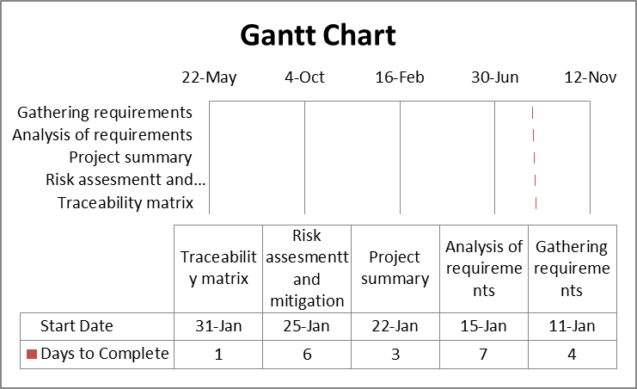

**[Gantt Chart]**

1. **REQUIREMENTS TRACEBILITY MATRIX:**

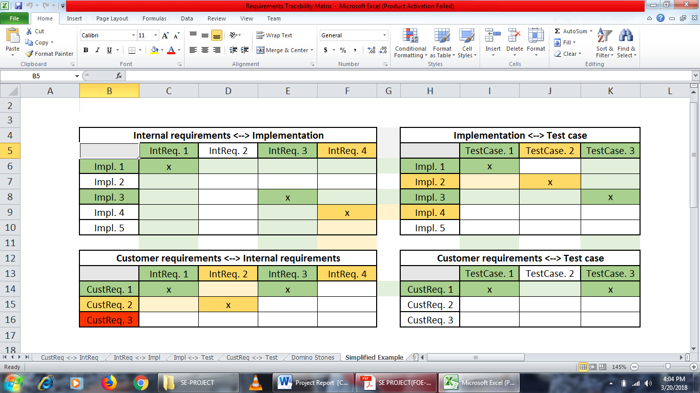

**[Sample Example RTS]**

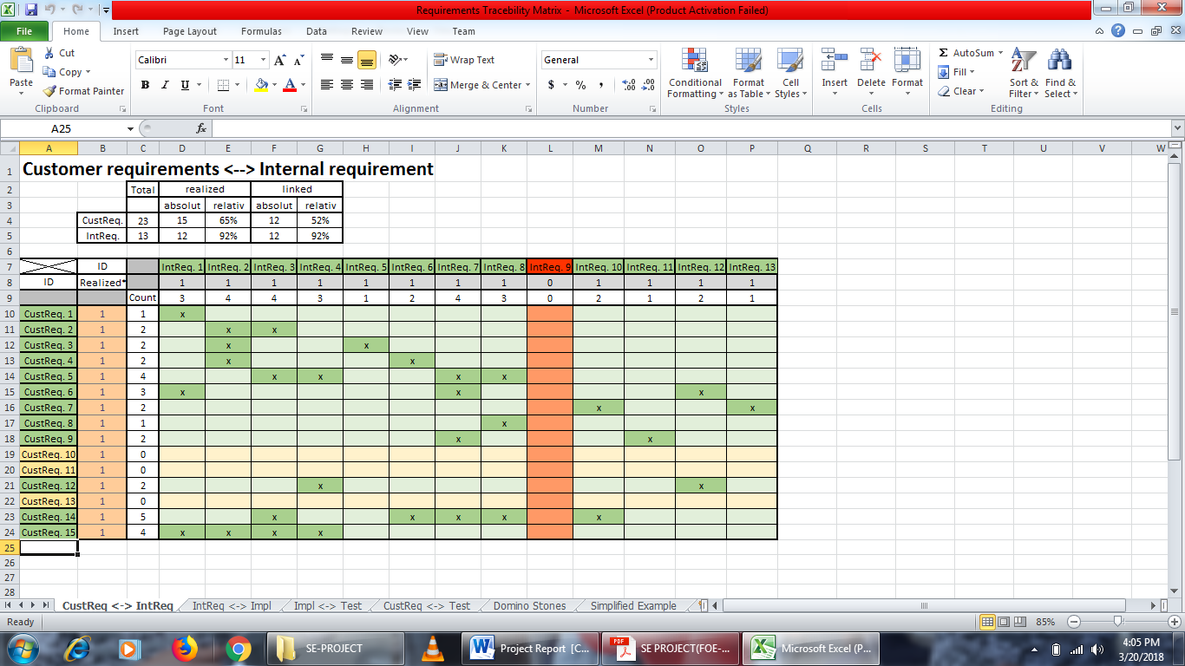

**[Customer** <-> **Internal Example RTS]**

1. **RMMM TABLE:**

|  |  |  |  |  |
| --- | --- | --- | --- | --- |
| **Risks** | **Category** | **Probability** | **Impact** | **RMMM** |
| Receipt is not generated. | TI | 20% | Marginal | We inform user by E-mail. |
| Tracking of request. | TI | 20% | Negligible | We allocate consumer id to user. |
| Monitoring of customer. | TI | 20% | Critical | We divide users by area. |
| Request not reaches to Electricity Board. | TI | 30% | Catastrophic | We inform user about resend the request. |
| Incase Server Down. | TI | 20% | Marginal | SMS message through complaint. |
| High electric bill. | TE | 40% | Catastrophic | Unplugging electronic devices when not in use. |
| Switches of light not working. | BI | 30% | Marginal | It can also be the fault of wiring or circuit or outlet. You can consult an electrician for this issue. |
| Frequent Burning out of light bulbs. | TE | 30% | Marginal | Fixed Volt bulb and light use. |
| Electric shocks. | TI | 40% | Catastrophic | An electric shock happens [in old homes](https://www.johnmooreservices.com/electrical-problems-in-old-homes/), just talk with your electrician to resolve the issues. |

**[RMMM TABLE]**

|  |  |  |  |  |  |  |
| --- | --- | --- | --- | --- | --- | --- |
|  |  |  | **INDEX** |  |  |  |
|  |  |  |  |  |  |  |
|  | **Sr. No.** |  | **Title** | **Pg.** |  |  |
|  |  | **No.** |  |  |
|  |  |  |  |  |  |
|  | **A** | Process Report | | 04-05 |  |  |
|  |  |  |  |  |  |  |
|  |  | **1.** | Introduction | 04 |  |  |
|  |  |  |  |  |  |  |
|  |  | **2.** | Purpose | 04 |  |  |
|  |  |  |  |  |  |  |
|  |  | **3.** | Targeted Audience | 05 |  |  |
|  |  |  |  |  |  |  |
|  |  | **4.** | Scope | 06 |  |  |
|  |  |  | |  |  |  |
|  | **B** | Gantt Chart | | 07 |  |  |
|  |  |  | |  |  |  |
|  | **C** | Requirements Tracebility Matrix | | 08 |  |  |
|  |  |  |  |  |  |  |
|  | **D** | RMMM Table | | 09 |  |  |
|  |  |  |  |  |  |  |

REFERENCES

* [www.pgvcl.com](http://www.pgvcl.com)
* [www.PowerDirect.com](http://www.PowerDirect.com)
* [www.complaintboard.in](http://www.complaintboard.in)
* [www.mgvcl.com](http://www.mgvcl.com)

Future Enhancement

* To make android application for comfort
* Make payment gateway
* Bulk message service
* Launch in market
* Solve the limitation