## Project Report On



***E-COMMERCE STORE (THE MARKETPLACE)***

**Submitted in partial fulfillment for the award of E-Diploma in Advance Computing PG-DAC Guided By,**

## Ms. Anu Mehra

**Presented By**

Makrand Gangurde- 220320520049

Vaibhav Gaykar- 220320520050

Mahesh Londal- 220320520074

Hrishikesh Borse- 220320520033

**Centre of Development of Advanced Computing (C-DAC), Noida**

## CDAC, NOIDA

### CERTIFICATE

This is to certify that Report entitled **“E-COMMERCE STORE”** which is submitted by **Makrand Gangurde, Vaibhav Gaykar, Hrishikesh Borse and Mahesh Londal** in partial fulfillment of the requirement for the award of PG Diploma in **Wireless Technologies and Application** to **CDAC, Noida** is a record of the candidates own work carried out by them under my supervision. The matter embodied in this report is original and has not been submitted for the award of any other degree.

#### Mr. Vinod Kumar Sharma Mrs. Anu Mehra

(Project Coordinator) (Project Guide)

**CDAC, Noida CDAC, Noida**

### ACKNOWLEDGEMENT

Setting an endeavor may not always be an easy task, obstacles are bound to come in its way and when this happens, help is welcome and without help of those people whom I am mentioning here, this endeavor would not have been successful. The completion of any project brings with it a sense of satisfaction, but it is never complete without thanking those people who made it possible and whose constant support has crowned our efforts with success.

One cannot even imagine the power of the force that guides us all and neither can we succeed without acknowledging it. Our deepest gratitude to Almighty God for holding our hands and guiding us throughout our lives.

We would like to thank our Project Mentor, **Mrs. Anu Mehra**, Project Engineer, CDAC, Noida who explained us how to perform better. She has told us the way to get the job done, not only by providing the exact way to do it but also the concept behind it. When we could not find the solution or was unable to adopt the better solution, she taught us how the work is to be done in an efficient and in the best possible way. She was the one who inspired us with his dynamic energy and his proficiency in technical aspect made us spellbound. She is the woman behind the success of our project.

We also thank all the staff members of ‘CDAC, Noida’ for their valuable suggestions. They always helped us with their smiling faces.

We are extremely happy to acknowledge and express our sincere gratitude to our parents for their constant support and encouragement and last but not the least, friends and well-wishers for their help and cooperation and solutions to problems during the course of the project.

**Makrand Gangurde Vaibhav Gaykar Hrishikesh Borse Mahesh Londal**

## ABSTRACT

The business to consumer aspect of electronic commerce (e-commerce) is the most visible business use of the World Wide Web. The primary goal of an e- commerce site is to sell goods and services online. This project deals with developing an e-commerce website for Online dairy products , clothing , etc. sale. The system is implemented using a backend database, a middle tier of Microsoft Internet Information Services (IIS)and a web browser as the front end client. In order to develop an e-commerce website, a number of Technologies must be studied and understood. These include multi-tiered architecture, server and client side scripting techniques such as programming language (such as java , java script , html, css, etc.), relational databases (such as MySQL).In this project, the main aim is to demonstrate that with better interaction features in dairy products , clothing and foot-wear web sites could improve sales over the net.

## Index

##### Introduction

1. **Project Overview**
   1. Purpose
   2. Objective
   3. Feasibility Study

##### Overall Description

* 1. Product Features
  2. Technology Used
  3. User Classes

##### Software Requirement 5 Sequence Details

1. **Non-Functional Requirements**
   1. Performance Requirement
   2. Security Requirement

##### 7 .Database Tables

1. **UML Diagram**

##### Activity Diagram

* 1. Admin Activity Diagram
  2. Sub-Admin Activity Diagram

##### Interfaces

1. **Future Scope 12.References 13.Conclusion**

# Introduction

Meeting of The project is implemented in React Js platform using MYSQL and Spring Boot database as back-end application. Main aim of this project is to develop an

online application through which users can easily buy products which they want.

The Internet has become an essential part of our daily life, and companies realize that the Internet can be a shopping channel to reach existing and potential consumers.

With popular trends and demands the concept of the Internet as the way forward to increase profit margins, companies new and old are creating websites here and there.

The significance for retailers to having a web site is that a web site is informational and transactional in nature. As the web site can be used for advertising and direct marketing; sales; customer support and public relations..

# Project Overview

#### Purpose:

There are a variety of purposes that a website can serve, but most of them can be traced back to one common goal: generating a profit. Some of them do this more subtly, choosing to highlight the quality of a craft or to showcase one’s expertise in a particular field. Others, namely the ecommerce site, act as a virtual store in which visitors become customers walking down the digital aisles of your business, filling up their carts with your products.

#### Objective: -

With Builderfly, let your eCommerce business move to the next level. Get to know how Builderfly will help you drive more traffic and leads to your eCommerce store!

It’s time that you know how important an eCommerce st ore will become when you are someone who loves to own a business. Shift to eCommerce with Builderfly and explore endless possibilities.

#### Feasibility Study:

Building an e-commerce site isn’t as difficult as it sounds, though you will need to work with a professional web development company to ensure that it offers secure, efficient e-commerce capabilities. You want your site to be trustworthy and capable of handling all size transactions

#### Website Security :

It’s crucial that your e-commerce site is safe from hackers because these sites handle sensitive information. Any website that asks for this type of information should have an [SSL certificate.](https://blog.hubspot.com/marketing/what-is-ssl) This certificate also avoids Google from flagging your site as “not secure.” Additionally, you should have a payment processing tool that offers extra security during the shopping cart and payment processes

#### Website Performance :

##### . If they’re not, we If your site is not enjoyable to shop on, you will lose customers. Your web pages should load in milliseconds, and if they’re not,

**your e-commerce vendor should be working on a solution for you. At Magna Technology, we monitor e-commerce websites 24-hours a day to ensure that all pages are operating**

#### Overall Description: -

* + 1. **Product Features**

The main feature of this system is the consumers can book conference Hall online via card payment. The system shows the details of that consumer and consumer can also update his profile. The consumer must be a registered before he/she uses this online conference Hall Booking. The consumer can see his bill report and payment history. Consumer can book meeting room online so it will save time for admin as well as consumer.

#### Technology Used

##### BACK END

Framework Spring Boot Database MySQL

Build Tool Maven

Language Java

##### FRONT END

Framework React HTML

CSS

JavaScript Bootstrap

#### User Classes

##### Admin

The super user, admin class represents complete authority over the system an admin can

1. Admin can add Amin, sub-Admin and Consumer.
2. View the number of sub-admin and consumers.
3. Admin can update his own profile.
4. Admin can update and delete the sub-admin and consumer.
5. The bill generated by admin to particular consumer by searching consumer Id
6. Admin can see bill report by particular consumer by searching consumer Id
7. Admin can see bill payment report by particular consumer by searching consumer Id

##### Consumer

1. This system consumer can easily register using Signup.
2. The consumer can easily see his profile and update profile.
3. Consumer can see current bill and pay via card payment and also print the bill.
4. Consumer can see bill history.
5. Consumer can see payment history.

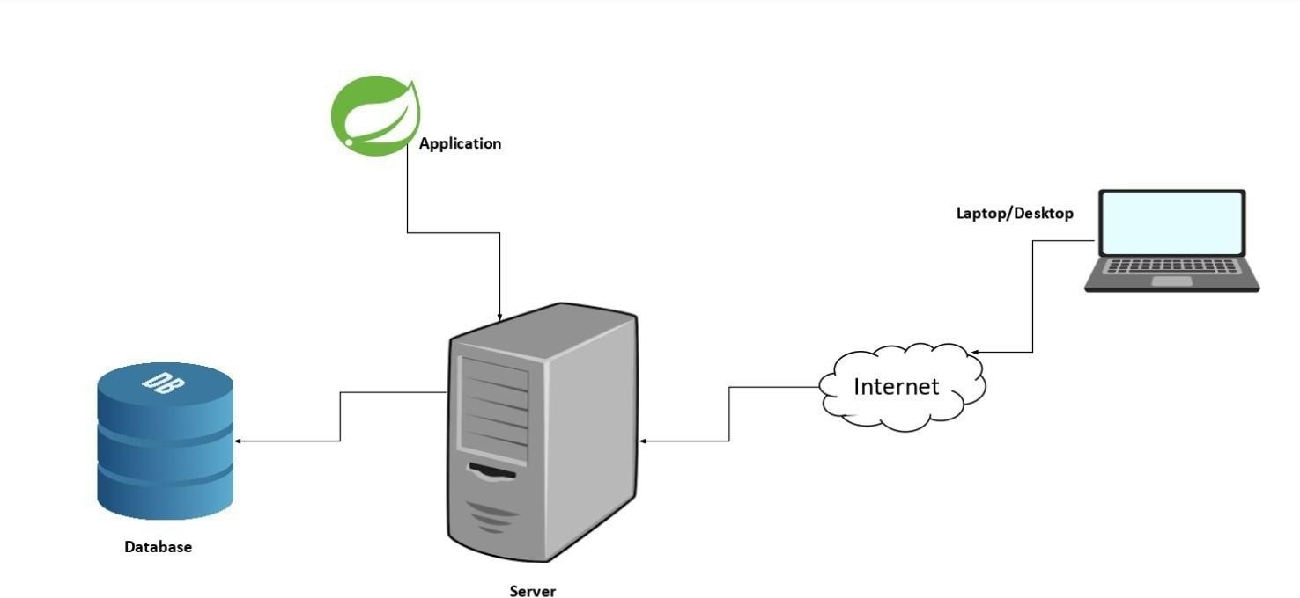

#### Architecture Diagram: -

Figure 1. Architecture Diagram

#### Software Requirements Specification

##### Use case diagram

There is entry interface that is intended to admin, sub-admin and consumer to login to the system by their own account. If the consumer is not registered, he/she can register using sign-up. User has to enter the login credentials i.e., Email-Id and Password information forLogin.

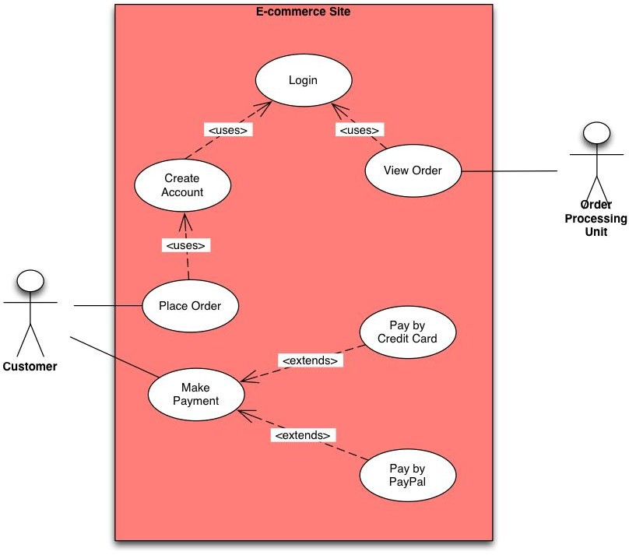

#### Sequence Details

* 1. **Admin**
     + **Profile**

Main Mainline Sequence:

1. **Admin:** Admin logs in.
2. **System:** Opens admin home page.
3. **Admin:** Clicks on profile.
4. **System:** Opens profile page.
5. **Admin**: Click Update Button.
6. **System**: Update form get open
7. **Admin:** Enter Update details and click on update button
   * + **Add User**

Main Mainline Sequence:

1. **Admin:** Admin logs in.
2. **System:** Opens admin home page.
3. **Admin:** Clicks on Add user.
4. **System:** Opens the register page.
5. **Admin**: Enter the user details and select role

[Admin, Sub-Admin and Consumer] Click on submit Button.

1. **System**: It display User register successfully.
   * + **View Consumer**

Main Mainline Sequence:

1. **Admin:** Admin logs in.
2. **System:** Opens admin home page.
3. **Admin:** Clicks on view consumer.
4. **System:** Available consumer list page get open.
5. **Admin**: Can update and delete consumer profile on click Update and delete button.
6. **System**: Update page open on click update button.
7. **Admin:** Enter update details and click on update.
8. **System**: Update Successfully massage display.

#### Non-Functional Requirements

##### Performance Requirement

1. The time between request and response should be less
2. Minimum time should be taken by the application to display the result.
3. In case of power failure, the data should be stored in the state that was last saved by the user

##### Security Requirement

* + - Only one active session per user
    - Passwords shall never be viewable at the point of entry or at any other time.
    - Duplicate bill will not be generated of same month and year

#### Database Tables

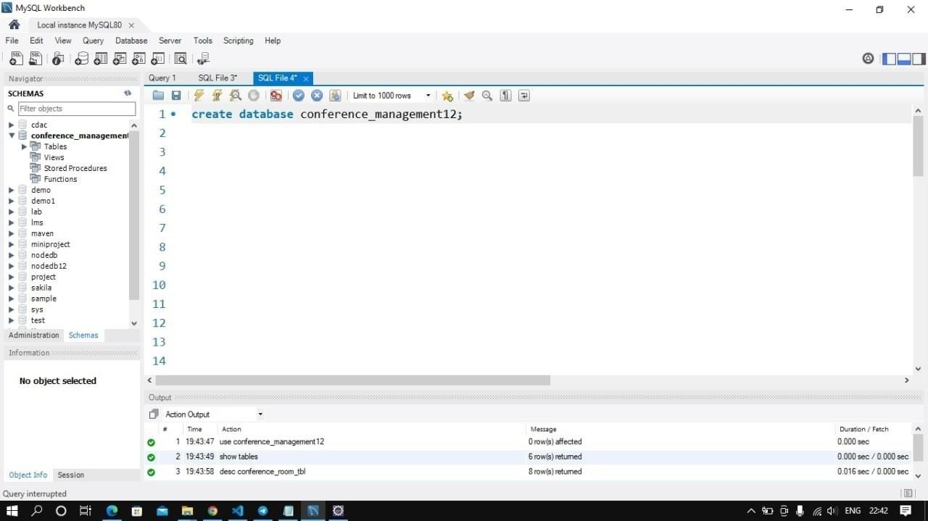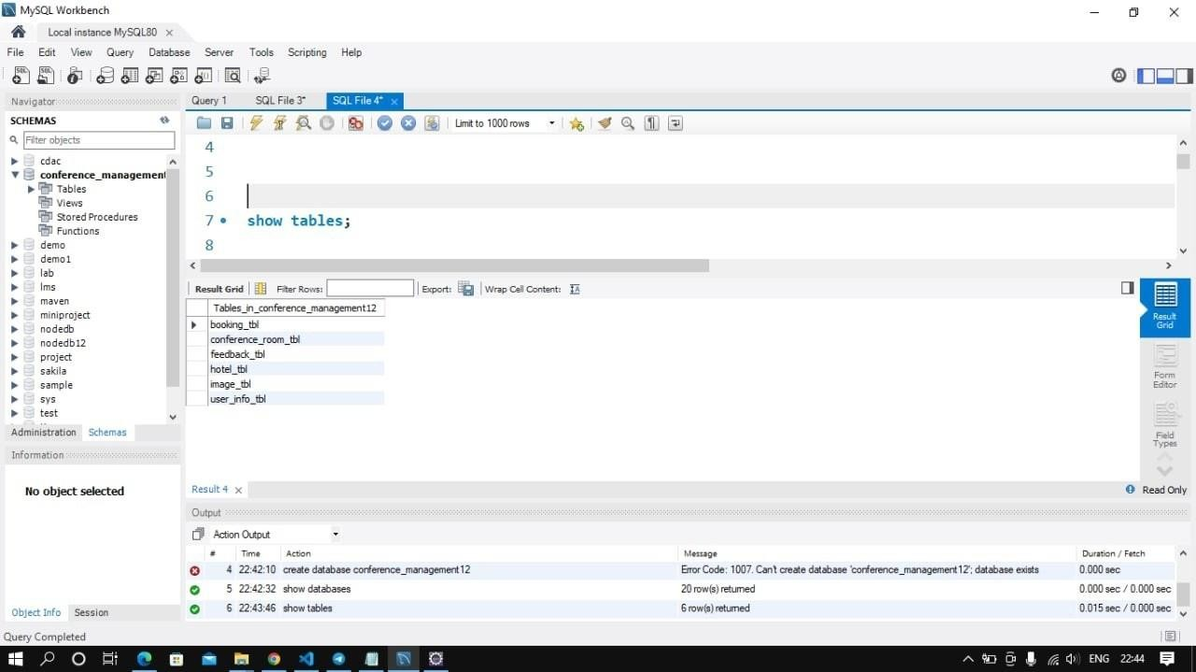

**Database Created**

Query = Create database conference_management12**;**

#### Tables in Database

Query =show tables;

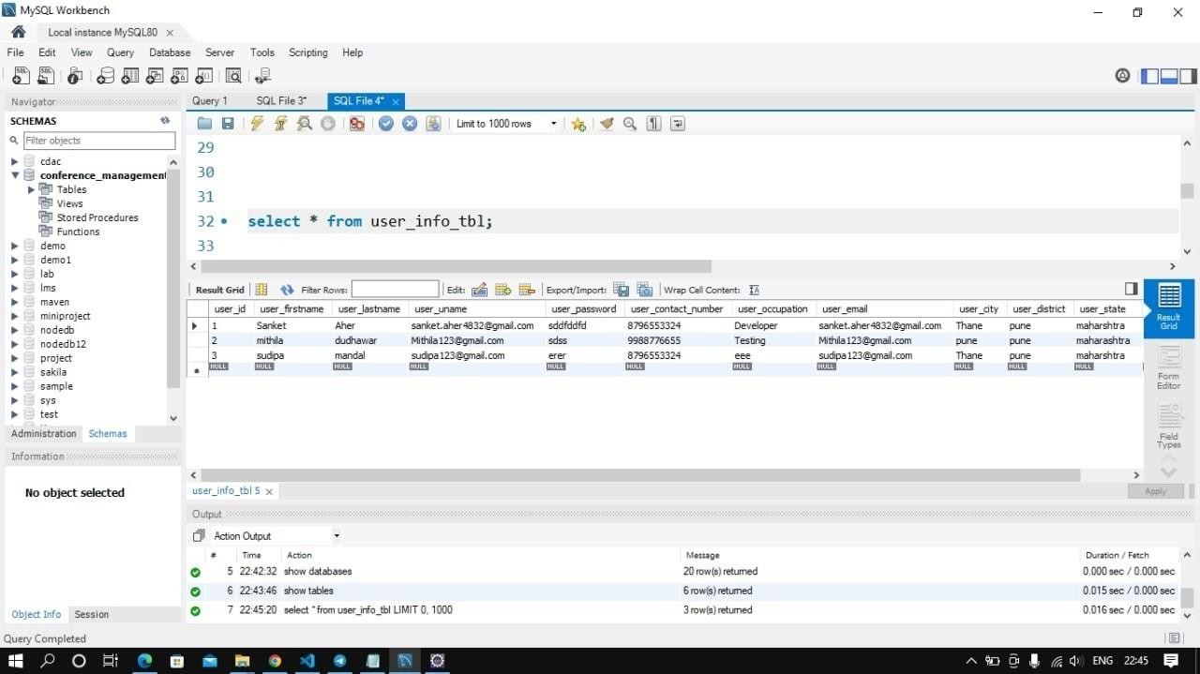

**User Table**

Query = select * from user_info_tbl;

### UML Diagram

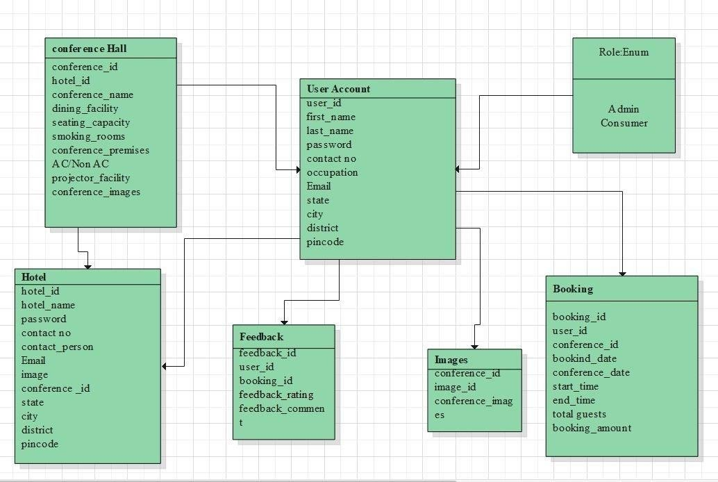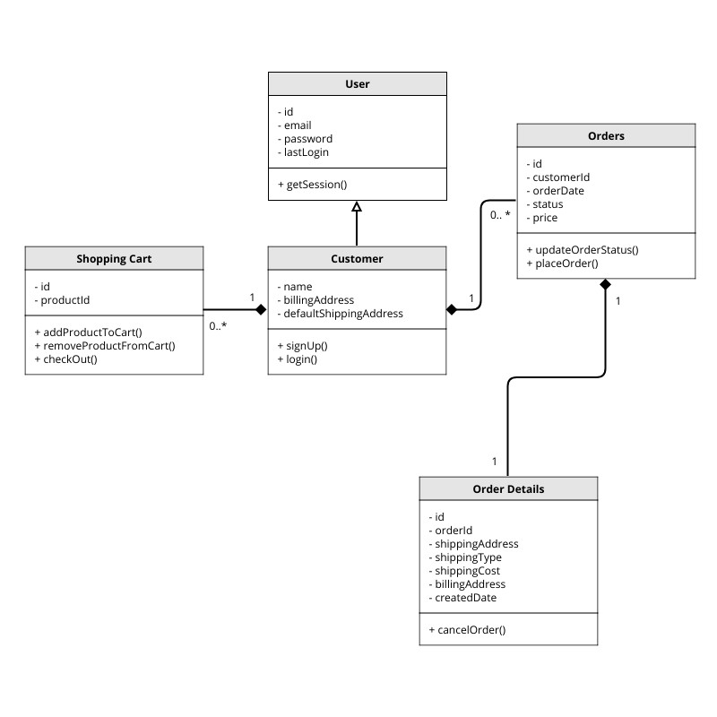

* + **Class Diagram**

### Activity Diagram

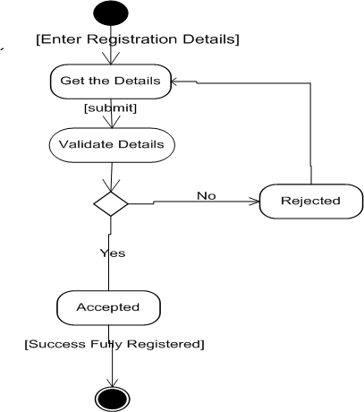**1. Admin Activity**

### iagram

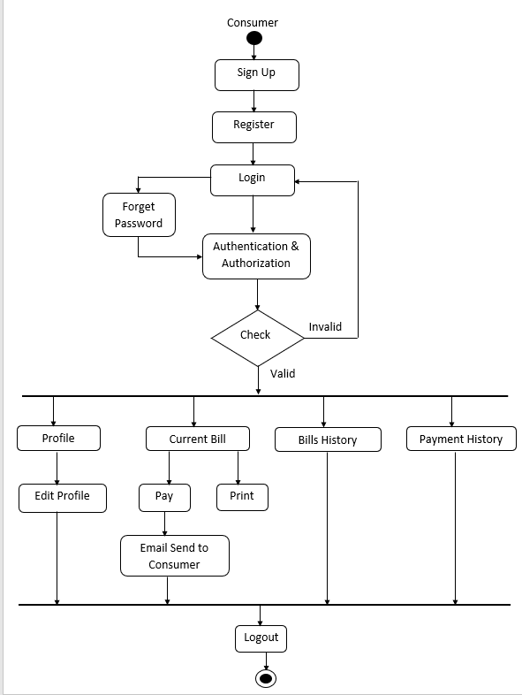

**1. User Activity Diagram**

### Interface

##### Welcome page

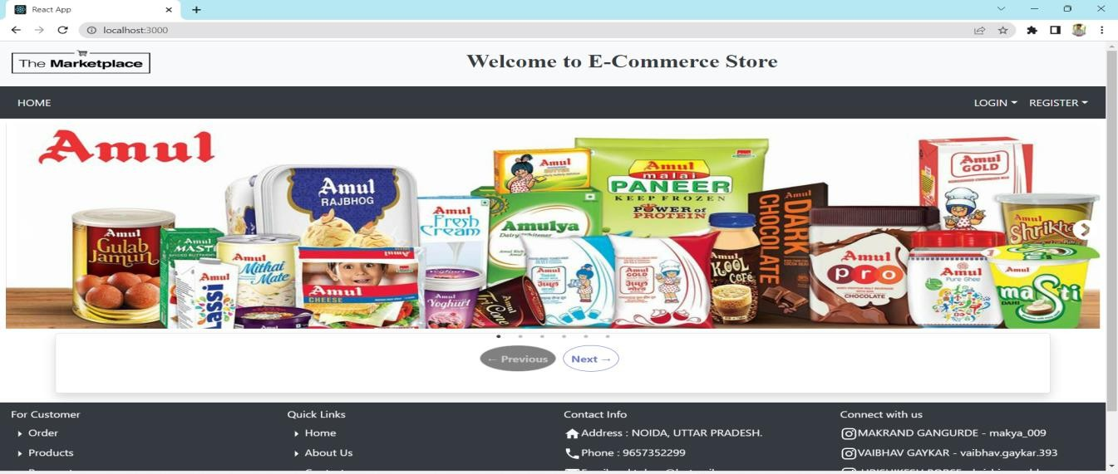

1. **Registration Page**

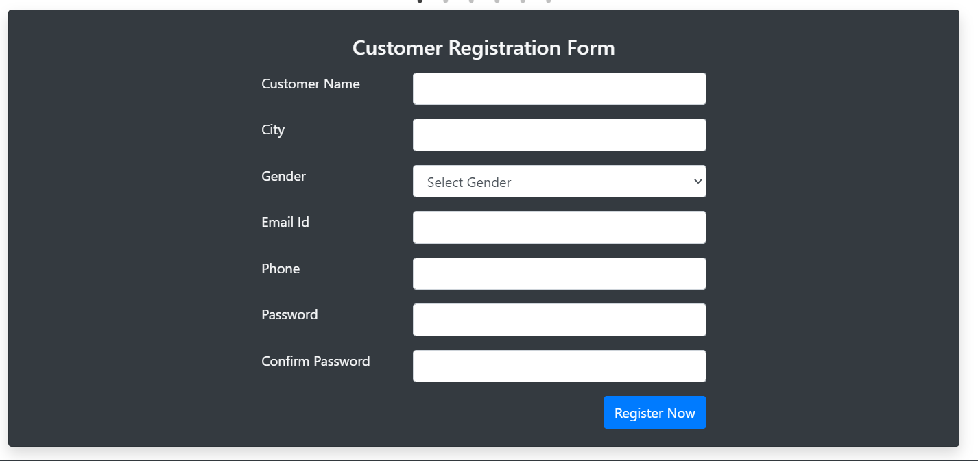

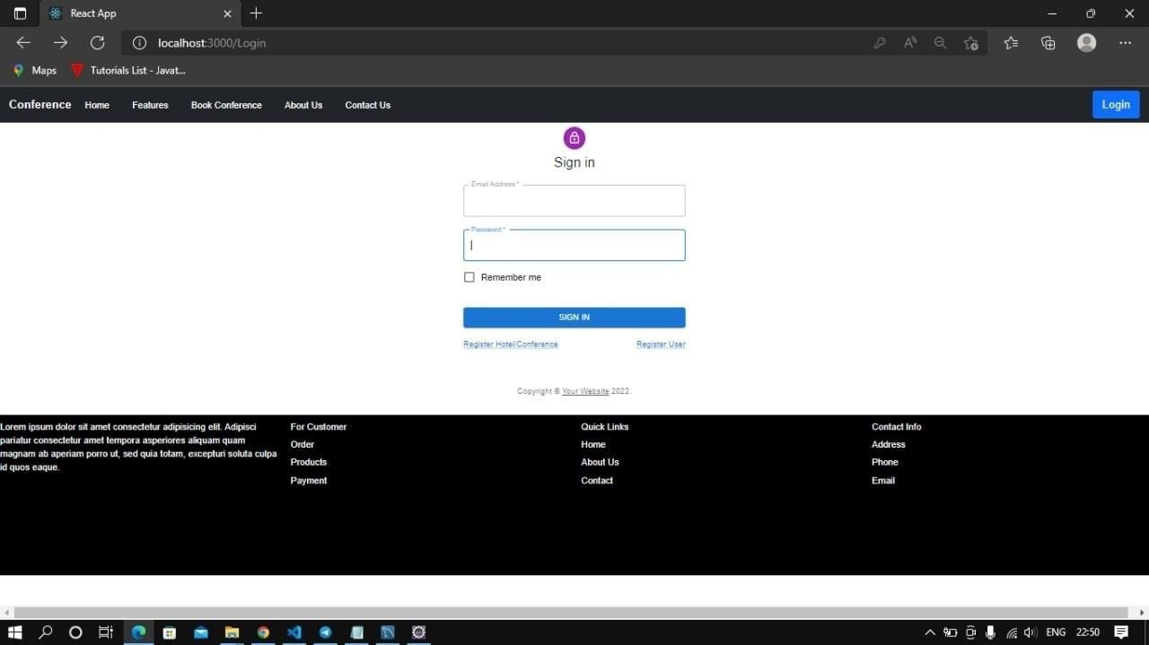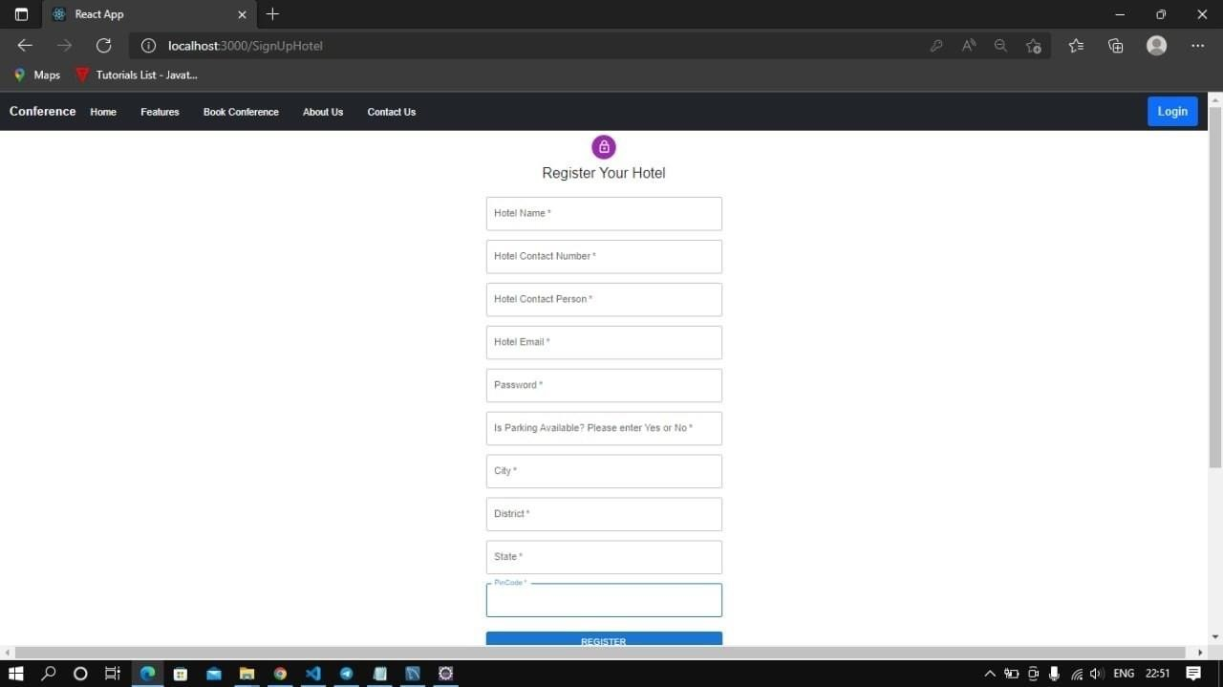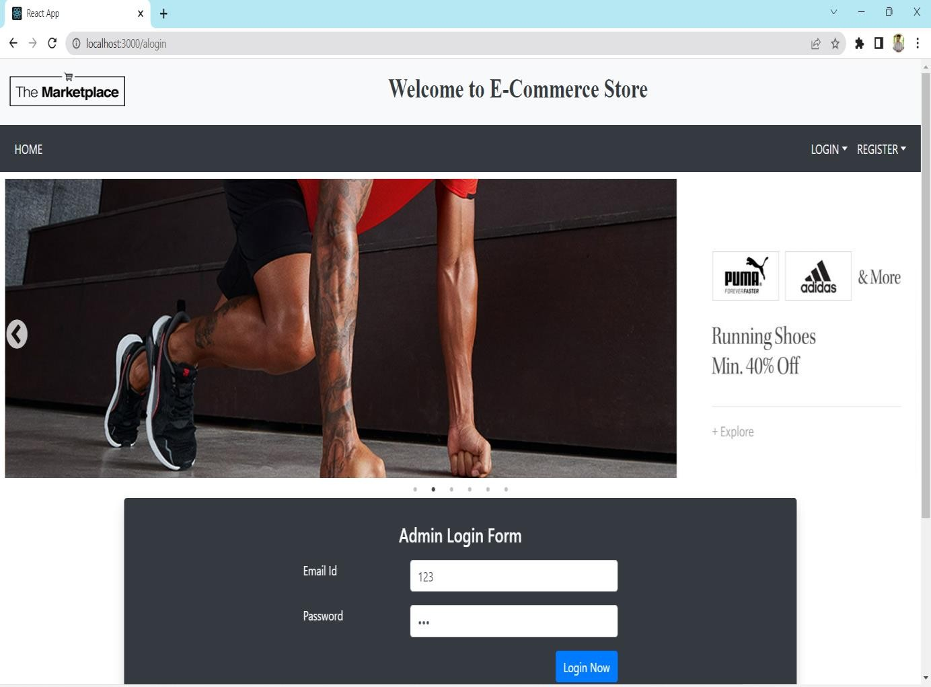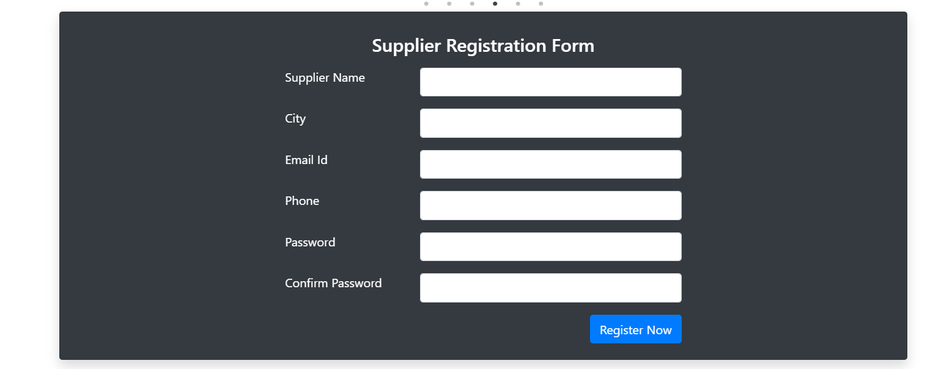

##### Login

* 1. **Registration ;**

1. **Future Scope**

In future, certain changes can be incorporated as per the requirements of the organizations implementing the system. Those are: - Live Chat with our xecutive whether they are available in particular Country.

1. **References and Bibliography**
2. [www.w3sch](http://www.w3school.com/)o[ol.com](http://www.w3school.com/)
3. https://docs.oracle.com/javase/8/docs/api/index.html?overview- summary.html
4. <https://youtu.be/ZmArHSRDPaA>
5. **Conclusion: -**

* Conclusion An eCommerce website can work for well for some businesses that operate an online storefront. A web portal is wonderful for some companies that operate exclusively with established clients and most likely in B2B capacities.