1. Explain the importance of Docker in modern software development, provide 2 examples (like why do use docker, no code is needed).

Docker plays a pivotal role in modern software development for several reasons. Firstly, it enables consistent and predictable deployment environments across different machines, which helps mitigate the "it works on my machine" problem. Developers can package their applications and all dependencies into Docker containers, ensuring that they run identically regardless of the underlying infrastructure.

Secondly, Docker facilitates scalability and efficiency by allowing applications to be easily scaled up or down based on demand. With Docker's containerization, it's straightforward to spin up multiple instances of an application or service to handle increased traffic or workload spikes, and then scale them back down when the demand decreases.

As for examples:

1. **Microservices Architecture**: In a microservices architecture, applications are divided into smaller, loosely coupled services that communicate with each other via APIs. Docker is instrumental in this setup as it allows each microservice to be containerized independently. This means that developers can develop, test, and deploy each microservice in isolation, without worrying about compatibility issues with other services. Docker containers make it easier to manage and orchestrate a large number of microservices, leading to greater agility and scalability.
2. **Continuous Integration/Continuous Deployment (CI/CD)**: Docker is an essential component of CI/CD pipelines, where code changes are automatically built, tested, and deployed. By containerizing the application and its dependencies, developers can ensure consistent environments throughout the CI/CD process, from development to testing to production. This consistency minimizes the risk of errors or discrepancies between different stages of the pipeline. Additionally, Docker's lightweight nature and fast startup times make it ideal for rapidly deploying new features or updates to production environments.
3. Explain how Docker containers are different from virtual machines, provide 2 examples (no need to a vm, just comare them).

Docker containers and virtual machines (VMs) serve similar purposes in isolating applications, but they differ significantly in their architectures and resource utilization.

1. **Resource Efficiency**:
   * Docker Containers: Containers share the host operating system's kernel and use lightweight isolation mechanisms, such as namespaces and cgroups, to partition resources. This results in minimal overhead and faster startup times. Since containers don't require a separate operating system for each instance, they consume significantly fewer resources compared to VMs.
   * Virtual Machines: VMs, on the other hand, emulate complete hardware, including a guest operating system, on top of a hypervisor. Each VM requires its own operating system instance, which can lead to higher resource utilization and slower boot times compared to containers.
2. **Isolation Level**:
   * Docker Containers: Containers provide process-level isolation, meaning each container runs as an isolated process on the host operating system. They share the host kernel but have their own filesystem, network, and process space. This level of isolation is sufficient for most applications and allows for high-density deployments.
   * Virtual Machines: VMs offer stronger isolation by providing full isolation at the hardware level. Each VM runs its own operating system instance, completely separate from the host and other VMs. This makes VMs ideal for scenarios where strong isolation is required, such as running different operating systems or hosting applications with diverse dependencies.

Examples:

1. **Web Server Deployment**:
   * Docker Containers: Suppose you have a web application consisting of multiple microservices, such as a front-end server and a backend API. You can use Docker containers to containerize each microservice independently. This allows you to deploy and scale each component separately, utilizing resources more efficiently.
   * Virtual Machines: If you were to use VMs for the same scenario, you would need to provision a separate VM for each microservice, each running its own operating system instance. This would lead to higher resource overhead and slower deployment times compared to Docker containers.
2. **Development Environment**:
   * Docker Containers: Developers often use Docker containers to create consistent development environments across different machines. They can package their application and its dependencies into a Docker container, ensuring that it runs the same way regardless of the host machine's configuration. This simplifies collaboration and reduces the "it works on my machine" issue.
   * Virtual Machines: While developers can also use VMs for development environments, the overhead of running a full virtualized operating system for each environment can be burdensome. VMs may be more suitable for scenarios where developers need to work with different operating systems or require stronger isolation between environments.
3. Find examples for use cases for docker-compose, and make the files tree for each use case (2 use cases, just expain the examples)
4. **Development Environment Setup:**

**Use Case:** Setting up a development environment with multiple interconnected services, such as a web application with a frontend, backend API, and database.

**Docker Compose File Tree:**

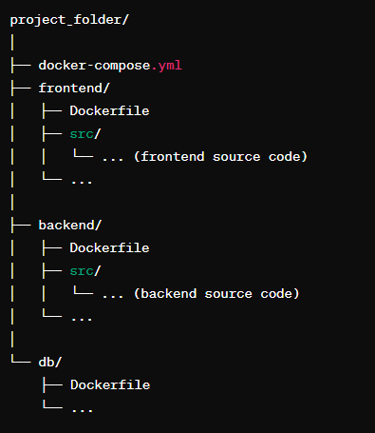

1. **Local Testing Environment for Microservices:**

**Use Case:** Creating a local testing environment for a microservices architecture, where each microservice is a separate component.

**Docker Compose File Tree:**

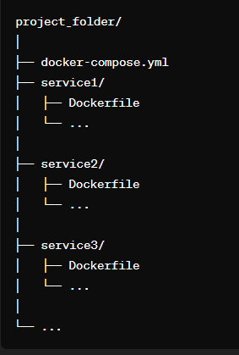

In both cases, the docker-compose.yml file defines the services, networks, and volumes required for the application. Each service may have its own Dockerfile defining its image and dependencies. The folder structure organizes the source code and Dockerfiles for each service/component.

These examples illustrate how Docker Compose can be used to define and manage multi-container Docker applications, making it easier to develop, test, and deploy complex systems with interconnected services.