Customer Churn Prediction & Retention Analytics
Project Report – Machine Learning (Classification) | Telecom / Subscription Services
Dataset: IBM Telco Customer Churn (7,043 customers, 21 attributes)
Tools: Python, NumPy, Pandas, Matplotlib, Seaborn, Scikit-learn
Companion files: Customer_Churn_Prediction.ipynb (full code and outputs), README.md, data/, outputs/

Executive Summary
About one in four customers (26.5%) in the dataset churned. We built and compared five classification models to predict churn and to explain why customers leave. The main findings are:
- Contract type and tenure dominate churn. Month-to-month customers churn at 43% versus 11% (one-year) and 3% (two-year). Customers in their first 12 months churn at 47%; month-to-month customers in year one churn at 51%.
- Fibre-optic customers are the biggest product-level problem. They pay the most yet churn at 42% (DSL: 19%). Fibre customers with neither OnlineSecurity nor TechSupport churn at 55%.
- Payment and support habits matter. Electronic-check payers churn at 45% versus 15–17% for automatic payers; customers with OnlineSecurity or TechSupport churn at ~15% versus ~42% without.
- Final model: tuned Logistic Regression with a recall-oriented decision threshold (0.32). On unseen test data it catches 92.5% of churners (recall) with ROC-AUC 0.84 and precision 44%. Train and test performance are nearly identical (no overfitting).
- The model concentrates retention effort. The 40% of customers it rates High or Critical risk contain 79% of all churners and account for 82% of monthly revenue lost to churn.
Important caveats: model quality is limited by the data (no usage, complaint or competitor information), the feature engineering gave no measurable accuracy gain, the model scores over-state absolute probabilities and should be used to rank customers, and the business-value figures rely on stated assumptions.

1. Problem Statement and Objectives
Churn erodes recurring revenue, and replacing a lost customer costs more than retaining one. The project objectives are to (1) predict whether a customer will churn, (2) identify the patterns and factors associated with churn, and (3) convert the findings into practical retention recommendations. Following the assignment brief, the work covers the full workflow: data understanding, statistics, EDA, preprocessing, feature engineering, modelling, evaluation, insights and recommendations.

2. Data Understanding
The dataset has 7,043 rows and 21 columns: 3 numerical variables (tenure, MonthlyCharges, TotalCharges), 1 binary flag stored as 0/1 (SeniorCitizen), 16 categorical variables, the customer ID, and the target Churn. Variables cover demographics, subscribed services, contract and billing details.

Data-quality findings
- No duplicates: there are no duplicate rows or customer IDs, and no NaN values in the raw file.
- Hidden missing values: TotalCharges is stored as text because 11 rows hold a blank string. All 11 customers have tenure = 0 (not yet billed), so the correct value is 0 rather than a statistical imputation.
- Inconsistent labels: add-on columns contain "No internet service" / "No phone service", which are logically the same as "No"; SeniorCitizen uses 0/1 while all other binary columns use Yes/No.
- Class imbalance: 5,174 retained (73.5%) versus 1,869 churned (26.5%).

3. Statistical Analysis
Statistic | tenure (months) | MonthlyCharges ($) | TotalCharges ($)
Mean | 32.37 | 64.76 | 2,279.73
Median | 29 | 70.35 | 1,394.55
Mode | 1 | 20.05 | 0
Min / Max | 0 / 72 | 18.25 / 118.75 | 0 / 8,684.80
Std. deviation | 24.56 | 30.09 | 2,266.79
Variance | 603.17 | 905.41 | 5,138,357
Q1 / Q3 | 9 / 55 | 35.50 / 89.85 | 398.55 / 3,786.60
IQR | 46 | 54.35 | 3,388.05
Skewness | 0.24 | −0.22 | 0.96

What the numbers mean for the business. Tenure is spread across the full range with a large group of brand-new customers (1,371 customers have tenure under 6 months) and another large group of loyal customers (1,483 with 60+ months): the base is a mix of high early-life volume and a loyal core. MonthlyCharges is wide ($18 to $119) and the median ($70) is above the mean ($65), reflecting a cluster of low-bill phone-only customers and a larger group on higher-priced internet bundles. TotalCharges is right-skewed (mean $2,280 versus median $1,395): a minority of long-tenure customers generate a disproportionate share of lifetime revenue, so losing them is costly. The 1.5×IQR rule flags no outliers in any column; the extremes are genuine customers, so no rows were removed.
Churn status | Mean tenure | Median tenure | Mean monthly charge | Median monthly charge
Retained | 37.6 | 38 | $61.27 | $64.43
Churned | 18.0 | 10 | $74.44 | $79.65

Churners are clearly different: they leave early (median 10 months versus 38) and pay more per month (about $15 more).

4. Exploratory Data Analysis
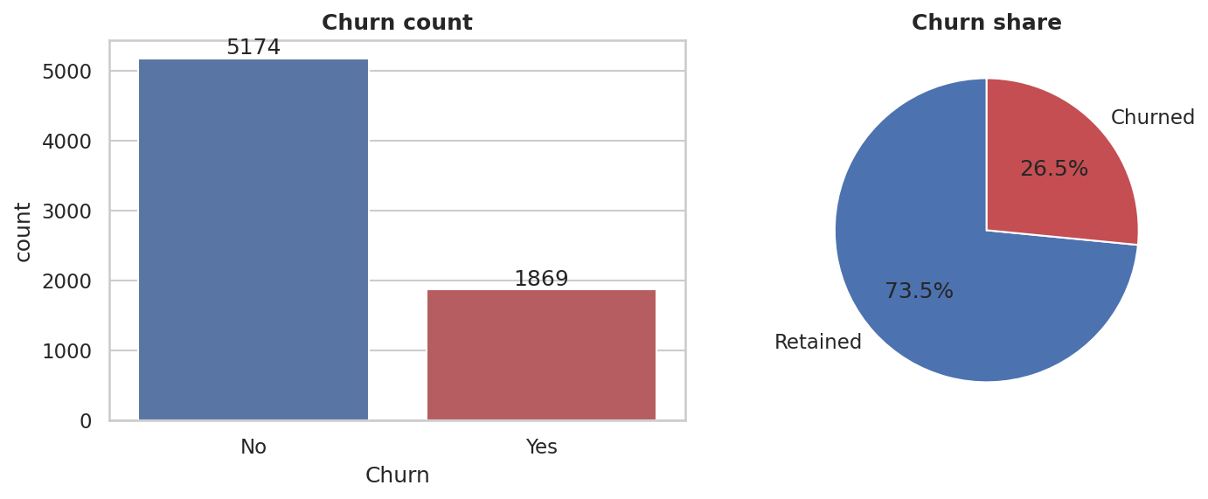
Figure 1 – Churn distribution (26.5% churned)
The imbalance means plain accuracy is misleading: a rule that predicts "nobody churns" would be 73.5% accurate while catching no churners. This shaped the choice of evaluation metrics.
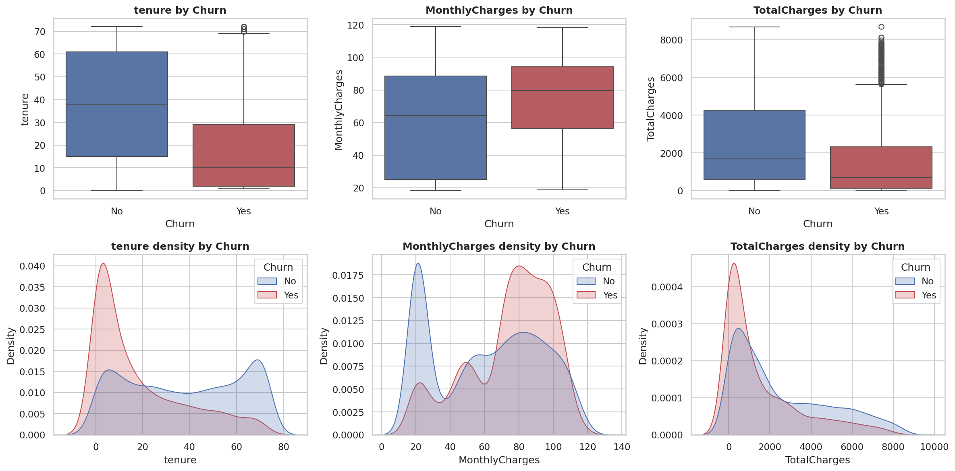
Figure 2 – Numerical variables versus churn
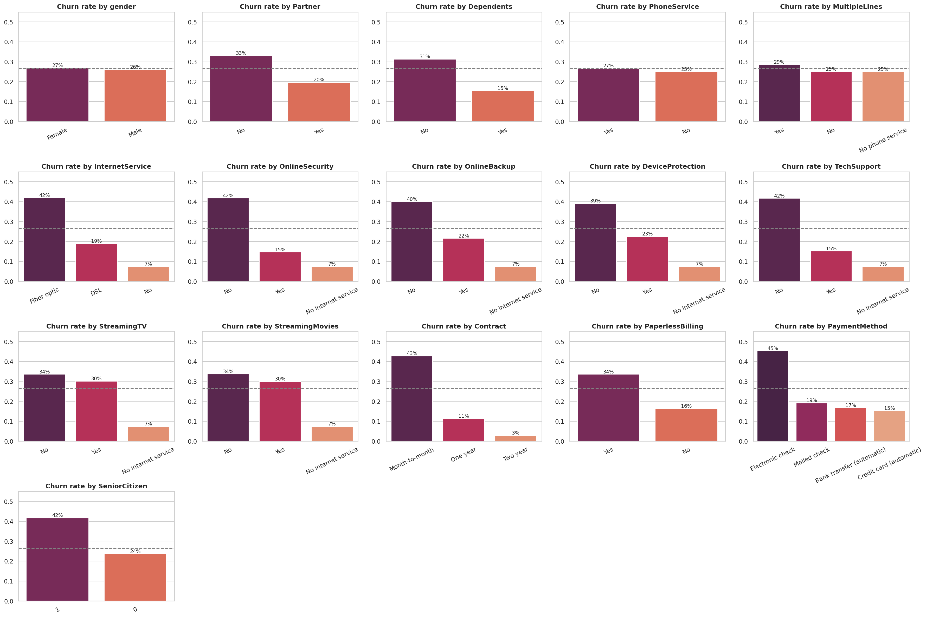
Figure 3 – Churn rate by categorical variable (dashed line = overall 26.5%)

Key patterns
Segment | Churn rate | Comment
Month-to-month contract | 42.7% | vs 11.3% one-year, 2.8% two-year
Fibre-optic internet | 41.9% | vs 19.0% DSL, 7.4% no internet
Electronic-check payment | 45.3% | vs 15–19% for all other methods
No OnlineSecurity / no TechSupport | 41.8% / 41.6% | vs 14.6% / 15.2% with the service
Senior citizens | 41.7% | vs 23.6% non-seniors
No partner / no dependents | 33.0% / 31.3% | vs 19.7% / 15.5%
Paperless billing | 33.6% | vs 16.3% paper billing
Gender, PhoneService | ≈ 26–27% | no meaningful relationship

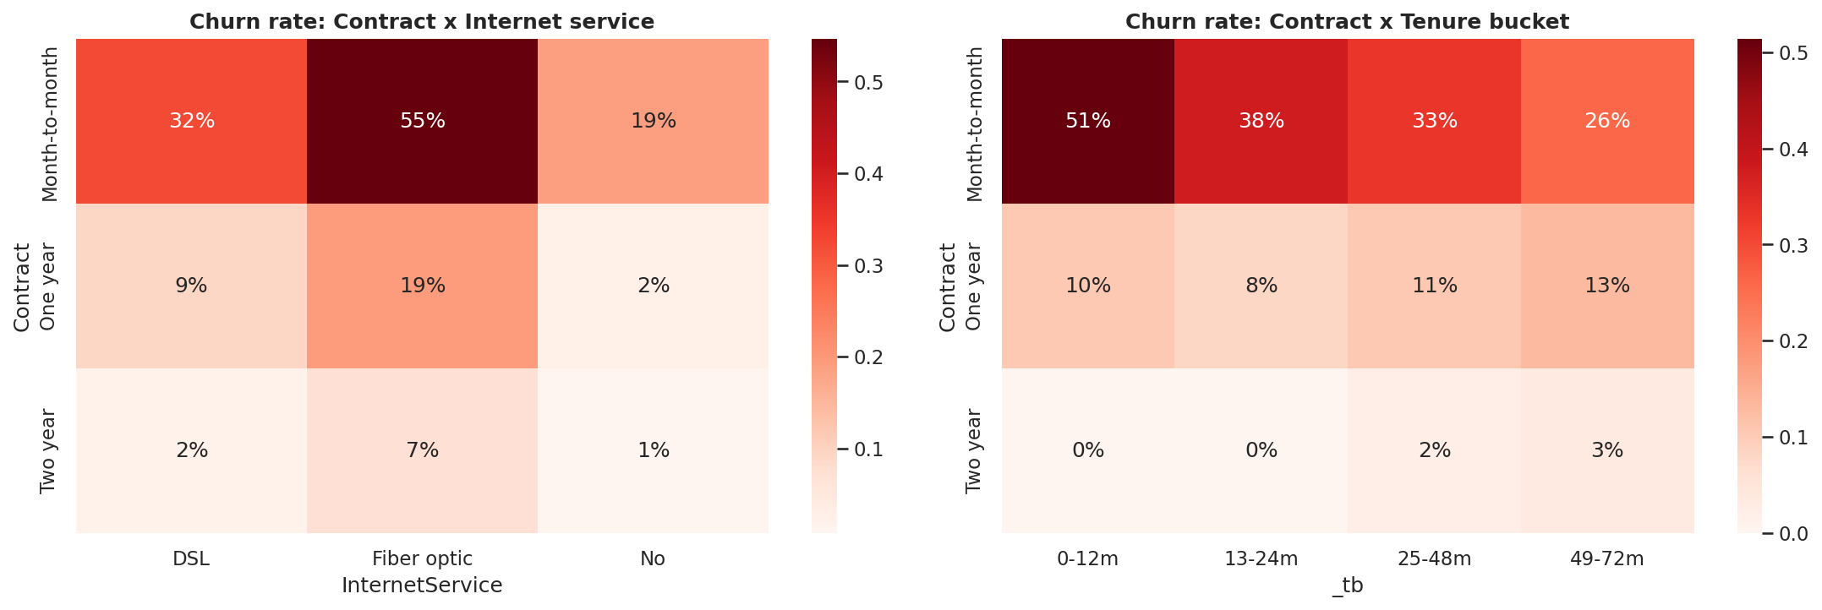
Figure 4 – Churn rate by contract × internet service and contract × tenure bucket
Multivariate findings. Tenure has the strongest correlation with churn (−0.35) and is highly correlated with TotalCharges (≈ 0.83), so TotalCharges adds little independent information and creates multicollinearity for linear models. The riskiest combination is month-to-month + fibre optic (54.6% churn) and especially in the first year; fibre customers on a two-year contract churn at only 7.2%. This suggests that the contract commitment, rather than the fibre product itself, is what protects the relationship.

5. Data Preprocessing
- Blank TotalCharges (11 rows, all tenure = 0) set to 0 and the column converted to numeric.
- "No internet service" / "No phone service" merged into "No"; SeniorCitizen recoded to Yes/No; customerID dropped.
- Outliers: none detected by the IQR rule, so all rows retained.
- Stratified 80/20 train-test split (5,634 / 1,409 customers, churn rate 26.5% in both), fixed random seed 42.
- One-hot encoding for categorical variables and standard scaling for numerical variables, both inside a scikit-learn Pipeline so that the test set never influences fitting (no data leakage).

6. Feature Engineering
Feature | Definition | Rationale
tenure_group | 0–12 / 13–24 / 25–48 / 49–72 months | Churn risk is non-linear in tenure
num_addons | Count of add-on services | Measures how embedded the customer is
num_protect_services | Security + backup + device protection + tech support | Protection services linked to low churn
no_support_bundle | Has internet but no OnlineSecurity and no TechSupport | Flags the unsupported-user segment
auto_pay | Pays by bank transfer or credit card | Low payment friction
is_month_to_month | Contract = month-to-month | Dominant risk flag, made explicit
avg_monthly_spend | TotalCharges ÷ tenure | Historical average bill
charge_change | MonthlyCharges − avg_monthly_spend | Proxy for a recent price rise
fiber_month_to_month | Fibre optic AND month-to-month | Highest-risk interaction from EDA

Did it help? Not measurably. An ablation compared each model on base versus engineered features using 5-fold cross-validation on the training data. The change in CV F1 ranged from −0.027 to +0.004 and the change in ROC-AUC from −0.018 to +0.005, which is within fold-to-fold noise (CV std ≈ 0.02). Only Random Forest improved slightly (F1 +0.004, AUC +0.005). The engineered columns are largely re-expressions of information already present in the raw columns. They were kept because they do no harm to the final model and make the findings easier to communicate (for example, no_support_bundle). The conclusion is that for this dataset the raw features already carry most of the available signal.

7. Model Development
Five algorithms from the training were compared: Logistic Regression, Decision Tree, Random Forest, AdaBoost and KNN. Class imbalance was handled with class_weight="balanced" where supported (Logistic Regression, Decision Tree, Random Forest). Each model was first fitted with default or baseline settings, then tuned with 5-fold GridSearchCV optimising F1 on the training set only.

7.1 Baseline models (default threshold 0.5)
Model | Train F1 | Test F1 | Test Prec. | Test Recall | Test Acc. | Test AUC
Logistic Regression | 0.631 | 0.615 | 0.503 | 0.789 | 0.737 | 0.842
Decision Tree (unpruned) | 0.996 | 0.518 | 0.505 | 0.532 | 0.737 | 0.672
Random Forest (300 trees) | 0.996 | 0.551 | 0.631 | 0.489 | 0.789 | 0.825
AdaBoost (200 est.) | 0.603 | 0.572 | 0.633 | 0.521 | 0.793 | 0.841
KNN (k = 11) | 0.630 | 0.551 | 0.601 | 0.508 | 0.780 | 0.807

The unpruned Decision Tree and the Random Forest memorise the training set (train F1 ≈ 0.996 versus test 0.52–0.55): a textbook case of overfitting. AdaBoost and KNN, which have no class weighting, achieve the highest accuracy (about 0.79) but detect only about half of the churners.
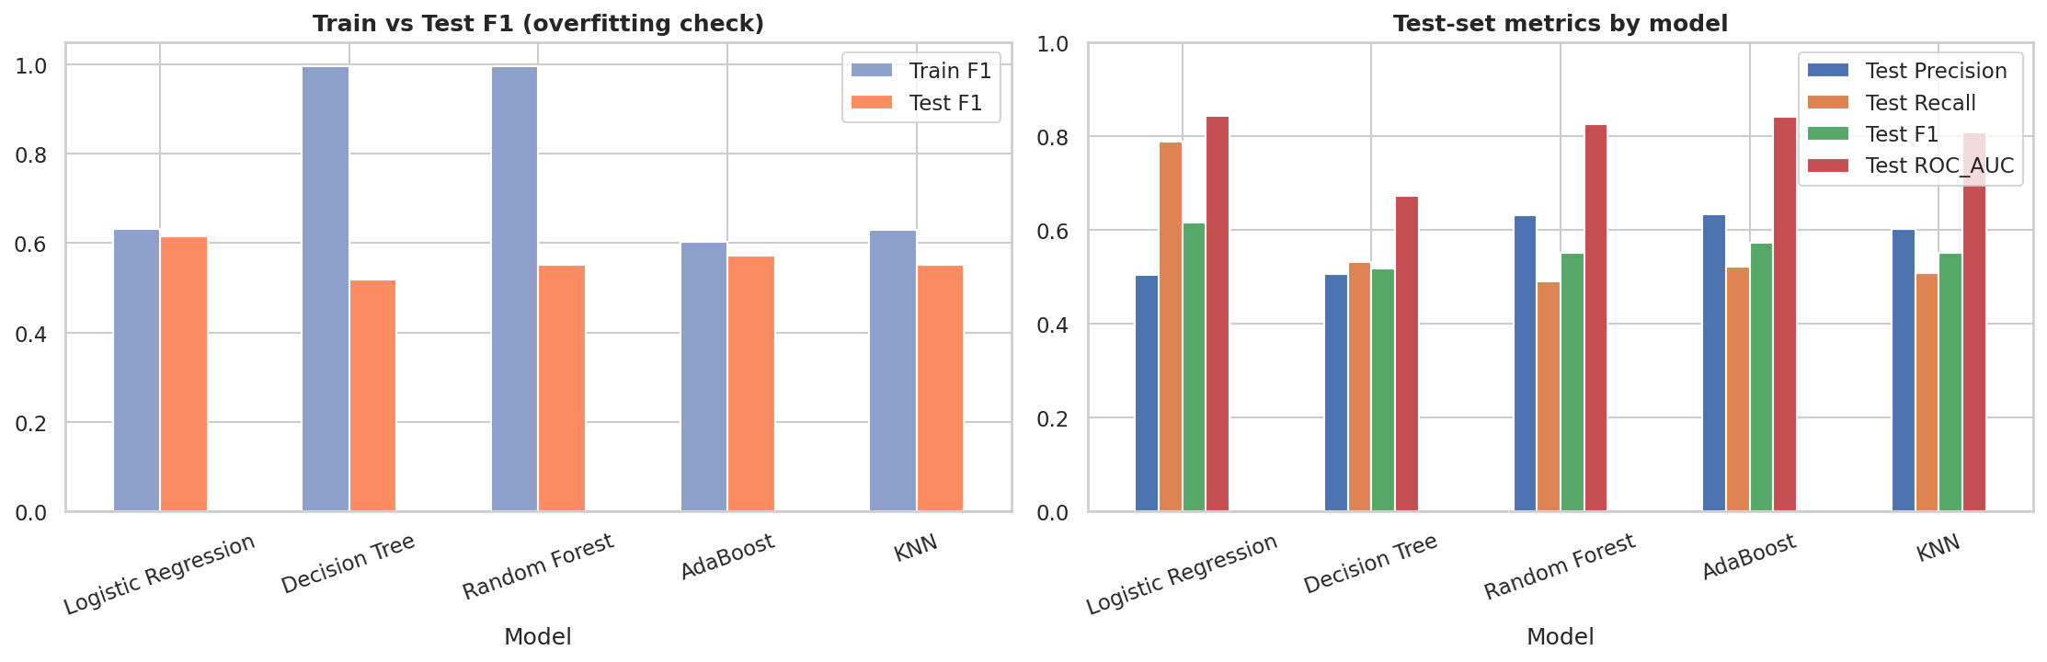
Figure 5 – Baseline models: train versus test F1 (left) and test metrics (right)

7.2 Tuned models
Model | Best parameters | CV F1 | Train F1 | Test F1 | Test Recall | Test AUC
Logistic Regression | C = 0.03 | 0.628 | 0.631 | 0.622 | 0.786 | 0.840
Decision Tree | depth 3, leaf 10 | 0.613 | 0.621 | 0.621 | 0.783 | 0.814
Random Forest | depth 12, leaf 5 | 0.637 | 0.764 | 0.633 | 0.733 | 0.844
AdaBoost | lr 0.5, 100 est. | 0.586 | 0.582 | 0.548 | 0.484 | 0.836
KNN | k = 61, uniform | 0.596 | 0.613 | 0.588 | 0.570 | 0.832

Tuning removes the overfitting of the tree (depth 3 gives identical train and test F1) and narrows the gap for Random Forest (0.13 remaining). All models fall in a narrow band of test ROC-AUC (0.81–0.84), which again suggests that the dataset, not the algorithm, is the limiting factor.

7.3 Strengths and weaknesses
Model | Strengths | Weaknesses here
Logistic Regression | Fast, explainable coefficients, stable | Linear assumptions; coefficients shared between correlated features
Decision Tree | Readable rules | Unpruned tree memorises data; unstable
Random Forest | Captures interactions; strong AUC | Remaining overfit; harder to explain
AdaBoost | Good ranking (AUC 0.84 baseline) | No class weighting → misses half of churners at 0.5
KNN | Simple, no training step | Slow at prediction; weak in one-hot space; no explanation

8. Model Evaluation and Selection

8.1 Why these metrics?
For churn, the two error types have different costs. A false negative (a churner we miss) loses recurring revenue; a false positive (a loyal customer we contact) only costs a retention offer. Recall is therefore the most important metric, balanced by precision so that offers are not wasted; F1 combines the two and ROC-AUC measures ranking quality independent of any threshold. Accuracy is reported but not used for selection, because the majority class makes it uninformative: the highest-accuracy model (AdaBoost, 0.79) identifies fewer than half of the churners.

8.2 Choosing the final model
Random Forest has the best tuned test F1 (0.633) and AUC (0.844), but its train-test F1 gap is 0.13, it is harder to explain and the margin over Logistic Regression is small (F1 +0.011, AUC +0.004, within noise). Logistic Regression was selected because it:
- generalises best (train F1 0.631 versus test 0.622, AUC within 0.004 of the best model);
- has the highest recall at the default threshold among well-generalising models (0.79);
- is fully explainable, which matters for gaining the trust of marketing and retention teams.
Transparency note: the tuned-model comparison table was also printed on the test set, so the test set was seen once when comparing models. The selection argument rests on cross-validation and train-test stability rather than on the test scores.

8.3 Decision threshold
The default 0.5 threshold is arbitrary. Using out-of-fold predictions on the training set only (no test leakage), the threshold was chosen to maximise F-beta with β = 2, so that recall counts twice as much as precision. This gave a threshold of 0.32.
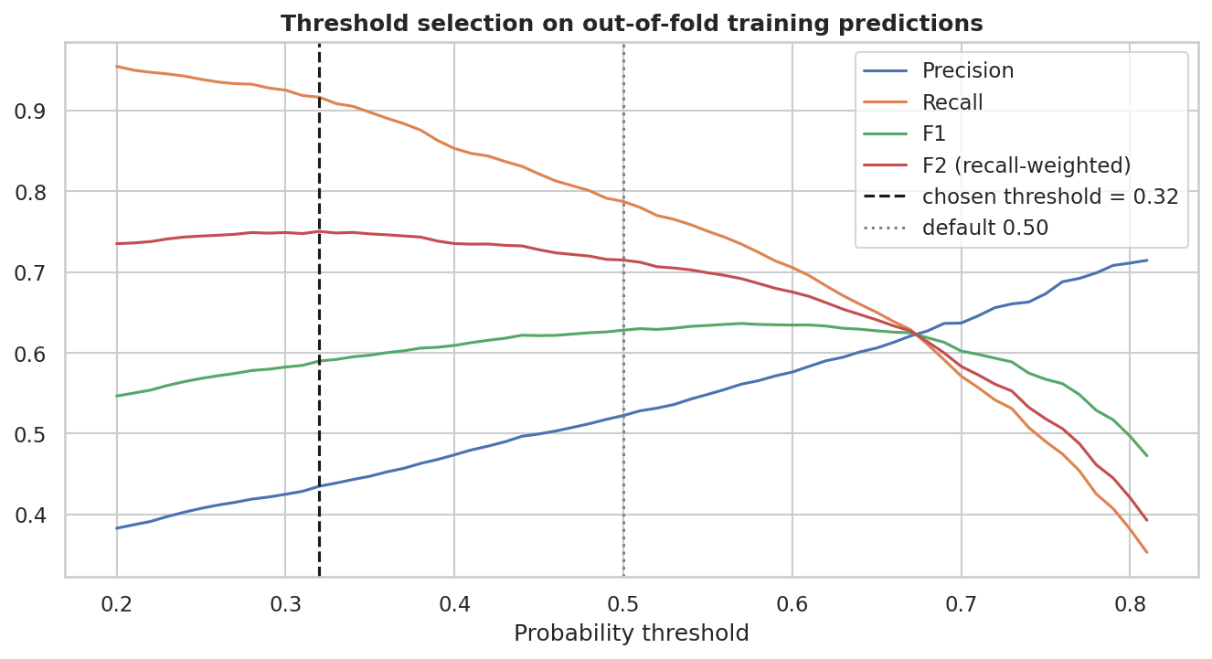
Figure 6 – Threshold selection on out-of-fold training predictions

8.4 Final results on the unseen test set (1,409 customers)
Setting | Accuracy | Precision | Recall | F1 | ROC-AUC
Threshold 0.50 | 0.746 | 0.514 | 0.786 | 0.622 | 0.840
Threshold 0.32 (final) | 0.666 | 0.439 | 0.925 | 0.595 | 0.840

Confusion matrix at the final threshold: 346 churners correctly flagged (true positives), 28 churners missed (false negatives), 443 loyal customers flagged unnecessarily (false positives) and 592 loyal customers correctly left alone (true negatives). The model finds 92.5% of churners; the price is that 56% of the customers it flags would not have left. Lowering the threshold trades precision for recall, and the right setting depends on the real cost of an offer and the retention budget.
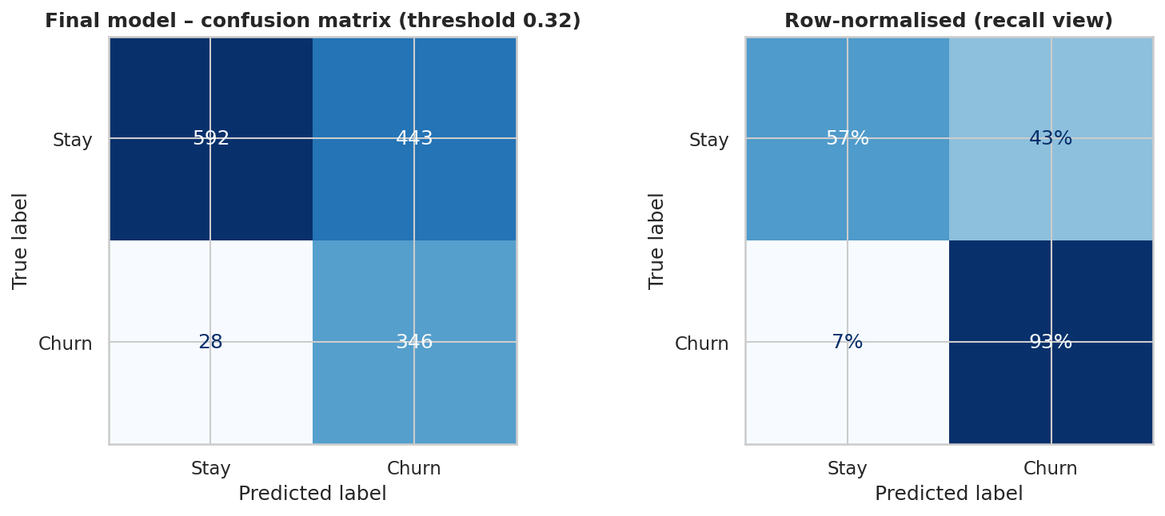
Figure 7 – Final model confusion matrix (counts and recall view)

9. Validating the Results – Why Trust This Model?
Question: "If you were working as a Data Scientist in this company, why would you trust this model?"
Check | Result
Overfitting / underfitting | Train vs test (final model): F1 0.591 vs 0.595, recall 0.917 vs 0.925, AUC 0.849 vs 0.840. No sign of overfitting. Performance is well above the naive baseline, so it is not underfitting either.
Stability across folds | 5-fold CV: ROC-AUC 0.826–0.860 (std 0.013); recall 0.896–0.930 (std 0.013); F1 0.581–0.602 (std 0.009).
Uncertainty on test set | 95% bootstrap intervals: ROC-AUC 0.820–0.861; recall 0.897–0.950; F1 0.562–0.627.
No data leakage | Preprocessing inside pipelines; tuning and the threshold chosen with training data only.
Explainability | Drivers found by the model (contract, tenure, internet service, support add-ons) match the EDA and an independent Random Forest importance ranking.
Practical value | In a cost-benefit simulation the model-targeted campaign earns about $51,100 versus $15,300 for contacting the same number of customers at random, and $27,500 for contacting everyone (assumptions in Section 10.3).
Ranking quality | Actual churn rises steadily across risk tiers, from 4% (Low) to 68% (Critical).

Calibration limitation. Because class weighting inflates the minority class, the model over-states absolute probabilities (mean score 0.42 versus 26.5% actual churn). The output is therefore reported as a churn risk score used to rank customers, not as a literal probability. If true probabilities are needed, a calibration step (for example CalibratedClassifierCV) should be added.
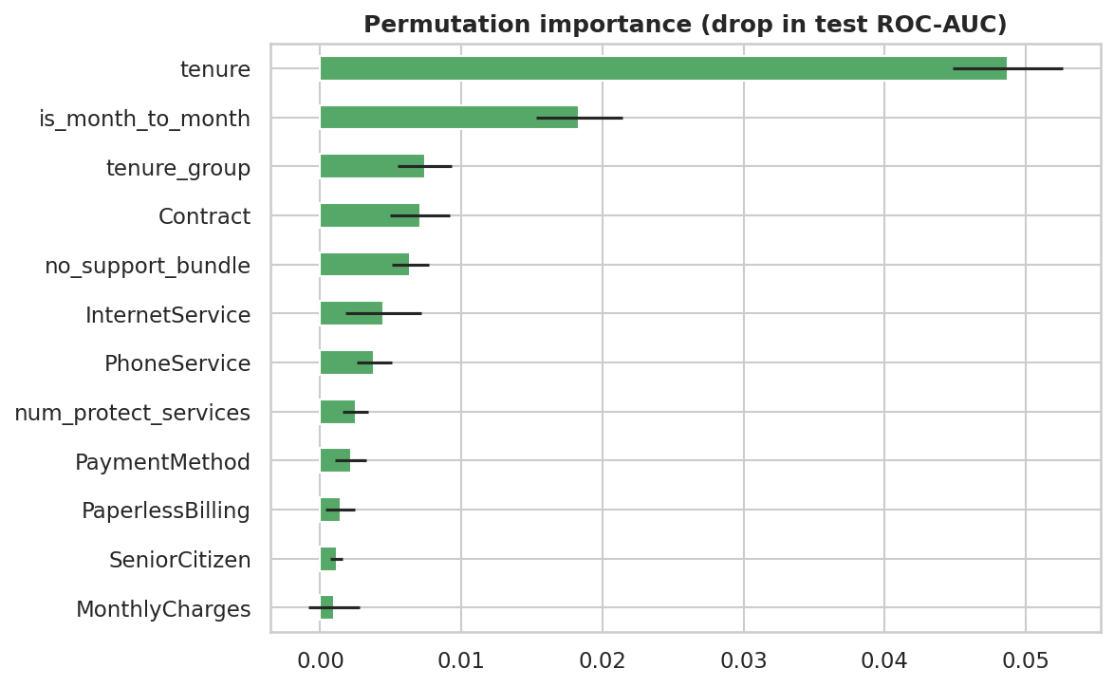
Figure 8 – Permutation importance on the test set (drop in ROC-AUC)

10. Business Insights and Recommendations

10.1 Risk segmentation
Every customer was scored using 5-fold out-of-fold predictions (each customer scored by a model that never saw them) and placed into a risk tier.
Risk tier | Customers | Share | Actual churn rate | Avg tenure (months) | Avg monthly charge | Observed monthly revenue lost
Low | 2,696 | 38.3% | 4.0% | 50.2 | $54.39 | $7,379
Medium | 1,514 | 21.5% | 18.5% | 30.1 | $61.29 | $17,007
High | 1,490 | 21.2% | 38.3% | 23.0 | $71.95 | $40,441
Critical | 1,343 | 19.1% | 67.8% | 9.7 | $81.53 | $74,304

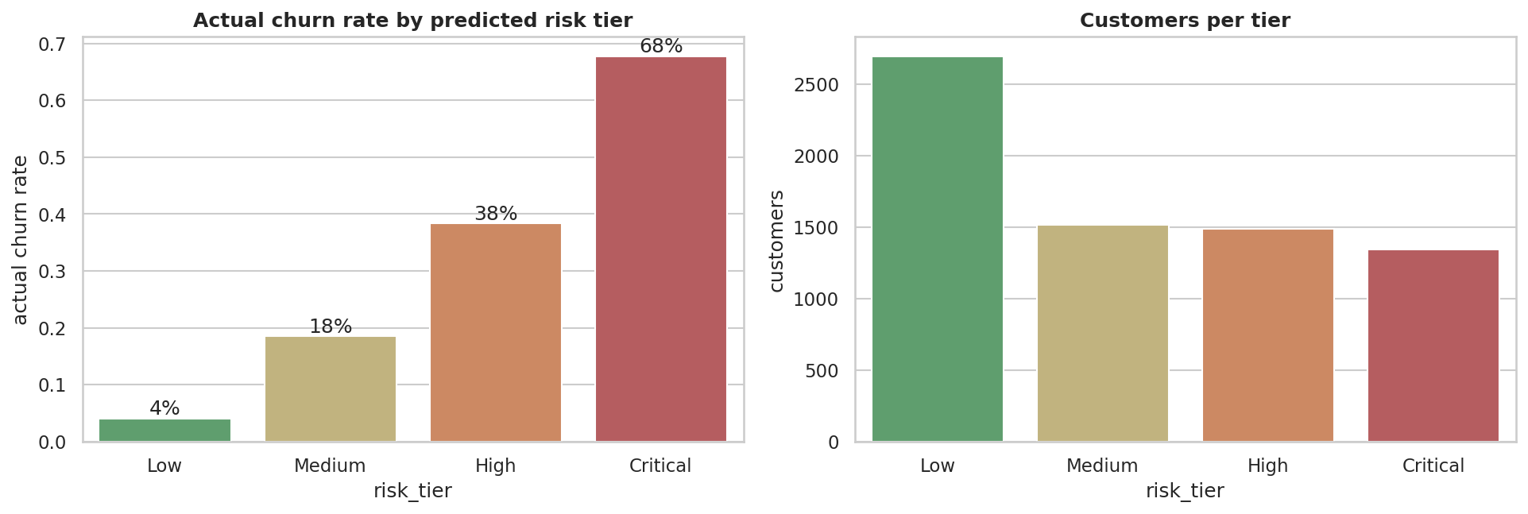
Figure 9 – Actual churn rate and customer count by predicted risk tier
Profile of high-risk customers (High + Critical, 2,833 customers) compared with everyone else:
Characteristic | High / Critical risk | All other customers
Median tenure | 10 months | 47 months
Median monthly charge | $79.95 | $55.70
On month-to-month contract | 97% | 27%
On fibre-optic internet | 72% | 25%
Pay by electronic check | 60% | 16%

High and Critical customers are 40% of the base but hold about 79% of all churners and 82% of the observed monthly revenue lost to churn, so retention effort focused on them is far more efficient than a blanket campaign.

10.2 Answers to the business questions
- Who is more likely to churn? Newer customers (first 12 months), on month-to-month contracts, with fibre-optic internet, paying by electronic check, without security or tech-support services, and higher monthly bills; also senior citizens and single customers without dependents.
- Which factors are most strongly associated? Contract type and tenure are the strongest, followed by internet service type, the absence of support add-ons, payment method and billing type.
- Which segments need attention? Month-to-month fibre customers in their first year (about 55% churn for month-to-month fibre overall), and fibre customers without security or support (55% churn, 1,765 customers).

10.3 Estimated value of acting on the model (illustrative)
Assumptions (to be replaced with the company's real figures): a retention offer costs $50 per contacted customer and succeeds 30% of the time; a saved customer is worth 12 further months of their monthly bill. Applied to the 1,409 test customers:
Strategy | Customers contacted | Net value
Do nothing | 0 | $0
Contact everyone | 1,409 | $27,524
Random customers (same count as model) | 789 | ≈ $15,301
Contact only customers flagged by the model | 789 | $51,131

10.4 Recommendations
- Convert month-to-month customers to longer contracts. Offer a bill credit or discount for 12/24-month plans, starting with High/Critical customers. Contract type is the single strongest driver, and two-year customers churn at only 3%.
- Fix the first year. Introduce an onboarding journey (welcome call in week 1, service-quality check at day 30, loyalty offer at months 6–9) because 47% of customers with tenure up to 12 months churn.
- Bundle security and tech support with fibre plans. Offer a free 3-month trial. Fibre customers without these services churn at 55%; customers who have them churn at roughly 15%. (This is an association; it should be tested with an A/B trial.)
- Investigate fibre service quality and pricing. Fibre customers pay the most and churn the most, which signals a price-value or reliability problem. Run a satisfaction survey and benchmark competitor fibre prices.
- Move electronic-check payers to automatic payment with a small one-time credit, reducing payment friction (45% churn versus 15–17%).
- Targeted support for senior citizens and single-person households, with simpler pricing and dedicated help channels.
- Operationalise the model. Score customers monthly, give the retention team the ranked list (outputs/churn_predictions.csv), tune the threshold to the real offer cost and budget, measure the realised save rate, and retrain quarterly.

11. Limitations and Future Work
- Single snapshot with no time dimension: drift cannot be tested and we cannot model when customers churn.
- The data lacks customer-service interactions, usage, complaints, network quality and competitor pricing, which likely drive real churn. This is probably why all models plateau at ROC-AUC ≈ 0.84.
- Associations are not causal; the effectiveness of any retention offer must be A/B tested.
- Precision is 44% at the recall-oriented threshold, so more than half of flagged customers would not have left; offers must be inexpensive.
- Scores are over-stated in absolute terms (class weighting) and should be used for ranking, or calibrated.
- Cost-benefit figures rely on assumed offer cost, success rate and customer lifetime.
- Possible next steps: gradient boosting (XGBoost/LightGBM), SMOTE or cost-sensitive learning, SHAP explanations, survival analysis, probability calibration, and a monitoring dashboard.

Appendix – Reproducibility
All results come from Customer_Churn_Prediction.ipynb with random seed 42 (scikit-learn 1.8, pandas 3.0 at time of execution). The notebook reads data/Telco-Customer-Churn.csv, writes figures to images/ and the customer-level risk scores to outputs/churn_predictions.csv. See README.md for setup instructions.

